WasteWise
Survey Insights Report
Based on 21 respondents • July 24–29, 2026

Executive summary
The pre-launch survey validates the core problem WasteWise is built to solve and gives clear direction on pricing, features, and the biggest barrier to adoption: trust in reliability.
81%  Willing to pay for scheduled pickup | 76%  Would be “very likely” to use it | 81%  Would test an early beta

1. The problem is real and current solutions are failing people
Over half of respondents (57%) have no formal waste disposal system — they either dump or burn their waste. Only 24% use municipal pickup. Satisfaction with current arrangements averages 2.95 out of 5, and 45% rate it a 1 or 2.
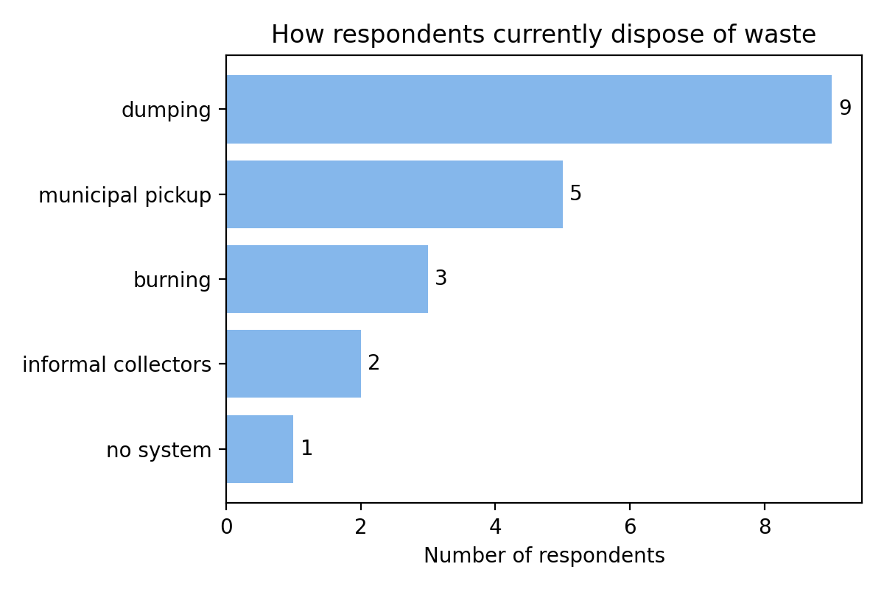
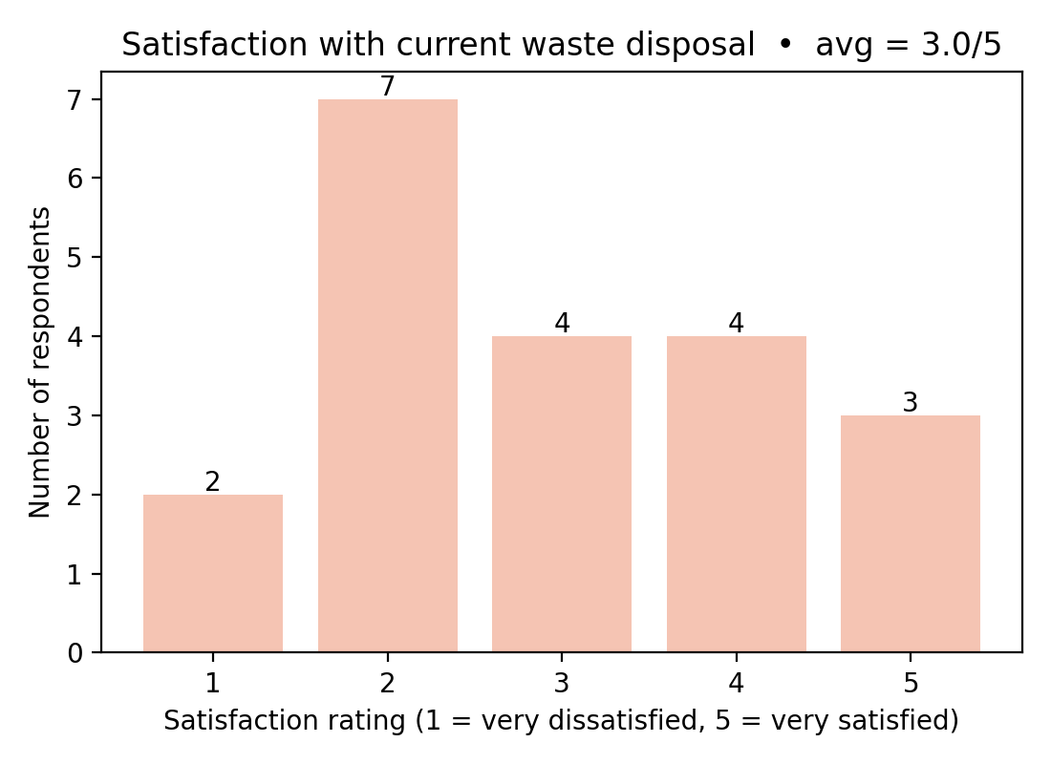
- Direction: Position WasteWise around solving a real, painful gap — not adding convenience on top of a system that already works.

2. The #1 adoption barrier is reliability, not price or tech
52% of respondents said their biggest hesitation about a new waste app is worrying the pickup won't actually show up as scheduled — more than double any other concern, including data privacy or legitimacy.
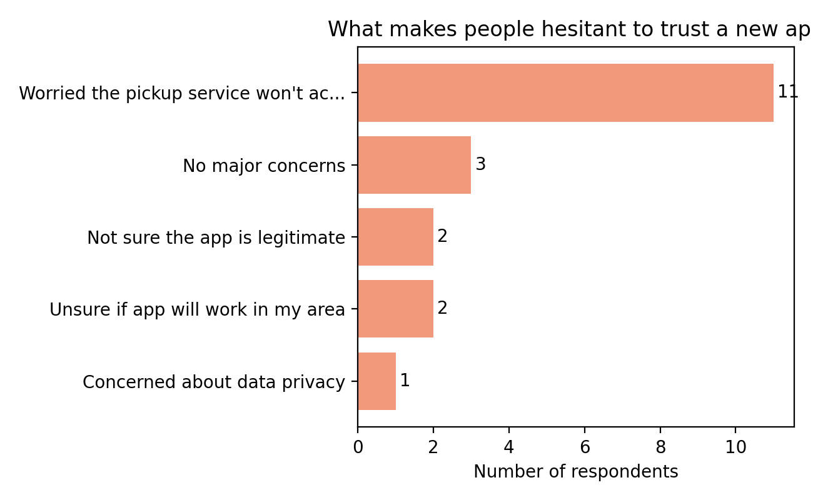
- Direction: Real-time tracking, live status updates, and visible on-time performance are not optional polish — they are the core trust-building feature that will determine adoption.

3. People will pay — price the base plan around ₦2,000–3,000/month
81% said yes or “only if cheaper than my current option.” Among those who gave a number, the median amount was ₨2,500/month, with ₨2,000 being the most common single answer.
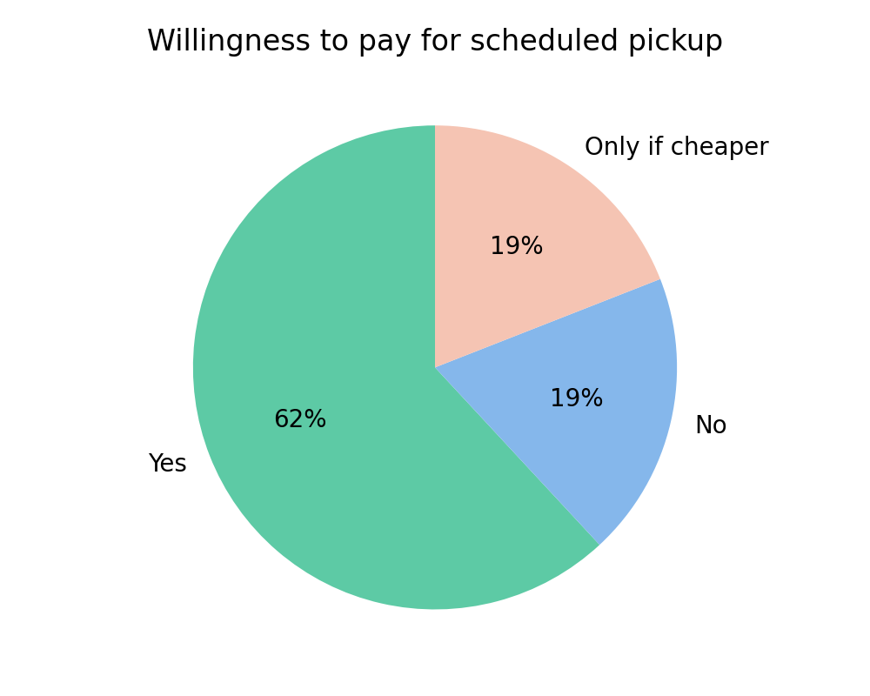
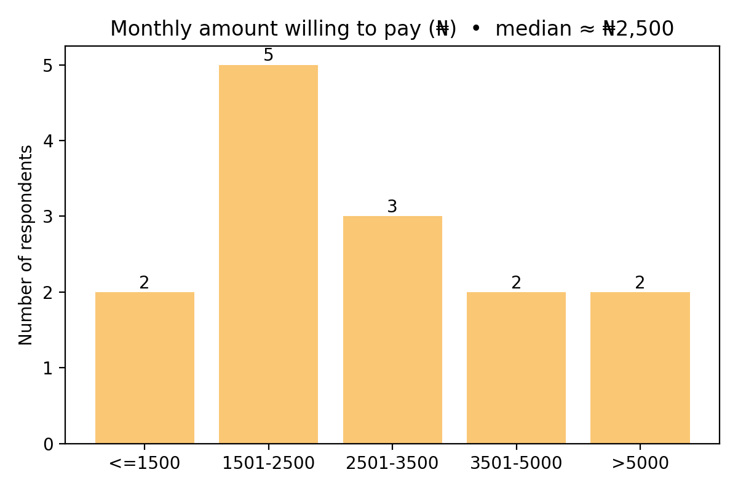
- Direction: Anchor the base subscription near ₨2,000–2,500/month, with a lower pay-per-pickup option for the price-sensitive “only if cheaper” segment (19% of respondents).

4. Feature priority: scheduling and a recycling locator lead
Pickup scheduling and a recycling drop-off locator tied for the most requested feature, each cited by a third of respondents. Payment tracking and recycling rewards trailed behind.
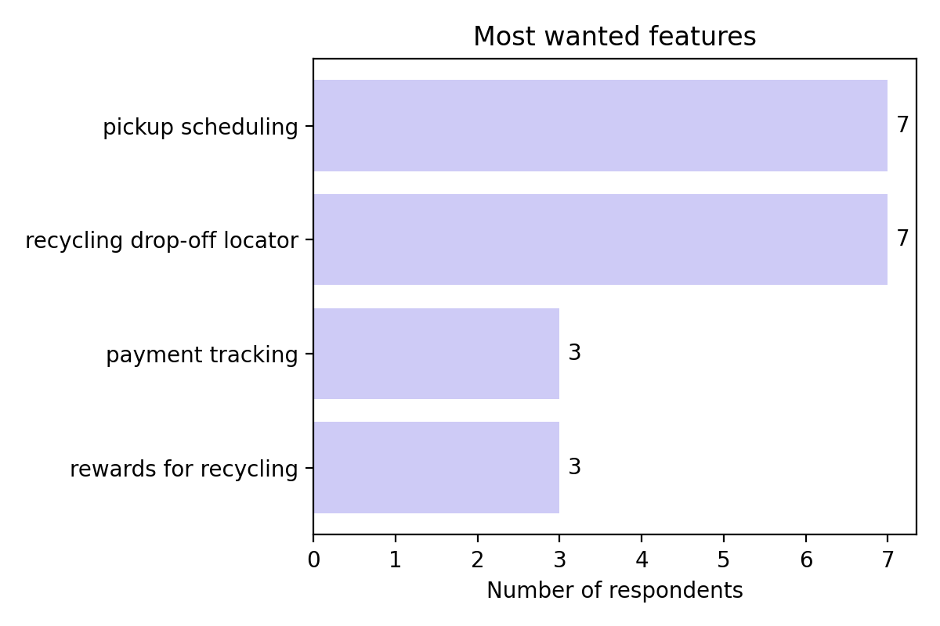
- Direction: Build the MVP around scheduling plus live tracking (from section 2), and treat the recycling locator as a strong second feature rather than a later add-on.

5. Social media is the dominant discovery channel
71% of respondents said they would most likely hear about an app like this through social media, well ahead of WhatsApp community groups or search.
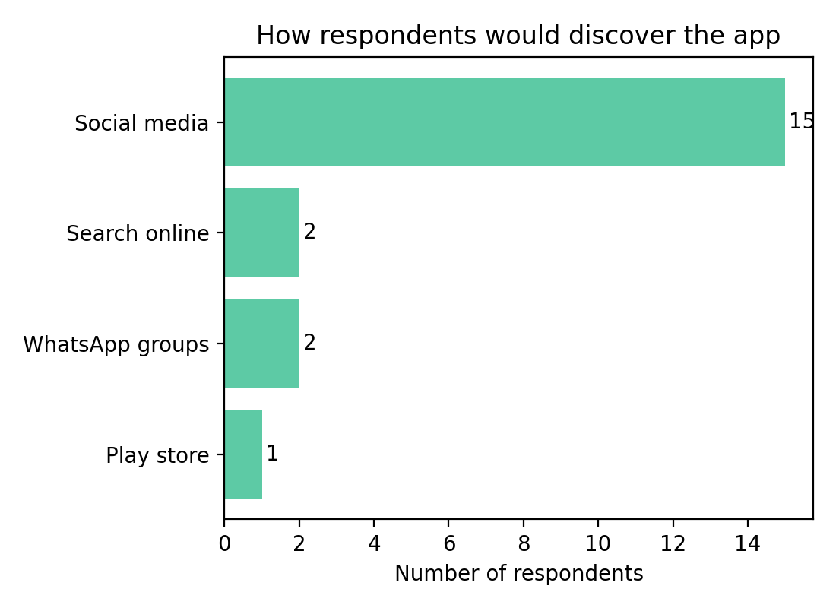
- Direction: Concentrate early marketing spend on social media, with estate/community WhatsApp groups as a low-cost secondary channel for hyperlocal trust-building.

6. Caution flags before you finalize decisions
- Small sample (21 responses), heavily skewed urban (81%) — treat findings as directional, not statistically conclusive.
- 38% weren't sure or unaware of competing solutions, while another 38% said they were aware of one — worth a follow-up question naming the specific competitor.
- 14% didn't know they should be separating their waste — build light in-app education, but don't gate core usage behind it.

Recommended build priority
- 1. Real-time tracking and status notifications — solves the #1 trust barrier.
- 2. Pickup scheduling — most requested feature.
- 3. Recycling drop-off locator — tied most requested feature.
- 4. Price the core plan at ₨2,000–2,500/month, with a pay-per-pickup fallback.
- 5. Launch marketing primarily on social media.

