Coding Task 2

Eduardo Buscató Anaya

## The application

The application consumes a set of services shared by <https://jsonplaceholder.typicode.com/>

The services offered use the following types of data: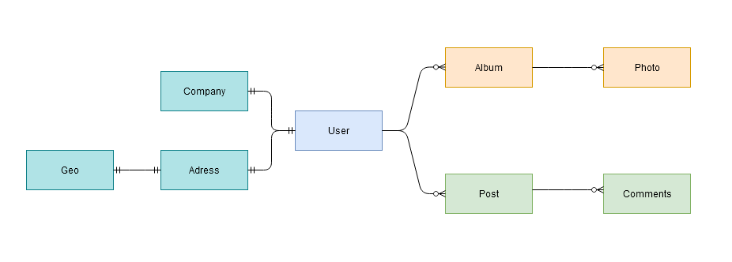

The provided coding task involves a part of the functionalities than can be featured. It’s focused on the album-photo area. The post-comments part is very similar in development concepts.

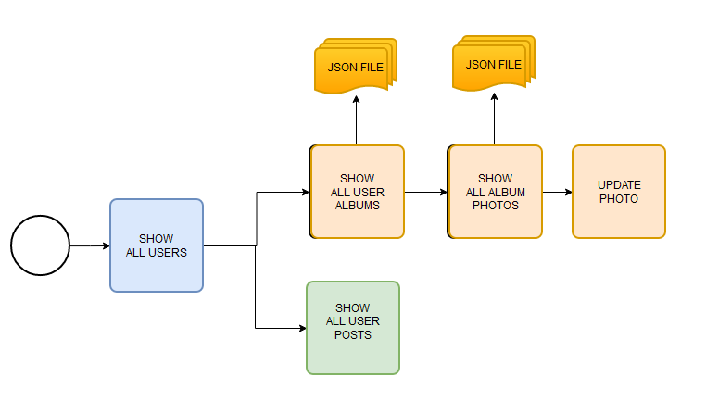

This application will list all the users. For every one, to links allow to show lists of albums or post belonging to that user.

The albums list can be exported to JSON. Every album has a link allow show the photos included.

The list of photos can be exported to JSON too. Clicking on the photo a update page is showed. In this page the user can change the values for:

* URL
* Thumbnail URL
* Title

After click on update, same page is showed, but showing the results returned for the service.

## Decisions

**Spring Boot** was used as the base of the project, because is a well-known framework, which facilitates development tasks.

To a higher clarity in the code of beans, **Lombok** was used to reduce obvious methods, but to String was overwritten to clarify the information about the project.

The communication between controllers and front was implemented by **Thymeleaf**. This is a easy way to share information between both layers.

In the implementation, Albums and Posts are very similar in functionality. I focused in one of them, that allowed to reach a clear fluid workflow.

In the provided task we found services consumed to:

* Get list of data
  + Users
* Get filtered lists of data
  + Albums by Users
  + Photos by Albums
* Get single data
  + Photo
* Update/modify data
  + Photo
* Convert data to JSON
  + Albums List
  + Photos List
* Export files
  + Albums List
  + Photos List

The code is structured focused to be logical and understandable for other developers, and be easily extended.

The code follows the same way. The methods to convert and export file can be called for any other resource (post, users..). Both albums and photos use the same functionality.

## Future improvements

The development can be extended to provide data to third-party applications than can consume a data produced by the combination of this basic structure. For example, comments can be associated to photos and offered as a unique data set.

Also, can be complemented with databases or importation of data files.

Unit test must be consider to be added to improve the efficiency during code development.