**Project 2: High Dynamic Range Imaging**

Emily Busche

Giang Doan

{ebusche@cs.wisc.edu, gdoan@cs.wisc.edu}

**Introduction**

Image stitching is a technique to combine a set of images into a larger image by registering, warping, resampling and blending them together. A popular application of image stitching is to create panoramas. Generally speaking, there are two classes of methods for image stitching: direct methods and feature-based methods.

In this project, we implement a feature-based method to generate panoramic images.

* Step 1: capture images
* Step 2: warp images into cylindrical coordinates
* Step 3: take the feature sets of two cylindrical images and apply the RANSAC algorithm to estimate the translational motion (pair-wise feature matching),
* Step 4: stitch and blend images in the order of matching and crop out the final panorama.
* Extension part: develop pyramid blending technique

The camera we used has the following parameters that are necessary when calculating the intrinsic matrix for distortion removal:

|  |  |  |  |  |
| --- | --- | --- | --- | --- |
| Canon A640, tag 4726208879 | 480x640 | 660.8799 | -0.18533 | 0.21517 |

# **Capture Images (Emily and Giang)**

We went to the Capitol and shot around outside scene at 20-degree intervals. Then 18 best images in 360 degrees are selected for the project.

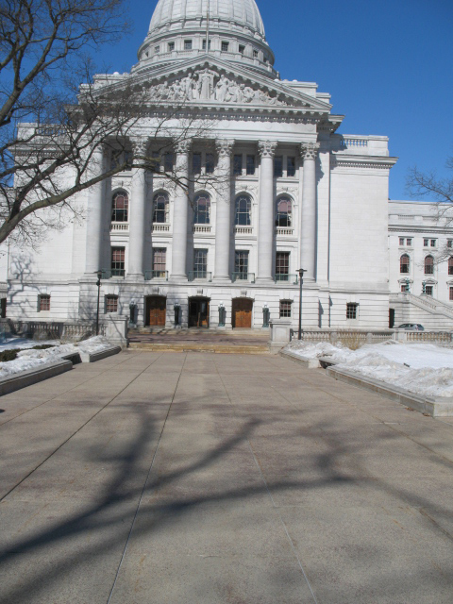

**Figure 1:** State Capitol Building – outside scene

# **Warping each image into cylindrical coordinates (Emily)**

We implement this section in the following steps:

1. Images are converted into cylindrical coordinates (**warpCylinder.m**)
2. Cylindrical coordinates are unwarped into a flattened image (**unwarpCylinder.m**)

# **Computing the alignment of the image in pairs (Giang)**

We implement this section in the following steps:

1. Two feature detectors are implemented:

* Harris feature detector (**HarrisFeatureDetector.m**)
* Moravec feature detector (**MoravecFeatureDetector.m**)

1. We need to implement feature removal techniques to reduce the number of features

* Feature removal by boundary (**FeatureRemovalBoundary.m**)
* Feature removal by low contrast (**FeatureRemovalLowContrast.m**)
* Feature removal by edge (**FeatureRemovalEdge.m**)

1. SIFT feature descriptor is implemented (**SIFTFeatureDescriptor.m**)
2. RANSAC algorithm is used to eliminate the outliers (**RANSACMethod.m**)
3. Find all matching images and their connected sets (**ImageMatching.m**)

# **Stitching and cropping the result aligned images (Emily)**

We implement this section in the following steps:

1. A linear alpha blending is used to blend 2 adjacent images (**blendImage.m**)
2. Implement an auto cropping technique by removing all the rows in the image that contain at least one non-scene black pixel resulting from the cylindrical projection steps (**perfectCrop.m**)

# **Creating the final result. (Giang)**

Final image is imported into PanoramaStudio Pro 2.5.1 and converted to a 360 degree panorama.

The result is available at: <http://humanrank.us/pano_capitol/capitol.html>

# **Bonus**

## **Pyramid blending technique (Emily and Giang)**

We choose pyramid blending technique to replace the linear alpha blending technique in Section 4 for better results. The pyramid blending technique is implemented in following steps:

1. An application that can implement pyramid blending technique in 2 images at the same sizes, then output an image as a results. (**Giang**)
2. A more advanced application that can implement pyramid blending technique in images with different sizes. This version is implementing in the project in section 4. (**Emily**)

# **References**

1. R. Szeliski and H.-Y. Shum. “Creating Full View Panoramic Image Mosaics and Environment Maps”, SIGGRAPH 1997, pp251-258.
2. M. Brown, D. G. Lowe, “Recognising Panoramas”, ICCV 2003.