

SCHOOL OF EECE

ECE107L/A13

SIGNALS SPECTRA, AND SIGNAL PROCESSING

PROJECT

**Submitted by:**

**GROUP 3**

**DOCDOCIL, CHRISTIAN G.**

**VILLENA, EDUARDO B.**

Engr. Leonardo D. Valiente

Instructor

**INTRODUCTION OF THE PROJECT**

Modern technology now enable us to do a lot of different things. While many other programs offer features that lets us do these things easily, it can sometimes be beneficial to us that we learn how do these programs work. One of these programs is Photoshop which is developed by Adobe. It is a powerful software that allows us to edit images and make modifications that is before is complicated and difficult to do. With this application, innovation simply took place and lots of other programs were also created similar to that of Photoshop.

# **ACKNOWLEDGMENT**

Our deepest gratitude to our Engr. Leonardo D. Valiente Jr. for whole-heartedly teaching and guiding us about digital signal processing. His teachings made this project a possibility as the professor of our digital signal processing laboratory class.

**DOCDOCIL, Christian G.**

**VILLENA, Eduardo B.**

# **PROGRAM DESCRIPTION**

The program is developed under MATLAB R2016b with the Image Processing Toolbox. It retrieves an image file with a .jpg, .tif, .png, and .gif. It has the capability to do FIR filter image processing, such as motion, gaussian, average, unsharp, laplacian, and sobel. The input image can also be converted to binary or grayscale. Morphological conversions such as invert, erosion, dilate, estimate, and subtract are also in the program. A contrast slider is also present in the program, which has an option of low in, low out, high in, or high out. Upon opening an input image, a histogram is automatically generated. This includes the red, green, and blue spectrum. It is also automatically generated after using an option and then clicking the apply button and after configuring the generated image it can be save using file menu and ‘Save Generated Image’.

# **SCOPE AND LIMITATIONS**

The program is only limited to image files that are locally stored in the machine. It cannot retrieve an image located on the internet and download it on the host machine. Apart from the provided options in the program itself, it cannot do anything more.

# **SCREEN CAPTURE OF IMAGE FILE**

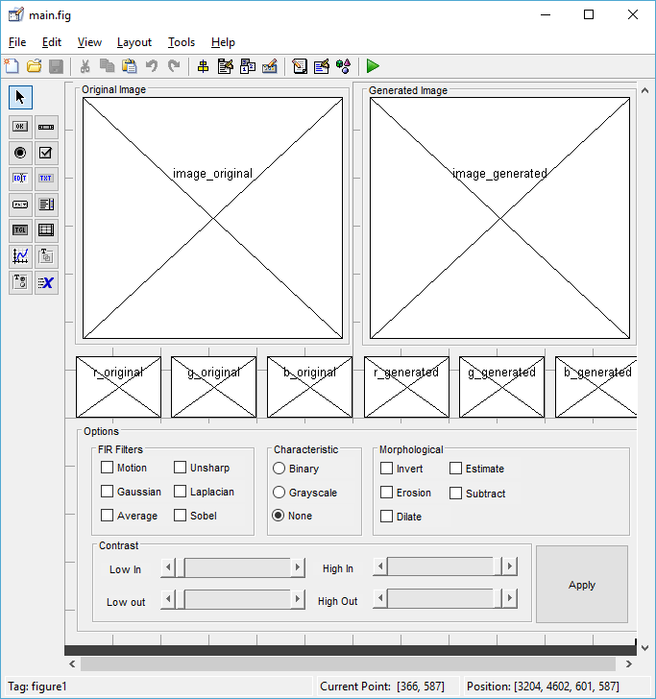

Fig. 1) Image file screen capture

# **ALL M-FILES USED IN THE PROJECT**

function varargout = main(varargin)

gui_Singleton = 1;

gui_State = struct('gui_Name', mfilename, ...

'gui_Singleton', gui_Singleton, ...

'gui_OpeningFcn', @main_OpeningFcn, ...

'gui_OutputFcn', @main_OutputFcn, ...

'gui_LayoutFcn', [] , ...

'gui_Callback', []);

if nargin && ischar(varargin{1})

gui_State.gui_Callback = str2func(varargin{1});

end

if nargout

[varargout{1:nargout}] = gui_mainfcn(gui_State, varargin{:});

else

gui_mainfcn(gui_State, varargin{:});

end

function main_OpeningFcn(hObject, eventdata, handles, varargin)

handles.output = hObject;

guidata(hObject, handles);

movegui('center');

function varargout = main_OutputFcn(hObject, eventdata, handles)

varargout{1} = handles.output;

% --------------------------------------------------------------------

function menu_file_Callback(hObject, eventdata, handles)

% --------------------------------------------------------------------

function menu_other_Callback(hObject, eventdata, handles)

% --------------------------------------------------------------------

function other_help_Callback(hObject, eventdata, handles)

% --------------------------------------------------------------------

function file_open_Callback(hObject, eventdata, handles)

[filename,pathname] = uigetfile({'*.jpg;*.tif;*.png;*.gif','All Image Files';'*.*','All Files' },'Open an image...');

global full_path

full_path = strcat(pathname,filename);

disp(full_path);

axes(handles.image_original);

imshow(full_path);

image_original = imread(full_path);

Red = image_original(:,:,1);

Green = image_original(:,:,2);

Blue = image_original(:,:,3);

axes(handles.r_original);

histogram(Red,'FaceColor','r','EdgeColor','r');

axis off

axes(handles.g_original);

histogram(Green,'FaceColor','g','EdgeColor','g');

axis off

axes(handles.b_original);

histogram(Blue,'FaceColor','b','EdgeColor','b');

axis off

apply_button_Callback(handles.apply_button,eventdata,handles);

% --------------------------------------------------------------------

function file_save_Callback(hObject, eventdata, handles)

global image_filtered

imwrite(image_filtered,'result.jpg');

% --- Executes on button press in checkbox1.

function checkbox1_Callback(hObject, eventdata, handles)

% --- Executes on button press in apply_button.

function apply_button_Callback(hObject, eventdata, handles)

global full_path;

global image_filtered;

global image_original;

image_original = imread(full_path);

image_filtered = imread(full_path);

low_in = get(handles.c_lowin,'value');

low_out = get(handles.c_lowout,'value');

high_in = get(handles.c_highin,'value');

high_out = get(handles.c_highout,'value');

disp(low_in);

disp(low_out);

disp(high_in);

disp(high_out);

image_filtered = imadjust(image_filtered, [low_in;high_in],[low_out;high_out]);

if(get(handles.c_binary, 'value') == 1)

image_filtered = rgb2gray(image_filtered);

image_filtered = imbinarize(image_filtered);

elseif(get(handles.c_grayscale, 'value') == 1)

image_filtered = rgb2gray(image_filtered);

else

%do nothing

end

if(get(handles.c_motion, 'value') == 1)

h = fspecial('motion');

image_filtered = imfilter(image_filtered,h);

end

if(get(handles.c_gaussian, 'value') == 1)

h = fspecial('gaussian',[1000,1],1);

image_filtered = imfilter(image_filtered,h);

end

if(get(handles.c_laplacian, 'value') == 1)

h = fspecial('average');

image_filtered = imfilter(image_filtered,h);

end

if(get(handles.c_disk, 'value') == 1)

h = fspecial('unsharp');

image_filtered = imfilter(image_filtered,h);

end

if(get(handles.c_prewitt, 'value') == 1)

h = fspecial('laplacian');

image_filtered = imfilter(image_filtered,h);

end

if(get(handles.c_sobel, 'value') == 1)

h = fspecial('sobel');

image_filtered = imfilter(image_filtered,h);

end

if(get(handles.c_invert, 'value') == 1)

image_filtered = imcomplement(image_filtered);

end

if(get(handles.c_erosion, 'value') == 1)

image_filtered = imerode(image_filtered,ones(3));

end

if(get(handles.c_erosion, 'value') == 1)

image_filtered = imerode(image_filtered,ones(3));

end

if(get(handles.c_estimate, 'value') == 1)

image_filtered = imopen(image_filtered,strel('disk',15));

end

if(get(handles.c_subtract, 'value') == 1)

image_filtered = imsubtract(image_original,image_filtered);

end

axes(handles.image_generated);

imshow(image_filtered);

if(get(handles.c_grayscale, 'value') == 1 || get(handles.c_binary, 'value') == 1 )

cla(handles.r_generated);

cla(handles.b_generated);

axes(handles.g_generated);

imhist(image_filtered);

else

Red = image_filtered(:,:,1);

Green = image_filtered(:,:,2);

Blue = image_filtered(:,:,3);

axes(handles.r_generated);

histogram(Red,'FaceColor','r','EdgeColor','r');

axis off

axes(handles.g_generated);

histogram(Green,'FaceColor','g','EdgeColor','g');

axis off

axes(handles.b_generated);

histogram(Blue,'FaceColor','b','EdgeColor','b');

axis off

end

% --- Executes on selection change in popupmenu1.

function popupmenu1_Callback(hObject, eventdata, handles)

% hObject handle to popupmenu1 (see GCBO)

% eventdata reserved - to be defined in a future version of MATLAB

% handles structure with handles and user data (see GUIDATA)

% Hints: contents = cellstr(get(hObject,'String')) returns popupmenu1 contents as cell array

% contents{get(hObject,'Value')} returns selected item from popupmenu1

% --- Executes during object creation, after setting all properties.

function popupmenu1_CreateFcn(hObject, eventdata, handles)

% hObject handle to popupmenu1 (see GCBO)

% eventdata reserved - to be defined in a future version of MATLAB

% handles empty - handles not created until after all CreateFcns called

% Hint: popupmenu controls usually have a white background on Windows.

% See ISPC and COMPUTER.

if ispc && isequal(get(hObject,'BackgroundColor'), get(0,'defaultUicontrolBackgroundColor'))

set(hObject,'BackgroundColor','white');

end

% --- Executes on button press in reset_button.

function reset_button_Callback(hObject, eventdata, handles)

% hObject handle to reset_button (see GCBO)

% eventdata reserved - to be defined in a future version of MATLAB

% handles structure with handles and user data (see GUIDATA)

global image_original

global image_filtered

figure(2),imhist(rgb2gray(image_original));

% --- Executes on button press in c_laplacian.

function c_laplacian_Callback(hObject, eventdata, handles)

% hObject handle to c_laplacian (see GCBO)

% eventdata reserved - to be defined in a future version of MATLAB

% handles structure with handles and user data (see GUIDATA)

% Hint: get(hObject,'Value') returns toggle state of c_laplacian

% --- Executes on button press in c_gaussian.

function c_gaussian_Callback(hObject, eventdata, handles)

% hObject handle to c_gaussian (see GCBO)

% eventdata reserved - to be defined in a future version of MATLAB

% handles structure with handles and user data (see GUIDATA)

% Hint: get(hObject,'Value') returns toggle state of c_gaussian

% --- Executes on button press in c_motion.

function c_motion_Callback(hObject, eventdata, handles)

% hObject handle to c_motion (see GCBO)

% eventdata reserved - to be defined in a future version of MATLAB

% handles structure with handles and user data (see GUIDATA)

% Hint: get(hObject,'Value') returns toggle state of c_motion

% --- Executes on button press in c_sobel.

function c_sobel_Callback(hObject, eventdata, handles)

% hObject handle to c_sobel (see GCBO)

% eventdata reserved - to be defined in a future version of MATLAB

% handles structure with handles and user data (see GUIDATA)

% Hint: get(hObject,'Value') returns toggle state of c_sobel

% --- Executes on button press in c_prewitt.

function c_prewitt_Callback(hObject, eventdata, handles)

% hObject handle to c_prewitt (see GCBO)

% eventdata reserved - to be defined in a future version of MATLAB

% handles structure with handles and user data (see GUIDATA)

% Hint: get(hObject,'Value') returns toggle state of c_prewitt

% --- Executes on button press in c_disk.

function c_disk_Callback(hObject, eventdata, handles)

% hObject handle to c_disk (see GCBO)

% eventdata reserved - to be defined in a future version of MATLAB

% handles structure with handles and user data (see GUIDATA)

% Hint: get(hObject,'Value') returns toggle state of c_disk

function c_contrast_Callback(hObject, eventdata, handles)

% hObject handle to c_contrast (see GCBO)

% eventdata reserved - to be defined in a future version of MATLAB

% handles structure with handles and user data (see GUIDATA)

% Hints: get(hObject,'String') returns contents of c_contrast as text

% str2double(get(hObject,'String')) returns contents of c_contrast as a double

% --- Executes during object creation, after setting all properties.

function c_contrast_CreateFcn(hObject, eventdata, handles)

% hObject handle to c_contrast (see GCBO)

% eventdata reserved - to be defined in a future version of MATLAB

% handles empty - handles not created until after all CreateFcns called

% Hint: edit controls usually have a white background on Windows.

% See ISPC and COMPUTER.

if ispc && isequal(get(hObject,'BackgroundColor'), get(0,'defaultUicontrolBackgroundColor'))

set(hObject,'BackgroundColor','white');

end

function c_threshold_Callback(hObject, eventdata, handles)

% hObject handle to c_threshold (see GCBO)

% eventdata reserved - to be defined in a future version of MATLAB

% handles structure with handles and user data (see GUIDATA)

% Hints: get(hObject,'String') returns contents of c_threshold as text

% str2double(get(hObject,'String')) returns contents of c_threshold as a double

% --- Executes during object creation, after setting all properties.

function c_threshold_CreateFcn(hObject, eventdata, handles)

% hObject handle to c_threshold (see GCBO)

% eventdata reserved - to be defined in a future version of MATLAB

% handles empty - handles not created until after all CreateFcns called

% Hint: edit controls usually have a white background on Windows.

% See ISPC and COMPUTER.

if ispc && isequal(get(hObject,'BackgroundColor'), get(0,'defaultUicontrolBackgroundColor'))

set(hObject,'BackgroundColor','white');

end

% --- Executes on button press in c_invert.

function c_invert_Callback(hObject, eventdata, handles)

% hObject handle to c_invert (see GCBO)

% eventdata reserved - to be defined in a future version of MATLAB

% handles structure with handles and user data (see GUIDATA)

% Hint: get(hObject,'Value') returns toggle state of c_invert

% --- Executes on button press in c_erosion.

function c_erosion_Callback(hObject, eventdata, handles)

% hObject handle to c_erosion (see GCBO)

% eventdata reserved - to be defined in a future version of MATLAB

% handles structure with handles and user data (see GUIDATA)

% Hint: get(hObject,'Value') returns toggle state of c_erosion

% --- Executes on button press in c_dilate.

function c_dilate_Callback(hObject, eventdata, handles)

% hObject handle to c_dilate (see GCBO)

% eventdata reserved - to be defined in a future version of MATLAB

% handles structure with handles and user data (see GUIDATA)

% Hint: get(hObject,'Value') returns toggle state of c_dilate

% --- Executes on button press in c_estimate.

function c_estimate_Callback(hObject, eventdata, handles)

% hObject handle to c_estimate (see GCBO)

% eventdata reserved - to be defined in a future version of MATLAB

% handles structure with handles and user data (see GUIDATA)

% Hint: get(hObject,'Value') returns toggle state of c_estimate

% --- Executes on button press in c_subtract.

function c_subtract_Callback(hObject, eventdata, handles)

% hObject handle to c_subtract (see GCBO)

% eventdata reserved - to be defined in a future version of MATLAB

% handles structure with handles and user data (see GUIDATA)

% Hint: get(hObject,'Value') returns toggle state of c_subtract

% --- Executes on slider movement.

function c_lowin_Callback(hObject, eventdata, handles)

% hObject handle to c_lowin (see GCBO)

% eventdata reserved - to be defined in a future version of MATLAB

% handles structure with handles and user data (see GUIDATA)

% Hints: get(hObject,'Value') returns position of slider

% get(hObject,'Min') and get(hObject,'Max') to determine range of slider

% --- Executes during object creation, after setting all properties.

function c_lowin_CreateFcn(hObject, eventdata, handles)

% hObject handle to c_lowin (see GCBO)

% eventdata reserved - to be defined in a future version of MATLAB

% handles empty - handles not created until after all CreateFcns called

% Hint: slider controls usually have a light gray background.

if isequal(get(hObject,'BackgroundColor'), get(0,'defaultUicontrolBackgroundColor'))

set(hObject,'BackgroundColor',[.9 .9 .9]);

end

% --- Executes on slider movement.

function slider3_Callback(hObject, eventdata, handles)

% hObject handle to slider3 (see GCBO)

% eventdata reserved - to be defined in a future version of MATLAB

% handles structure with handles and user data (see GUIDATA)

% Hints: get(hObject,'Value') returns position of slider

% get(hObject,'Min') and get(hObject,'Max') to determine range of slider

% --- Executes during object creation, after setting all properties.

function slider3_CreateFcn(hObject, eventdata, handles)

% hObject handle to slider3 (see GCBO)

% eventdata reserved - to be defined in a future version of MATLAB

% handles empty - handles not created until after all CreateFcns called

% Hint: slider controls usually have a light gray background.

if isequal(get(hObject,'BackgroundColor'), get(0,'defaultUicontrolBackgroundColor'))

set(hObject,'BackgroundColor',[.9 .9 .9]);

end

% --- Executes on slider movement.

function c_lowout_Callback(hObject, eventdata, handles)

% hObject handle to c_lowout (see GCBO)

% eventdata reserved - to be defined in a future version of MATLAB

% handles structure with handles and user data (see GUIDATA)

% Hints: get(hObject,'Value') returns position of slider

% get(hObject,'Min') and get(hObject,'Max') to determine range of slider

% --- Executes during object creation, after setting all properties.

function c_lowout_CreateFcn(hObject, eventdata, handles)

% hObject handle to c_lowout (see GCBO)

% eventdata reserved - to be defined in a future version of MATLAB

% handles empty - handles not created until after all CreateFcns called

% Hint: slider controls usually have a light gray background.

if isequal(get(hObject,'BackgroundColor'), get(0,'defaultUicontrolBackgroundColor'))

set(hObject,'BackgroundColor',[.9 .9 .9]);

end

% --- Executes on slider movement.

function c_highin_Callback(hObject, eventdata, handles)

% hObject handle to c_highin (see GCBO)

% eventdata reserved - to be defined in a future version of MATLAB

% handles structure with handles and user data (see GUIDATA)

% Hints: get(hObject,'Value') returns position of slider

% get(hObject,'Min') and get(hObject,'Max') to determine range of slider

% --- Executes during object creation, after setting all properties.

function c_highin_CreateFcn(hObject, eventdata, handles)

% hObject handle to c_highin (see GCBO)

% eventdata reserved - to be defined in a future version of MATLAB

% handles empty - handles not created until after all CreateFcns called

% Hint: slider controls usually have a light gray background.

if isequal(get(hObject,'BackgroundColor'), get(0,'defaultUicontrolBackgroundColor'))

set(hObject,'BackgroundColor',[.9 .9 .9]);

end

% --- Executes on slider movement.

function c_highout_Callback(hObject, eventdata, handles)

% hObject handle to c_highout (see GCBO)

% eventdata reserved - to be defined in a future version of MATLAB

% handles structure with handles and user data (see GUIDATA)

% Hints: get(hObject,'Value') returns position of slider

% get(hObject,'Min') and get(hObject,'Max') to determine range of slider

% --- Executes during object creation, after setting all properties.

function c_highout_CreateFcn(hObject, eventdata, handles)

% hObject handle to c_highout (see GCBO)

% eventdata reserved - to be defined in a future version of MATLAB

% handles empty - handles not created until after all CreateFcns called

% Hint: slider controls usually have a light gray background.

if isequal(get(hObject,'BackgroundColor'), get(0,'defaultUicontrolBackgroundColor'))

set(hObject,'BackgroundColor',[.9 .9 .9]);

end

% --- Executes on button press in c_edited.

function c_edited_Callback(hObject, eventdata, handles)

% hObject handle to c_edited (see GCBO)

% eventdata reserved - to be defined in a future version of MATLAB

% handles structure with handles and user data (see GUIDATA)

# **THREE (3) SAMPLE OUTPUT**

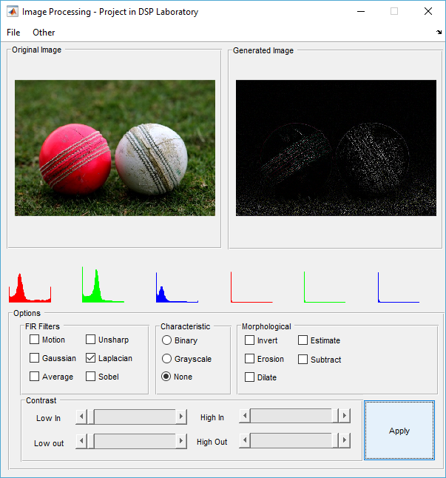

Fig. 2) First Output

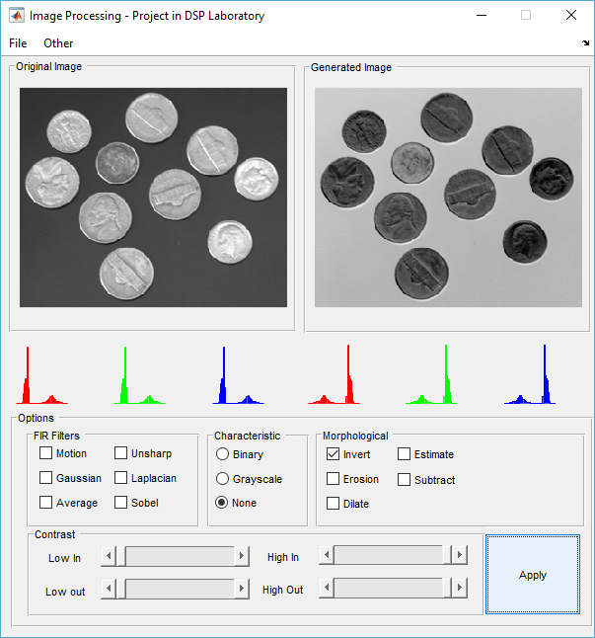

Fig. 3) Second Output

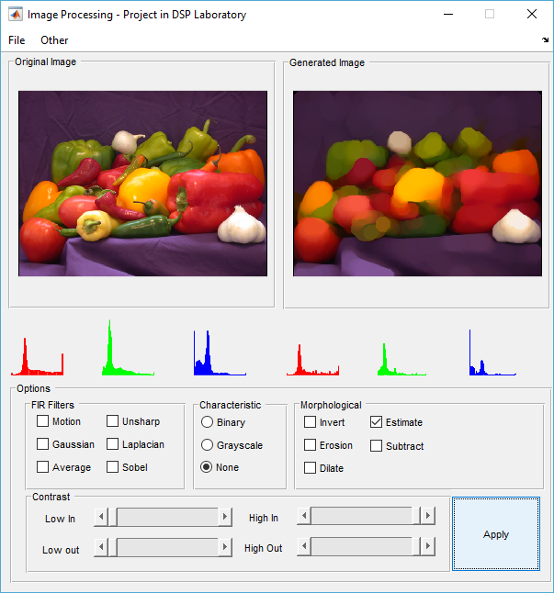

Fig. 4) Third Output

# **REFERENCES**

[1] Image Processing Toolbox. (n.d.). Retrieved March 05, 2017, from https://www.mathworks.com/products/image.html

[2] fspecial - MATLAB. (n.d.). Retrieved March 05, 2017, from https://www.mathworks.com/help/images/ref/fspecial.html

[3] Morphologically open image - MATLAB imopen. (n.d.). Retrieved March 05, 2017, from https://www.mathworks.com/help/images/ref/imopen.html

[4] Perform morphological opening on an image - MATLAB. (n.d.). Retrieved March 05, 2017, from https://www.mathworks.com/help/vision/ref/vision.morphologicalopen-class.html

[5] How to calculate a RGB histogram? (n.d.). Retrieved March 05, 2017, from https://www.mathworks.com/matlabcentral/newsreader/view_thread/68712