Form Guidance on IPR
Patent Information Centre
West Bengal State Council of Science and Technology
BigyaanChetana Bhavan, 3rd Floor, Block-DD, 26/B, Salt Lake, Kolkata – 700064.
Application is hereby made by (a) IIEST Shibpur furnishing the following particulars:
Name of the Inventor: | Anwesa Sarkar, Siluveru Raja Viveka Vardhan, Dr Ananya Barui
Name of the Applicant: | Indian Institute of Engineering Science and Technology, Shibpur (IIEST Shibpur)
Name of the University/Research Institute/College/Govt. Department: | Centre for Healthcare Science and Technology, Indian Institute of Engineering Science and Technology, Shibpur (IIEST Shibpur)
Address with Contact No. | Botanical Garden Rd, Indian Institute of Engineering Science and Technology Shibpur, Howrah, West Bengal – 711103 Contact No.:
E-mail: | 2024hcm005.siluveru@students.iiests.ac.in  2024hcm011.anwesa@students.iiests.ac.in  ananya.pariksha@gmail.com
Guidance for: | Patent Searching, search report
Abstract of the invention: | The present invention discloses an IoT-enabled, multi-modal microgravity and partial-gravity simulation platform for biological, physicochemical, and mechanotransducive research. The device operates in 2D clinostat, 3D clinostat, Random Positioning Machine (RPM), and a novel Hybrid Clinostat–RPM mode, with automated planetary gravity profile selection for Earth (1 g), Moon (0.166 g), Mars (0.376 g), and Space (microgravity, ~0 g). The platform is controlled wirelessly via a dedicated mobile application communicating with a Raspberry Pi 3 central computing unit over Wi-Fi, with an integrated Raspberry Pi Camera Module providing real-time live video monitoring of the rotating sample. A Universal Sample Holding Module (USHM) accommodates standard T25 cell culture flasks, well plates, microfluidic devices, and Lab-on-Chip (LoC) carriers, enabling the novel 'Microgravity-on-Chip' (MoC) paradigm. Dual NEMA 14 stepper motors with TMC2209 silent stepper drivers provide low-noise, high-precision, dual-axis rotation. A unified real-time mathematical framework continuously quantifies and displays the time-averaged residual gravitational vector, confirming simulation fidelity across all modes.
Key words: | microgravity simulation, clinostat, Random Positioning Machine, RPM, 3D clinostat, microgravity-on-chip, microfluidic, partial gravity, planetary gravity simulation, IoT laboratory instrument, wireless control, stepper motor, Raspberry Pi, cell culture, space biology, Mechanotransduction, Lab-on-Chip, well plate, hybrid mode, NEMA 14, TMC2209, live monitoring
Full Invention (attach extra sheet) | See attached
Drawing (attach extra sheet) | See attached

Signature: _______________________
Date: _______________

Full Invention
Title: Automated Multi-Modal Microgravity-on-a-Chip Simulation Platform
Abstract
The present invention discloses a multi-modal, IoT-enabled microgravity and partial-gravity simulation platform designed for controlled experimental studies in space biology, cellular mechanotransduction, pharmaceutical research, and tissue engineering. The device integrates dual-axis gimbal mechanics driven by two NEMA 14 stepper motors with TMC2209 silent step drivers, enabling operation in four distinct modes: 2D clinostat, 3D clinostat, Random Positioning Machine (RPM), and a novel Hybrid Clinostat–RPM mode. Automated planetary gravity profile algorithms allow the platform to simulate gravitational environments representative of Earth (1 g), Moon (0.166 g), Mars (0.376 g), and near-zero Space microgravity with algorithmically tuned residual g-vectors. The platform is governed by a Raspberry Pi 3 single-board computer communicating wirelessly with a dedicated mobile application GUI over Wi-Fi, enabling fully remote parameter configuration, operational mode selection, real-time telemetry monitoring, and live video feed from an integrated Raspberry Pi Camera Module. A Universal Sample Holding Module (USHM) accepts standard T25 cell culture flasks, multiwell plates, microfluidic devices, and Lab-on-Chip (LoC) carriers interchangeably, introducing the 'Microgravity-on-Chip' (MoC) concept that miniaturizes the microgravity biological experiment to the chip scale for high-throughput, low-volume parallel cell culture. A unified embedded mathematical framework continuously computes and displays the time-averaged residual gravitational acceleration across all operational modes. The system provides a standardized, reproducible, remotely operable laboratory instrument that consolidates multiple gravitational simulation modalities, planetary environment replication, wireless control, and advanced microfluidic sample compatibility into a single compact platform.

Keywords
Microgravity simulation, clinostat, 3D clinostat, Random Positioning Machine (RPM), Hybrid Clinostat–RPM, Microgravity-on-Chip (MoC), microfluidic cell culture, partial gravity, planetary gravity emulation, space biology mechanotransduction.

Description

Hardware Components
The mechanical architecture of the platform is built around a rigid outer frame fabricated from structural PLA/ABS polymer or metallic alloy, mounted on broad triangular base supports that distribute load uniformly and suppress resonance vibration during continuous rotation. The core moving assembly employs a gimbal configuration consisting of two nested orthogonal frames: an outer frame rotating about the vertical (yaw) axis and an inner frame rotating about the horizontal (pitch or roll) axis. This arrangement enables the centrally mounted sample platform to be subjected to independent or synchronized rotational forces along two orthogonal axes. A precision spur gear train on each axis provides the required torque multiplication and speed reduction for low-speed clinostat operation, while minimizing rotational backlash and transmission vibration.
Two NEMA 14 stepper motors serve as the primary actuators for each rotational axis, selected for their compact form factor and high torque-to-size ratio. Each motor is driven by a dedicated TMC2209 stepper driver operating in StealthChop2 mode, which provides virtually silent motor operation critical for vibration-sensitive biological assays, with microstepping resolution up to 1/256 step for ultra-smooth motion profiles. SpreadCycle mode enables high-torque operation during axis transitions in RPM and Hybrid modes. UART-based motor configuration via the Raspberry Pi 3 allows full software control of current limits, microstepping resolution, and speed profiles. An appropriately rated Switched Mode Power Supply (SMPS) delivers stable, low-ripple electrical power to all platform electronics.

Embedded Control: Raspberry Pi 3 Platform
A Raspberry Pi 3 Model B single-board computer serves as the central intelligence of the platform, selected for its integrated IEEE 802.11 b/g/n Wi-Fi radio, quad-core ARM Cortex-A53 processor, dedicated Camera Serial Interface (CSI) port, and robust Python/GPIO ecosystem enabling direct UART control of the TMC2209 motor drivers. The Raspberry Pi 3 receives operational commands from the mobile application over a local Wi-Fi network or a dedicated Wi-Fi hotspot hosted by the device itself, ensuring secure, low-latency command communication in isolated laboratory environments without requiring internet connectivity. The controller executes real-time motor velocity profiles for each operational mode, processes and streams live video from the Raspberry Pi Camera Module to the mobile application, monitors system telemetry, executes automated planetary gravity profile algorithms, and logs complete experimental histories to onboard microSD storage for data traceability and reproducibility.

Wireless Control and Mobile Application GUI
The mobile application, available on Android and iOS platforms, provides the primary user interface for device control and monitoring. Its functional modules include: (1) Mode Selection Panel — enabling selection of 2D Clinostat, 3D Clinostat, RPM, Hybrid Clinostat–RPM, and Planetary Gravity modes from a clearly organized interface; (2) Speed and Parameter Configuration — providing individual speed sliders, numerical input fields, direction toggles, and advanced parameter access for microstepping resolution, acceleration ramp profiles, and dwell intervals; (3) Live Camera Feed — displaying the real-time video stream from the Raspberry Pi Camera for remote visual monitoring of the rotating sample; (4) System Status Dashboard — showing real-time telemetry including motor speed, operational mode, elapsed time, power supply status, motor driver temperature, G_avg computation, and system fault alerts; and (5) Experiment Scheduling and Automation — enabling definition of multi-step programmable experimental protocols with automated mode transitions, notification generation, and timestamped logging.

Operational Modes
The platform supports four distinct operational modes, each implementing a different gravitational randomization strategy. In 2D Clinostat Mode, the sample undergoes continuous single-axis rotation at a user-defined rotational speed, averaging the gravitational vector over one rotation cycle. In 3D Clinostat Mode, both inner and outer axes rotate simultaneously at programmed velocity ratios, distributing the gravitational stimulus across two orthogonal planes. In Random Positioning Machine (RPM) Mode, pseudo-random velocities and directions are continuously assigned to both axes independently, achieving near-zero time-averaged gravitational vector through statistical randomization. The novel Hybrid Clinostat–RPM Mode employs a stochastic switching algorithm that alternates between single-axis clinostat rotation and dual-axis RPM operation at configurable probabilistic switching intervals, generating a complex non-periodic gravitational stimulus history with a near-zero time-averaged vector.

Planetary Gravity Profile System
One of the most distinctive innovations of the platform is its automated planetary gravity profile system, which enables simulation of gravitational environments corresponding to specific celestial bodies through algorithmic modulation of motor velocities. The Earth profile (1 g) corresponds to zero rotation in a static incubator-like condition. The Moon profile (0.166 g) employs a calibrated partial-rotation protocol with controlled residual vector tuned to approximately 0.166 g. The Mars profile (0.376 g) uses an intermediate velocity partial-averaging protocol to maintain a residual vector of approximately 0.376 g. The Space (microgravity) profile executes full RPM or Hybrid mode operation to achieve maximum gravitational vector randomization, targeting a time-averaged g-level of less than 0.01 g. The platform's embedded firmware continuously computes the time-averaged residual gravitational vector G_avg using the expression G_avg = (1/T) × ∫₀ᵀ g(t) dt, displaying real-time results on the mobile application dashboard.

Universal Sample Holding Module (USHM) and Microgravity-on-Chip (MoC)
The USHM is designed with a modular interface accepting standard T25 cell culture flasks in a dual symmetric configuration, multiwell culture plates, microfluidic devices, and Lab-on-Chip carriers interchangeably without mechanical modification. The novel Microgravity-on-Chip (MoC) module integrates a purpose-designed microfluidic chip into the rotating platform, comprising microfabricated microwell arrays (200–1000 µm diameter) in optically transparent biocompatible substrates such as PDMS or COC, integrated microfluidic channels for perfusion-based culture, Luer-lock compatible loading ports for syringe-based loading, and a standardized rigid carrier frame interfacing with the USHM. The MoC paradigm dramatically reduces culture medium volume to the nanoliter-to-microliter range per well, enables massively parallel experimental multiplexing with hundreds to thousands of discrete culture wells per chip, minimizes centrifugal effects due to reduced chip mass, and enables on-chip optical microscopy without disturbing the culture environment. This positions the platform as the first microgravity simulator with chip-scale biological sample compatibility, enabling applications in Lab-on-Chip mechanotransduction research and miniaturized space biology assays.

Patent
Automated Multi-Modal Microgravity-on-a-Chip Simulation Platform: IoT-Enabled, Wirelessly Controlled, Multi-Mode Gravity Simulation System with Planetary Gravity Profiles and Universal Sample Compatibility
[Inventor Name(s)]

Claims
- A multi-modal microgravity simulation platform comprising: a dual-axis gimbal mechanical assembly with an outer frame and an inner frame, driven by two independent NEMA 14 stepper motors each controlled by a TMC2209 silent step driver with StealthChop2 and SpreadCycle operating modes; a Raspberry Pi 3 single-board computer serving as the central computing and communication unit with integrated IEEE 802.11 b/g/n Wi-Fi; a dedicated mobile application graphical user interface (GUI) for wireless mode selection, parameter configuration, real-time telemetry monitoring, and experiment scheduling; an integrated Raspberry Pi Camera Module providing live video streaming of the rotating sample assembly to the mobile application; a plurality of operational modes comprising 2D clinostat, 3D clinostat, Random Positioning Machine (RPM), and Hybrid Clinostat–RPM with stochastic axis alternation; automated planetary gravity profile algorithms simulating Earth (1 g), Moon (0.166 g), Mars (0.376 g), and Space (microgravity, <0.01 g) gravitational environments; and a Universal Sample Holding Module (USHM) accommodating standard T25 cell culture flasks, multiwell plates, microfluidic devices, and Lab-on-Chip carriers interchangeably.
- The platform of claim 1, wherein the planetary gravity profiles are achieved by algorithmic modulation of motor velocities and rotation-on to rotation-off time intervals to produce time-averaged residual gravitational vectors G_avg converging to target g-levels of 1.00 g, 0.166 g, 0.376 g, and <0.01 g for Earth, Moon, Mars, and Space environments respectively, with real-time G_avg computation and display on the mobile application dashboard.
- The platform of claim 1, wherein the Hybrid Clinostat–RPM mode employs a stochastic switching algorithm executing autonomously on the Raspberry Pi 3 that alternates between single-axis clinostat rotation and dual-axis RPM operation at configurable probabilistic switching intervals drawn from user-defined probability distributions, with complete event logging to onboard microSD storage.
- The platform of claim 1, wherein the Universal Sample Holding Module is interchangeably compatible with standard T25 and T75 cell culture flasks, standard multiwell plates, microfluidic chip carriers, and Lab-on-Chip device holders without mechanical modification of the rotating platform structure.
- The platform of claim 1, wherein the TMC2209 stepper motor drivers are configured in UART-based programmable mode for real-time adjustment of current limits, microstepping resolution up to 1/256 step, and operating parameters from the Raspberry Pi 3, providing silent, vibration-minimized rotation critical for sensitive biological mechanotransduction experiments.
- The platform of claim 1, wherein a unified mathematical framework embedded in the platform firmware continuously quantifies the time-averaged residual gravitational acceleration G_avg = (1/T) × ∫₀ᵀ g(t) dt across all operational modes and displays the computed value on the mobile application dashboard in real time.
- A Microgravity-on-Chip (MoC) module for use with the platform of claim 1, comprising: a biocompatible optically transparent substrate of polydimethylsiloxane (PDMS) or cyclic olefin copolymer (COC) with microfabricated microwell arrays of 200–1000 µm diameter for high-density cell seeding; integrated microfluidic channels for perfusion-based culture medium delivery; Luer-lock compatible gasket-sealed loading ports; and a standardized rigid carrier frame for secure mechanical fixture within the USHM under rotational forces.
- The MoC module of claim 7, wherein the optically transparent substrate enables on-chip bright-field and fluorescence microscopy for real-time cellular imaging without removal from the culture environment, and the microwell array is compatible with downstream analytical methods including plate readers, optical microscopy, fluorescence imaging, and electrochemical biosensors.
- The MoC module of claim 7, wherein the microfluidic chip architecture supports Lab-on-Chip (LoC) platforms for advanced cellular assays including mechanotransduction studies, three-dimensional spheroid formation, and multi-parameter biochemical sensing under simulated microgravity and partial-gravity conditions.
- A method for simulating planetary gravitational environments in a laboratory setting using the platform of claim 1, comprising: selecting a target gravitational environment from Earth, Moon, Mars, or Space via the mobile application GUI; computing motor velocity profiles and rotation-on to rotation-off time ratios required to achieve a time-averaged residual gravitational vector equal to the gravitational acceleration of the selected celestial body; executing the computed velocity profile via dual-axis NEMA 14 stepper motor control supervised by the Raspberry Pi 3; continuously monitoring and displaying the real-time computed G_avg on the mobile dashboard; and logging all experimental parameters, mode transitions, and motor velocity histories to onboard storage for experimental reproducibility.

Field of Invention
This invention belongs to the fields of space biology instrumentation, biological laboratory equipment, and biomedical research technology. Specifically, the invention relates to a ground-based microgravity and partial-gravity simulation platform integrating multi-modal mechanical rotation, IoT-based wireless control, planetary gravity emulation, real-time live monitoring, and advanced microfluidic sample compatibility. The device is targeted at enabling controlled experimental studies of the biological, physicochemical, and mechanotransductive effects of altered gravitational environments at the cellular, tissue, and organ levels, in a reproducible, remotely operable, and standardized laboratory instrument format.

Background
The simulation of microgravity in ground-based laboratory environments has emerged as an essential methodology in space biology, cellular mechanics, tissue engineering, cancer biology, and pharmaceutical research. Extended exposure to microgravity conditions, as experienced aboard the International Space Station (ISS) or during long-duration deep-space missions, induces profound physiological alterations at the cellular and molecular level. These include cytoskeletal remodeling, altered gene expression profiles, impaired mechanotransduction signaling, disrupted cell proliferation and differentiation patterns, and modified extracellular matrix production. Understanding these effects is critically important both for the safety of future crewed space missions and for the development of novel therapeutic strategies targeting gravity-sensitive biological pathways on Earth.
Ground-based microgravity simulators, principally two-dimensional (2D) clinostats, three-dimensional (3D) clinostats, rotating wall vessels (RWVs), and Random Positioning Machines (RPMs), provide cost-effective and operationally accessible alternatives to actual spaceflight experiments. These devices operate by continuously reorienting the biological sample relative to the gravity vector, such that the time-averaged gravitational stimulus experienced by the sample approaches zero over sufficiently long averaging periods. Each modality has demonstrated efficacy in replicating specific aspects of spaceflight-induced cellular responses; however, the field has long suffered from the absence of standardized, multi-modal platforms capable of operating across diverse gravitational regimes in a programmable, reproducible, and remotely controllable manner.
Contemporary microgravity simulation platforms impose significant limitations that the present invention is designed to overcome. First, existing systems are universally controlled via tethered PC-based or manual interfaces, with no provision for wireless operation or remote monitoring, making them impractical for use within biosafety cabinets, cleanrooms, or geographically distributed laboratory settings. Second, no currently available platform integrates real-time live visual monitoring of the rotating biological sample, preventing immediate detection of mechanical anomalies or sample disruption during experiments. Third, existing clinostats and RPMs are designed exclusively to simulate near-zero microgravity and provide no mechanism for the controlled simulation of intermediate partial-gravity environments representative of planetary bodies such as the Moon (approximately 0.166 g) or Mars (approximately 0.376 g), which are directly relevant to emerging lunar and Martian crewed mission planning. Fourth, all known microgravity simulation platforms are designed for use with macro-scale culture vessels, specifically T25 or T75 cell culture flasks or rotating wall vessel bioreactors, with no provision for microfluidic chip-based culture, Lab-on-Chip integration, well plate compatibility, or any miniaturized sample format. This imposes substantial material costs, restricts experimental throughput, and precludes the application of microgravity simulation to emerging chip-scale biology platforms. The present invention addresses all of these identified deficiencies through a comprehensively engineered, multi-modal, IoT-enabled, microfluidic-compatible microgravity simulation platform.

Summary of the Invention
The present invention provides a laboratory-scale, multi-modal microgravity and partial-gravity simulation platform that unifies the capabilities of 2D clinostats, 3D clinostats, Random Positioning Machines, and a novel Hybrid Clinostat–RPM mode within a single automated, wirelessly controlled instrument. The invention is characterized by: a dual-axis gimbal mechanical architecture driven by two NEMA 14 stepper motors with TMC2209 silent step drivers enabling low-noise, precision rotation; a Raspberry Pi 3 central computing unit with integrated Wi-Fi connectivity receiving commands from a dedicated mobile application GUI; automated planetary gravity profile algorithms for Earth, Moon, Mars, and Space (microgravity) environments implemented through algorithmic velocity and rotation profile tuning; an integrated Raspberry Pi Camera Module providing live video streaming of the rotating sample assembly to the mobile application for real-time remote monitoring; a Universal Sample Holding Module accommodating standard T25 cell culture flasks, multiwell plates, microfluidic devices, and Lab-on-Chip carriers interchangeably; the novel Microgravity-on-Chip (MoC) microfluidic sample module with microfabricated microwell arrays enabling high-density, low-volume parallel cell culture under simulated microgravity; and a unified mathematical framework for real-time quantification and display of the time-averaged residual gravitational vector across all operational modes. The invention is intended for space biology and astrobiology research, pharmaceutical and drug development, tissue engineering, cancer biology, stem cell research, educational institutions, and the commercial space sector.

References
- Albrecht-Buehler G. (1992). The simulation of microgravity conditions on the ground. ASGSB Bulletin, 5(2), 3–10.
- Borst AG, van Loon JJWA. (2009). Technology and Developments for the Random Positioning Machine, RPM. Microgravity Science and Technology, 21(4), 287–292. https://doi.org/10.1007/s12217-008-9043-2
- Brungs S, Egli M, Wuest SL, Christianen PC, van Loon JJWA, Ngo Anh TJ, Hemmersbach R. (2016). Facilities for Simulation of Microgravity in the ESA Ground-Based Facility Programme. Microgravity Science and Technology, 28(3), 191–203.
- Ferranti F, Del Bianco M, Pacelli C. (2021). Advantages and Limitations of Current Microgravity Platforms for Space Biology Research. Applied Sciences, 11(1), 68.
- Grimm D, Schulz H, Krüger M, Cortés-Sánchez JL, Saar K, Huber O, et al. (2022). The Fight against Cancer by Microgravity: The Multicellular Spheroid as a Metastasis Model. International Journal of Molecular Sciences, 23(6), 3073.
- Hughes-Fulford M. (2003). Function of the cytoskeleton in gravisensing during spaceflight. Advances in Space Research, 32(8), 1585–1593.
- Ingber DE. (1999). How cells (might) sense microgravity. FASEB Journal, 13 Suppl, S3–S15.
- Ley SJ, Faisst A, Baltz JM, Bhatt DL, Blaber EA. (2022). Current State of Microfluidic Technology for Cell Culture in Space and Partial Gravity Environments. Frontiers in Space Technologies, 3, 869490.
- Manzey D, Lorenz B. (1998). Mental performance during short-term and long-term spaceflight. Acta Astronautica, 42(1–8), 155–168.
- Morey-Holton ER, Globus RK. (2002). Hindlimb unloading rodent model: technical aspects. Journal of Applied Physiology, 92(4), 1367–1377.
- Pletser V. (2016). Short duration microgravity experiments in physical and life sciences during parabolic flights. Acta Astronautica, 127, 324–330.
- van Loon JJWA. (2016). Centrifuges for microgravity simulation: the reduced gravity paradigm. Frontiers in Astronomy and Space Sciences, 3, 21.
- Wuest SL, Richard S, Kopp S, Grimm D, Egli M. (2015). Simulated Microgravity: Critical Review on the Use of Random Positioning Machines for Mammalian Cell Culture. BioMed Research International, 2015, 971474.

Drawings

Figure 1: Complete assembly drawing of the Automated Multi-Modal Microgravity-on-a-Chip Simulation Platform (MMSA) showing all labeled components including the outer frame, inner frame, rotating platform, spur gear assemblies, NEMA 14 motor, stand, and controller module.
Figure 2: Detailed engineering drawing of the Inner Frame (v3) component showing structural dimensions and geometric profile.
Figure 3: Detailed engineering drawing of the Rotating Platform (v7) component showing dimensional specifications and mounting geometry.

Figure 1
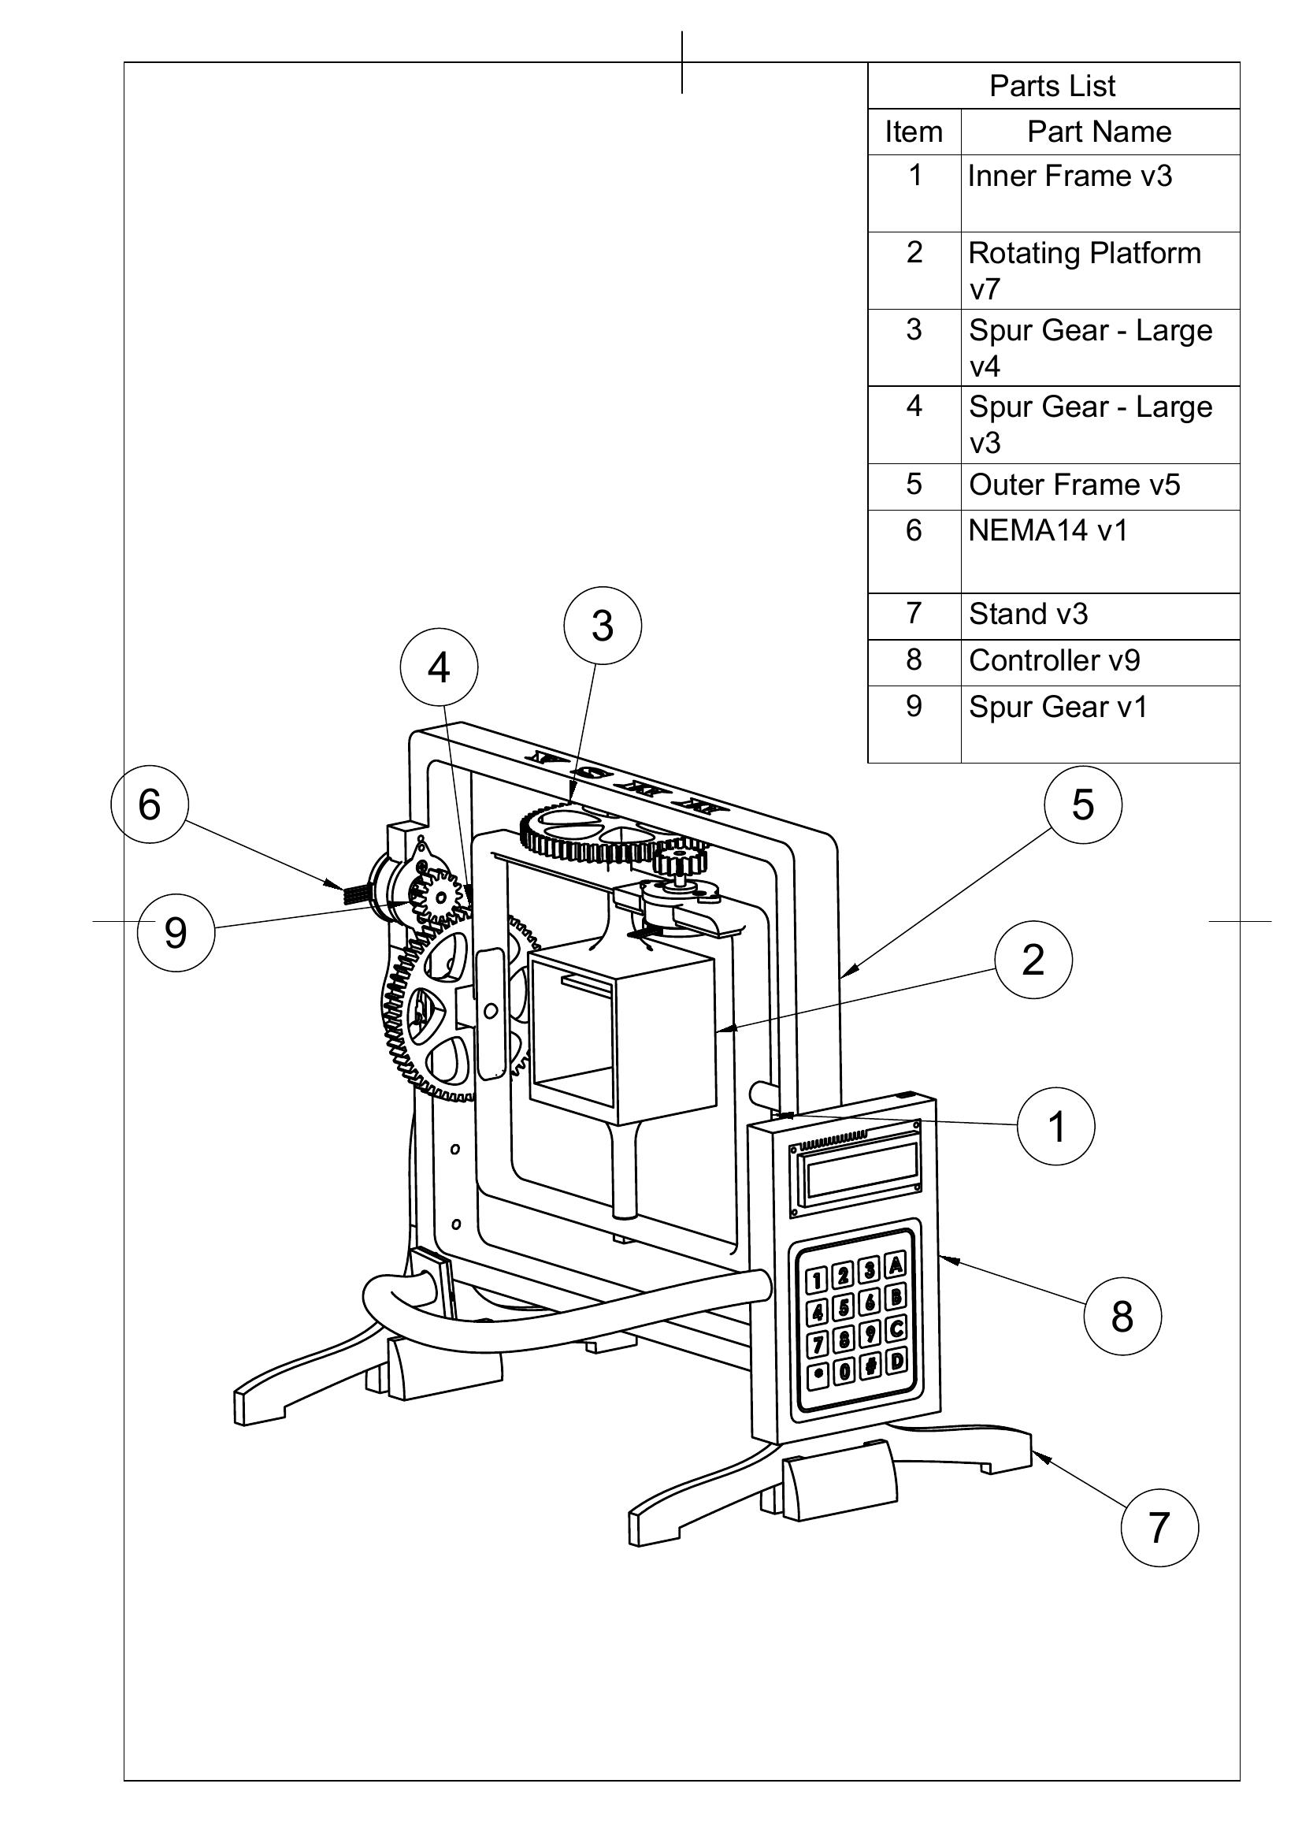
Figure 1. Complete Assembly Drawing of the Automated Multi-Modal Microgravity Simulation Platform (MMSA v1), showing labeled components: (1) Inner Frame v3, (2) Rotating Platform v7, (3 & 4) Spur Gear – Large, (5) Outer Frame v5, (6) NEMA 14 Motor v1, (7) Stand v3, (8) Controller v9, (9) Spur Gear v1.

Figure 2
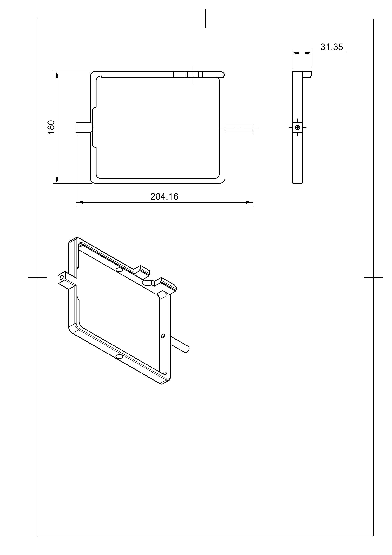
Figure 2. Detailed engineering drawing of the Inner Frame (v3), illustrating the structural profile and primary dimensional specifications (180 mm × 284.16 mm × 31.35 mm wall thickness).

Figure 3
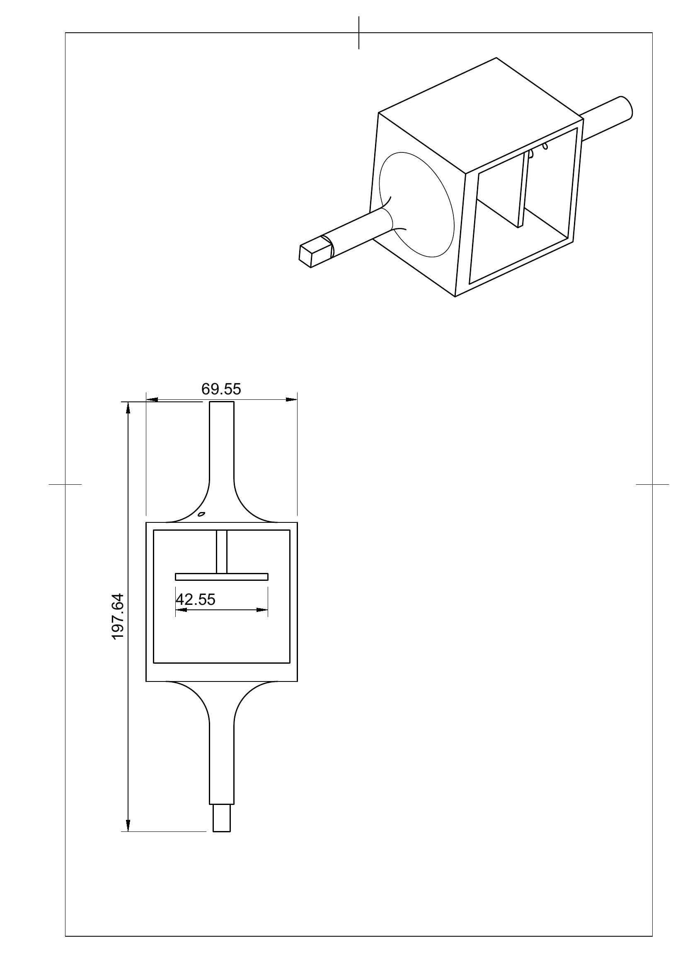
Figure 3. Detailed engineering drawing of the Rotating Platform (v7), showing the dimensional specifications (69.55 mm × 197.64 mm × 42.55 mm) and the mounting geometry for sample holder integration.

Detailed Description of Drawings

Figure 1
Figure 1 presents the complete assembly drawing of the Automated Multi-Modal Microgravity Simulation Platform (MMSA v1). The drawing identifies nine primary structural and functional components with numbered callouts. Component (1), the Inner Frame v3, constitutes the innermost rotating structural element that directly mounts the Universal Sample Holding Module and its interchangeable sample carriers. Component (2), the Rotating Platform v7, is the central disk-form assembly that forms the mechanical interface between the inner frame and the sample holder. Components (3) and (4) are the large-format spur gears providing torque multiplication and speed reduction on the primary drive axis, with the gear set visible at the left and upper portions of the assembly. Component (5), the Outer Frame v5, is the rigid perimeter structure that houses the inner gimbal assembly and provides the mounting surface for the outer axis motor and gear drive. Component (6) is the NEMA 14 stepper motor (v1) providing primary axial drive. Component (7), the Stand v3, constitutes the structural base assembly supporting the entire rotating frame, with visible triangular support geometry for load distribution and vibration suppression. Component (8) is the Controller v9 module housing the Raspberry Pi 3 computing unit, TMC2209 motor driver boards, power supply electronics, and communication hardware. Component (9) is the secondary spur gear on the inner drive axis, completing the dual-axis gear transmission system.

Figure 2
Figure 2 presents the detailed engineering drawing of the Inner Frame (v3), which is the innermost rotating structural element of the gimbal assembly. The drawing depicts the rectangular frame geometry, machined bearing interfaces at each end of the primary rotation axis, and the mounting features for the Rotating Platform and Universal Sample Holding Module. Primary dimensional specifications are shown as 180 mm in the transverse width dimension, 284.16 mm in the axial height dimension, and 31.35 mm in structural wall thickness. The lightweight frame design minimizes rotational inertia at the innermost gimbal axis while maintaining sufficient structural rigidity to support the loaded sample module during continuous multi-hour rotation at clinostat and RPM operational speeds.

Figure 3
Figure 3 presents the detailed engineering drawing of the Rotating Platform (v7), which interfaces the Inner Frame with the Universal Sample Holding Module. The drawing illustrates the disk-form geometry with dimensioned features showing overall length of 197.64 mm, width of 69.55 mm, and depth/thickness of 42.55 mm. The platform incorporates symmetric mounting provisions for the dual T25 flask configuration and the modular MoC chip carrier, enabling interchangeable sample format operation. The compact platform geometry is optimized to minimize centrifugal mass offset during rotation, reducing asymmetric loading artifacts that could introduce systematic g-vector deviations during partial-gravity simulation experiments.

