**Peg Solitaire**

**Designed by**

**EBY**

**Main Menu**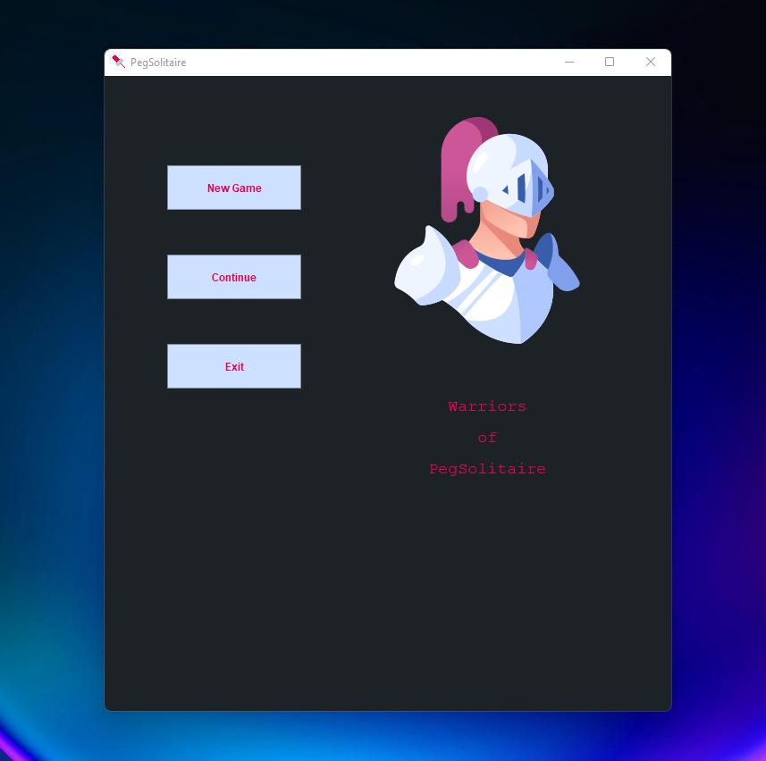

Welcome page for PegSolitaire game.

**Game Configuration Menu**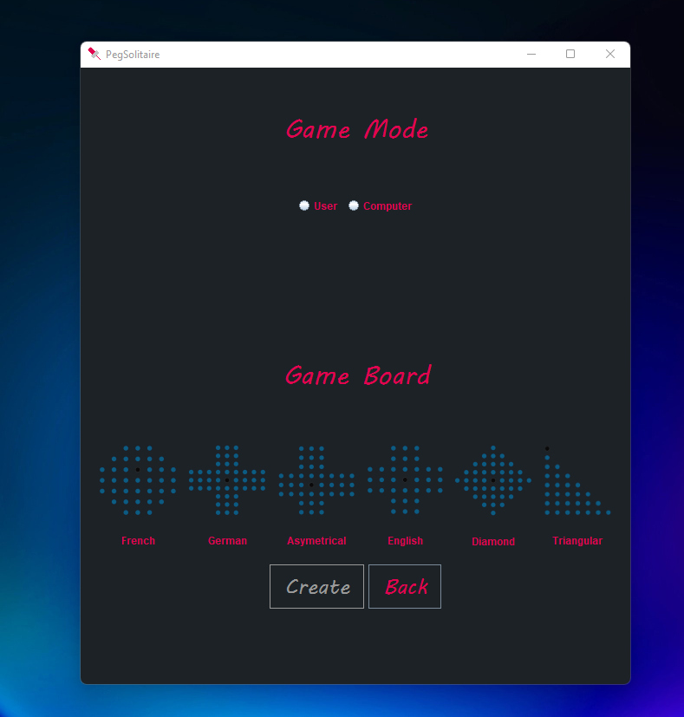

There are 2 different game mode and 6 different game board exist. To start a new game player must select game mode and board type.

In computer mode, game is played by computer no user interaction allowed. This is useful for player to learn game movements and the boards.

In user mode, player can made movement auto movement with the play button as well as manual movements by selected start and end positions. User can made undo movement to turn back previos positions of the board cells.

**Start of the Game**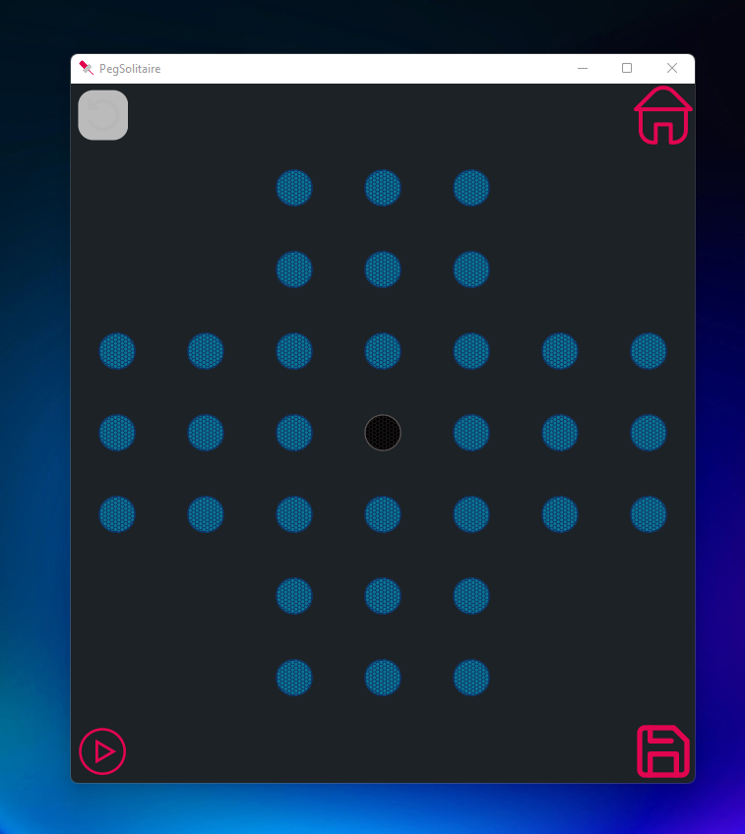

There are four different buttons in the game screen

* The top left one is undo button, initially non enable due to no movement made yet.
* The top right one is home button to turn back main menu.
* The bottom left is play button to make one movement.
* The bottom right one is save button which saves the game board by user registration.

**Movement Predictor Feature**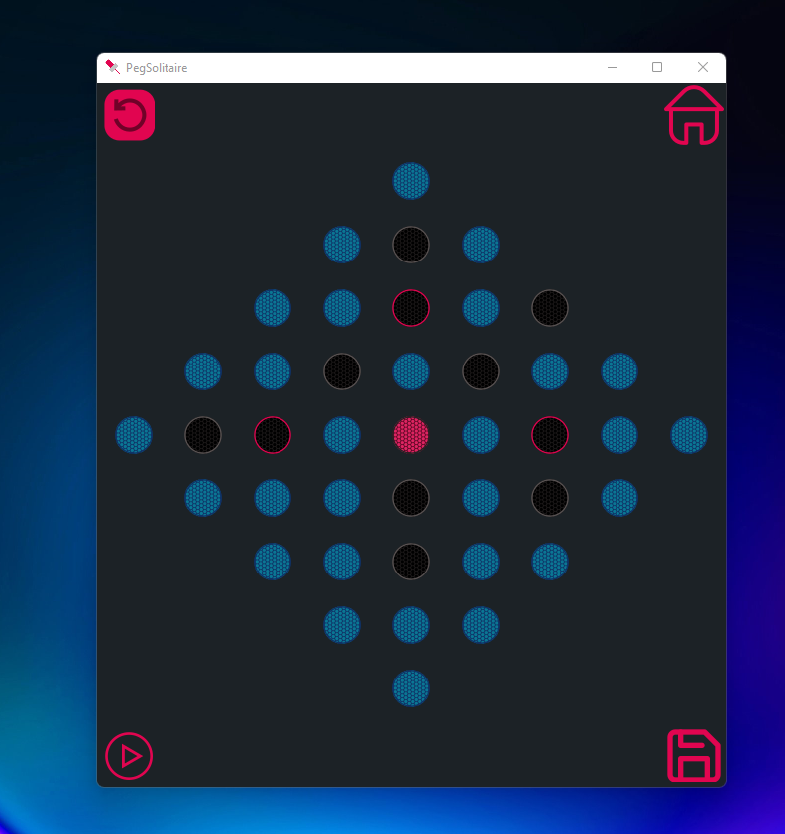

If selected cell can have a valid movement then it’s colour become red and the possible end positions are showed to help user to choose proper end position.

**Saving Game** 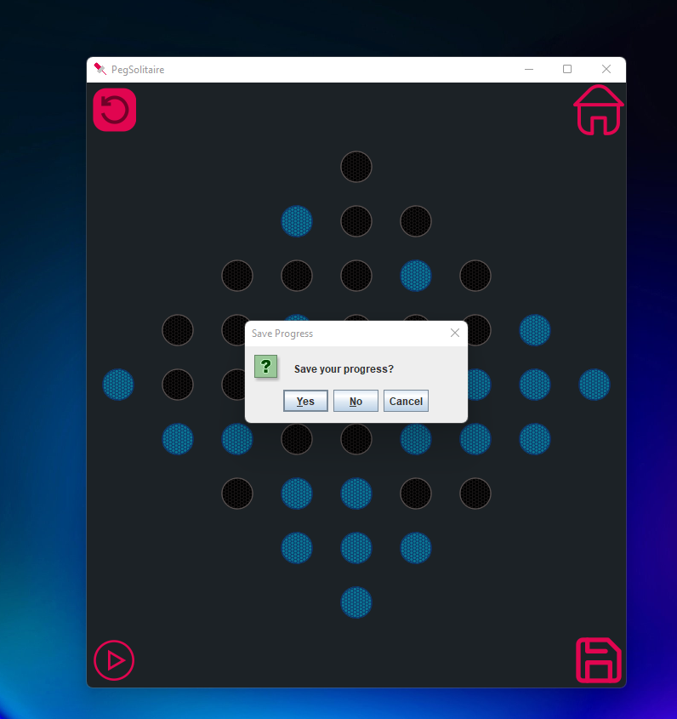

Games are saved by registration. Player must enter an username and a password to save the game. If there exist a same username then password should be correct to save/load the current game status.

**Loading Game Session**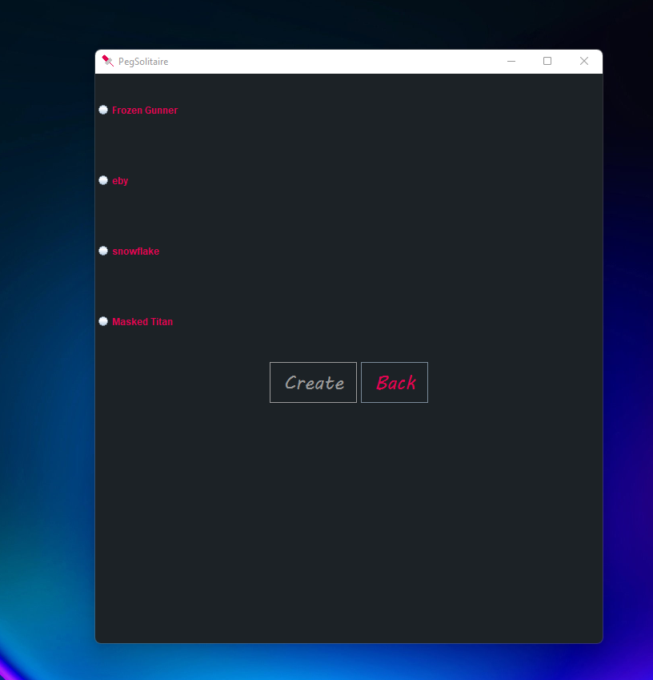

Games are load by registration like saving. Player must choose a section which are showed by username. To load the game the user password must be entered correctly to play the selected game session.