EUROMOD User Interface – Help on Help

You may find that the EUROMOD help is displaying *“Navigation to the webpage was cancelled”*. This document describes some ways to solve this problem.

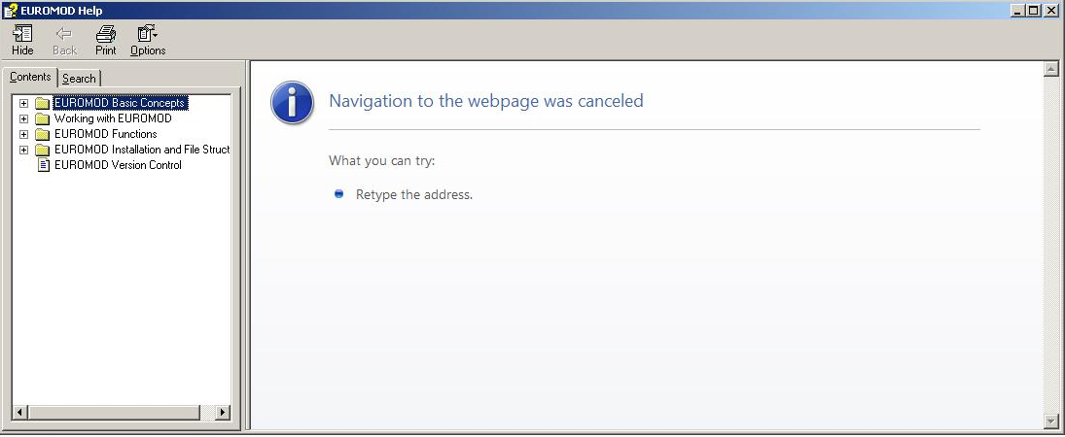

## Solution 1

This error can happen if the EUROMOD user interface is installed on a network drive. So one way to solve it, is to install the interface locally.

## Solution 2

Right-click the file *EUROMODHelp.chm* and unblock it:  
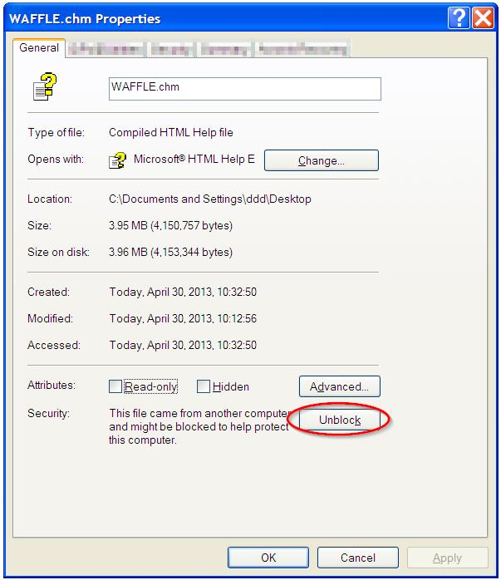

The file *EUROMODHelp.chm* can be found in one of the following folders, depending upon the setup used and the software version installed:

* The user interface was installed using the (old) click-once-setup:
  + *EMFS\Help\EUROMODHelp.chm*, where *EMFS* denotes the EUROMOD file structure, i.e. the folder containing the EUROMOD parameter files (usually called *EuromodFiles_F6.36+*, or similar).
* The user interface was installed using the (new) setup allowing for installation options:
  + *C:\Programm Files\EUROMOD\Help\EUROMODHelp.chm*
  + *C:\Programm Files (x86)\EUROMOD\Help\EUROMODHelp.chm*
  + If you selected a custom installation path: *CustomInstallationPath\EUROMOD\Help\EUROMODHelp.chm*

## Solution 3

Open the file *EUROMODHelp.chm* by double clicking. If the following dialog pops up

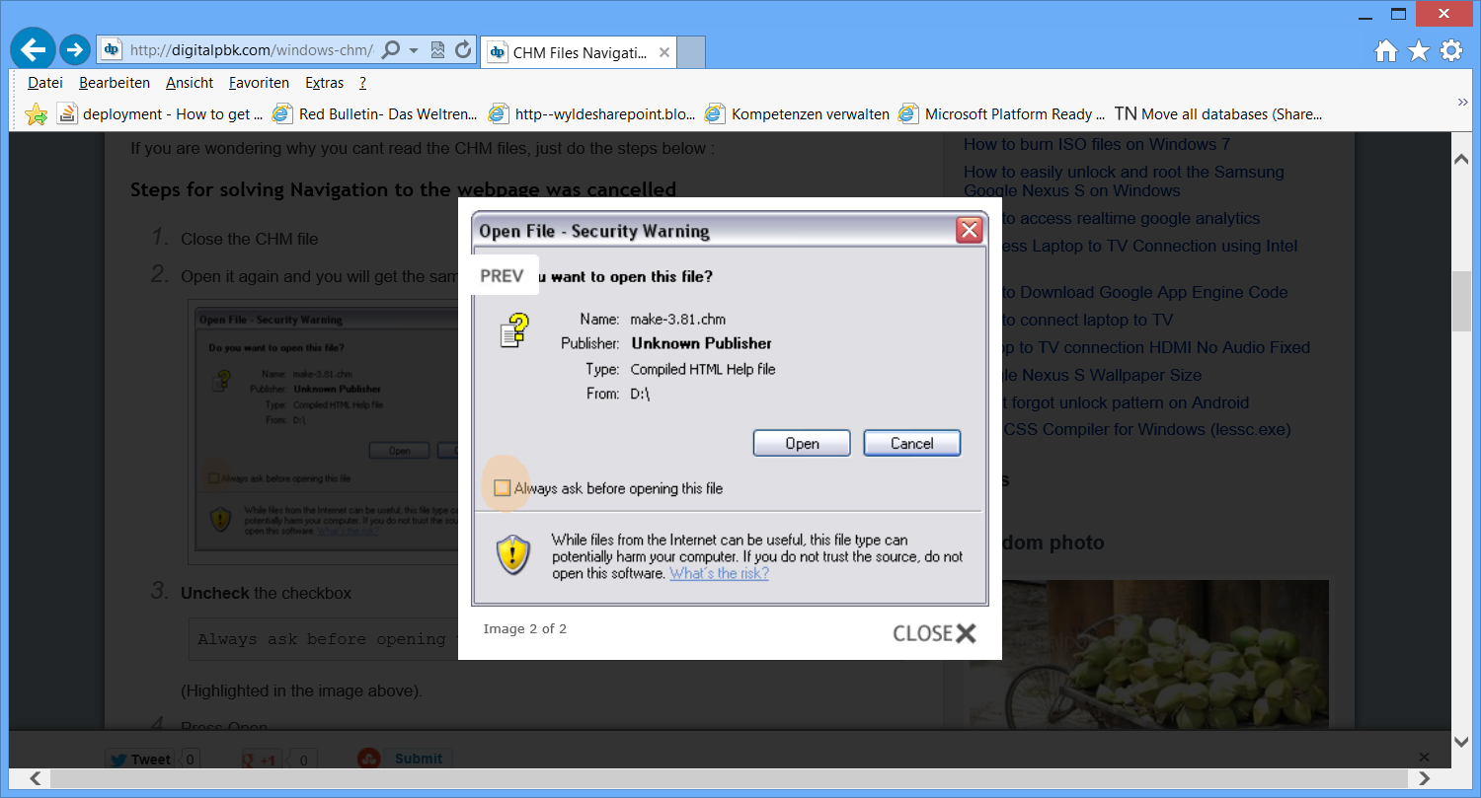

uncheck the checkbox *“Always ask before opening this file”*.

See solution 2 for where to find the file *EUROMODHelp.chm*.