# 1-How to install flutter

Flutter installation link:

<https://docs.flutter.dev/get-started/install/windows>

# 2-How to download android Studio

Android studio Installation link:

<https://developer.android.com/studio>

# 3-How to create an emulator

1. First install and open android studio
2. Then Setup an emulator by clicking on the V**irtual Device Manager**

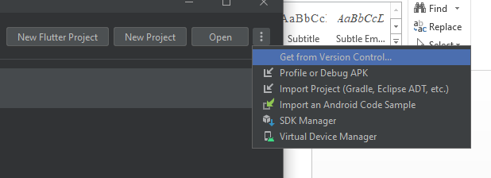

1. Click on **Create New Device**
2. Select any device, I used a pixel 2 for most of the development.

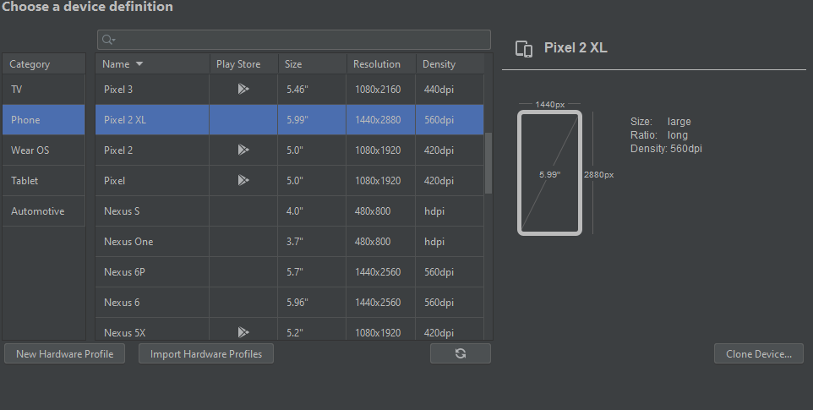

1. Download android version minimum API 22.

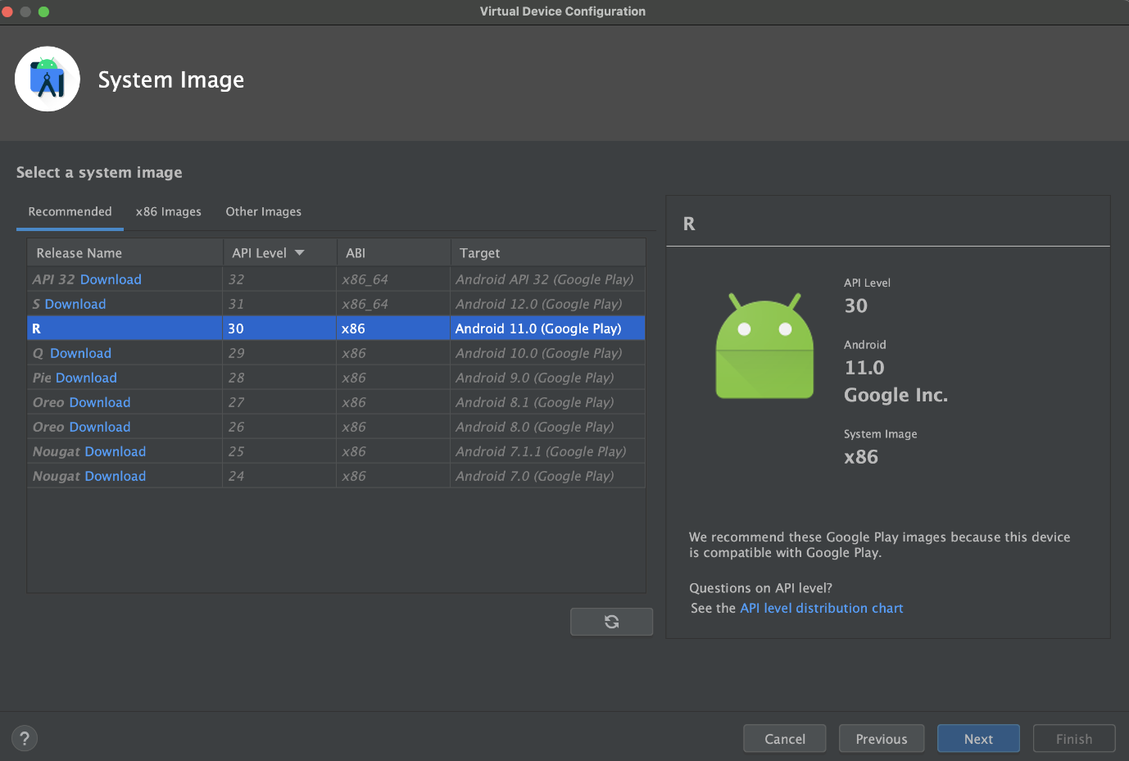

1. Select the system image for a particular API level, and then click **Next**.
2. Lastly, click **Finish**

# 4. How to run the application

1. Unzip the project downloaded from the repository as a ZIP file.
2. Open this folder in **Android-Studio**
3. Go to **Device Manager** and turn-on the emulator which we created recently.



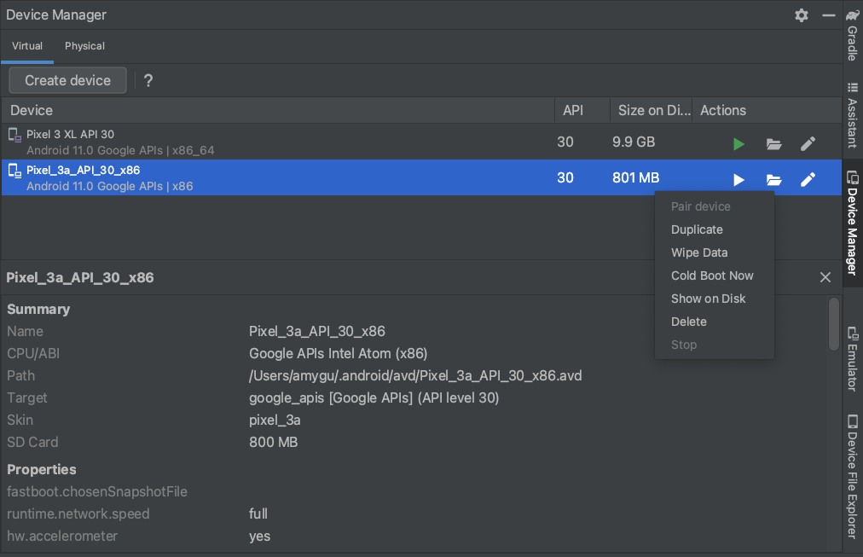

Once the emulator is ready, click on the **Green Play Button.** Project will be executed and can be used on the emulator. (It may take a while when executing for the first time).

