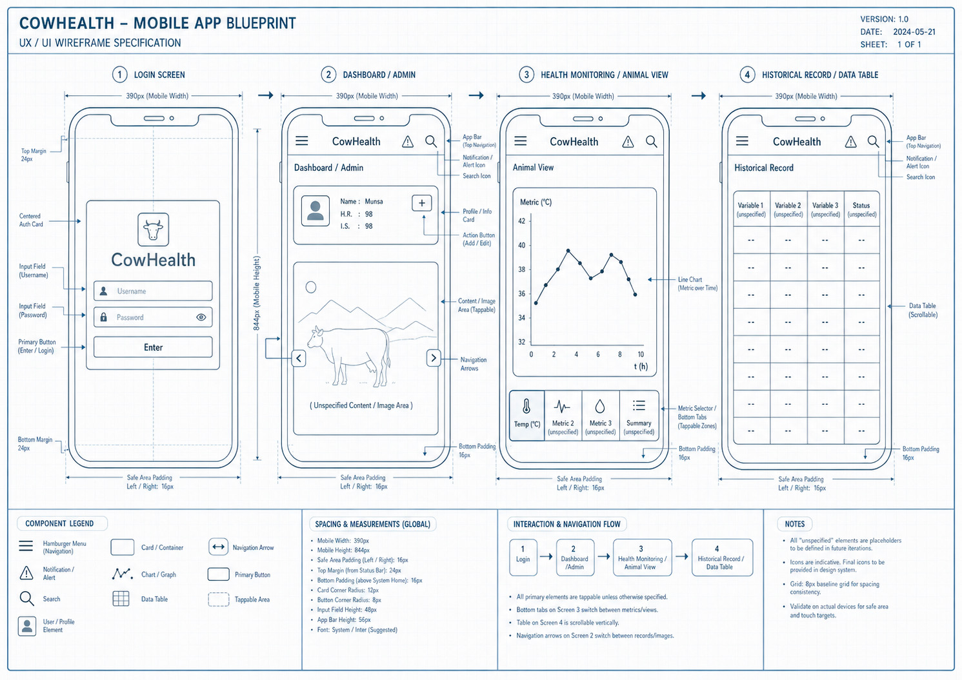
VERSION: 1.0
DATE: 2026-05-08
SHEET: 1 of 1

