Note: I could not get 3d plotting to work, it was being quite thorny. I realize I should have tried it sooner and worked out the kinks, but as it is please look at my data/methods and see if they would have graphed correctly. Thank you.

Question 1

Initial data:

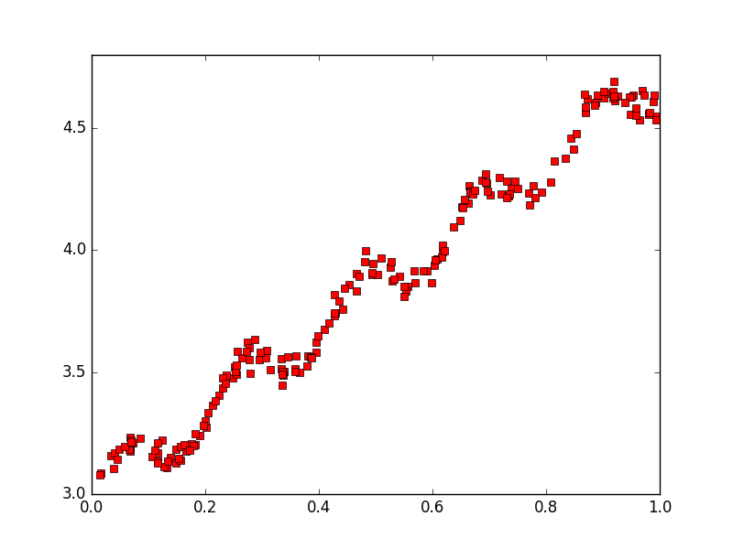

Standard Linear Regression:

Theta = [[ 3.00774324]

[ 1.69532264]]

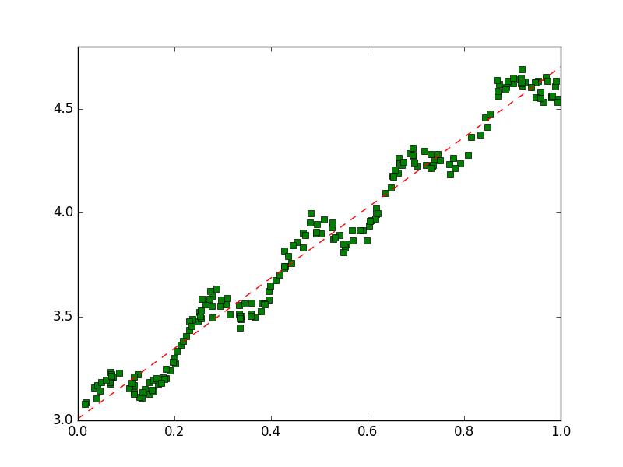

Second Order Linear Regression:

Theta = [[ 3.01139245]

[ 1.67414864]

[ 0.02065965]]

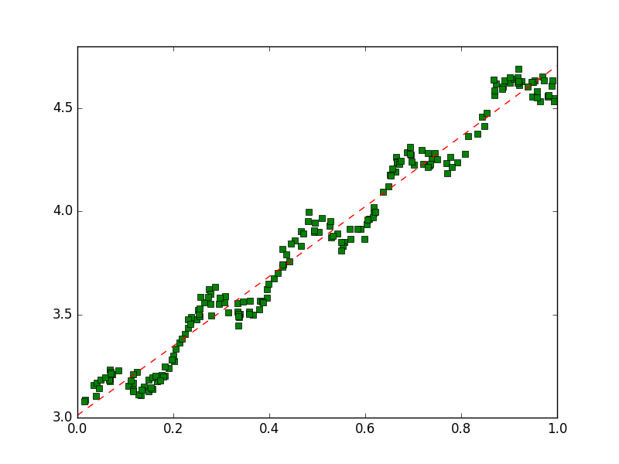

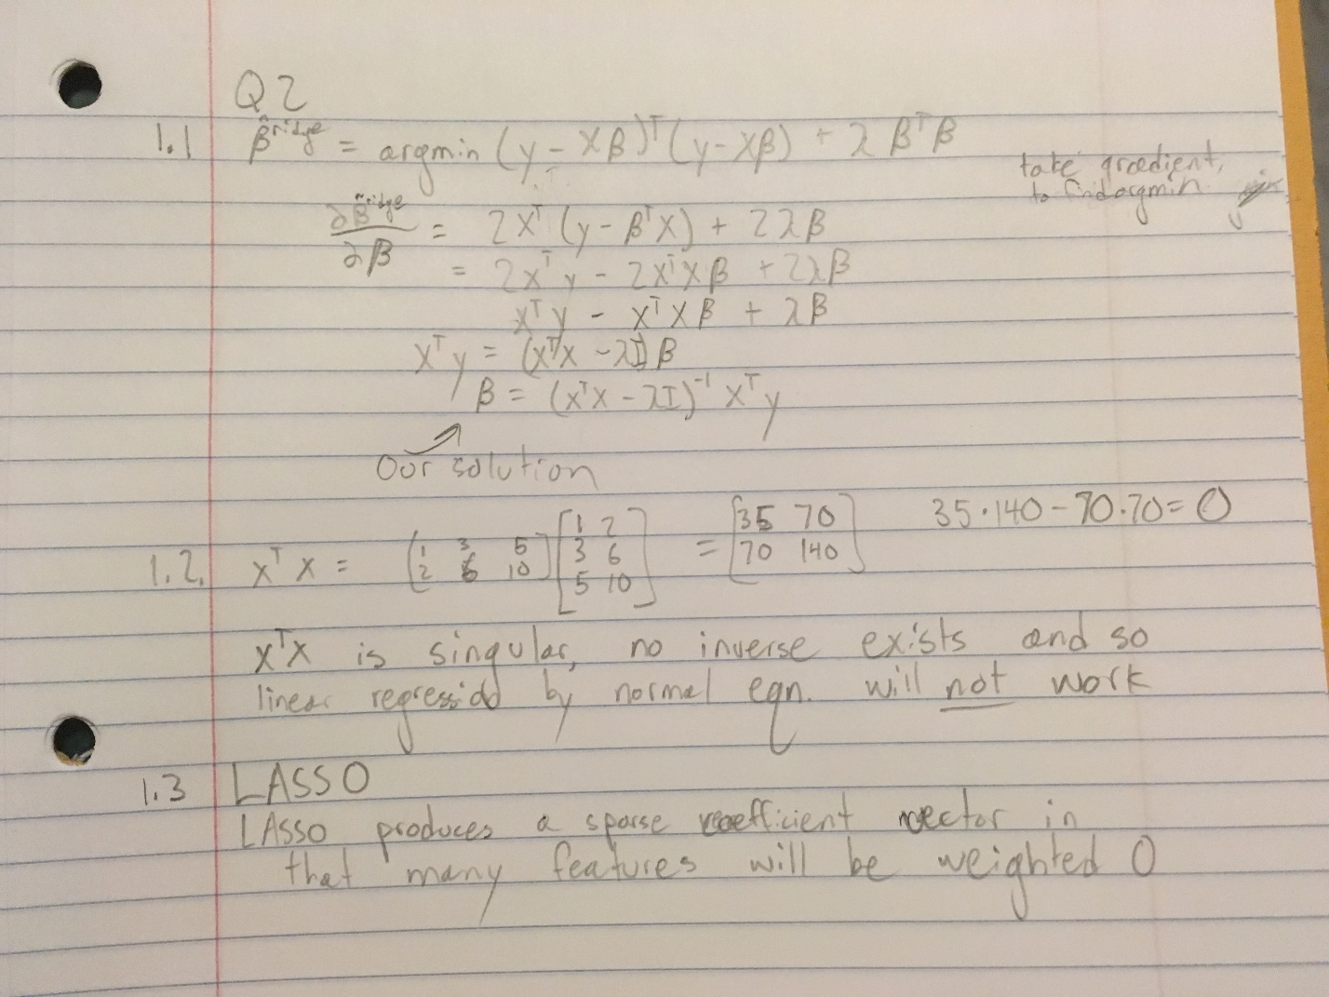Question 2

Ridge Regression Lambda = 0

Beta = [[ 2.97139801]

[-11.00332214]

[ 6.96229098]]

Ridge Regression after iterative lambda testing:

Beta = [[ 2.97264929]

[-1.54499492]

[ 2.23351352]]

Best lambda = .02

Mean squared error = . 739515616958

1.5.

The Beta values for ridge regression are much more accurate than those calculated by linear regression.

Upon implementing a standard regression between x1 and x2, we see that x2 is almost always about 2 times x1. Ridge regression is better when some of the features are highly correlated because it adds some bias to the variables.