What drives the persistence in current account imbalances?★
Eric Clowera, Hiro Ito^{b}, Jamel Saadaoui^{c}
a Aptech Systems, Inc, PO Box 618, Higley, AZ 85236, USA
b Department of Economics, Portland State University, 506 SW Mill Street, Urban Center Building, #450, Portland, OR, 97201, USA
cParis 8 University, France

Abstract

Keywords:
JEL: F32, F41

1. Introduction
The persistence of global current account imbalances has been an important policy consideration for policymakers and academics alike, especially those in developed economies. Whether it be after the Great Recession in 2008, during the Euro Crisis between 2010 and 2012, or in the current era of geoeconomic fragmentation, economists and policymakers have long expressed concerns of the persistence current account imbalances. These concerns have at times permeated the financial markets, leading to credit downgrades or speculative attacks on government bonds. This is not just a developing country issue, with Moody's downgrading the United States' credit rating in May of 2025. These concerns can, in turn, lead to fiscal policy constraints, limiting the ability of countries to implement fiscal stimulus when needed. In particular, maintaining current account surpluses and accumulating a strategic stock of international reserves in the past is associated with better resilience during monetary tightenings (Aizenman et al. 2024, 2025). A similar line of reasoning can be formulated for episodes of financial stress. During the Great Recession in 2008 and the Pandemic Recession in 2020, many countries sought international bailouts to maintain solvency or used swap lines to ensure short-term liquidity. Yet, while these countries struggled to meet their debt obligations, others amassed savings and more immune to financial turmoil.
Once again after the post-Great Recession correction, the current account imbalances are growing with the IMF (2025) reporting a global current account widening of 0.6 percentage points of world GDP. Before the Great Recession, there has been a consistent and recurring profligacy of several advanced economies, including the US, being financed by excess savings of emerging market economies, most notably the People’s Republic of China (PRC), and oil-exporting countries. Imbalanced capital flows have enabled some countries to run persistent and massive current account deficits, financed by the persistent current account surpluses of other countries. Researchers, such as Chinn (2011), have investigated the causes of global imbalances and found that many factors are intricately intertwined, creating 'uphill' flows of excess savings from developing countries with high rates of return to developed countries with lower rates of return but more advanced financial markets (the 'Lucas paradox', Lucas (1990)). However, the global financial crisis and the European debt crisis revealed that the world economy is on a delicate balancing act regarding imbalances in capital flows. A change in global economic conditions can suddenly alter the direction of capital flows, potentially disrupting real economies. On the other hand, persistent capital flows can put the world economy in a crisis-prone situation like that of the pre-crisis period. Given this unstable environment, examining the country-specific determinants of persistent current account deficits or surpluses can provide deeper insights about the understanding of the growing global imbalances and the stability of the international financial system.
In theory, current account balances of a country should evolve in a way that satisfies the long-run intertemporal national budget constraint (LRBC). In reference to Feldstein (1980), Taylor (2002) argues that the LRBC implies that savings and investment must be highly correlated as countries approach long-run steady-state. This does not preclude short-run deviations from the LRBC, however, as these can be caused by macroeconomic and institutional policy changes related to savings and investment.
It is difficult to draw conclusions on current account sustainability from past literature, however, due to inconsistent or, at best, inconclusive evidence on the sustainability of current account balances. This may, in part, arise from inconsistencies in testing methodologies. Alternatively, it may reflect a failure to appropriately distinguish long-run sustainability from short-run dynamics. As Taylor (2002) argues, even within the context of the LRBC, countries may run 'unsustainable' current account imbalances for short periods without necessarily violating the long-run constraint. Hence, it is important to distinguish long-run sustainability from short-run deviations from the intertemporal constraint and not falsely reject long-run current account sustainability based on evidence of short-run non-stationarity of current account balances.
Once current account balances are found to be mean-reverting, either globally or locally, the degree of current account persistency can vary not only across countries but also over time. As we will show later, in the period leading up to the Great Recession, both current account surplus and deficit countries experienced persistent current account imbalances. Persistent current account imbalances do not necessarily lead to immediate concerns about external debt sustainability, as the speed of reversion can differ across countries and time periods, depending on their macroeconomic policies and institutional characteristics. Before the Great Recession, the PRC’s persistent current account surplus and its quasi-fixed exchange rate policy have raised questions about whether and how exchange rate regimes affect current account persistency. Chinn and Wei (2013) investigated this issue and found no significant or systematic relationship between exchange rate regimes and the degree of current account persistency, contrary to the common anecdotal belief that flexible exchange rates should lead to current account adjustments. Beyond exchange rate regimes, it is important to investigate the fundamentals that contribute to different degrees of current account persistence.
Given this background, this paper will examine the dynamics of current account balances leveraging a large quarterly dataset for current account balances, focusing particularly on their persistence and the factors that determine it. First, we will re-examine the stationarity of current account balances for 77 countries. Several stationarity tests using standard linear unit root procedures confirm that the time series of current account balances (as a share of GDP) are not stationary for many countries, contrary to theoretical predictions. Second, we will investigate whether the lack of statistical evidence for the stationarity of current account balances is driven by regime shifts in their time series, following an ongoing strand of literature that tests nonlinearity in current account persistence using Markov-Switching models (Taylor, 2002; Raybaudi et al., 2004; Chen, 2011; Poulakis & Krykilis, 2024). Finally, we will examine whether the probability of entering a non-stationary current account regime, as well as the degree of persistence across different regimes, can be explained by cross-sectional and temporal variations in policies, institutions, and macroeconomic fundamentals.

2. Current account persistency: facts and theory
2.1. Facts: Current Account Divergence and Persistency
As financial markets have become increasingly intertwined, current account balances have become more divergent across countries. Globalization provides easier access to international financial markets, helping countries delink domestic saving and investment (Feldstein and Horioka 1980; Faruqee and Lee 2009). Figure 1 illustrates the cross-sectional mean of the current account balances (as a share of GDP) in absolute values and the annual cross-country standard deviation of the current account balances $σ_{CA/Y_{t}}$ for our sample of 77 countries. As Figure 1 demonstrates, absolute current account balances grow steadily in mean looking at three time periods, pre-1970, 1975-1994, and 1995-September 2008. After the Global Financial Crisis, the absolute current account balances show a slight drop in mean. Additionally, the growth in the cross-country standard deviation of current account balances highlights increasing global current account imbalances.
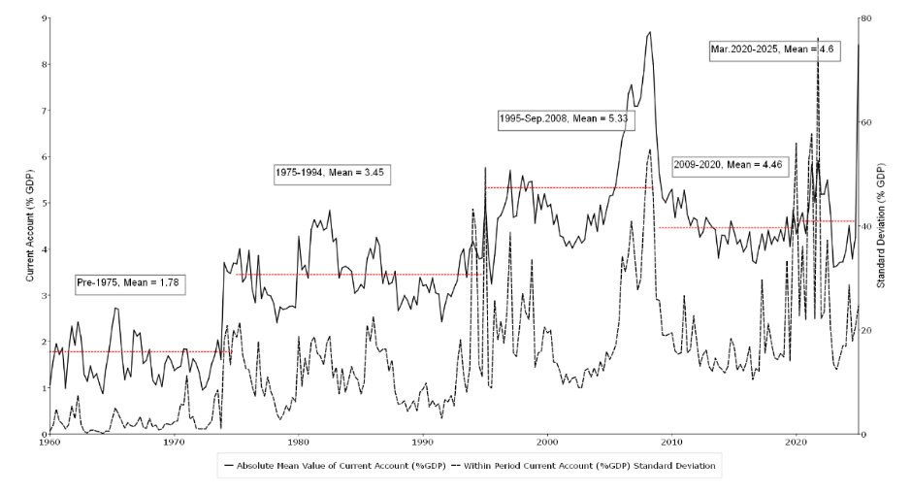
Figure 1. Global Current Account Imbalances.
Figure 2 provides an additional view of the evolution of current account balances over time. The median value of current account balances stays relatively stable over time. One interesting observation is that the median current account balances drop prior to global recessions in 1975, 1982, 1991, and 2009. The only global recession where the median current account balance does not drop beforehand is the COVID 2020 recession. In the case of the 2020 global recession, the median current account balance was growing in the time just prior and drops post-recession. Figure 2 also highlights growing global imbalances, with the consistent widening of the distribution from 1960 to 2008. The band narrows slightly after the global financial crisis but remains wider than pre-2000s levels.
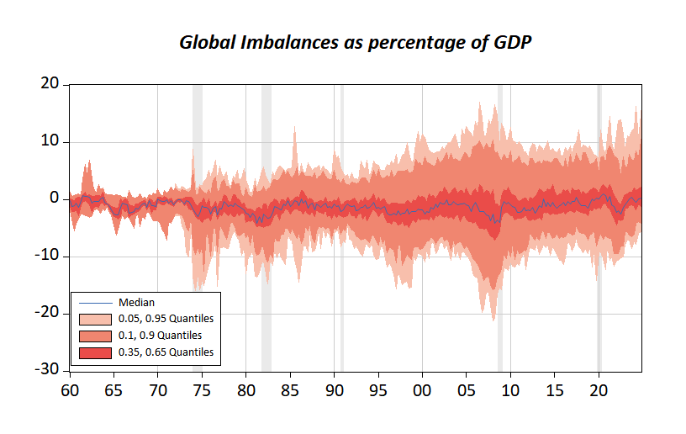
Figure 2. Current Account Balances Fan Chart.
Looking across country groups in Figure 3 reiterates many of the patterns found in the full sample, while also highlighting some important cross-group differences. Across all groups, the figures show that both the typical size of current account imbalances (absolute mean, solid line) and their dispersion within each group (standard deviation, dashed line) are time-varying, with clear common global. However, we should highlight some distinct patterns across the groups. First, industrialized economies exhibit a pronounced run-up in imbalance magnitudes from the late 1990s through the mid-2000s, followed by partial retrenchment. Conversely, emerging and less-developed groups display larger short-run volatility earlier in the sample (notably in the 1970s–1980s) and a renewed widening around the 2000s before easing. East Asia & Pacific shows persistently moderate imbalances with episodic spikes, while Latin America features sharper cyclical surges, especially around the mid-2000s, along with elevated cross-country dispersion in recent years. The Euro Zone stands out for a marked increase in both the level and dispersion of imbalances in the 2000s (around and after euro formation), consistent with greater intra-area divergence, and, like other advanced groups, shows heightened dispersion again at the end of the sample (reflecting more heterogeneous country experiences during recent global shocks).
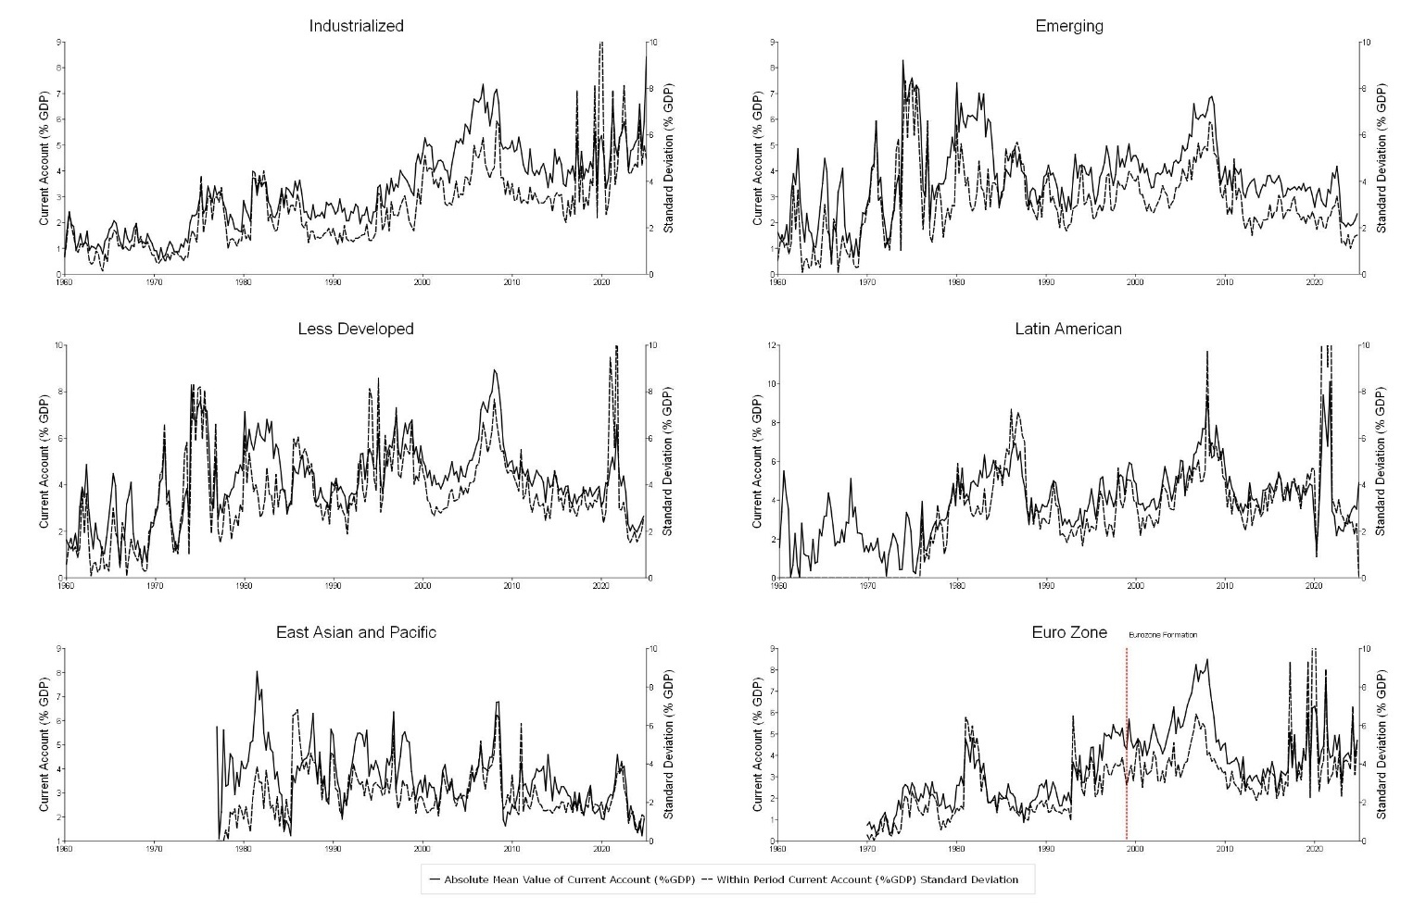
Figure 3. Current Account Balances by Country Groups.

2.2. Current account sustainability
The intertemporal approach with an infinitely lived representative agent who smooths consumption provides the standard theoretical foundation for assessing current account sustainability (Trehan and Walsh 1991; Hakkio and Rush 1991). In this framework, the long run budget constraint implies that the current account must be stationary in equilibrium.
The aggregate resource constraint is
$$\begin{matrix} & C_{t}+I_{t}+G_{t}+B_{t}=Y_{t}+(1+r_{t})B_{t-1}, & & \text{(1)}\end{matrix}$$
where $C_{t}$, $I_{t}$, $G_{t}$, $B_{t}$, $Y_{t}$, and $r_{t}$ denote consumption, private investment, government spending, net foreign assets, output, and the world real interest rate. Net foreign assets evolve as
$$\begin{matrix} & B_{t}=(1+r_{t})B_{t-1}+NX_{t}, & & \text{(2)}\end{matrix}$$
with net exports defined by
$$\begin{matrix} & NX_{t}=Y_{t}-C_{t}-I_{t}-G_{t}. & & \text{(3)}\end{matrix}$$
The current account is therefore
$$\begin{matrix} & CA_{t}=r_{t}B_{t-1}+NX_{t}. & & \text{(4)}\end{matrix}$$
This expression highlights that the current account reflects both net income from foreign asset positions and net exports of goods, services, and capital.
Following Taylor (2002), consider the dynamic behavior of this system in a stochastic steady state. Define $R_{t}=1+r_{t}$and assume that conditional expectations satisfy
$$\begin{matrix} & E(R_{t+i}∣Ω_{t-1})=R,i≥0, & & \text{(5)}\end{matrix}$$
where $Ω_{t-1}$denotes the information set in the previous period. Forward iteration of equation (2) yields
$$\begin{matrix} & B_{t-1}=\underset{j→∞}{lim⁡}R^{-(j+1)}E(B_{t+j}∣Ω_{t-1})-\sum_{j=0}^{∞}{}R^{-(j+1)}E(NX_{t+j}∣Ω_{t-1}). & & \text{(6)}\end{matrix}$$
The long run budget constraint requires the transversality condition
$$\begin{matrix} & \underset{j→∞}{lim⁡}R^{-(j+1)}E(B_{t+j}∣Ω_{t-1})=0. & & \text{(7)}\end{matrix}$$
This condition holds when the real-world interest rate is positive and the current account follows a stationary process.
The same logic holds when the model allows for stochastic output growth. Suppose world output grows at rate $g_{t}$with $E(g_{t})>0$. Define the foreign asset ratio $b_{t}=B_{t}/Y_{t}$ and the scaled return
$$\begin{matrix} & ρ_{t}=\frac{R_{t}}{g_{t}}. & & \text{(8)}\end{matrix}$$
The intertemporal constraint then becomes
$$\begin{matrix} & \underset{j→∞}{lim⁡}ρ_{t}^{-(j+1)}E(b_{t+j}∣Ω_{t-1})=0, & & \text{(9)}\end{matrix}$$
which holds when $ρ_{t}>1$ and the current account expressed as a share of output is stationary.
3. Stationarity of current account balances and regime shifts
The first portion of our analysis focuses on the time-series dynamics of current account balances. Despite theoretical predictions that a country must obey the LRBC and that current account balances must be long-run stationarity processes, empirical unit root tests have varied success supporting this conclusion. The contradictions across the literature have been well documented (Chen, 2011).
3.1.1 Linear Unit Root Tests and Current Account Balances
Here, we briefly revisit the issue of current account stationarity by employing several different stationarity tests, and confirm the inconsistencies found in the previous literature. We conduct the Augmented Dickey Fuller (ADF) unit root test on the standard data series as well as on the generalized least squares de-trended data (ADF-GLS). For robustness checks, we also conduct the Kwiatkowski, Phillips, Schmidt, and Shin (KPSS) test. Unlike the other unit root test, this test tests the null hypothesis of stationarity.
3.1.2 Unit Root Testing Results
Appendix 2 reports standard linear unit root and stationarity tests for current account balances (% of GDP) across the 77-country sample. The central message is that conclusions are highly test-dependent and heterogeneous across countries, suggesting that a single, constant-parameter time-series characterization is often too restrictive. In many cases, Phillips–Perron-type statistics (ZT and Za) reject the unit-root null even when ADF and DFGLS provide weaker evidence, consistent with the idea that current accounts may exhibit time variation in persistence and volatility that different tests handle differently. The KPSS test, which takes stationarity as the null, frequently rejects stationarity as well, reinforcing that linear tests do not deliver a uniform “one-process-fits-all” description of current account behavior over long samples.
Cross-country differences are pronounced: some economies show comparatively strong evidence of mean-reverting dynamics across multiple tests, while others display much weaker evidence against highly persistent behavior, patterns that may reflect differing exposure to global shocks, domestic policy regimes, and structural change over time. Sample lengths also differ substantially across countries, implying uneven test power and increasing the value of methods that do not hinge on a single full-sample classification. Taken together, these results echo the mixed findings in the existing literature and motivate our regime-switching framework. Rather than treating stationarity as the primary endpoint, we use Markov switching to model how current account dynamics evolve across episodes, allowing the mean, variance, and persistence parameters to shift across regimes.
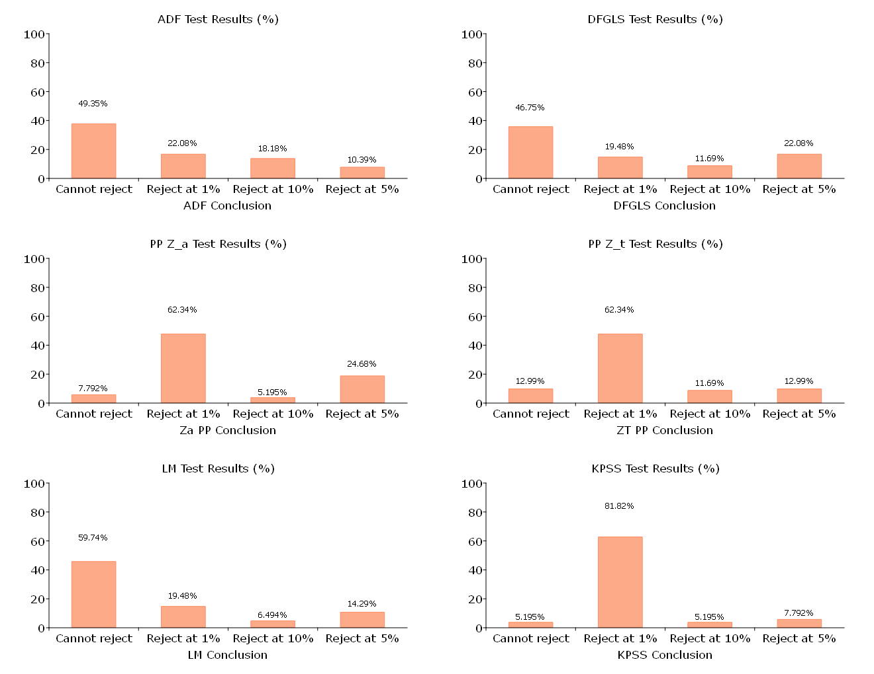
Figure 4. Linear Unit Root Results
Figure 4 summarizes how standard linear tests classify current account balance dynamics across our 77-country sample. The ADF and DFGLS tests are relatively conservative, with roughly half of the series failing to reject a unit root, while the remainder show evidence of mean reversion at conventional levels. In contrast, the Phillips–Perron statistics (both Z_a and Z_t) reject the unit-root null for a much larger share of countries (only about 7.8% and 13%, respectively, fail to reject), whereas the LM test again yields more non-rejections (about 60%). Finally, KPSS, under which stationarity is the null hypothesis, rejects for about 95% of the series, with more than 80% rejecting at the 1% level.
Rather than interpreting these splits as a binary verdict on whether current accounts are stationary, we treat them as evidence that a single-regime linear representation is often inadequate: persistence signals, volatility, and average imbalance levels appear to shift over time, and different tests weigh these features differently. This motivates our modeling strategy, which focuses on capturing time variation in current account dynamics by allowing the mean, variance, and persistence to change across regimes. Our empirical characterization centers on how current accounts evolve through episodes of widening, adjustment, and heightened dispersion, not solely on whether any one long-run stochastic classification holds over the full sample.
3.2.1 Markov-Switching Estimation
We document changes in persistence, volatility, and mean across regimes and investigate whether current account balances exhibit local or global unit roots. Our empirical strategy follows the Markov-switching framework proposed by Morita et al. (2023), which is specifically designed to detect transitions between stationary, unit-root, and explosive regimes. This approach allows each country’s current account to switch among regimes that differ in persistence, intercept, and error variance, with each component governed by an independent Markov process.
Formally, let $X_{t}$denote the current account balance as a percentage of GDP. We consider the following Markov-switching autoregressive model of order $B+1$:
$$\begin{matrix} & X_{t}=α_{0}+\left(α_{1}-α_{0}\right)S_{1,t}+\sum_{k=1}^{B}{\left[ψ_{0,k}+\left(ψ_{1,k}-ψ_{0,k}\right)S_{3,t}\right]}ΔX_{t-k}+ω_{0}+\left(ω_{1}-ω_{0}\right)S_{2,t}+u_{t}, & & \text{(10)}\end{matrix}$$
where $\{S_{1,t}\}$, $\{S_{2,t}\}$, and $\{S_{3,t}\}$ are unobserved regime indicators that take values in {0,1} and are independent of the error term $\{u_{t}\}$. The parameters $α_{0},α_{1},ϕ_{0},ϕ_{1},ψ_{0,k},ψ_{1,k},ω_{0},ω_{1}$and the six transition probabilities are jointly estimated by maximum likelihood.
As emphasized by Morita et al. (2023), two features of this specification are crucial for robust unit-root inference. First, allowing the mean, variance, and persistence to switch improves reliability because failing to model changes in mean or volatility may cause these shifts to be absorbed into persistence estimates, thereby generating spurious unit-root results (Shi 2012; Harvey et al. 2016; Monschauer and Wilfling 2021; Morita et al. 2024). Second, the regime shifts in mean, variance, and persistence are driven by independent Markov chains. This independence allows us to distinguish shifts in persistence from changes in mean or volatility. For instance, an explosive-persistence regime may occur regardless of whether volatility is high or low.
3.2.2 Regime Identification
The regime indicators $\{S_{1,t}\}$, $\{S_{2,t}\}$, and $\{S_{3,t}\}$ are assumed to follow temporally homogeneous Markov chains with transition probabilities
$$P_{ij}^{\left(r\right)}=Pr\left(S_{r,t+1}=j ∣ S_{r,t}=i\right),i,j∈0,1, r=1,2,3$$
Changes in persistence are governed solely by the chain $\{S_{3,t}\}$. Observations are assigned to regime 1 whenever $Pr⁡(S_{3,t}=1∣I_{t},\hat{Θ})>0.5$, and to regime 0 otherwise. In practice, these probabilities are generally far from 0.5, making regime classification highly stable.
Each regime is then classified as stationary, unit-root, or explosive based on the estimated persistence parameters. Regime $r$is stationary when $ϕ_{0}<0$and $ϕ_{1}<0$, a unit-root regime when $ϕ_{0}=0$ and $ϕ_{1}=0$, and explosive when $ϕ_{0}>0$ and $ϕ_{1}>0$.
We conduct two one-sided tests for each $ϕ_{i}$. The first tests the unit-root null $ϕ_{i}=0$ against the explosive alternative $ϕ_{i}>0$, rejecting the null for large values of
$$T_{i}=\frac{{\hat{ϕ}}_{i}}{s({\hat{ϕ}}_{i})},i=0,1.$$
The second tests the unit-root null against the stationary alternative $ϕ_{i}<0$, rejecting the null for sufficiently small values of $T_{i}$. The p-values and critical values are obtained via a parametric bootstrap following Hall, Psaradakis, and Sola (1999) and Morita et al. (2023). Bootstrap samples $\left\{X_{t}^{*}\right\}$are generated recursively from the estimated model:
$$X_{t}^{*}=X_{t-1}^{*}+{\hat{α}}_{0}+({\hat{α}}_{1}-{\hat{α}}_{0})S_{1,t}^{*}+\sum_{k=1}^{B}{[{\hat{ψ}}_{0,k}+({\hat{ψ}}_{1,k}-{\hat{ψ}}_{0,k})S_{3,t}^{*}]}ΔX_{t-k}^{*}+{\hat{ω}}_{0}+({\hat{ω}}_{1}-{\hat{ω}}_{0})S_{2,t}^{*}+u_{t}^{*}.$$
Regime indicators in the bootstrap samples are also generated from estimated transition probabilities. We use 1000 bootstrap replications to construct p-values.
3.2.3 Global Stationarity
A key advantage of this framework is its ability to distinguish local stationarity, which describes the behavior within a given regime, from global stationarity, which concerns the stability of the full Markov-switching process. Local stationarity alone is not sufficient for assessing long-run sustainability because transitions across regimes also affect the global dynamics.
Global stationarity requires evaluating the second-order stationarity conditions of Psaradakis et al. (2004). Let $p_{0,0}$and $p_{1,1}$denote the persistence of the two regimes and let $ρ_{0}$and $ρ_{1}$denote the respective persistence parameters. The necessary and sufficient conditions for global stationarity are
$$\begin{matrix} & p_{0,0}ρ_{0}^{2}+p_{1,1}ρ_{1}^{2}+[1-p_{0,0}-p_{1,1}]ρ_{0}^{2}ρ_{1}^{2}<1, & & \text{(11)}\end{matrix} \\ \begin{matrix} & p_{0,0}ρ_{0}^{2}+p_{1,1}ρ_{1}^{2}<2. & & \text{(12)}\end{matrix}$$
Even if each regime is locally stationary, these inequalities may fail, implying that the overall current account process is globally non-stationary. For example, current account balances may appear mean reverting within each regime, yet frequent transitions between regimes may prevent convergence to a stable long run distribution.
The Markov-switching approach delivers an empirical counterpart to the core theoretical insight of the intertemporal model: external sustainability requires that the current account does not follow a path that violates the long run budget constraint. In theory, this condition appears through the transversality requirement, which rules out ever-increasing foreign liabilities and ensures that the country’s intertemporal budget remains balanced. In practice, however, countries may go through periods of temporary overheating, sharp reversals, or structural breaks. These shifts make a single-regime unit-root test poorly suited to capturing the dynamics implied by the theory.
The Markov-switching model provides a way to reconcile these theoretical requirements with the empirical reality of current account dynamics. By allowing the series to alternate between stationary, unit-root, and explosive regimes, the model acknowledges that countries may temporarily experience explosive behavior, for example during crises or episodes of sudden stops. What matters for sustainability is not the absence of such episodes, but their frequency and persistence. The regime transition probabilities therefore play a central role: they tell us whether the economy tends to return to stable dynamics quickly enough to be consistent with the long run intertemporal constraint.
Global stationarity in this framework has a direct theoretical interpretation. When the combined effect of persistence within each regime and the probability of remaining in those regimes satisfies the Psaradakis et al. (2004) conditions, the overall process behaves in a way that is compatible with the long-term budget constraint. This means that even if the current account occasionally enters an explosive regime, the system does not drift indefinitely away from equilibrium. The Bohn-type sustainability logic is naturally embedded here: the model allows the current account to react differently to the accumulation of external positions across regimes, and global stationarity requires a sufficiently strong corrective mechanism over the long run.
In this sense, the Markov-switching approach does more than simply classify regimes: it offers a rigorous way to assess whether the observed behavior of the current account is consistent with the theoretical foundations of external sustainability. It captures the fact that countries live through structural change, crises, and adjustments while still being subject to the intertemporal budget constraint that governs their long-run external position.
4 Results from the Markov-Switching Unit Root Model
4.1 Distribution of Regime Classifications
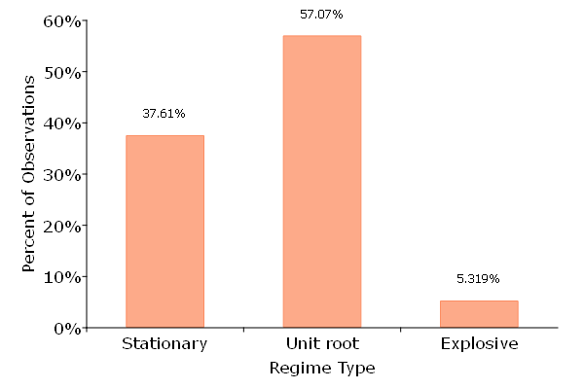
Figure 5. Markov-Switching Unit Root Results

Figure 5 reports the distribution of quarterly regime classifications across the full sample. Three regimes are identified: stationary, unit root, and explosive.
Across all countries and quarters, the unit root regime is the most prevalent state, accounting for approximately 57 percent of observations. The stationary regime comprises roughly 38 percent of the sample, while explosive episodes represent about 5 percent of observations.
These results indicate that current account balances most commonly exhibit highly persistent dynamics consistent with near-unit-root behavior. Nonetheless, a substantial fraction of observations fall into the stationary regime, indicating economically meaningful mean reversion in a nontrivial portion of the sample. Explosive dynamics are comparatively rare but clearly present, justifying the use of a nonlinear framework rather than imposing global stationarity.
The relatively low frequency of explosive states suggests that such episodes are episodic rather than representative of typical behavior, potentially corresponding to periods of macroeconomic stress or adjustment.
4.2 Cross-Country Heterogeneity
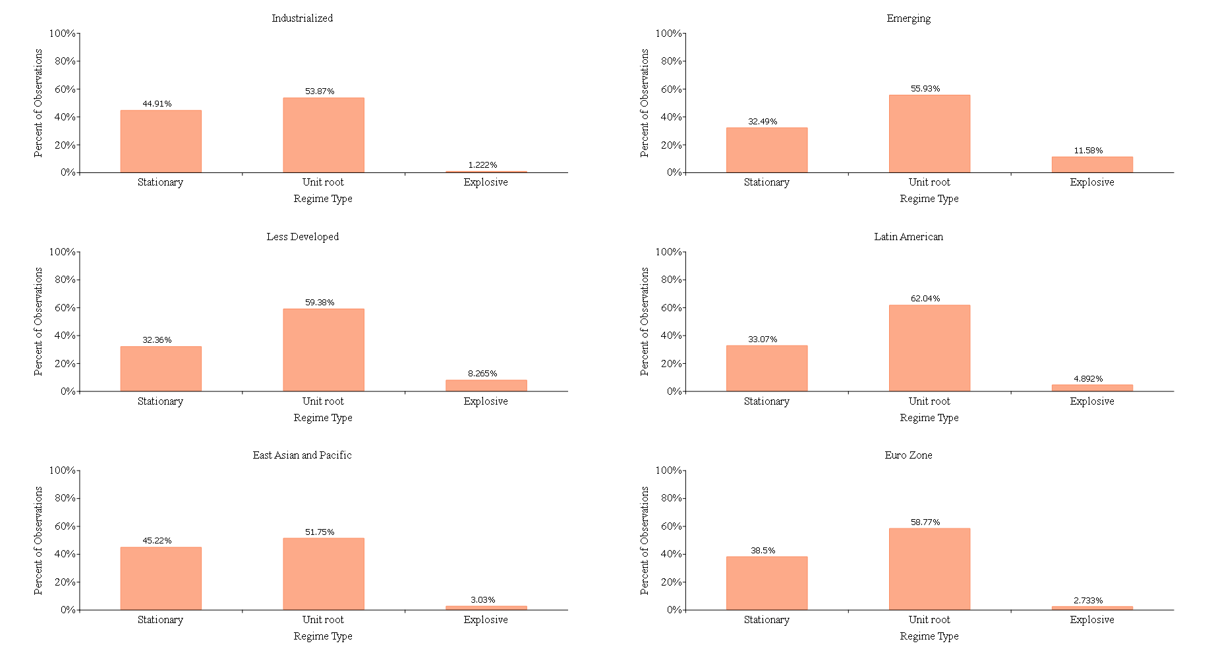
Figure 6. Country Group Markov-Switching Unit Root Results
Figure 6 disaggregates regime frequencies by country group. Clear differences emerge across development levels and regions.
Industrialized economies exhibit a high prevalence of unit root behavior (53.9 percent) and a substantial stationary component (44.9 percent), with explosive episodes accounting for only 1.2 percent of observations. Explosive dynamics are therefore extremely rare among advanced economies.
Emerging markets display greater instability. While unit root behavior remains dominant (55.9 percent), explosive episodes rise to 11.6 percent of observations. Less developed economies show a similar pattern, with 59.4 percent unit root and 8.3 percent explosive classifications.
Regional heterogeneity is also evident. Latin American economies exhibit the highest share of unit root behavior (62.0 percent) among reported groupings, while East Asian economies display a comparatively larger stationary component (45.2 percent). Euro area countries are characterized by dominant unit root behavior (58.8 percent) and minimal explosive episodes (2.7 percent).
Taken together, these patterns indicate that regime dynamics are not uniform across country types. More developed economies tend to experience fewer explosive episodes, while emerging and developing economies exhibit greater exposure to explosive dynamics.
4.3 Time Evolution of Regimes
Figure 7 presents the evolution of regime shares over time.
The unit root regime remains the modal state throughout the sample period. The stationary share fluctuates cyclically but persists at economically meaningful levels. Explosive regimes appear intermittently and cluster in specific subperiods rather than being evenly distributed across time.
This temporal concentration supports the interpretation that explosive states correspond to discrete adjustment episodes rather than persistent structural features of external balances.
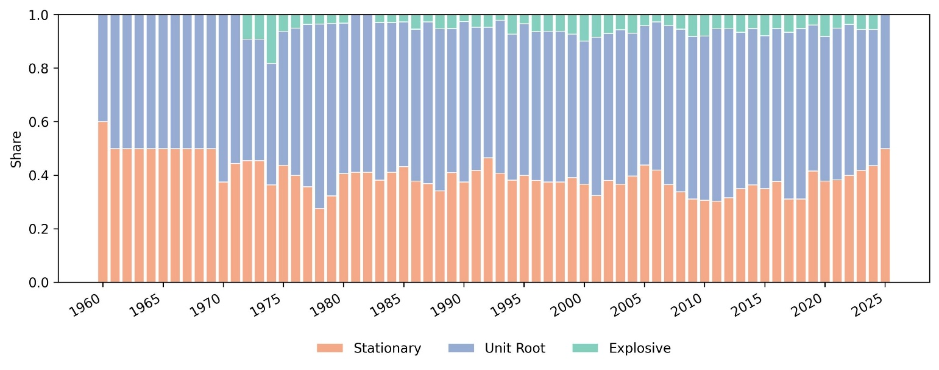
Figure 7. Persistence Regimes Across Times
4.4 Implications for Second-Stage Analysis
The Markov-Switching analysis demonstrates that current account dynamics are characterized by meaningful regime heterogeneity across countries and over time. While unit root behavior is the modal state, stationary and explosive regimes occur with nontrivial frequency and exhibit systematic variation across development groups and regions. These findings raise a natural question: which structural and macroeconomic characteristics are associated with a country being in one regime rather than another? To address this question, we aggregate quarterly regime classifications to the annual level and estimate a multinomial logit model in which the dependent variable is the prevailing current account regime. This second-stage analysis allows us to examine how fiscal, trade, financial, and institutional factors are related to the likelihood of stationary, unit root, or explosive dynamics.

4. Determinants of current account persistence
The Markov-switching framework provides country-specific classifications of current account dynamics into stationary, unit-root, and explosive regimes. While this characterization establishes the nonlinear nature of current account behavior, it does not explain why countries transition across these regimes. The next step is therefore to investigate whether macroeconomic, institutional, and structural variables systematically predict the likelihood that a country-year observation falls into a given persistence regime.

For each country and quarter, we assign the regime corresponding to the highest filtered probability from the Markov-switching estimation. This produces a three-category outcome variable: Stationary, Unit Root, and Explosive. We then estimate a multinomial logit model in which the probability of observing regime j∈S,U,E is modeled as a function of lagged macroeconomic and structural characteristics.

The multinomial logit specification allows regime probabilities to vary flexibly with fundamentals while preserving a clear interpretation of relative odds. Because the regime classification is discrete and unordered, this framework is well suited to examining whether structural characteristics systematically shift the likelihood of persistent or explosive current account behavior relative to stationary dynamics.

To account for within-country correlation in unobserved shocks, all standard errors are clustered at the country level.

Overview of the results
In this subsection, we give an overview of the results found in our research, as we run several sub-sample analyses and use several types of econometric models.

5. Concluding remarks

References

Aizenman, J. 2008. International reserve management and the current account. Central Banking, Analysis, and Economic Policies Book Series. In: Current Account and External Financing, edition 1, volume 12, chapter 11, edited by K. Cowan, S. Edwards, R. O. Valdés, N. Loayza (series editors), and K. Schmid (ed.), Central Bank of Chile.
Aizenman, J., and R. Glick. 2009. Sterilization, Monetary Policy, and Global Financial Integration. Review of International Economics 17(4): 816–840.
Aizenman, J., and J. Lee. 2007. International reserves: precautionary versus mercantilist views, theory and evidence. Open Economies Review 18(2): 191–214.
Aizenman, J., and N. Marion. 2004. International reserves holdings with sovereign risk and costly tax collection. Economic Journal 114: 569–91.
Aizenman, J., M. Chinn, and H. Ito. 2012. The 'Impossible Trinity' Hypothesis in an Era of Global Imbalances: Measurement and Testing. Mimeo. Forthcoming in Review of International Economics.
Aizenman, J., M. Chinn, and H. Ito. 2010. The Emerging Global Financial Architecture: Tracing and Evaluating New Patterns of Trilemma Configuration. International Journal of Money and Finance 29(4): 615–641.
Aizenman, J., Park, D., Qureshi, I. A., Saadaoui, J., & Uddin, G. S. (2024). The performance of emerging markets during the Fed’s easing and tightening cycles: a cross-country resilience analysis. Journal of International Money and Finance, 148, 103169.
Aizenman, J., & Saadaoui, J. (2025). The Cross-Country Resilience of Central, Eastern, and Southeastern European Countries during ECB Monetary Cycles. Open Economies Review, 1-35.
Baum, C. 2001. Stata: The language of choice for time series analysis? The Stata Journal 1: 1–16.
Bernanke, B. 2005. The Global Saving Glut and the U.S. Current Account. Remarks at the Sandridge Lecture. Virginia Association of Economics. Richmond, VA. 10 March.
Caballero, R., E. Farhi, and P. Gourinchas. 2008. An Equilibrium Model of ‘Global Imbalances’ and Low Interest Rates. American Economic Review 98(1) (March): 358–393.
Candelon, B., E. I. Dumitrescu, and C. Hurlin. 2009. How to evaluate an early warning system? Towards a unified statistical framework for assessing financial crises forecasting methods, Working Paper.
Chen, S. 2011. Current account deficits and sustainability: Evidence from the OECD countries. Economic Modelling. doi:10.10.1016/j.econmod.2011.01.011.
Chinn, M., and H. Ito. 2006. What matters for financial development? Capital controls, institutions, and interactions. Journal of Development Economics 81(1): 163–192.
Chinn, M. D., B. Eichengreen, and H. Ito. 2011. A Forensic Analysis of Global Imbalances. NBER Working Paper Series No. 17513 (October). Cambridge, MA: NBER.
Chinn, M., and S. J. Wei. 2013. A faith-based initiative meets the evidence: Does a flexible exchange rate regime really facilitate current account adjustment? Review of Economics and Statistics 95(1): 168-184.
Clemente, J., A. Montanes, and M. Reyes. 1998. Testing for a unit root in variables with a double change in the mean. Economic Letters 59: 175–182.
Eichengreen, B., A. Rose, and C. Wyplosz. 1995. Exchange Market Mayhem: The Antecedents and Aftermaths of Speculative Attacks. Economic Policy 21 (October): 249−312.
Eichengreen, B., A. Rose, and C. Wyplosz. 1996. Contagious Currency Crises: First Tests. Scandinavian Journal of Economics 98(4): 463−484.
Elliot, G., and U. K. Muller. 2006. Efficient tests for persistent time variations in regression coefficients. The Review of Economic Studies 73(4): 907–940.
Faruqee, H., and J. Lee. 2009. Global dispersion of current accounts: Is the universe expanding? IMF Staff Papers 56: 574–595.
Feldstein, M., and C. Horioka. 1980. Domestic saving and international capital flows. Economic Journal 90(2): 314–329.
Freund, C., and F. Warnock. 2007. Current Account Deficits in Industrial Countries: The Bigger They Are, The Harder They Fall? In: G7 Current Account Imbalances: Sustainability and Adjustment, edited by R. H. Clarida. Cambridge, MA: University of Chicago Press.
Friedman, M. 1964. Monetary Studies of the National Bureau. The National Bureau Enters Its 45th Year, 44th Annual Report, 7–25; Reprinted in M. Friedman. 1969. The Optimum Quantity of Money and Other Essays. Chicago, IL: Aldine.
Hall, S. G., Psaradakis, Z., & Sola, M. (1999). Detecting periodically collapsing bubbles: a Markov‐switching unit root test. Journal of Applied Econometrics, 14(2), 143-154.
Hakkio, C., and M. Rush. 1991. Is the budget deficit too large? Economic Inquiry 29(3): 429–445.
Hansen, B. 1992. Testing for parameter instability in linear models. Journal of Policy Modeling 14(4): 517–533.
Ilzetzki, E., C. Reinhart, and K. Rogoff. 2008. Exchange rate arrangements entering the 21st century: Which anchor will hold? Quarterly Journal of Economics 119(1): 1–48.
International Monetary Fund. Research Dept. (2025). External Sector Report 2025. USA: International Monetary Fund. Retrieved Jul 30, 2025. https://doi.org/10.5089/9798229017329.085
Kim, J. Y. 2000. Detection of change in persistence of a linear time series. Journal of Econometrics 95: 97–116.

Kim, C.-J., and C. R. Nelson. 1998. State-Space Models with Markov-Switching: Classical and Gibbs-Sampling Approaches with Applications. Cambridge, MA: MIT Press.

Lane, P. R., and G. M. Milesi-Ferretti. 2007. The external wealth of nations mark II: Revised and extended estimates of foreign assets and liabilities, 1970–2004. Journal of International Economics 73(November): 223–250.

Lucas, R. E. (1990). Why Doesn’t Capital Flow from Rich to Poor Countries? The American Economic Review, 80(2), 92–96. http://www.jstor.org/stable/2006549

Matsubayashi, Y. 2005. Are US current account deficits unsustainable? Testing for the private and government intertemporal budget constraints. Japan and the World Economy 17: 223–237.

Morita, R., Psaradakis, Z., Sola, M. & Yunis, P. (2024). On testing for bubbles during hyperinflations. Studies in Nonlinear Dynamics & Econometrics, 28(1), 25-37. https://doi.org/10.1515/snde-2022-0014

Nelson, C., J. Piger, and E. Zivot. 2001. Markov regime switching and unit-root tests. Journal of Business & Economic Statistics 19(4): 404–415.

Perron, P. 1989. The great crash, the oil price shock and the unit root hypothesis. Econometrica 57: 1361–1401.

Poulakis, T., & Kyrkilis, D. (2024). A Non-Linear Approach to Current Account Sustainability—The Cases of Germany, China, and the USA. Journal of Risk and Financial Management, 17(12), 565. https://doi.org/10.3390/jrfm17120565
Psaradakis, Z., M. Sola, and F. Spagnolo. 2004. On Markov error-correction models, with an application to stock prices and dividends. Journal of Applied Econometrics 19: 69–88.

Ramsey, J. 1969. Tests for specification errors in classical linear least squares regression analysis. Journal of the Royal Statistical Society 31(2): 350–371.

Raybaudi, M., M. Sola, and F. Spagnolo. 2004. Red Signals: current account deficits and sustainability. Economic Letters 84: 217–223.

Shi, S. 2013. Specification sensitivities in the Markov-switching unit root test for bubbles. Empirical Economics 45: 697–713. https://doi.org/10.1007/s00181-012-0635-8

Taylor, A. M. 2002. A century of current account dynamics. Journal of International Money and Finance 21: 725–742.
Trehan, B., and C. Walsh. 1991. Testing intertemporal budget constraints: Theory and applications to U.S. federal budget and current account deficits. Journal of Money, Credit and Banking 23(2): 206–223.

Zivot, E., and D. Andrews. 1992. Further evidence on the great crash, the oil-price shock, and the unit-root hypothesis. Journal of Business & Economic Statistics 10: 251–270.

Appendix 1. Summary statistics by country for current account (% GDP)
 | Country | Mean | SD | Min | Max | Start | End | N
1 | Albania | -6.541 | 2.823 | -11.295 | 0.461 | 2015-Q1 | 2024-Q3 | 39
2 | Argentina | -0.619 | 3.812 | -13.387 | 13.851 | 1985-Q1 | 2024-Q4 | 160
3 | Armenia | -11.246 | 9.544 | -52.759 | 2.022 | 1994-Q1 | 2020-Q3 | 107
4 | Australia | -2.963 | 2.167 | -7.323 | 3.532 | 1960-Q1 | 2024-Q4 | 260
5 | Austria | 0.143 | 2.381 | -6.288 | 6.914 | 1970-Q1 | 2024-Q4 | 220
6 | Belarus | -5.118 | 5.266 | -24.871 | 9.211 | 1996-Q1 | 2020-Q1 | 97
7 | Belgium | 1.834 | 3.076 | -7.935 | 7.507 | 1995-Q1 | 2024-Q4 | 120
8 | Bolivia | -2.131 | 7.201 | -17.940 | 17.557 | 1985-Q1 | 2019-Q4 | 140
9 | Bosnia And Herzegovina | -4.905 | 2.502 | -11.912 | -0.426 | 2010-Q1 | 2024-Q2 | 58
10 | Brazil | -2.109 | 2.084 | -6.240 | 1.892 | 1978-Q1 | 2024-Q4 | 188
11 | Bulgaria | -3.413 | 7.614 | -25.496 | 20.421 | 1994-Q1 | 2024-Q4 | 124
12 | Cambodia | -8.432 | 8.532 | -58.275 | 5.417 | 1994-Q1 | 2021-Q4 | 112
13 | Canada | -1.714 | 1.929 | -5.196 | 3.715 | 1961-Q1 | 2024-Q4 | 256
14 | Chile | -2.386 | 3.742 | -11.762 | 7.343 | 1991-Q1 | 2024-Q4 | 136
15 | China | 2.700 | 2.584 | -2.372 | 10.880 | 1991-Q1 | 2024-Q4 | 136
16 | Colombia | -3.036 | 2.033 | -6.948 | 1.226 | 1996-Q1 | 2024-Q4 | 116
17 | Costa Rica | -3.759 | 2.020 | -12.192 | 0.760 | 1999-Q1 | 2024-Q4 | 104
18 | Croatia | -4.414 | 4.384 | -20.039 | 4.770 | 1994-Q4 | 2024-Q3 | 120
19 | Cyprus | -5.935 | 3.736 | -15.955 | 1.248 | 2004-Q1 | 2024-Q3 | 83
20 | Czech Republic | -1.859 | 2.886 | -8.130 | 7.833 | 1993-Q1 | 2024-Q4 | 128
21 | Denmark | 2.720 | 4.761 | -6.155 | 16.506 | 1977-Q1 | 2025-Q1 | 193
22 | El Salvador | -3.609 | 2.227 | -8.230 | 1.285 | 1999-Q1 | 2020-Q1 | 85
23 | Estonia | -4.348 | 5.910 | -18.793 | 6.571 | 1993-Q1 | 2024-Q4 | 128
24 | Finland | 0.438 | 3.518 | -7.258 | 9.127 | 1975-Q1 | 2024-Q4 | 200
25 | France | 0.032 | 1.190 | -3.910 | 3.756 | 1975-Q1 | 2024-Q4 | 200
26 | Georgia | -10.901 | 4.915 | -29.074 | -3.763 | 1997-Q1 | 2020-Q1 | 93
27 | Germany | 2.966 | 3.350 | -2.785 | 9.892 | 1971-Q1 | 2024-Q4 | 216
28 | Greece | -5.016 | 3.806 | -16.156 | 2.881 | 1976-Q1 | 2024-Q4 | 196
29 | Guatemala | -3.611 | 2.969 | -13.072 | 5.747 | 1977-Q1 | 2020-Q1 | 173
30 | Hong Kong China | 6.508 | 4.436 | -1.650 | 17.995 | 1999-Q1 | 2020-Q1 | 85
31 | Hungary | -3.210 | 4.855 | -17.736 | 5.338 | 1989-Q4 | 2024-Q4 | 141
32 | Iceland | -3.188 | 6.991 | -30.086 | 10.202 | 1976-Q1 | 2024-Q4 | 196
33 | India | -1.279 | 1.610 | -6.332 | 9.091 | 1960-Q1 | 2024-Q4 | 260
34 | Indonesia | -0.795 | 3.125 | -13.379 | 8.163 | 1981-Q1 | 2024-Q4 | 176
35 | Ireland | 0.548 | 9.809 | -58.296 | 25.322 | 1990-Q1 | 2024-Q4 | 140
36 | Israel | -1.218 | 5.553 | -16.827 | 16.257 | 1972-Q1 | 2024-Q4 | 212
37 | Italy | 0.004 | 2.001 | -5.167 | 5.028 | 1970-Q1 | 2024-Q4 | 220
38 | Japan | 2.531 | 1.376 | -1.827 | 5.295 | 1977-Q1 | 2025-Q1 | 193
39 | Kazakhstan | -1.556 | 4.891 | -11.776 | 11.858 | 1995-Q1 | 2020-Q1 | 101
40 | Korea Rep. | 0.972 | 4.302 | -13.061 | 15.225 | 1976-Q1 | 2024-Q4 | 196
41 | Kyrgyz Republic | -9.721 | 8.924 | -34.828 | 16.061 | 1993-Q1 | 2021-Q4 | 116
42 | Latvia | -3.745 | 8.048 | -26.703 | 24.636 | 1993-Q1 | 2024-Q4 | 128
43 | Lithuania | -3.786 | 5.975 | -18.548 | 7.662 | 1993-Q1 | 2024-Q4 | 128
44 | Luxembourg | 7.669 | 7.299 | -14.452 | 37.352 | 1995-Q1 | 2024-Q4 | 120
45 | Macedonia FYR | -2.105 | 3.009 | -10.903 | 5.104 | 2011-Q1 | 2024-Q3 | 55
46 | Malaysia | 9.135 | 5.521 | 1.653 | 19.652 | 1999-Q1 | 2020-Q1 | 85
47 | Malta | 2.433 | 8.867 | -13.832 | 22.178 | 2004-Q1 | 2024-Q3 | 83
48 | Mauritius | -4.426 | 5.031 | -16.175 | 8.131 | 2000-Q1 | 2020-Q1 | 81
49 | Mexico | -1.587 | 2.225 | -8.641 | 5.913 | 1979-Q1 | 2024-Q4 | 184
50 | Moldova | -9.026 | 5.521 | -23.111 | 2.339 | 1995-Q1 | 2020-Q1 | 101
51 | Montenegro | -17.617 | 5.164 | -44.982 | -11.088 | 2013-Q1 | 2024-Q3 | 47
52 | Netherlands | 4.987 | 3.460 | -8.346 | 14.725 | 1977-Q1 | 2024-Q4 | 192
53 | New Zealand | -4.514 | 2.994 | -16.022 | 0.693 | 1980-Q1 | 2024-Q4 | 180
54 | Norway | 6.027 | 8.393 | -16.706 | 38.383 | 1975-Q1 | 2024-Q4 | 200
55 | Paraguay | 0.303 | 3.358 | -6.507 | 8.949 | 2000-Q1 | 2020-Q4 | 84
56 | Peru | -3.375 | 3.359 | -11.380 | 6.349 | 1979-Q1 | 2020-Q1 | 165
57 | Philippines | -0.973 | 4.037 | -11.834 | 7.061 | 1977-Q2 | 2020-Q1 | 165
58 | Poland | -2.563 | 3.316 | -8.720 | 17.707 | 1985-Q1 | 2024-Q4 | 160
59 | Portugal | -4.017 | 5.318 | -21.410 | 4.682 | 1977-Q1 | 2024-Q4 | 192
60 | Romania | -5.979 | 3.711 | -21.533 | 2.870 | 1991-Q1 | 2024-Q4 | 136
61 | Russian Federation | 5.652 | 4.453 | -2.449 | 19.539 | 1994-Q1 | 2021-Q3 | 111
62 | Saudi Arabia | 10.115 | 11.971 | -13.678 | 36.616 | 2006-Q1 | 2024-Q4 | 76
63 | Slovak Republic | -3.904 | 4.201 | -11.890 | 11.874 | 1993-Q1 | 2024-Q4 | 128
64 | Slovenia | 1.082 | 3.846 | -10.352 | 9.246 | 1995-Q1 | 2024-Q4 | 120
65 | South Africa | -1.026 | 3.235 | -10.599 | 11.214 | 1960-Q1 | 2024-Q4 | 260
66 | Spain | -1.616 | 3.180 | -9.992 | 3.807 | 1975-Q1 | 2024-Q4 | 200
67 | Sri Lanka | -4.768 | 4.561 | -21.080 | 4.906 | 1977-Q1 | 2021-Q1 | 177
68 | Sweden | 2.470 | 3.559 | -5.506 | 9.449 | 1975-Q1 | 2024-Q4 | 200
69 | Switzerland | 5.714 | 3.878 | -12.115 | 14.543 | 1972-Q1 | 2024-Q4 | 212
70 | Taiwan | 7.988 | 4.810 | -5.188 | 22.562 | 1981-Q1 | 2019-Q4 | 156
71 | Thailand | -0.262 | 6.403 | -12.561 | 13.725 | 1976-Q1 | 2019-Q4 | 176
72 | Turkey | -2.352 | 2.898 | -9.338 | 6.448 | 1987-Q1 | 2024-Q4 | 152
73 | United Kingdom | -1.554 | 1.902 | -6.880 | 3.799 | 1960-Q1 | 2024-Q4 | 260
74 | United States | -1.731 | 1.846 | -6.300 | 1.214 | 1960-Q1 | 2024-Q4 | 260
75 | Uruguay | -1.272 | 2.100 | -8.082 | 3.797 | 1999-Q1 | 2020-Q1 | 85
76 | Venezuela Rb | 4.906 | 6.186 | -6.652 | 24.883 | 1994-Q1 | 2014-Q4 | 84
77 | Vietnam | -1.302 | 6.510 | -38.299 | 8.760 | 1996-Q1 | 2021-Q4 | 104
Source: authors’ calculations.

Appendix 2. Unit root tests for individual countries
Country | ADF | DFGLS | ZT PP | Za PP | LM | KPSS | N
Albania | -0.3384 | -0.6183 | -2.86* | -15.96** | -1.581 | 1.5*** | 39
Argentina | -5.224*** | -4.954*** | -5.224*** | -47.03*** | -5.172*** | 0.6126** | 160
Armenia | -1.654 | -0.102 | -5.204*** | -37.13*** | -1.254 | 3.772*** | 107
Australia | -2.843* | -2.053** | -3.765*** | -27.01*** | -2.464 | 3.271*** | 260
Austria | -1.757 | -1.786* | -4.215*** | -33.22*** | -1.868 | 9.343*** | 220
Belarus | -4.775*** | -4.791*** | -4.775*** | -37.61*** | -4.721*** | 0.5718** | 97
Belgium | -1.823 | -0.5058 | -6.657*** | -65.18*** | -3.184** | 4.57*** | 120
Bolivia | -2.147 | -2.035** | -2.794* | -14.97** | -2.177 | 5.227*** | 140
Bosnia Herzegovina | -1.39 | -1.565 | -2.875* | -15.05** | -2.009 | 3.242*** | 58
Brazil | -2.964** | -2.816*** | -3.182** | -19.71** | -3.017** | 0.8329*** | 188
Bulgaria | -2.159 | -1.014 | -3.999*** | -24.77*** | -2.208 | 1.75*** | 124
Cambodia | 2.468 | 2.725 | -1.636 | -14.39** | -1.948 | 2.816*** | 112
Canada | -2.754* | -2.342** | -3.443*** | -22.8*** | -2.813* | 2.617*** | 256
Chile | -1.988 | -1.949* | -4.075*** | -29.94*** | -2.03 | 1.359*** | 136
China | -2.022 | -1.907* | -3.15** | -18.6** | -2.036 | 1.373*** | 136
Colombia | -2.875* | -2.416** | -2.875* | -15.43** | -2.353 | 2.473*** | 116
Costa_Rica | -5.018*** | -4.894*** | -5.018*** | -41.38*** | -5.894*** | 2.636*** | 104
Croatia | -1.731 | -1.546 | -4.604*** | -36.42*** | -1.942 | 5.021*** | 120
Cyprus | -2.317 | -2.048** | -2.429 | -11.21* | -2.255 | 0.7216** | 83
Czech Republic | -3.523*** | -1.273 | -5.599*** | -51.31*** | -2.615 | 3.235*** | 128
Denmark | 0.1432 | 1.403 | -2 | -8.903 | -4.216*** | 16.17*** | 193
El_Salvador | -2.405 | -2.077* | -3.281** | -20.72*** | -2.665 | 0.6591** | 85
Estonia | -2.571* | -1.401 | -3.612*** | -22.46*** | -1.953 | 3.731*** | 128
Finland | -2.651* | -0.9337 | -3.635*** | -22.45*** | -2 | 2.963*** | 200
France | -2.012 | -1.744* | -4.806*** | -41.7*** | -2.018 | 1.809*** | 200
Georgia | -2.794* | -2.228** | -2.516 | -11.88* | -2.388 | 0.8678*** | 93
Germany | -1.919 | -1.445 | -1.919 | -7.04 | -2.323 | 11.88*** | 216
Greece | -1.919 | -1.795* | -4.221*** | -33.01*** | -1.989 | 2.741*** | 196
Guatemala | -1.447 | -0.9584 | -6.212*** | -60.91*** | -0.8012 | 2.374*** | 173
Hong Kong | -0.9703 | -0.9417 | -3.439** | -22.08*** | -1.486 | 2.36*** | 85
Hungary | -2.335 | -1.711 | -3.208** | -19.37** | -2.374 | 3.51*** | 141
Iceland | -2.589* | -2.049** | -5.287*** | -48.98*** | -2.605 | 1.346*** | 196
India | -4.866*** | -4.335*** | -8.856*** | -121*** | -4.669*** | 0.3936* | 260
Indonesia | -2.677* | -1.838* | -4.071*** | -30.06*** | -2.473 | 2.717*** | 176
Ireland | -4.491*** | -3.943*** | -8.283*** | -94.44*** | -4.158*** | 0.4282* | 140
Israel | -2.876** | -2.835*** | -5.709*** | -57.1*** | -3.551*** | 10.66*** | 212
Italy | -3.127** | -2.845*** | -3.616*** | -25.2*** | -3.389** | 1.69*** | 220
Japan | -2.806* | -1.72* | -2.806* | -16.2** | -3.7*** | 4.137*** | 193
Kazakhstan | -2.934** | -1.348 | -5.197*** | -42.62*** | -1.918 | 0.3832* | 101
Korea Rep. | -2.212 | -0.9189 | 3.505*** | 22.34*** | -3.34** | 7.382*** | 96
Kyrgyz Republic | -5.938*** | -5.483*** | -5.938*** | -57.53*** | -1.627 | 0.221 | 116
Latvia | -3.382** | -0.8074 | -3.829*** | -16.63** | -1.488 | 1.186*** | 128
Lithuania | -1.809 | -1.33 | -3.467*** | -21.11*** | -1.491 | 5.41*** | 128
Luxembourg | -2.13 | -0.7588 | -10.05*** | -109.7*** | -1.348 | 0.3593* | 120
Macedonia FYR | -3.998*** | -1.107 | -6.049*** | -42.88*** | -2.616 | 0.1025 | 55
Malaysia | -1.058 | -0.7198 | -1.46 | -4.213 | -2.558 | 4.603*** | 85
Malta | -1.931 | -1.815 | -2.795* | -14.55** | -2.143 | 4.559*** | 83
Mauritius | -1.596 | -1.295 | -2.961** | -16.1** | -1.666 | 2.407*** | 81
Mexico | -3.649*** | -3.35*** | -4.043*** | -30.91*** | -3.432** | 0.9175*** | 184
Moldova | -2.847** | -2.54** | -3.274** | -19.72** | -2.811* | 0.7676*** | 101
Montenegro | -4.529*** | -4.511*** | -4.529*** | -29.27*** | -4.258*** | 0.2804 | 47
Netherlands | -2.223 | -0.9674 | -7.146*** | -83.39*** | -3.369** | 8.626*** | 192
New Zealand | -4.42*** | -3.524*** | -4.42*** | -35.22*** | -4.367*** | 0.9916*** | 180
Norway | -2.811* | -1.024 | -2.811* | -14.54** | -3.846*** | 10.29*** | 200
Paraguay | -3.47*** | -2.7*** | -6.039*** | -52.21*** | -2.332 | 0.2988 | 84
Peru | -3.426** | -2.1** | -2.904** | -16.29** | -3.05** | 3.072*** | 165
Philippines | -1.985 | -1.954* | -4.633*** | -38.39*** | -2.159 | 5.834*** | 165
Poland | -3.807*** | -2.257** | -5.732*** | -54.42*** | -3.554** | 1.23*** | 160
Portugal | -2.862** | -2.605** | -2.755* | -15.17** | -2.979* | 1.911*** | 192
Romania | -2.323 | -2.314** | -5.499*** | -51.22*** | -3.015** | 0.7984*** | 136
Russian Federation | -2.569 | -2.185** | -2.569 | -12.63* | -2.129 | 1.645*** | 111
Saudi Arabia | -2.597* | -1.184 | -2.597* | -10.87 | -3.027* | 3.177*** | 76
Slovak Republic | -2.553* | -1.426 | -4.339*** | -32.76*** | -1.947 | 1.345*** | 128
Slovenia | -1.705 | -1.678 | -3.255** | -19.94** | -1.813 | 5.816*** | 120
South Africa | -4.805*** | -3.935*** | -4.978*** | -45.35*** | -4.844*** | 1.44*** | 260
Spain | -1.976 | -1.443 | -1.673 | -6.134 | -2.043 | 2.944*** | 200
Sri Lanka | -5.02*** | -2.342** | -6.873*** | -74.19*** | -4.116*** | 1.805*** | 177
Sweden | -1.151 | -0.5589 | -2.317 | -11.17* | -2.155 | 13.55*** | 200
Switzerland | -4.003*** | -1.583 | -7.724*** | -93.14*** | -4.374*** | 4.598*** | 212
Taiwan | -2.306 | -0.7968 | -3.647*** | -20.24** | -1.776 | 2.004*** | 156
Thailand | -2.453 | -2.224** | -3.06** | -18.6** | -3.497** | 8.055*** | 176
Turkey | -2.272 | -2.172** | -4.392*** | -34.67*** | -2.129 | 2.682*** | 152
United Kingdom | -2.717* | -2.115** | -5.78*** | -59.6*** | -3.632*** | 10.82*** | 260
United States | -1.797 | -0.4857 | -1.344 | -3.841 | -2.834* | 16.7*** | 260
Uruguay | -3.481*** | -3.423*** | -3.887*** | -26.21*** | -3.461** | 0.6034** | 85
Venezuela RB | -2.09 | -1.598 | -5.032*** | -39.79*** | -2.142 | 0.5123** | 84
Vietnam | -2.817* | -0.7119 | -4.707*** | -35.65*** | -1.948 | 1.045*** | 104

Appendix 4. Candidate determinants of the current account persistency

★ Corresponding author: Hiro Ito, Department of Economics, Portland State University, 506 SW Mill Street, Urban Center Building, #450, Portland, OR, 97201, USA. Email: ito@pdx.edu. Email addresses: eric@aptech.com (Eric Clower), ito@pdx.edu (Hiro Ito), jamelsaadaoui@gmail.com (Jamel Saadaoui). We thank…
The original dataset is unbalanced and consists of quarterly data for the period of 1960 through 2024. The dataset includes countries whose CA/Y data are available for at least 10 years. Appendix 1 provides a summary table of data availability and country level summary statistics. The majority of the quarterly observations are obtained from the IMF International Financial Statistics, OECD, and Eurostat.

