What Drives Persistence in Current Account Imbalances?★
Eric Clowera, Hiro Ito^{b}, Jamel Saadaoui^{c}
a Aptech Systems, Inc, PO Box 618, Higley, AZ 85236, USA
b Department of Economics, Portland State University, 506 SW Mill Street, Urban Center Building, #450, Portland, OR, 97201, USA
cParis 8 University, France

Abstract
This paper examines the structural determinants of current account balance (CAB) dynamics for a panel of 74 countries spanning 1971–2023. We characterize external adjustment behavior through a two-stage empirical strategy. In the first stage, we estimate country-specific Markov switching autoregressive models that classify each country-year observation into one of three dynamic regimes — explosive, unit root, or stationary — allowing persistence, mean, and volatility to switch independently. In the second stage, we estimate a multinomial logit model to identify the structural factors that predict regime membership. Fixed exchange rate arrangements reduce the probability of explosive current account dynamics by approximately nine percentage points on average, while manufacturing export specialization and trade openness increase it. These effects operate primarily through the explosive-versus-non-explosive channel. Within the stable regime space, the same structural variables do not reliably distinguish stationary from unit root behavior. Model fit is substantially higher for emerging market economies, indicating that exchange rate and trade policy are most consequential for middle-income countries. These findings contribute to the understanding of how macroeconomic policy frameworks shape the dynamics of external adjustment.

Keywords:
JEL: F32, F41

1. Introduction
The persistence of global current account imbalances has long been an important policy concern for policymakers and academics, particularly in advanced economies. Whether in the aftermath of the Great Recession of 2008, during the European sovereign debt crisis of 2010–2012, or in the current era of geoeconomic fragmentation, economists have repeatedly expressed concern about the durability of large external imbalances. At times, these concerns have spilled over into financial markets, contributing to credit rating downgrades or speculative pressures on sovereign debt. This is not solely a developing country issue: in May 2025, Moody’s downgraded the credit rating of the United States. Such developments can, in turn, constrain fiscal policy, limiting governments’ ability to deploy countercyclical stimulus when it is most needed. Maintaining current account surpluses and accumulating international reserves have historically been associated with greater resilience during periods of monetary tightening (Aizenman et al. 2024, Aizenman and Saadaoui 2025). A similar logic applies during episodes of financial stress.
During the Great Recession of 2008 and the pandemic induced recession of 2020, many countries sought international financial assistance to maintain solvency or relied on central bank swap lines to secure short-term liquidity. Yet while some countries struggled to meet their debt obligations, others accumulated savings and were more insulated from financial turmoil. Following the post–Great Recession correction, global current account imbalances have once again widened, with the IMF (2025) reporting a global current account expansion of 0.6 percentage points of world GDP. Prior to the Great Recession, persistent external deficits in several advanced economies—most notably the United States—were financed by excess savings from emerging market economies, particularly the People’s Republic of China (PRC), as well as from oil exporting countries. These imbalanced capital flows enabled some economies to sustain large and persistent current account deficits, financed by the equally persistent surpluses of others.
A substantial literature has examined the origins of these global imbalances. Chinn, Eichengreen, and Ito (204), among others, emphasizes that multiple factors interact to generate “uphill” capital flows—from developing countries with higher marginal returns to advanced economies with lower returns but deeper and more sophisticated financial markets—an outcome often associated with the Lucas (1990) paradox. The global financial crisis and the subsequent European debt crisis, however, underscored the fragility of this configuration. Shifts in global financial conditions can abruptly reverse capital flows, with disruptive consequences for real economic activity. Conversely, sustained and asymmetric capital flows may render the global economy vulnerable to crisis, as observed in the pre2008 period. In this environment, examining the country specific determinants of persistent current account deficits and surpluses can yield deeper insights into the dynamics of global imbalances and the stability of the international financial system.
In theory, a country’s current account should evolve in a manner consistent with the long-run intertemporal budget constraint (LRBC). Building on Feldstein and Horioka (1980), Taylor (2002) argues that the LRBC implies a strong long-run relationship between saving and investment as economies converge toward steady state. This does not preclude short-run deviations from the LRBC, which may arise from macroeconomic shocks, policy changes, or institutional reforms affecting saving and investment behavior. As Taylor (2002) emphasizes, even within the intertemporal framework, countries may experience periods of seemingly “unsustainable” current account behavior without violating the long-run constraint.
Empirical assessments of current account sustainability have nevertheless produced mixed and often inconclusive results. This ambiguity may reflect methodological inconsistencies across studies or a failure to distinguish clearly between long-run sustainability and short-run dynamics. In particular, rejecting long-run sustainability based on short-run, non-stationarity risks conflating temporary deviations from the LRBC with genuine violations of the intertemporal constraint. Distinguishing between these concepts is therefore essential for a meaningful assessment of external balance.
Even when current account balances exhibit mean reversion—either globally or locally—the degree of persistence can vary substantially across countries and over time. As we show below, in the period leading up to the Great Recession, both surplus and deficit countries experienced highly persistent current account imbalances. Persistence alone does not necessarily imply immediate concerns about external debt sustainability; the speed and nature of adjustment depend on macroeconomic policy frameworks and institutional characteristics. For example, the PRC’s prolonged current account surplus and quasi-fixed exchange rate regime prior to 2008 raised questions about whether exchange rate arrangements influence current account persistence. Chinn and Wei (2013) find no systematic relationship between exchange rate regime flexibility and the speed of current account adjustment, challenging the conventional view that flexible exchange rates necessarily facilitate external rebalancing. Beyond exchange rate regimes, however, relatively little is known about the structural factors that shape the persistence of current account dynamics.
Against this backdrop, this paper examines the dynamics of current account balances using a large quarterly dataset covering 77 countries. Our analysis focuses on persistence and the structural factors that govern it. First, we reassess the stationarity of current account balances expressed as a share of GDP. Standard linear unit root tests indicate that current account series are non-stationary for many countries, contrary to theoretical predictions. Second, we investigate whether this apparent non-stationarity reflects regime shifts in persistence, following a growing literature that applies Markov switching models to current account dynamics (Taylor 2002; Raybaudi et al. 2004; Chen 2011; Poulakis and Kyrkilis 2024). Finally, we examine whether the likelihood of entering different persistence regimes, particularly the explosive regime, where external dynamics become destabilizing, can be explained by cross-sectional and temporal variation in macroeconomic policies, institutional characteristics, and structural fundamentals. We show that structural factors are most informative for explaining which countries enter explosive adjustment paths; within the stable regime space, the same variables do not reliably distinguish stationary from unit-root behavior.
Our paper extends a small but growing literature that applies Markov switching models to current account dynamics. Earlier work in this field studied current account persistence using two-state Markov switching classifications and identified structural predictors of entry into a random-walk regime. Our contribution relative to that work is threefold. First, we adopt the independent-switching specification of Morita et al. (2024), which allows persistence, mean, and volatility to switch separately across regimes. This prevents changes in mean or volatility from being spuriously attributed to persistence shifts, a problem that biases classification in standard two-state models. Second, we extend to a three-regime framework that isolates an explosive tail separately from persistent-but-bounded dynamics. The two-state (stationary vs. random walk) framework cannot produce the central result of this paper, that structural variables matter primarily for explosive regime entry rather than for the stationary-unit-root distinction. Third, we add a formal multinomial logit second stage with cross-validated model selection and multiple robustness checks, including a binary logit that precisely bounds what the model can and cannot explain.
Our main findings are threefold. Fixed exchange rate arrangements reduce the probability of explosive current account dynamics by approximately nine percentage points, while manufacturing export specialization and trade openness increase it. Crucially, the model fits substantially better for emerging market economies (McFadden R² = 0.19) than for the full sample (0.05), indicating that exchange rate and trade policy are most consequential for middle-income countries, where institutional constraints on external adjustment are less deeply entrenched than in advanced economies.
2. Current account persistency: facts and theory
2.1. Facts: Current Account Divergence and Persistency
As international financial markets have become increasingly integrated, current account balances have grown more divergent across countries. Financial globalization has facilitated access to cross-border capital flows, allowing countries to partially delink domestic saving and investment (Feldstein and Horioka 1980; Faruqee and Lee 2009). As a result, both the magnitude and dispersion of current account imbalances have increased over time.
Figure 1 illustrates the evolution of global current account imbalances using two summary statistics computed across our sample of 77 countries: the cross-sectional mean of absolute current account balances (expressed as a share of GDP) and the corresponding cross-country standard deviation. The figure highlights a steady increase in the typical size of imbalances across three broad periods—pre1970, 1975–1994, and 1995–September 2008. Following the Global Financial Crisis, the mean absolute imbalance declines modestly but remains elevated relative to earlier decades. The growth in the cross-sectional standard deviation further underscores the widening dispersion of current account positions, reflecting increasingly asymmetric external balances across countries.
Figure 1. Global Current Account Imbalances
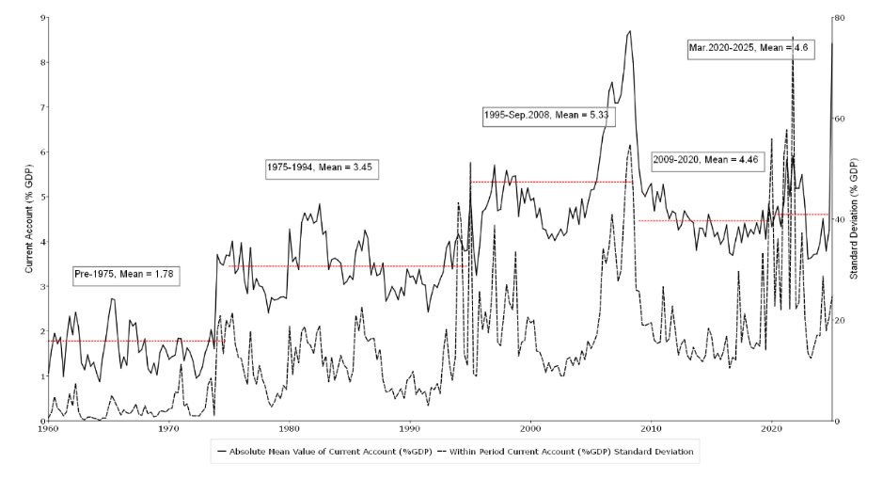
Figure 2 provides a complementary perspective by tracing the distribution of current account balances over time. While the median current account balance remains relatively stable, an important cyclical pattern emerges: the median tends to decline prior to major global recessions in 1975, 1982, 1991, and 2009. The COVID-19 recession of 2020 is the main exception, with the median rising in the period immediately preceding the downturn and declining only afterward. More broadly, the fan chart illustrates the pronounced widening of the distribution from the 1960s through 2008. Although the dispersion narrows somewhat after the Global Financial Crisis, it remains substantially wider than in the pre-2000 period.
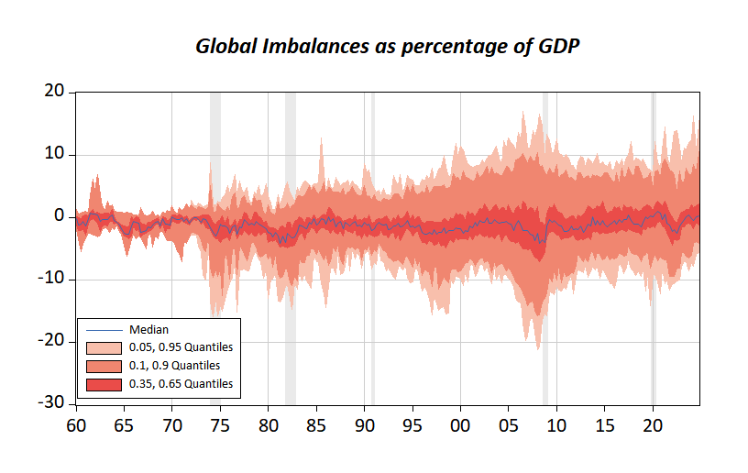
Figure 2. Dispersion of Global Current Account Imbalances
Disaggregating by country groups in Figure 3 reinforces these global patterns while revealing important heterogeneity across regions and levels of development. Across all groups, both the typical magnitude of imbalances (measured by the absolute mean) and their dispersion (measured by the standard deviation) vary over time and exhibit common global movements. At the same time, distinct group‑specific dynamics are evident. Industrialized economies display a pronounced run‑up in imbalance magnitudes from the late 1990s through the mid‑2000s, followed by partial retrenchment. Emerging and less‑developed economies exhibit higher short‑run volatility earlier in the sample, particularly during the 1970s and 1980s, and a renewed widening around the 2000s before moderating thereafter.
Regional differences are also salient. East Asia and the Pacific show persistently moderate imbalances punctuated by episodic spikes, while Latin America experiences sharper cyclical surges, especially in the mid‑2000s, alongside elevated cross‑country dispersion in recent years. The euro area stands out for a marked increase in both the level and dispersion of imbalances during the 2000s, coinciding with monetary union, and—like other advanced groups—exhibits renewed heterogeneity toward the end of the sample, reflecting divergent country experiences during recent global shocks.
Taken together, these descriptive facts point to two key features of current account dynamics. First, global imbalances have increased both in magnitude and dispersion over time. Second, the persistence and volatility of current account balances vary systematically across countries and episodes, suggesting that a single, time‑invariant characterization of external adjustment is unlikely to be adequate.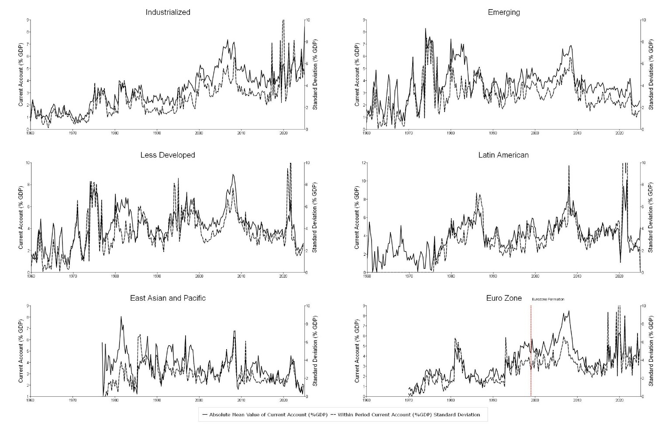
Figure 3. Current Account Imbalances by Country Groups
2.2. External balance and the intertemporal approach
The intertemporal approach to the current account provides the standard theoretical framework for assessing external balance and sustainability (Trehan and Walsh 1991; Hakkio and Rush 1991). In this framework, a representative, infinitely lived agent smooths consumption subject to an intertemporal budget constraint. The key implication is that the current account must be stationary in equilibrium to satisfy the long-run budget constraint.
The aggregate resource constraint is given by
$$\begin{matrix} & C_{t}+I_{t}+G_{t}+B_{t}=Y_{t}+(1+r_{t})B_{t-1}, & & \text{(1)}\end{matrix}$$
where $C_{t}$, $I_{t}$, $G_{t}$, $B_{t}$, $Y_{t}$, and $r_{t}$ denote consumption, private investment, government spending, net foreign assets, output, and the world real interest rate. Net foreign assets evolve according to
$$\begin{matrix} & B_{t}=(1+r_{t})B_{t-1}+NX_{t}, & & \text{(2)}\end{matrix}$$
with net exports defined by
$$\begin{matrix} & NX_{t}=Y_{t}-C_{t}-I_{t}-G_{t}. & & \text{(3)}\end{matrix}$$
The current account can therefore be expressed as
$$\begin{matrix} & CA_{t}=r_{t}B_{t-1}+NX_{t}. & & \text{(4)}\end{matrix}$$
highlighting that it reflects both net income flows from the international asset position and net exports of goods and services.
Following Taylor (2002), consider the dynamic behavior of this system in a stochastic steady state. Define $R_{t}=1+r_{t}$and assume that conditional expectations satisfy
$$\begin{matrix} & E(R_{t+i}∣Ω_{t-1})=R,i≥0, & & \text{(5)}\end{matrix}$$
where $Ω_{t-1},$denotes the information set in the previous period. Forward iteration of net foreign asset accumulation (Equation 2) yields
$$\begin{matrix} & B_{t-1}=\underset{j→∞}{lim⁡}R^{-(j+1)}E(B_{t+j}∣Ω_{t-1})-\sum_{j=0}^{∞}{R^{-(j+1)}}E(NX_{t+j}∣Ω_{t-1}). & & \text{(6)}\end{matrix}$$
The long-run budget constraint requires the transversality condition
$$\begin{matrix} & \underset{j→∞}{lim⁡}R^{-(j+1)}E(B_{t+j}∣Ω_{t-1})=0. & & \text{(7)}\end{matrix}$$
holds. When the real interest rate is positive, this condition is satisfied if the current account follows a stationary process.
The same logic extends naturally to environments with stochastic output growth. Suppose world output grows at rate $g_{t}$with $E(g_{t})>0$. Define the foreign asset ratio $b_{t}=B_{t}/Y_{t}$ and the scaled return
$$\begin{matrix} & ρ_{t}=\frac{R_{t}}{g_{t}}. & & \text{(8)}\end{matrix}$$
The intertemporal constraint then becomes
$$\begin{matrix} & \underset{j→∞}{lim⁡}ρ_{t}^{-(j+1)}E(b_{t+j}∣Ω_{t-1})=0, & & \text{(9)}\end{matrix}$$
which holds when $ρ_{t}>1$ and the current account expressed as a share of output is stationary.
This framework delivers a clear theoretical benchmark: sustained violations of stationarity in the current account are inconsistent with the intertemporal budget constraint. At the same time, the model allows for temporary deviations driven by shocks to income, preferences, fiscal policy, or investment opportunities. As Taylor (2002) emphasizes, periods of apparently “unsustainable” current account behavior need not imply a violation of the long-run constraint, provided that corrective dynamics eventually restore balance.
This distinction between long-run sustainability and -short-run dynamics is central to interpreting empirical evidence. Linear unit root tests that reject stationarity may conflate temporary shifts in persistence with genuine failures of the intertemporal constraint. If the parameters governing persistence, volatility, or mean adjustment change over time, standard tests may yield misleading conclusions. These considerations motivate empirical approaches that allow for regime-dependent dynamics, in which current account behavior can alternate between stationary, highly persistent, and even explosive episodes without violating the underlying theoretical restriction in the long run.
An alternative but complementary perspective on external sustainability is provided by the fiscal reaction function approach pioneered by Bohn (1998). Rather than requiring strict stationarity of the current account at all horizons, this framework emphasizes whether policy responses are sufficiently stabilizing to prevent explosive accumulation of external liabilities. Applied to the external balance, sustainability requires that the current account, equivalently, net exports, respond endogenously to the level of net foreign assets in a manner that ensures bounded debt dynamics over the long run. Under this logic, temporary episodes of highly persistent or even explosive current account behavior are not necessarily inconsistent with sustainability, provided that corrective forces eventually dominate. This insight aligns closely with the intertemporal framework discussed above and underscores the importance of distinguishing between local dynamics and global stability. Empirical approaches that allow adjustment behavior to vary across regimes, capturing periods of weak feedback alongside episodes of strong correction, offer a natural way to reconcile observed current account persistence with long-run sustainability. This perspective motivates our use of a -regime switching- framework in the empirical analysis that follows.
3. Stationarity of current account balances and regime shifts
Motivated by the distinction between short‑run persistence and long‑run sustainability emphasized by both the intertemporal budget constraint and the Bohn‑style reaction‑function approach, we now turn to an empirical assessment of current account dynamics. Our approach begins with an examination of linear unit root tests, which we then adapt to allow adjustment behavior to vary across regimes.
3.1. Linear unit root tests
Standard linear unit root tests provide a natural benchmark for assessing current account persistence. We apply ADF, DFGLS, and Phillips–Perron tests to current account balances expressed as a share of GDP across our 77-country sample (full results in Appendix 2). These tests assume that the mean, variance, and persistence of the current account process are time-invariant. This assumption may be too restrictive when dynamics shift over time due to structural change, policy regime shifts, or episodic adjustment. We therefore treat their results as a descriptive baseline rather than a definitive assessment, using them to motivate the regime-switching framework in Section 3.2.
Figure 4 summarizes the classification outcomes across tests. The central message is that conclusions are highly test dependent. The ADF and DFGLS tests are relatively conservative, with roughly half of all series failing to reject a unit root at conventional levels; Phillips–Perron statistics reject the null for a substantially larger share of countries, consistent with those tests' greater sensitivity to time variation in persistence and volatility. The KPSS test rejects stationarity for more than 80 percent of series. Cross-country heterogeneity is also pronounced: some economies show consistent mean-reverting evidence across multiple tests while others produce contradictory results, likely reflecting heterogeneity in policy frameworks, shock exposure, and available sample length. Rather than treating this divergence as evidence for or against stationarity, we interpret it as confirmation that a single constant-parameter linear framework is inadequate and that time variation in current account dynamics must be accommodated, motivating the Markov switching approach in Section 3.2.
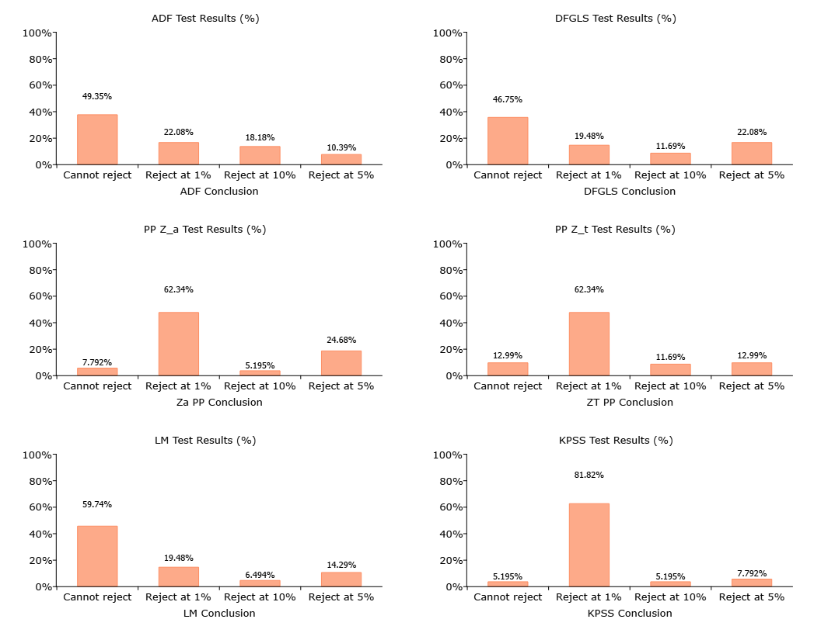Figure 4. Linear Unit Root Results
3.2 Markov Switching Estimation
To account for time variation in current account dynamics, we estimate a Markov switching autoregressive model that allows persistence, volatility, and the mean to change across regimes. Our empirical strategy follows Morita et al. (2024), who propose a framework designed to distinguish stationary, unit root, and explosive behavior within a unified nonlinear model.
This approach addresses two limitations of linear unit root tests. First, when persistence or volatility shifts over time, constant parameter models may misattribute these changes to non-stationarity. Second, linear tests impose a single global characterization of dynamics, even though adjustment behavior may differ across episodes. Allowing parameters to switch across regimes provides a more flexible representation of current account behavior over long samples.
Formally, let denote the current account balance as a percentage of GDP. We estimate a Markov switching autoregressive model, in which the intercept, autoregressive coefficient, and error variance are allowed to vary across regimes. To ensure comparability across countries, we impose a common AR(1) structure for all series. Allowing country-specific lag orders would complicate cross-country aggregation and is therefore left for future work. As such our Markov switching model is given by
$$\begin{matrix} & X_{t}=α_{0}+\left(α_{1}-α_{0}\right)S_{1,t}+\sum_{k=1}^{B}{\left[ψ_{0,k}+\left(ψ_{1,k}-ψ_{0,k}\right)S_{3,t}\right]}ΔX_{t-k}+ω_{0}+\left(ω_{1}-ω_{0}\right)S_{2,t}+u_{t}, & & \text{(10)}\end{matrix}$$
where $\{S_{1,t}\}$, $\{S_{2,t}\}$, and $\{S_{3,t}\}$ are unobserved regime indicators that take values in {0,1} and are independent of the error term $\{u_{t}\}$. The parameters $α_{0},α_{1},ϕ_{0},ϕ_{1},ψ_{0,k},ψ_{1,k},ω_{0},ω_{1}$and the six transition probabilities are jointly estimated by maximum likelihood.
As emphasized by Morita et al. (2024), two features of this specification are crucial for robust unit-root inference. Allowing the mean, variance, and persistence to switch independently over time improves reliability and helps prevent changes in mean or volatility being absorbed into persistence estimates. This is turn protects against spurious unit-root results (Shi 2013; Harvey et al. 2016; Monschang and Wilfling 2021; Morita et al. 2024). Second, the regime shifts in mean, variance, and persistence are driven by independent Markov chains. This independence allows us to distinguish shifts in persistence from changes in mean or volatility. For instance, an explosive-persistence regime may occur regardless of whether volatility is high or low.
For the second stage, quarterly regime classifications are aggregated to the annual level by taking the most frequent regime within each country-year. This aggregation matches the annual frequency of the structural covariates and produces a single interpretable outcome per observation. Within-year transitions are collapsed to the modal state, discarding potentially informative intra-year dynamics; more granular temporal aggregation approaches are left for future work.
3.3. Regime identification
The regime indicators $\{S_{1,t}\}$, $\{S_{2,t}\}$, and $\{S_{3,t}\}$ are assumed to follow temporally homogeneous Markov chains with transition probabilities
$$P_{ij}^{\left(r\right)}=Pr\left(S_{r,t+1}=j ∣ S_{r,t}=i\right),i,j∈0,1, r=1,2,3$$
Changes in persistence are governed solely by the chain $\left\{S_{3,t}\right\}$are assigned to regime 1 whenever $Pr⁡(S_{3,t}=1∣I_{t},\hat{Θ})>0.5$, and to regime 0 otherwise. In practice, these probabilities are generally far from 0.5, making regime classification highly stable.
Each regime is then classified as stationary, unit-root, or explosive based on the estimated persistence parameters. Regime $r$is stationary when $ϕ_{0}<0$and $ϕ_{1}<0$, a unit-root regime when $ϕ_{0}=0$ and $ϕ_{1}=0$, and explosive when $ϕ_{0}>0$ and $ϕ_{1}>0$.
We conduct two one-sided tests for each $ϕ_{i}$. The first tests the unit-root null $ϕ_{i}=0$ against the explosive alternative $ϕ_{i}>0$, rejecting the null for large values of
$$T_{i}=\frac{{\hat{ϕ}}_{i}}{s({\hat{ϕ}}_{i})},i=0,1.$$
The second tests the unit-root null against the stationary alternative $ϕ_{i}<0$, rejecting the null for sufficiently small values of $T_{i}$. The p-values and critical values are obtained via a parametric bootstrap following Hall, Psaradakis, and Sola (1999) and Morita et al. (2024). Bootstrap samples $X_{t}^{⋅}$ generated recursively from the estimated model:
$$X_{t}^{*}=X_{t-1}^{*}+{\hat{α}}_{0}+({\hat{α}}_{1}-{\hat{α}}_{0})S_{1,t}^{*}+\sum_{k=1}^{B}{[{\hat{ψ}}_{0,k}+({\hat{ψ}}_{1,k}-{\hat{ψ}}_{0,k})S_{3,t}^{*}]}ΔX_{t-k}^{*}+{\hat{ω}}_{0}+({\hat{ω}}_{1}-{\hat{ω}}_{0})S_{2,t}^{*}+u_{t}^{*}.$$
Regime indicators in the bootstrap samples are also generated from estimated transition probabilities. We use 1000 bootstrap replications to construct p-values.
3.4. Global stationarity
This framework allows us to distinguish local properties of the current account process from its global behavior. A series may appear stationary within each regime yet fail to satisfy global stationarity if transitions across regimes are sufficiently frequent. This distinction is central for assessing long-run sustainability. It aligns directly with the intertemporal and Bohn-style perspectives discussed in Section 2, which emphasize the importance of corrective dynamics over time rather than the absence of short-run instability.
Global stationarity requires evaluating the second-order stationarity conditions of Psaradakis et al. (2004). Let $p_{0,0}$and $p_{1,1}$denote the persistence of the two regimes and let $ρ_{0}$and $ρ_{1}$denote the respective persistence parameters. The necessary and sufficient conditions for global stationarity are
$$\begin{matrix} & p_{0,0}ρ_{0}^{2}+p_{1,1}ρ_{1}^{2}+[1-p_{0,0}-p_{1,1}]ρ_{0}^{2}ρ_{1}^{2}<1, & & \text{(11)}\end{matrix} \\ \begin{matrix} & p_{0,0}ρ_{0}^{2}+p_{1,1}ρ_{1}^{2}<2. & & \text{(12)}\end{matrix}$$
Even if each regime is locally stationary, these inequalities may fail, implying that the overall current account process is globally non-stationary.
In economic terms, current account balances may exhibit mean reversion within each regime, but frequent switching between regimes can offset this local stability. In such cases, the series does not converge in distribution over the long run. Global stationarity therefore imposes a stronger requirement than local stationarity within regimes.
This distinction has a direct interpretation within the intertemporal framework. External sustainability does not require that the current account always be stable. Instead, it requires that periods of instability be sufficiently infrequent or short lived so that corrective dynamics dominate over the long run. The same logic underlies the Bohn-style sustainability criterion discussed in Section 2, which emphasizes stabilizing feedback rather than the absence of short-run divergence.
The Markov switching model provides a way to reconcile these theoretical requirements with the empirical reality of current account dynamics. By allowing the current account to alternate between stationary, unit root, and explosive regimes, the model accommodates episodes of rapid divergence alongside periods of adjustment. What matters for sustainability is not whether explosive regimes occur, but how persistent they are and how quickly the process returns to more stable dynamics.
Global stationarity in this framework has a direct theoretical interpretation. When the combined effect of persistence within each regime and the probability of remaining in those regimes satisfies the Psaradakis et al. (2004) conditions, the overall process behaves in a way that is compatible with the long-term budget constraint. This means that even if the current account occasionally enters an explosive regime, the system does not drift indefinitely away from equilibrium. The Bohn-type sustainability logic is naturally embedded here: the model allows the current account to react differently to the accumulation of external positions across regimes, and global stationarity requires a sufficiently strong corrective mechanism over the long run.
In this sense, the Markov switching approach does more than simply classify regimes: it offers a rigorous way to assess whether the observed behavior of the current account is consistent with the theoretical foundations of external sustainability. It captures the fact that countries live through structural change, crises, and adjustments while still being subject to the intertemporal budget constraint that governs their long-run external position.
4 Results from the Markov switching Unit Root Model

This section presents the results from the Markov switching unit root model described in Section 3. The analysis characterizes current account dynamics in terms of stationary, unit root, and explosive regimes. Our focus is on the prevalence of each regime, cross-country heterogeneity, and their evolution over time.

We begin by documenting the distribution of regime classifications across countries and periods. We then examine how regime frequencies differ by income group and region. Finally, we analyze the time variation in regime shares and discuss the implications for the second stage analysis of persistence determinants.

4.1 Distribution of Regime Classifications
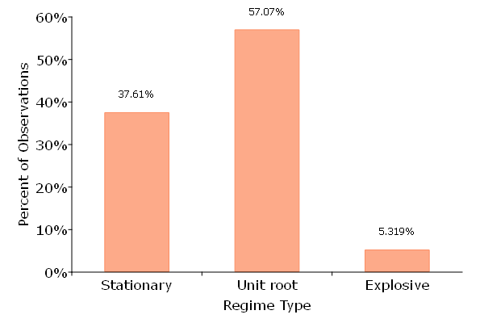
Figure 5. Markov Switching Unit Root Results

Figure 5 presents the regime classifications across the full sample. Using quarterly observations, we summarize the frequency of stationary, unit root, and explosive regimes across countries and over time. This provides a baseline characterization of current account dynamics before turning to cross-country and temporal heterogeneity.
Across all countries and quarters, the unit root regime is the most prevalent state, accounting for approximately 57 percent of observations. The stationary regime comprises roughly 38 percent of the sample, while explosive episodes represent about 5 percent of observations.
These results indicate that current account balances most commonly exhibit highly persistent dynamics consistent with near-unit-root behavior. Nonetheless, a substantial fraction of observations fall into the stationary regime, indicating economically meaningful mean reversion in a nontrivial portion of the sample. Explosive dynamics are comparatively rare but clearly present, justifying the use of a nonlinear framework rather than imposing global stationarity.
The relatively low frequency of explosive states suggests that such episodes are episodic rather than representative of typical behavior, potentially corresponding to periods of macroeconomic stress or adjustment.
4.2 Cross-Country Heterogeneity
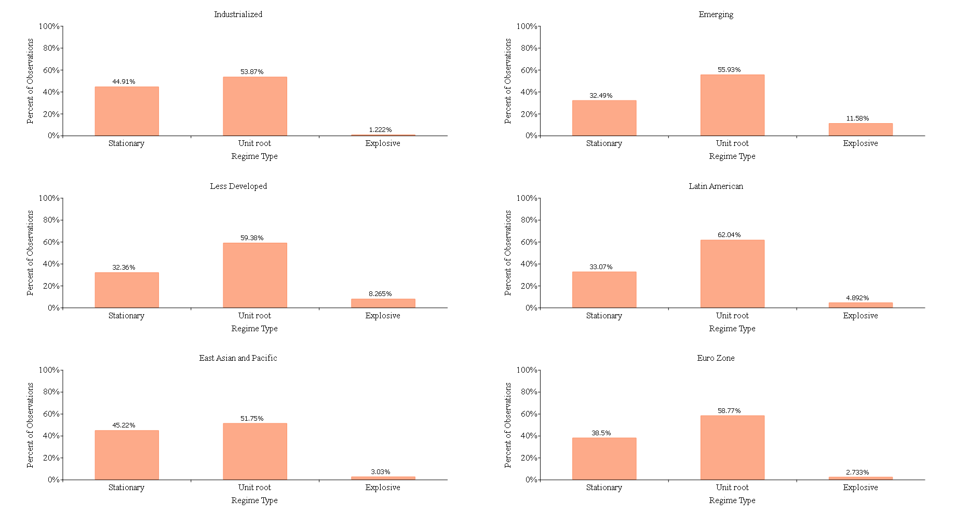
Figure 6. Country Group Markov Switching Unit Root Results
We next examine how regime frequencies vary across countries and groups. To highlight systematic differences, we disaggregate the results by income level and region. This comparison reveals how the prevalence of stationary, unit root, and explosive dynamics differs across stages of development and institutional environments.
Industrialized economies exhibit a high prevalence of unit root behavior (53.9 percent) and a substantial stationary component (44.9 percent), with explosive episodes accounting for only 1.2 percent of observations. Explosive dynamics are therefore extremely rare among advanced economies.
Emerging markets display greater instability. While unit root behavior remains dominant (55.9 percent), explosive episodes rise to 11.6 percent of observations. Less developed economies show a similar pattern, with 59.4 percent unit root and 8.3 percent explosive classifications.
Regional heterogeneity is also evident. Latin American economies exhibit the highest share of unit root behavior (62.0 percent) among reported groupings, while East Asian economies display a comparatively larger stationary component (45.2 percent). Euro area countries are characterized by dominant unit root behavior (58.8 percent) and minimal explosive episodes (2.7 percent).
Taken together, these patterns indicate that regime dynamics are not uniform across country types. More developed economies tend to experience fewer explosive episodes, while emerging and developing economies exhibit greater exposure to explosive dynamics.
4.3 Time Evolution of Regimes
We then analyze the evolution of regime shares over time. This perspective allows us to assess whether changes in current account dynamics are concentrated in specific periods or broadly distributed across the sample. Examining the timing of regime shifts provides additional insight into the episodic nature of explosive and highly persistent dynamics. The unit root regime remains the modal state throughout the sample period. The stationary share fluctuates cyclically but persists at economically meaningful levels. Explosive regimes appear intermittently and cluster in specific subperiods rather than being evenly distributed across time.
This temporal concentration supports the interpretation that explosive states correspond to discrete adjustment episodes rather than persistent structural features of external balances.
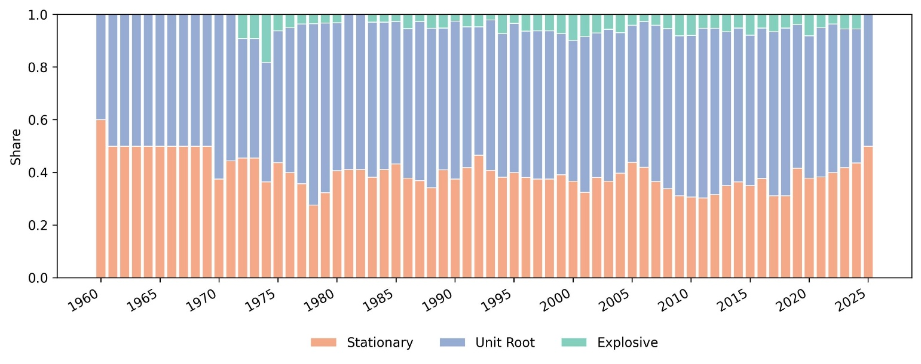
Figure 7. Persistence Regimes Over Time
4.4 Global Stationarity

The regime-level classification in Sections 4.1–4.3 characterizes the local dynamic state of each country at a given point in time. A complementary question concerns the global properties of the estimated Markov-switching process: even for a country that passes through unit root or explosive regimes, does the overall switching process satisfy the second-order stationarity conditions of Psaradakis, Sola, and Spagnolo (2004)? A globally stationary process is one in which regime transitions are sufficiently frequent and the explosive component sufficiently transient that the long-run distribution of the process remains bounded. In such circumstances, mean reversion is restored over time even when it is temporarily suspended.

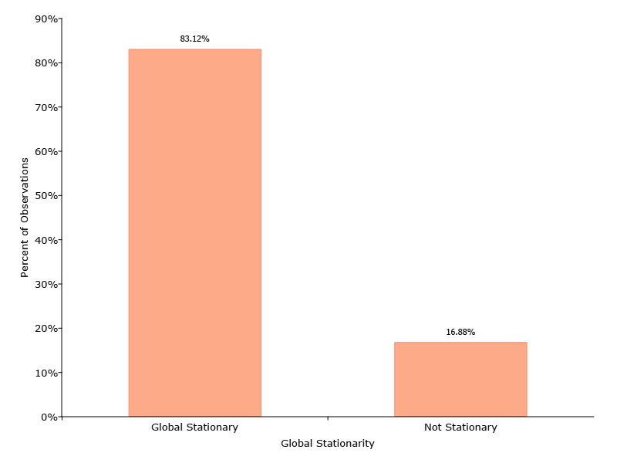
Figure 8 Global Stationarity Results

Figure 8 reports the share of country observations classified as globally stationary versus not stationary under this criterion. Across the full sample, 83.1 percent of observations belong to countries whose estimated Markov-switching process satisfies the global stationarity condition; the remaining 16.9 percent do not. This finding is broadly reassuring. For most countries, the presence of unit root or explosive episodes does not imply permanent divergence. Instead, these episodes are sufficiently episodic, and the transition probabilities sufficiently favorable, such that the overall process remains anchored.

The 16.9 percent of observations classified as globally non-stationary are concentrated among countries with persistent explosive dynamics and low regime-switching frequency. These cases are of particular interest for the second-stage analysis: they represent countries for which the usual mean-reversion mechanism appears to be weakest, and where structural factors that govern the transition out of explosive regimes are likely most consequential.

4.5 Implications for Second-Stage Analysis

The Markov switching results demonstrate that current account dynamics exhibit substantial regime heterogeneity across countries and over time. Although unit root behavior is the modal state, stationary and explosive regimes occur with non-trivial frequency. These regimes are not evenly distributed across country groups or periods.

The presence of meaningful variation in regime prevalence raises a natural question. Which structural and macroeconomic characteristics are associated with a country being in one persistence regime rather than another? Addressing this question requires moving beyond time-series characterization toward an explicit analysis of regime determinants.

To this end, we aggregate quarterly regime classifications to the annual level. We then estimate a multinomial logit model in which the dependent variable is the prevailing current account regime for each country year- observation. This approach allows us to examine how fiscal, trade, financial, and institutional factors are related to the likelihood of stationary, unit root, or explosive dynamics.
The second stage analysis shifts the focus from describing persistence regimes to explaining them. While the -Markov switching model identifies- when and where different regimes occur, the multinomial framework assesses which structural features systematically predict regime membership. The next section describes empirical specifications and variable construction in detail.

5. Determinants of Current Account Persistence
5.1 Methodology
5.1.1 Empirical Framework
To identify the structural determinants of current account persistence regimes, we estimate a multinomial logit (MNL) model in which the dependent variable is the regime classification assigned to each country-year observation. Let yᵢₜ ∈ {Explosive, Stationary, Unit root} denote the regime state identified by the Markov switching procedure described in Section 3. We model the probability of observing each regime outcome as a function of a vector of country-level structural characteristics xᵢₜ, normalizing by setting the explosive regime as the baseline category.
The model is normalized by setting the explosive regime as the reference category. This normalization reflects our substantive interest in identifying the factors that distinguish destabilizing external dynamics from the stable regime space. Standard errors are clustered at the country level throughout to account for serial correlation within country time series.
The multinomial framework allows us to exploit both cross-sectional and time variations in regime outcomes. It also accommodates the unordered nature of the three regimes without imposing cardinal structure. The model therefore provides a flexible platform for assessing how structural characteristics are associated with different patterns of current account persistence.
5.1.2 Covariates and Construction
The specification is guided by the theoretical literature on current account adjustment and exchange rate regime effects. We include six structural regressors.
The exchange rate regime is captured by a binary indicator equal to one if the country maintained a fixed or pegged exchange rate arrangement in year t. The classification is drawn from Ilzetzki, Reinhart, and Rogoff (2019). Under fixed exchange rates, external adjustment must operate through domestic prices rather than nominal depreciation, which may alter persistence dynamics.
We include a current account deficit indicator equal to one if the country ran a current account deficit in year $t$. This variable captures whether the initial balance position matters for regime classification, conditional on the other structural covariates.
Commodity exporters are identified using a binary indicator equal to one if the country is classified as a primary commodity exporter. Such economies are exposed to terms of trade volatility that may generate persistent or explosive current account movements.
Manufacturing exporters are identified by an indicator equal to one if manufactured goods represent the primary export category. Manufacturing exporters often face more elastic global demand and stronger competitive pressures. These features may generate sharper swings in export revenues and increase the likelihood of entering an explosive adjustment path.
Trade openness is measured as the ratio of total trade to GDP and is lagged one period. Lagging reduces simultaneity concerns, since regime classification at time $t$is contemporaneous with the openness measure. The lag ensures that openness reflects the pre-existing structural position rather than an outcome influenced by the regime.
The fiscal balance (3-year moving average, lagged) measures general government fiscal balance as a share of GDP, accumulated over t−2 through t and then lagged one period to the (t−3, t−1) window. Three-year accumulation reduces budget cycle noise and captures the medium-term fiscal position. Lagging mitigates reverse causality from the external regime to fiscal outcomes via automatic stabilizers.
All continuous variables are standardized at the sample level. The complete sample covers 74 countries observed annually spanning 1971–2023, yielding 2,451 usable observations after listwise deletion on all covariates. Three countries included in the unit root analysis (Section 4) are excluded from the MNL estimation because they have no usable observations after listwise deletion on covariates, reducing the sample from 77 to 74 countries. Country coverage is strongly unbalanced in the early part of the sample: fewer than 30 countries contribute observations before 1985, rising to 39 countries by 1995 and 70 or more from 2008 onward. The analysis retains these early observations rather than imposing a common start date, as the unbalanced structure reflects genuine data availability rather than sample selection.
5.1.3 Model Selection
Model specification follows a composite criterion balancing parsimony, predictive performance, and sample coverage The first is the Bayesian Information Criterion per observation, which penalizes overparameterization relative to sample size. The second is out of sample log loss computed using a country grouped five-fold cross validation procedure. The third is sample retention, since additional covariates reduce the usable sample. The preferred specification performs consistently well in all three dimensions.
Notable, including a full set of year fixed effects substantially worsens model fit and leads to convergence problems in some cases. The increased parameter dimensionality is not offset by meaningful gains in predictive performance.
To assess whether common global shocks drive regime classification, we also consider targeted crisis indicators for the Global Financial Crisis and the COVID 19 shock. These indicators do not improve model fit and are not statistically significant. This result suggests that regime dynamics are primarily driven by persistent cross-sectional structural differences rather than common time effects. We therefore exclude year fixed effects from the baseline specification.
Two limitations of the two-step framework merit acknowledgment. First, the regime classifications used as the dependent variable in the MNL are estimated from the Markov switching model in Step 1, not directly observed. Classification uncertainty from Step 1 is not propagated to the Step 2 standard errors. Ignoring first-stage uncertainty generally understates second-stage standard errors (Murphy and Topel 1985). While the Markov switching model provides relatively precise regime classifications for most observations, coefficients significant only near conventional thresholds should be interpreted with this caveat in mind.
Second, the multinomial logit rests on the independence of irrelevant alternatives (IIA) assumption. This assumption states that the relative probability of any two regime outcomes is independent of the third outcome. Given the natural persistence ordering of regimes (stationary < unit root < explosive), IIA may not hold exactly. We provide a formal check using the Hausman-McFadden (1984) test, which compares full-model coefficients against estimates from a restricted model that drops one outcome at a time. For both tests (dropping Stationary; dropping Unit root), we find that the restricted model is more efficient than the full model on the subsample. This outcome is theoretically consistent with IIA holding and rules out an IIA violation. The binary logit robustness in Section 5.4, which restricts attention to non-explosive observations and eliminates the cross-category IIA concern, provides an additional specification check. A nested logit with {{stationary, unit root}} as one nest and {{explosive}} as the other would relax IIA at the cost of additional parametric structure and is left for future work.
A third limitation concerns inference in the presence of rare events. The explosive regime comprises only 5.5 percent of the sample, covering 134 country-years concentrated in a small number of economies (principally Israel, Hungary, Malaysia, Germany, and Armenia). All MNL coefficient estimates for the explosive equation rely on this geographically concentrated reference group, raising concerns about small-sample bias in the explosive-equation parameters and sensitivity to influential observations. A fully rigorous treatment would include leave-one-country-out and leave-one-region-out sensitivity analysis and a Firth penalized logistic regression for the binary explosive-versus-non-explosive contrast. These extensions are left for future work. The lagged exchange rate robustness (Section 5.3.3) and the binary logit exercise (Section 5.4) provide partial assurance that the headline finding is not driven by a single influential country, but they do not constitute a full rare-events robustness analysis.
5.2 Baseline Results
5.2.1 Coefficient Estimates
Table 4 reports multinomial logit coefficient estimates for the preferred specification, with the explosive regime as the reference category and country clustered standard errors throughout.
Two variables emerge as the strongest and most robust predictors of regime membership. The first is the fixed exchange rate indicator. Countries operating under fixed exchange rate arrangements are significantly more likely to exhibit stationary or unit root current account behavior than explosive divergence. The estimated coefficients are large and statistically significant in both equations.
This result is consistent with the disciplining role of exchange rate pegs. Under a fixed exchange rate commitment, defending the peg requires policy adjustment when capital outflows threaten the reserve position. Such adjustment typically involves tightening fiscal or monetary policy, which compresses domestic demand and limits the scope for explosive current account deterioration. The mechanism is asymmetric. A peg constrains deficit dynamics but does not prevent surplus accumulation. This asymmetry may explain why pegged economies tend to avoid explosive deficit episodes.
The second key predictor is the manufacturing exporter indicator. Countries classified as manufacturing exporters are significantly less likely to be in the stationary or unit root regimes relative to the explosive category. This pattern suggests that specialization in manufactured exports is associated with current account dynamics that are more prone to explosive behavior. One possible interpretation is that manufacturing exporters face more elastic global demand and stronger competitive pressures, which can amplify external adjustment dynamics.
Trade openness enters negatively and significantly in both equations. More open economies are less likely to be in the stationary or unit root regimes relative to the explosive category. The lagged fiscal balance enters positively in the unit root equation and is marginally significant. This result suggests that stronger medium term fiscal positions are associated with persistent but bounded current account dynamics rather than explosive divergence. The current account deficit indicator is positive and marginally significant in the stationary equation only, which is consistent with faster rebalancing pressure in deficit countries.
5.2.2 Average Marginal Effects
Table 5 reports average marginal effects (AMEs), computed as the sample mean of individual-specific marginal effects. These estimates quantify the change in regime probabilities associated with changes in each covariate, holding all other variables at their observed values.
The marginal effects reveal a clear asymmetry in the model’s explanatory power. Fixed exchange rate arrangements are associated with a reduction in the probability of the explosive regime of approximately 9.1 percentage points. This effect is economically large, given that the unconditional probability of the explosive regime is only 5.5 percent. Trade openness has the opposite effect. A one-standard-deviation increase in openness raises the probability of explosive dynamics by roughly 4.7 percentage points.
No other covariate generates a statistically significant marginal effect on any regime probability. None of the variables significantly affect the probability of being in the stationary or unit root regimes when these outcomes are considered separately. This pattern indicates that the model primarily explains differences between explosive and non-explosive dynamics, rather than variation within the stable regime space.
Table C1 in the Appendix reports a confusion matrix for the baseline model. Overall, in-sample classification accuracy is 59.8 percent, compared to a base-rate accuracy of 56.1 percent. The model correctly classifies unit root observations with high recall but has very limited ability to identify explosive episodes: explosive recall is approximately 3 percent, meaning the model correctly identifies only about 4 of the 134 explosive country-years in-sample. This reflects the rarity of the explosive regime in the sample. The multinomial logit therefore captures probability gradients rather than functioning as a high-accuracy classifier. Country-grouped, five-fold cross-validation yields a mean log-loss of 0.945, indicating modest but meaningful out-of-sample predictive content. It is important to distinguish coefficient significance from predictive performance: the statistical significance of the exchange rate regime coefficient reflects a systematic shift in the probability distribution of regime outcomes, not a reliable ability to flag individual explosive episodes. A variable can strongly shift the probability of a rare event without enabling accurate event-by-event prediction, and the confusion matrix confirms that this is the case here.
  - Robustness Checks
5.3.1 Year Fixed Effects and Crisis Dummies
Table 6 summarizes fit statistics across the full set of candidate specifications. Year fixed effects are not supported by the data: models with full annual time dummies consistently produce higher BIC per an observation, and the contemporaneous openness specification with year FE fails to converge entirely. The year-FE penalty arises because the parameter count expands substantially with no commensurate improvement in fit, consistent with regime dynamics being driven primarily by cross-sectional structural differences rather than common time trends.
As a direct test of this conclusion, we include indicator variables for the Global Financial Crisis (2008–2009) and the COVID-19 shock (2020–2021) — the two largest identifiable global disturbances in the sample period. The targeted crisis dummies add only two parameters and produce BIC per an observation equal to 1.673, marginally worse than the baseline (1.661), with no meaningful change in the structural coefficient estimates. Neither crisis dummy is significant at conventional levels. This confirms that the structural variables absorb the relevant cross-country variation in regime behavior and that no residual global shock effect remains once these covariates are controlled.
The financial development gap specification yields a modest improvement in McFadden R² (0.067 versus 0.050) but reduces the estimation sample by approximately 16 percent due to missing financial development data (n = 2,064 versus n = 2,451 for the baseline). Given the cost in sample coverage relative to the marginal gain in fit, this variable is excluded from the preferred specification. A comparability caveat applies to BIC per an observation value across specifications with different estimation samples: because BIC per an observation is computed on distinct observation sets, the values are not strictly comparable. Readers should interpret the cross-specification BIC comparison as indicative rather than definitive for models estimated on different samples.
5.3.2 Oil Exporter Robustness
Replacing the commodity exporter dummy with a more narrowly defined oil exporter indicator cannot be implemented as a full MNL robustness check. The oil exporter dummy covers only 40 country-year observations and exhibits complete separation in the unit root equation: none of the 40 oil-exporter observations are classified as unit root. With P(Unit Root | oil = 1) = 0 in the data, the unit root equation parameters are unidentified and the MNL estimator cannot produce finite estimates. This is a data constraint, not a convergence failure.
The regime distribution among oil exporters is itself informative: 13 observations (32.5%) fall in the explosive regime and 27 (67.5%) in the stationary regime, with zero in the unit root regime. This pattern suggests that oil exporters face a sharper binary dynamic — either explosive external imbalance or rapid mean reversion — with no tendency toward persistent but bounded current account dynamics. We retain the broader commodity exporter classification in the baseline and note this finding as a descriptive result warranting future research with a larger sample of oil-exporting countries.
5.3.3 Lagged Exchange Rate Regime
As an additional robustness check addressing potential endogeneity of the contemporaneous exchange rate regime indicator, we re-estimate the baseline specification replacing the fixed exchange rate variable with its one-period within-country lag. Under fixed rates, countries that experience explosive current account dynamics may abandon their pegs in the same period, creating reverse causality that would inflate the contemporaneous coefficient. Lagging the exchange rate variable by one year breaks this within-period simultaneity.
The lagged specification produces nearly identical results. The fixed exchange rate coefficients are marginally larger in both equations (beta = 1.97 and 2.04 versus 1.87 and 1.98 in the baseline), and BIC per an observation marginally improves (1.659 versus 1.661). The average marginal effect on the explosive regime is -0.094 (p = 0.029), compared to -0.091 (p = 0.044) in the baseline — directionally identical and statistically equivalent. Cross-validated log-loss is virtually unchanged (0.945 versus 0.945). This confirms that the fixed exchange rate finding is not an artifact of contemporaneous reverse causality.
5.4 Binary Logit Robustness
The explosive regime comprises only 134 observations (5.5% of the sample). All MNL coefficient estimates therefore reflect contrasts relative to this small reference group, raising the question of whether the baseline results are driven by the explosive-versus-all-others split or reflect genuine differentiation among all three regimes. We address this by estimating a binary logit model on the 2,317 non-explosive observations only. The explosive regime is geographically concentrated: Israel (48 country-year observations), Hungary (20), Malaysia (18), Germany (15), and Armenia (13) together account for the majority of explosive episodes, spanning both chronic-deficit trajectories (Hungary, Armenia) and persistent-surplus ones (Malaysia, Germany).
We drop the 134 explosive observations and estimate a binary logit with unit root as the positive outcome (y = 1) and stationary as the negative outcome (y = 0), using the same six structural regressors and country-clustered standard errors as the baseline MNL.
None of the six regressors attain statistical significance in the binary logit (all p > 0.25). This finding has a precise interpretation: the structural variables in the baseline MNL primarily explain which countries avoid explosive current account dynamics, not what drives stationary versus unit root behavior within the non-explosive group. Exchange rate arrangements, trade openness, and manufacturing export structure effectively predict whether a country's current account is prone to explosive divergence; they do not differentiate between mean-reverting and persistently stable dynamics among countries already in the non-explosive group.
This result does not undermine the MNL findings but rather it refines their interpretation. The baseline MNL should be read primarily as a classifier of explosive versus non-explosive regime propensity. The stationary-unit root contrast is a secondary outcome, and the absence of significant binary-logit predictors points to a research agenda on within-stable-regime persistence that likely requires covariates capturing financial market depth, creditor composition, or country-specific institutional features not available at this scale.
5.5 Subgroup Heterogeneity
5.5.1 Income Groups
We re-estimate the baseline specification separately for three income subgroups: advanced economies (23 countries, 1,041 observations), emerging markets (28 countries, 903 observations), and low-income developing countries (23 countries, 507 observations). Table 8 presents the fit comparison across these sub-groups, as well as the coefficients estimates for the emerging market economies.
The income-group results reveal pronounced heterogeneity. Model fit is dramatically higher for emerging market economies (McFadden R² = 0.186) than for the full sample (0.050), a nearly four-fold improvement. This indicates that structural policy variables are far more powerful predictors of current account regime dynamics in emerging markets than in advanced or low-income economies.
The finding is consistent with the broader institutional literature: advanced economies possess more entrenched adjustment mechanisms, including flexible exchange rates, deep capital markets, and credible policy framework. These insulate their current account dynamics from the structural policy variables under study. Low-income economies have too few explosive observations to reliably identify the explosive equation and likely exhibit dynamics dominated by aid flows, commodity dependence, and program conditionality outside our covariate set. The emerging-market result has direct policy implications: exchange rate policy and export diversification have measurable effects on the likelihood of explosive external imbalances in precisely the group of countries where such imbalances carry the greatest consequences for financial stability. An additional caveat applies to the advanced-economy subgroup: with only 23 country clusters, cluster-robust standard errors may be less reliable than in the full sample (Cameron and Miller 2015 suggest at least 30 clusters for conventional cluster-robust inference), so these results should be interpreted with additional caution.
5.5.2 Time Periods
Table 9 reports results separately for the pre-GFC (before 2008) and post-GFC (2008 onward) subsamples. Model fit more than doubles in the post-GFC period (McFadden R² from 0.042 to 0.089; BIC/obs improves from 1.692 to 1.645). Structural variables have become increasingly relevant predictors of current account regime classification since the financial crisis, consistent with heightened post-crisis international scrutiny of global imbalances. Three institutional developments are plausibly consistent with this interpretation, though they are not directly measured in the data. First, the G20 Mutual Assessment Process (MAP, launched 2009) elevated exchange rate and current account adjustment to the center of multilateral policy coordination. Second, the IMF Article IV surveillance intensified its focus on external sector assessments and currency misalignment from 2012 onward. This, Basel III capital and liquidity requirements (phased from 2013) increased cross-country differentiation in financial-sector capacity to sustain external imbalances, sharpening the role of exchange rate arrangements and export structure as regime determinants.
Crucially, this improvement in fit is not explained by a common post-crisis time trend and the targeted crisis-dummy robustness check confirms that global shocks add no predictive value once structural covariates are controlled. One interpretation, albeit not directly tested, since these institutional developments are not measured in the data, is that the post-GFC period represents a structural change in how cross-country differences in policy frameworks translate into external regime behavior.
5.6 Summary of Main Findings
The multinomial logit analysis yields three principal findings. First, the primary determinant of explosive current account dynamics is the exchange rate regime. Countries under fixed exchange rate arrangements are significantly and substantially less likely to enter the explosive regime, with average marginal effects indicating an approximately 9 percentage point association with lower probability of explosive behavior. This result holds consistently across specifications, income subgroups, and time periods.
Second, the model's explanatory power operates principally through the explosive-versus-non-explosive channel. Structural variables reliably predict whether a country is prone to explosive current account divergence but do not significantly distinguish between stationary and persistently stable behavior within the stable regime. The binary logit robustness exercise finds no significant predictors of the stationary-unit root distinction.
Third, model performance is substantially higher for emerging market economies and in the post-GFC period, confirming that the structural policy variables under study are most consequential for middle-income countries and that the post-crisis international monetary environment has amplified the role of policy frameworks in determining external adjustment dynamics.
6. Concluding remarks
This paper characterizes the dynamic adjustment behavior of current account balances across a diverse panel of 74 countries using annual data spanning 1971–2023 (with country coverage growing from a small early-adopting group to 70 or more countries from 2008 onward). Our two-stage country-specific Markov switching autoregressive models followed by a multinomial logit analysis of regime determinants yields three contributions to the literature on external adjustment.
First, we document that standard linear unit root tests produce inconsistent evidence of current account stationarity, replicating the contradictions established in prior work. The Markov switching framework resolves this by allowing persistence, mean, and volatility to switch independently across regimes. The resulting three-regime classification, explosive, unit root, and stationary, provides a richer characterization of external adjustment dynamics, capturing both the incidence and duration of episodes of heightened persistence or rapid divergence.
Second, we identify fixed exchange rate arrangements and manufacturing export specialization as the primary structural predictors of regime membership. Fixed pegs are associated with substantially lower probability of explosive current account dynamics, consistent with the theoretical prediction that exchange rate commitments constrain the scope for unchecked external imbalances by limiting expenditure-switching. This result diverges from Chinn and Wei (2013) in an important and interpretable respect: the exchange rate regime effect is concentrated in the tails of the adjustment distribution — the explosive regime — a nonlinearity that is invisible to linear mean-persistence regressions.
Third, the model's predictive power is concentrated among emerging market economies (McFadden R² = 0.19 versus 0.05 for the full sample) and has strengthened in the post-GFC period (R² = 0.09 versus 0.04 pre-crisis). These patterns suggest that structural policy variables are most informative for middle-income countries, where institutional adjustment mechanisms are less entrenched, and that the post-crisis international monetary environment has amplified the role of policy frameworks in shaping external adjustment dynamics.
Our binary logit robustness exercise reveals a further asymmetry: the same structural covariates that predict explosive regime entry do not distinguish between stationary and unit root behavior within the stable regime. This points to a natural agenda for future research. It demonstrates a need for identifying the country-specific institutional and financial factors that govern within-stable-regime persistence, likely requiring data on financial market depth, creditor composition, and central bank credibility that fall outside the cross-country structural variables available at this scale.
From a policy perspective, these results highlight the continued relevance of exchange rate regime choice for external adjustment dynamics, particularly in emerging markets. Countries maintaining fixed arrangements face a lower probability of explosive current account divergence but may also forgo the automatic stabilization that exchange rate flexibility provides. Understanding how this tradeoff evolves across different phases of the global financial cycle — and whether it has sharpened in the post-crisis era of global imbalance surveillance — remains an important open question for international macroeconomic policy.

References

Aizenman, J., Park, D., Qureshi, I. A., Saadaoui, J., & Uddin, G. S. (2024). The performance of emerging markets during the Fed’s easing and tightening cycles: a cross-country resilience analysis. Journal of International Money and Finance, 148, 103169.
Aizenman, J., & Saadaoui, J. (2025). The Cross-Country Resilience of Central, Eastern, and Southeastern European Countries during ECB Monetary Cycles. Open Economies Review, 1-35.
Bohn, H. (1998). The behavior of U.S. public debt and deficits. The Quarterly Journal of Economics, 113(3), 949–963.
Cameron, A. C., & Miller, D. L. (2015). A practitioner’s guide to cluster-robust inference. Journal of Human Resources, 50(2), 317–372. https://doi.org/10.3368/jhr.50.2.317
Chen, S. 2011. Current account deficits and sustainability: Evidence from the OECD countries. Economic Modelling. doi:10.10.1016/j.econmod.2011.01.011.
Chinn, M. D., Eichengreen, B., & Ito, H. (2014). A forensic analysis of global imbalances. Oxford Economic Papers, 66(2), 465–490. http://www.jstor.org/stable/43772874
Chinn, M., and S. J. Wei. 2013. A faith-based initiative meets the evidence: Does a flexible exchange rate regime really facilitate current account adjustment? Review of Economics and Statistics 95(1): 168-184.
Faruqee, H., and J. Lee. 2009. Global dispersion of current accounts: Is the universe expanding? IMF Staff Papers 56: 574–595.
Feldstein, M., and C. Horioka. 1980. Domestic saving and international capital flows. Economic Journal 90(2): 314–329.
Hall, S. G., Psaradakis, Z., & Sola, M. (1999). Detecting periodically collapsing bubbles: a Markov‐switching unit root test. Journal of Applied Econometrics, 14(2), 143-154.
Hakkio, C., and M. Rush. 1991. Is the budget deficit too large? Economic Inquiry 29(3): 429–445.
Harvey, D. I., S. J. Leybourne, R. Sollis, and A. M. R. Taylor. 2016. “Tests for Explosive Financial Bubbles in the Presence of Non-stationary Volatility.” Journal of Empirical Finance 38: 548–74. https://doi.org/10.1080/07474938.2018.1536099.
Hausman, J., & McFadden, D. (1984). Specification Tests for the Multinomial Logit Model. Econometrica, 52(5), 1219–1240. https://doi.org/10.2307/1910997
Ilzetzki, E., Reinhart, C. M., & Rogoff, K. S. (2019). Exchange arrangements entering the twenty-first century: Which anchor will hold? The Quarterly Journal of Economics, 134(2), 599–646.
International Monetary Fund. Research Dept. (2025). External Sector Report 2025. USA: International Monetary Fund. Retrieved Jul 30, 2025. https://doi.org/10.5089/9798229017329.085
Lucas, R. E. (1990). Why Doesn’t Capital Flow from Rich to Poor Countries? The American Economic Review, 80(2), 92–96. http://www.jstor.org/stable/2006549

Monschang, V., and B. Wilfling. 2021. “Sup-ADF-Style Bubble-Detection Methods under Test.” Empirical Economics 61: 145–72. https://doi.org/10.1007/s00181-020-01859-7.

Morita, R., Psaradakis, Z., Sola, M. & Yunis, P. (2024). On testing for bubbles during hyperinflations. Studies in Nonlinear Dynamics & Econometrics, 28(1), 25-37. https://doi.org/10.1515/snde-2022-0014

Murphy, K. M., & Topel, R. H. (1985). Estimation and Inference in Two-Step Econometric Models. Journal of Business & Economic Statistics, 3(4), 370–379. https://doi.org/10.2307/1391724

Poulakis, T., & Kyrkilis, D. (2024). A Non-Linear Approach to Current Account Sustainability—The Cases of Germany, China, and the USA. Journal of Risk and Financial Management, 17(12), 565. https://doi.org/10.3390/jrfm17120565
Psaradakis, Z., M. Sola, and F. Spagnolo. 2004. On Markov error-correction models, with an application to stock prices and dividends. Journal of Applied Econometrics 19: 69–88.

Raybaudi, M., M. Sola, and F. Spagnolo. 2004. Red Signals: current account deficits and sustainability. Economic Letters 84: 217–223.

Shi, S. 2013. Specification sensitivities in the Markov switching unit root test for bubbles. Empirical Economics 45: 697–713. https://doi.org/10.1007/s00181-012-0635-8

Taylor, A. M. 2002. A century of current account dynamics. Journal of International Money and Finance 21: 725–742.
Trehan, B., and C. Walsh. 1991. Testing intertemporal budget constraints: Theory and applications to U.S. federal budget and current account deficits. Journal of Money, Credit and Banking 23(2): 206–223.

Appendix 1. Summary statistics by country for current account (% GDP)
 | Country | Mean | SD | Min | Max | Start | End | N
1 | Albania | -6.541 | 2.823 | -11.295 | 0.461 | 2015-Q1 | 2024-Q3 | 39
2 | Argentina | -0.619 | 3.812 | -13.387 | 13.851 | 1985-Q1 | 2024-Q4 | 160
3 | Armenia | -11.246 | 9.544 | -52.759 | 2.022 | 1994-Q1 | 2020-Q3 | 107
4 | Australia | -2.963 | 2.167 | -7.323 | 3.532 | 1960-Q1 | 2024-Q4 | 260
5 | Austria | 0.143 | 2.381 | -6.288 | 6.914 | 1970-Q1 | 2024-Q4 | 220
6 | Belarus | -5.118 | 5.266 | -24.871 | 9.211 | 1996-Q1 | 2020-Q1 | 97
7 | Belgium | 1.834 | 3.076 | -7.935 | 7.507 | 1995-Q1 | 2024-Q4 | 120
8 | Bolivia | -2.131 | 7.201 | -17.940 | 17.557 | 1985-Q1 | 2019-Q4 | 140
9 | Bosnia And Herzegovina | -4.905 | 2.502 | -11.912 | -0.426 | 2010-Q1 | 2024-Q2 | 58
10 | Brazil | -2.109 | 2.084 | -6.240 | 1.892 | 1978-Q1 | 2024-Q4 | 188
11 | Bulgaria | -3.413 | 7.614 | -25.496 | 20.421 | 1994-Q1 | 2024-Q4 | 124
12 | Cambodia | -8.432 | 8.532 | -58.275 | 5.417 | 1994-Q1 | 2021-Q4 | 112
13 | Canada | -1.714 | 1.929 | -5.196 | 3.715 | 1961-Q1 | 2024-Q4 | 256
14 | Chile | -2.386 | 3.742 | -11.762 | 7.343 | 1991-Q1 | 2024-Q4 | 136
15 | China | 2.700 | 2.584 | -2.372 | 10.880 | 1991-Q1 | 2024-Q4 | 136
16 | Colombia | -3.036 | 2.033 | -6.948 | 1.226 | 1996-Q1 | 2024-Q4 | 116
17 | Costa Rica | -3.759 | 2.020 | -12.192 | 0.760 | 1999-Q1 | 2024-Q4 | 104
18 | Croatia | -4.414 | 4.384 | -20.039 | 4.770 | 1994-Q4 | 2024-Q3 | 120
19 | Cyprus | -5.935 | 3.736 | -15.955 | 1.248 | 2004-Q1 | 2024-Q3 | 83
20 | Czech Republic | -1.859 | 2.886 | -8.130 | 7.833 | 1993-Q1 | 2024-Q4 | 128
21 | Denmark | 2.720 | 4.761 | -6.155 | 16.506 | 1977-Q1 | 2025-Q1 | 193
22 | El Salvador | -3.609 | 2.227 | -8.230 | 1.285 | 1999-Q1 | 2020-Q1 | 85
23 | Estonia | -4.348 | 5.910 | -18.793 | 6.571 | 1993-Q1 | 2024-Q4 | 128
24 | Finland | 0.438 | 3.518 | -7.258 | 9.127 | 1975-Q1 | 2024-Q4 | 200
25 | France | 0.032 | 1.190 | -3.910 | 3.756 | 1975-Q1 | 2024-Q4 | 200
26 | Georgia | -10.901 | 4.915 | -29.074 | -3.763 | 1997-Q1 | 2020-Q1 | 93
27 | Germany | 2.966 | 3.350 | -2.785 | 9.892 | 1971-Q1 | 2024-Q4 | 216
28 | Greece | -5.016 | 3.806 | -16.156 | 2.881 | 1976-Q1 | 2024-Q4 | 196
29 | Guatemala | -3.611 | 2.969 | -13.072 | 5.747 | 1977-Q1 | 2020-Q1 | 173
30 | Hong Kong China | 6.508 | 4.436 | -1.650 | 17.995 | 1999-Q1 | 2020-Q1 | 85
31 | Hungary | -3.210 | 4.855 | -17.736 | 5.338 | 1989-Q4 | 2024-Q4 | 141
32 | Iceland | -3.188 | 6.991 | -30.086 | 10.202 | 1976-Q1 | 2024-Q4 | 196
33 | India | -1.279 | 1.610 | -6.332 | 9.091 | 1960-Q1 | 2024-Q4 | 260
34 | Indonesia | -0.795 | 3.125 | -13.379 | 8.163 | 1981-Q1 | 2024-Q4 | 176
35 | Ireland | 0.548 | 9.809 | -58.296 | 25.322 | 1990-Q1 | 2024-Q4 | 140
36 | Israel | -1.218 | 5.553 | -16.827 | 16.257 | 1972-Q1 | 2024-Q4 | 212
37 | Italy | 0.004 | 2.001 | -5.167 | 5.028 | 1970-Q1 | 2024-Q4 | 220
38 | Japan | 2.531 | 1.376 | -1.827 | 5.295 | 1977-Q1 | 2025-Q1 | 193
39 | Kazakhstan | -1.556 | 4.891 | -11.776 | 11.858 | 1995-Q1 | 2020-Q1 | 101
40 | Korea Rep. | 0.972 | 4.302 | -13.061 | 15.225 | 1976-Q1 | 2024-Q4 | 196
41 | Kyrgyz Republic | -9.721 | 8.924 | -34.828 | 16.061 | 1993-Q1 | 2021-Q4 | 116
42 | Latvia | -3.745 | 8.048 | -26.703 | 24.636 | 1993-Q1 | 2024-Q4 | 128
43 | Lithuania | -3.786 | 5.975 | -18.548 | 7.662 | 1993-Q1 | 2024-Q4 | 128
44 | Luxembourg | 7.669 | 7.299 | -14.452 | 37.352 | 1995-Q1 | 2024-Q4 | 120
45 | Macedonia FYR | -2.105 | 3.009 | -10.903 | 5.104 | 2011-Q1 | 2024-Q3 | 55
46 | Malaysia | 9.135 | 5.521 | 1.653 | 19.652 | 1999-Q1 | 2020-Q1 | 85
47 | Malta | 2.433 | 8.867 | -13.832 | 22.178 | 2004-Q1 | 2024-Q3 | 83
48 | Mauritius | -4.426 | 5.031 | -16.175 | 8.131 | 2000-Q1 | 2020-Q1 | 81
49 | Mexico | -1.587 | 2.225 | -8.641 | 5.913 | 1979-Q1 | 2024-Q4 | 184
50 | Moldova | -9.026 | 5.521 | -23.111 | 2.339 | 1995-Q1 | 2020-Q1 | 101
51 | Montenegro | -17.617 | 5.164 | -44.982 | -11.088 | 2013-Q1 | 2024-Q3 | 47
52 | Netherlands | 4.987 | 3.460 | -8.346 | 14.725 | 1977-Q1 | 2024-Q4 | 192
53 | New Zealand | -4.514 | 2.994 | -16.022 | 0.693 | 1980-Q1 | 2024-Q4 | 180
54 | Norway | 6.027 | 8.393 | -16.706 | 38.383 | 1975-Q1 | 2024-Q4 | 200
55 | Paraguay | 0.303 | 3.358 | -6.507 | 8.949 | 2000-Q1 | 2020-Q4 | 84
56 | Peru | -3.375 | 3.359 | -11.380 | 6.349 | 1979-Q1 | 2020-Q1 | 165
57 | Philippines | -0.973 | 4.037 | -11.834 | 7.061 | 1977-Q2 | 2020-Q1 | 165
58 | Poland | -2.563 | 3.316 | -8.720 | 17.707 | 1985-Q1 | 2024-Q4 | 160
59 | Portugal | -4.017 | 5.318 | -21.410 | 4.682 | 1977-Q1 | 2024-Q4 | 192
60 | Romania | -5.979 | 3.711 | -21.533 | 2.870 | 1991-Q1 | 2024-Q4 | 136
61 | Russian Federation | 5.652 | 4.453 | -2.449 | 19.539 | 1994-Q1 | 2021-Q3 | 111
62 | Saudi Arabia | 10.115 | 11.971 | -13.678 | 36.616 | 2006-Q1 | 2024-Q4 | 76
63 | Slovak Republic | -3.904 | 4.201 | -11.890 | 11.874 | 1993-Q1 | 2024-Q4 | 128
64 | Slovenia | 1.082 | 3.846 | -10.352 | 9.246 | 1995-Q1 | 2024-Q4 | 120
65 | South Africa | -1.026 | 3.235 | -10.599 | 11.214 | 1960-Q1 | 2024-Q4 | 260
66 | Spain | -1.616 | 3.180 | -9.992 | 3.807 | 1975-Q1 | 2024-Q4 | 200
67 | Sri Lanka | -4.768 | 4.561 | -21.080 | 4.906 | 1977-Q1 | 2021-Q1 | 177
68 | Sweden | 2.470 | 3.559 | -5.506 | 9.449 | 1975-Q1 | 2024-Q4 | 200
69 | Switzerland | 5.714 | 3.878 | -12.115 | 14.543 | 1972-Q1 | 2024-Q4 | 212
70 | Taiwan | 7.988 | 4.810 | -5.188 | 22.562 | 1981-Q1 | 2019-Q4 | 156
71 | Thailand | -0.262 | 6.403 | -12.561 | 13.725 | 1976-Q1 | 2019-Q4 | 176
72 | Turkey | -2.352 | 2.898 | -9.338 | 6.448 | 1987-Q1 | 2024-Q4 | 152
73 | United Kingdom | -1.554 | 1.902 | -6.880 | 3.799 | 1960-Q1 | 2024-Q4 | 260
74 | United States | -1.731 | 1.846 | -6.300 | 1.214 | 1960-Q1 | 2024-Q4 | 260
75 | Uruguay | -1.272 | 2.100 | -8.082 | 3.797 | 1999-Q1 | 2020-Q1 | 85
76 | Venezuela Rb | 4.906 | 6.186 | -6.652 | 24.883 | 1994-Q1 | 2014-Q4 | 84
77 | Vietnam | -1.302 | 6.510 | -38.299 | 8.760 | 1996-Q1 | 2021-Q4 | 104
Source: authors’ calculations.

Appendix 2. Unit root tests for individual countries
Country | ADF | DFGLS | ZT PP | Za PP | LM | KPSS | N
Albania | -0.3384 | -0.6183 | -2.86* | -15.96** | -1.581 | 1.5*** | 39
Argentina | -5.224*** | -4.954*** | -5.224*** | -47.03*** | -5.172*** | 0.6126** | 160
Armenia | -1.654 | -0.102 | -5.204*** | -37.13*** | -1.254 | 3.772*** | 107
Australia | -2.843* | -2.053** | -3.765*** | -27.01*** | -2.464 | 3.271*** | 260
Austria | -1.757 | -1.786* | -4.215*** | -33.22*** | -1.868 | 9.343*** | 220
Belarus | -4.775*** | -4.791*** | -4.775*** | -37.61*** | -4.721*** | 0.5718** | 97
Belgium | -1.823 | -0.5058 | -6.657*** | -65.18*** | -3.184** | 4.57*** | 120
Bolivia | -2.147 | -2.035** | -2.794* | -14.97** | -2.177 | 5.227*** | 140
Bosnia Herzegovina | -1.39 | -1.565 | -2.875* | -15.05** | -2.009 | 3.242*** | 58
Brazil | -2.964** | -2.816*** | -3.182** | -19.71** | -3.017** | 0.8329*** | 188
Bulgaria | -2.159 | -1.014 | -3.999*** | -24.77*** | -2.208 | 1.75*** | 124
Cambodia | 2.468 | 2.725 | -1.636 | -14.39** | -1.948 | 2.816*** | 112
Canada | -2.754* | -2.342** | -3.443*** | -22.8*** | -2.813* | 2.617*** | 256
Chile | -1.988 | -1.949* | -4.075*** | -29.94*** | -2.03 | 1.359*** | 136
China | -2.022 | -1.907* | -3.15** | -18.6** | -2.036 | 1.373*** | 136
Colombia | -2.875* | -2.416** | -2.875* | -15.43** | -2.353 | 2.473*** | 116
Costa_Rica | -5.018*** | -4.894*** | -5.018*** | -41.38*** | -5.894*** | 2.636*** | 104
Croatia | -1.731 | -1.546 | -4.604*** | -36.42*** | -1.942 | 5.021*** | 120
Cyprus | -2.317 | -2.048** | -2.429 | -11.21* | -2.255 | 0.7216** | 83
Czech Republic | -3.523*** | -1.273 | -5.599*** | -51.31*** | -2.615 | 3.235*** | 128
Denmark | 0.1432 | 1.403 | -2 | -8.903 | -4.216*** | 16.17*** | 193
El_Salvador | -2.405 | -2.077* | -3.281** | -20.72*** | -2.665 | 0.6591** | 85
Estonia | -2.571* | -1.401 | -3.612*** | -22.46*** | -1.953 | 3.731*** | 128
Finland | -2.651* | -0.9337 | -3.635*** | -22.45*** | -2 | 2.963*** | 200
France | -2.012 | -1.744* | -4.806*** | -41.7*** | -2.018 | 1.809*** | 200
Georgia | -2.794* | -2.228** | -2.516 | -11.88* | -2.388 | 0.8678*** | 93
Germany | -1.919 | -1.445 | -1.919 | -7.04 | -2.323 | 11.88*** | 216
Greece | -1.919 | -1.795* | -4.221*** | -33.01*** | -1.989 | 2.741*** | 196
Guatemala | -1.447 | -0.9584 | -6.212*** | -60.91*** | -0.8012 | 2.374*** | 173
Hong Kong | -0.9703 | -0.9417 | -3.439** | -22.08*** | -1.486 | 2.36*** | 85
Hungary | -2.335 | -1.711 | -3.208** | -19.37** | -2.374 | 3.51*** | 141
Iceland | -2.589* | -2.049** | -5.287*** | -48.98*** | -2.605 | 1.346*** | 196
India | -4.866*** | -4.335*** | -8.856*** | -121*** | -4.669*** | 0.3936* | 260
Indonesia | -2.677* | -1.838* | -4.071*** | -30.06*** | -2.473 | 2.717*** | 176
Ireland | -4.491*** | -3.943*** | -8.283*** | -94.44*** | -4.158*** | 0.4282* | 140
Israel | -2.876** | -2.835*** | -5.709*** | -57.1*** | -3.551*** | 10.66*** | 212
Italy | -3.127** | -2.845*** | -3.616*** | -25.2*** | -3.389** | 1.69*** | 220
Japan | -2.806* | -1.72* | -2.806* | -16.2** | -3.7*** | 4.137*** | 193
Kazakhstan | -2.934** | -1.348 | -5.197*** | -42.62*** | -1.918 | 0.3832* | 101
Korea Rep. | -2.212 | -0.9189 | 3.505*** | 22.34*** | -3.34** | 7.382*** | 96
Kyrgyz Republic | -5.938*** | -5.483*** | -5.938*** | -57.53*** | -1.627 | 0.221 | 116
Latvia | -3.382** | -0.8074 | -3.829*** | -16.63** | -1.488 | 1.186*** | 128
Lithuania | -1.809 | -1.33 | -3.467*** | -21.11*** | -1.491 | 5.41*** | 128
Luxembourg | -2.13 | -0.7588 | -10.05*** | -109.7*** | -1.348 | 0.3593* | 120
Macedonia FYR | -3.998*** | -1.107 | -6.049*** | -42.88*** | -2.616 | 0.1025 | 55
Malaysia | -1.058 | -0.7198 | -1.46 | -4.213 | -2.558 | 4.603*** | 85
Malta | -1.931 | -1.815 | -2.795* | -14.55** | -2.143 | 4.559*** | 83
Mauritius | -1.596 | -1.295 | -2.961** | -16.1** | -1.666 | 2.407*** | 81
Mexico | -3.649*** | -3.35*** | -4.043*** | -30.91*** | -3.432** | 0.9175*** | 184
Moldova | -2.847** | -2.54** | -3.274** | -19.72** | -2.811* | 0.7676*** | 101
Montenegro | -4.529*** | -4.511*** | -4.529*** | -29.27*** | -4.258*** | 0.2804 | 47
Netherlands | -2.223 | -0.9674 | -7.146*** | -83.39*** | -3.369** | 8.626*** | 192
New Zealand | -4.42*** | -3.524*** | -4.42*** | -35.22*** | -4.367*** | 0.9916*** | 180
Norway | -2.811* | -1.024 | -2.811* | -14.54** | -3.846*** | 10.29*** | 200
Paraguay | -3.47*** | -2.7*** | -6.039*** | -52.21*** | -2.332 | 0.2988 | 84
Peru | -3.426** | -2.1** | -2.904** | -16.29** | -3.05** | 3.072*** | 165
Philippines | -1.985 | -1.954* | -4.633*** | -38.39*** | -2.159 | 5.834*** | 165
Poland | -3.807*** | -2.257** | -5.732*** | -54.42*** | -3.554** | 1.23*** | 160
Portugal | -2.862** | -2.605** | -2.755* | -15.17** | -2.979* | 1.911*** | 192
Romania | -2.323 | -2.314** | -5.499*** | -51.22*** | -3.015** | 0.7984*** | 136
Russian Federation | -2.569 | -2.185** | -2.569 | -12.63* | -2.129 | 1.645*** | 111
Saudi Arabia | -2.597* | -1.184 | -2.597* | -10.87 | -3.027* | 3.177*** | 76
Slovak Republic | -2.553* | -1.426 | -4.339*** | -32.76*** | -1.947 | 1.345*** | 128
Slovenia | -1.705 | -1.678 | -3.255** | -19.94** | -1.813 | 5.816*** | 120
South Africa | -4.805*** | -3.935*** | -4.978*** | -45.35*** | -4.844*** | 1.44*** | 260
Spain | -1.976 | -1.443 | -1.673 | -6.134 | -2.043 | 2.944*** | 200
Sri Lanka | -5.02*** | -2.342** | -6.873*** | -74.19*** | -4.116*** | 1.805*** | 177
Sweden | -1.151 | -0.5589 | -2.317 | -11.17* | -2.155 | 13.55*** | 200
Switzerland | -4.003*** | -1.583 | -7.724*** | -93.14*** | -4.374*** | 4.598*** | 212
Taiwan | -2.306 | -0.7968 | -3.647*** | -20.24** | -1.776 | 2.004*** | 156
Thailand | -2.453 | -2.224** | -3.06** | -18.6** | -3.497** | 8.055*** | 176
Turkey | -2.272 | -2.172** | -4.392*** | -34.67*** | -2.129 | 2.682*** | 152
United Kingdom | -2.717* | -2.115** | -5.78*** | -59.6*** | -3.632*** | 10.82*** | 260
United States | -1.797 | -0.4857 | -1.344 | -3.841 | -2.834* | 16.7*** | 260
Uruguay | -3.481*** | -3.423*** | -3.887*** | -26.21*** | -3.461** | 0.6034** | 85
Venezuela RB | -2.09 | -1.598 | -5.032*** | -39.79*** | -2.142 | 0.5123** | 84
Vietnam | -2.817* | -0.7119 | -4.707*** | -35.65*** | -1.948 | 1.045*** | 104

★ Corresponding author: Hiro Ito, Department of Economics, Portland State University, 506 SW Mill Street, Urban Center Building, #450, Portland, OR, 97201, USA. Email: ito@pdx.edu. Email addresses: eric@aptech.com (Eric Clower), ito@pdx.edu (Hiro Ito), jamelsaadaoui@gmail.com (Jamel Saadaoui).

