**Markov-Switching Results**

**Regime Assignments**

Our Markov-Switching testing model allows us to assign three different labels to persistence regimes: stationary, unit root, and explosive. Furthermore, because there are no restrictions a country can have any combination of these across their two regimes. For example, a country may reject the unit root in favor of stationary across both regimes or we may not be able to reject the unit root in one regime and may reject it in favor of explosiveness in another.

In our panel of 71 countries, we observe 5 different types of behavior listed in Table ____.

|  |  |  |  |
| --- | --- | --- | --- |
| **Outcome** | **Number of Countries** | **Countries** | **Example** |
| **Case One:**  Cannot reject the unit root null hypothesis in either regime. | 20 | Austria  Bolivia  Canada  Czech Republic  Denmark  France  Germany  Hungary  Indonesia  Japan  Peru  Philippines  Russia  South Africa  Spain  Sweden  Thailand  United Kingdom  Uruguay  Vietnam |  |
| **Case Two:** Both regimes reject the unit root hypothesis in favor of stationarity. | 15 | Argentina  Australia  Belgium  Colombia  Costa Rica  El Salvador  Georgia  Guatemala  Kazakhstan  Kyrgyz Republic  Luxembourg  New Zealand  Sri Lanka  Switzerland  Turkey |  |
| **Case Three:**  One regime rejects the unit root hypothesis in favor of explosiveness.  On regime rejects the unit root hypothesis in favor of stationarity. | 6 | Bulgaria  Mauritius  Portugal  Chile  Croatia  Estonia |  |
| **Case Four:**  One regime rejects the unit root hypothesis in favor of explosiveness.  One regime cannot reject the unit root hypothesis. | 3 | Cambodia  Slovenia  Malaysia |  |
| **Case Five:**  One regime rejects the unit root hypothesis in favor of stationarity.  One regime cannot reject the unit root hypothesis. | 26 | Belarus  Brazil  China  Finland  India  Ireland  Mexico  Netherlands  Paraguay  Poland  Venezuela  Armenia  Greece  Hong Kong  Iceland  Israel  Italy  Latvia  Lithuania  Moldova  Norway  Romania  Slovak Republic  South Korea  Taiwan  United States |  |

**Euro Countries**

|  |  |  |  |
| --- | --- | --- | --- |
|  |  |  | **Cyprus** |
|  |  |  |  |
|  |  |  |  |
|  |  |  |  |
|  |  |  |  |

**ASIAN CRISIS COUNTRIES**

|  |  |  |  |
| --- | --- | --- | --- |
|  |  |  |  |
|  |  |  |  |



**Case One Examples: Japan and Indonesia**

**Japan –Globally stationary**

|  |  |
| --- | --- |
| **Coefficient** | **Estimate** |
| **α0** | 0.267 |
| **α1** | 0.267 |
| **σ0** | 0.309 |
| **σ1** | 0.817 |
| **ϕ0** | -0.0267 |
| **ϕ 1** | -0.114 |

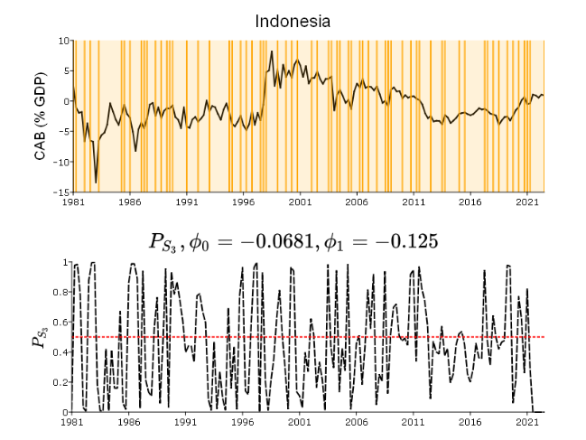 **Indonesia –Not globally stationary**

|  |  |
| --- | --- |
| **Coefficient** | **Estimate** |
| **α0** | 0.38005532 |
| **α1** | -1.0190985 |
| **σ0** | 0.44786302 |
| **σ1** | 3.03661863 |
| **ϕ0** | -0.0681228 |
| **ϕ 1** | -0.1246302 |

**Case Two Examples: Belgium and Argentina**

**Belgium –Not globally stationary**

|  |  |
| --- | --- |
| **Coefficient** | **Estimate** |
| **α0** | 0.554894892 |
| **α1** | 0.550594289 |
| **σ0** | 1.077678736 |
| **σ1** | 3.818275642 |
| **ϕ0** | -0.756886214 |
| **ϕ 1** | -0.166532778 |

**Argentina –Globally stationary**

|  |  |
| --- | --- |
| **Coefficient** | **Estimate** |
| **α0** | 0.26596759 |
| **α1** | -0.7802886 |
| **σ0** | 0.83620508 |
| **σ1** | 6.90297772 |
| **ϕ0** | -0.5100561 |
| **ϕ 1** | -0.1715431 |

**Case Three Examples: Estonia and Chile**

**Estonia –Not globally stationary**

|  |  |
| --- | --- |
| **Coefficient** | **Estimate** |
| **α0** | -0.2134975 |
| **α1** | -0.2134214 |
| **σ0** | 1.6968248 |
| **σ1** | 4.93365131 |
| **ϕ0** | -0.2229213 |
| **ϕ 1** | 0.1390557 |

**Chile –Not globally stationary**

|  |  |
| --- | --- |
| **Coefficient** | **Estimate** |
| **α0** | -0.3883023 |
| **α1** | -0.388271 |
| **σ0** | 0.39797889 |
| **σ1** | 2.50940249 |
| **ϕ0** | -0.2550154 |
| **ϕ 1** | 0.14025882 |

**Case Four Examples: Malaysia and Cambodia**

**Malaysia 🡪 Globally stationary**

|  |  |
| --- | --- |
| **Coefficient** | **Estimate** |
| **α0** | 0.46580022 |
| **α1** | 0.46580151 |
| **σ0** | 1.03613149 |
| **σ1** | 7.62208753 |
| **ϕ0** | -0.1587182 |
| **ϕ 1** | 0.01005086 |

**Cambodia 🡪 Globally stationary**

|  |  |
| --- | --- |
| **Coefficient** | **Estimate** |
| **α0** | -0.8063736 |
| **α1** | -0.8062916 |
| **σ0** | 1.62786886 |
| **σ1** | 23.8452766 |
| **ϕ0** | 0.23951742 |
| **ϕ 1** | -0.1804094 |

**Case Five Examples: Belarus and India**

**Belarus - > Not globally stationary**

|  |  |
| --- | --- |
| **Coefficient** | **Estimate** |
| **α0** | -1.8257876 |
| **α1** | -1.8257904 |
| **σ0** | 2.27067943 |
| **σ1** | 11.1368292 |
| **ϕ0** | -0.6686786 |
| **ϕ 1** | 0.01766355 |

**India 🡪 Globally stationary**

|  |  |
| --- | --- |
| **Coefficient** | **Estimate** |
| **α0** | -0.2782611 |
| **α1** | -0.2782734 |
| **σ0** | 0.83141326 |
| **σ1** | 5.10996984 |
| **ϕ0** | -0.4611487 |
| **ϕ 1** | -0.1383991 |