**Projector Buddy**: *Projector Energy Saver*

California Plug Load Research Center

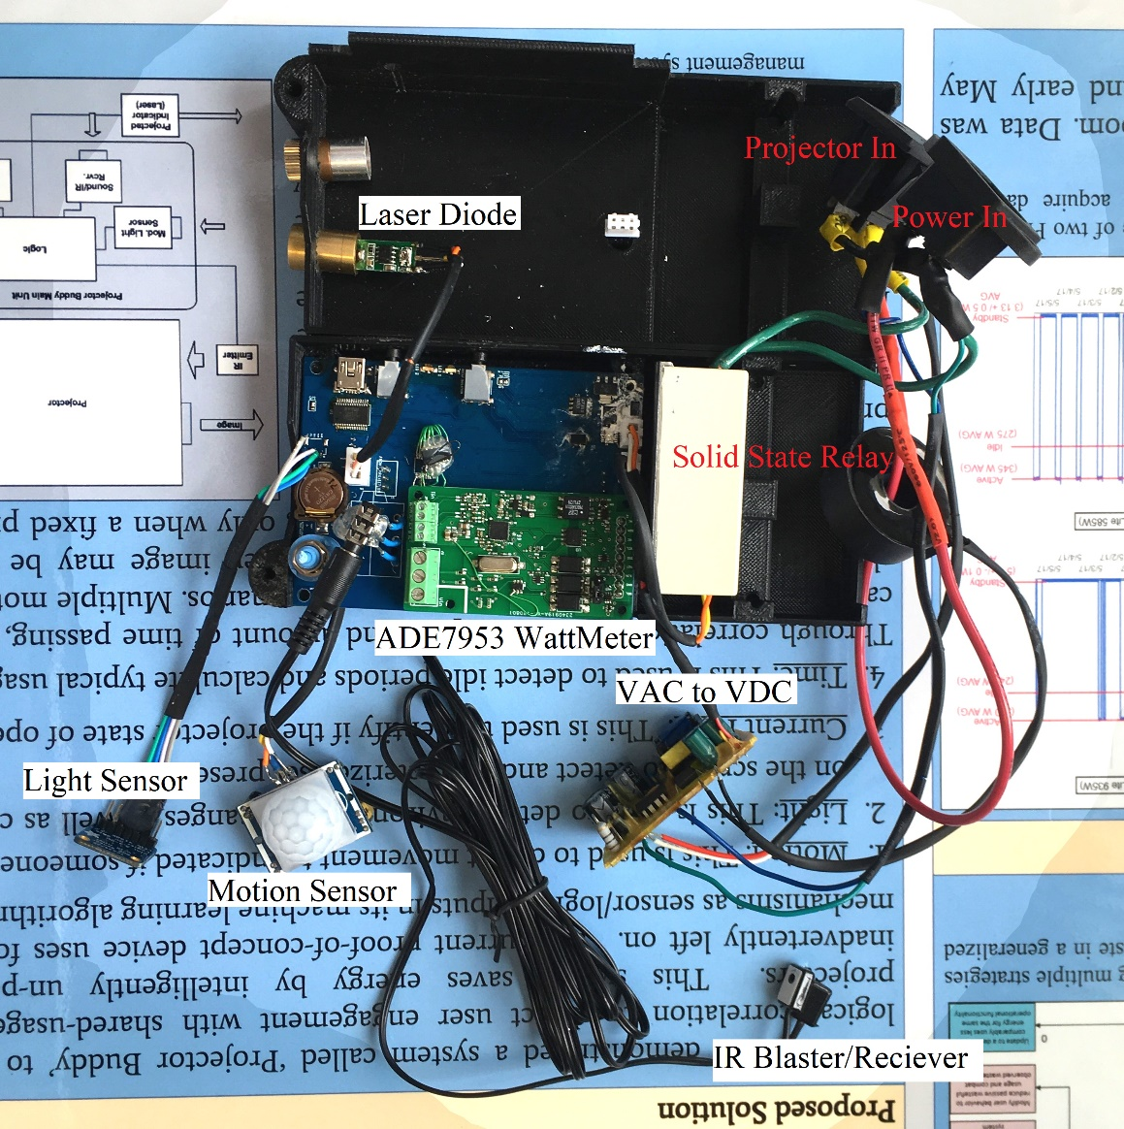

Projector Buddy

**Three Phase Watt Meter ADE9078**: *Three Phase Power Fault Detection*

California Plug Load Research Center

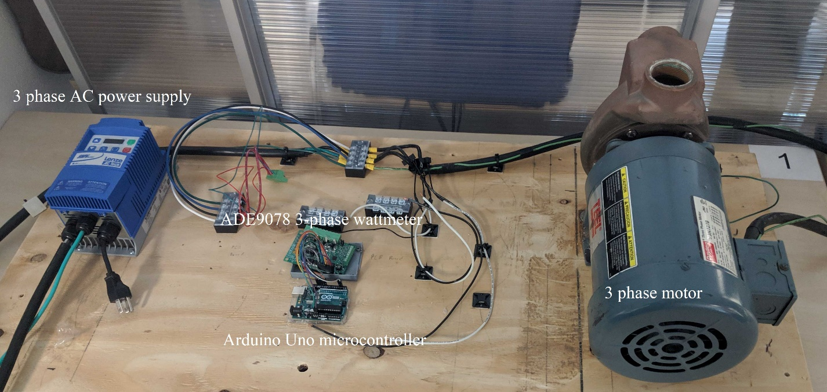

Three Phase Wattmeter Demonstration

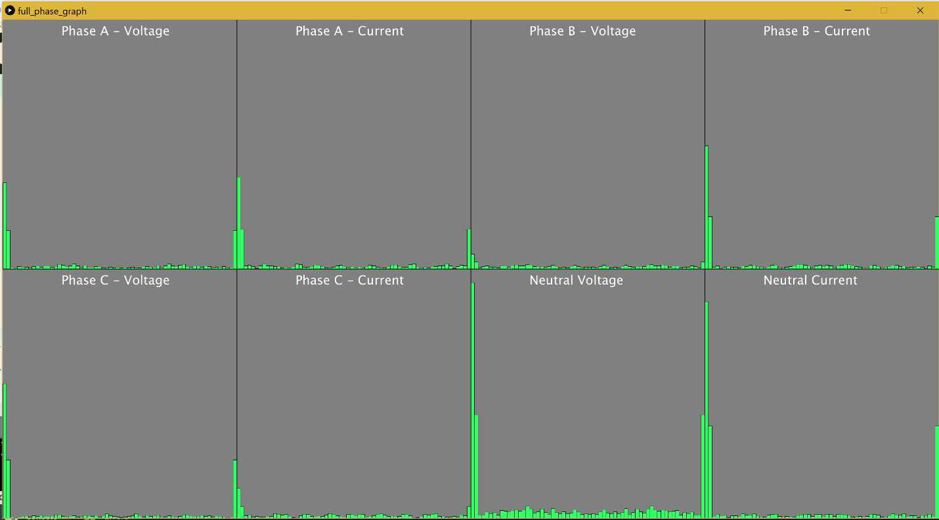Data processing Visualization for Fast Fourier Transform

**Micro-Mouse**: *Autonomous Maze Solving Robot*

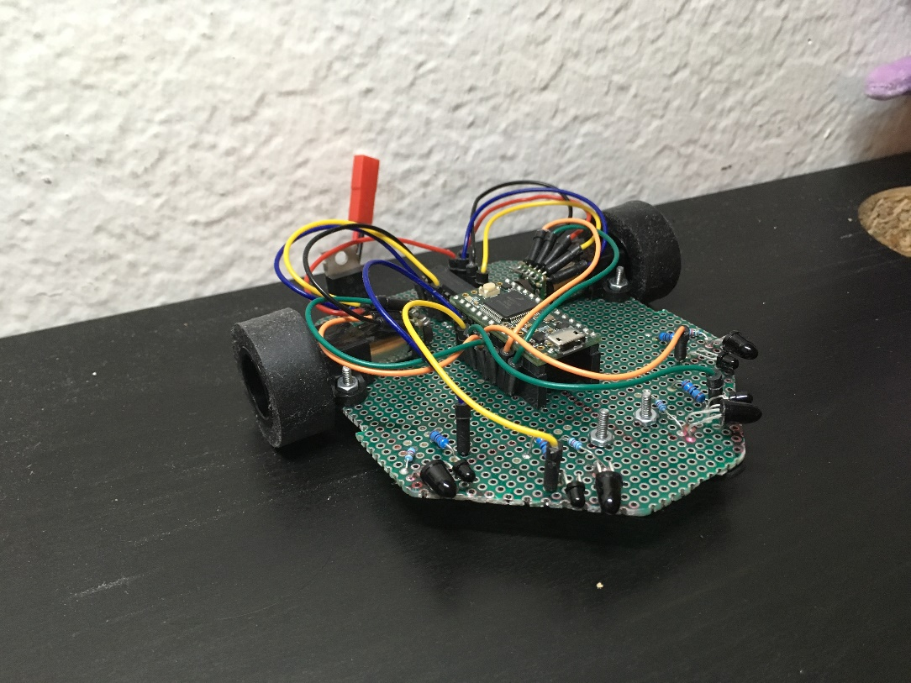

Micro-Mouse

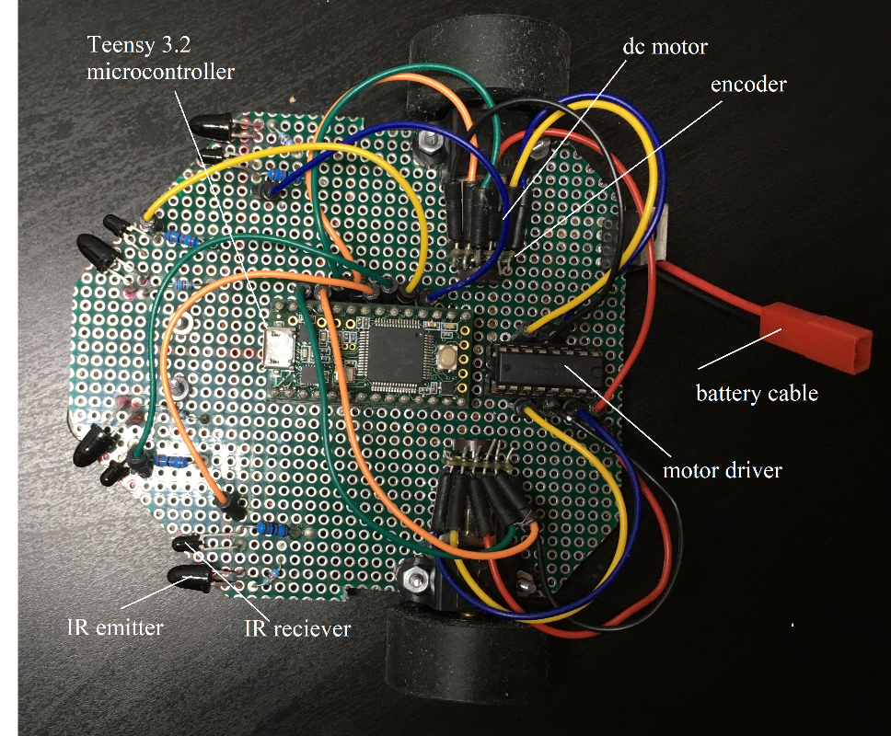

Micro-Mouse top down

**The C-ing Hat**: *Object Avoidance for the Visually Impaired*

Hack UCI 2019 Hackathon

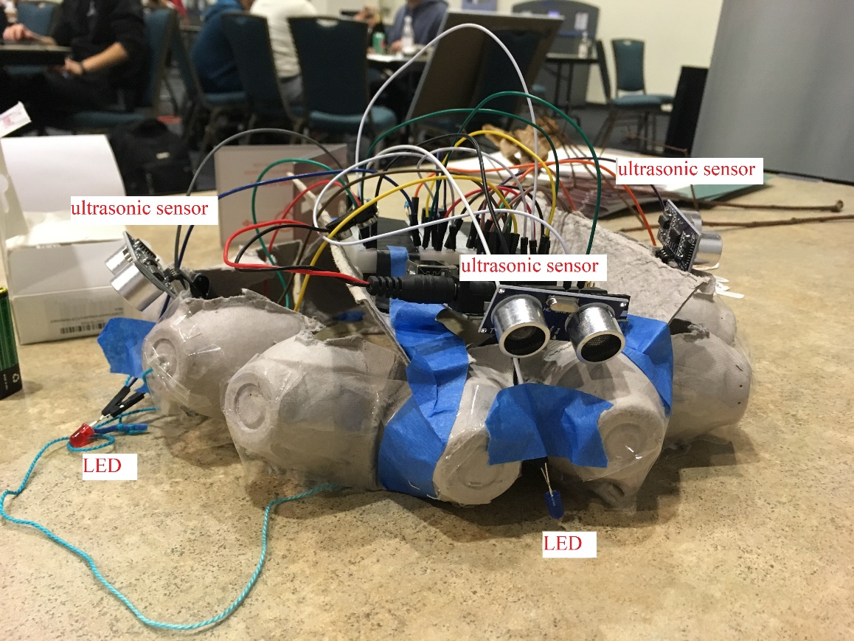

The C-ing Hat

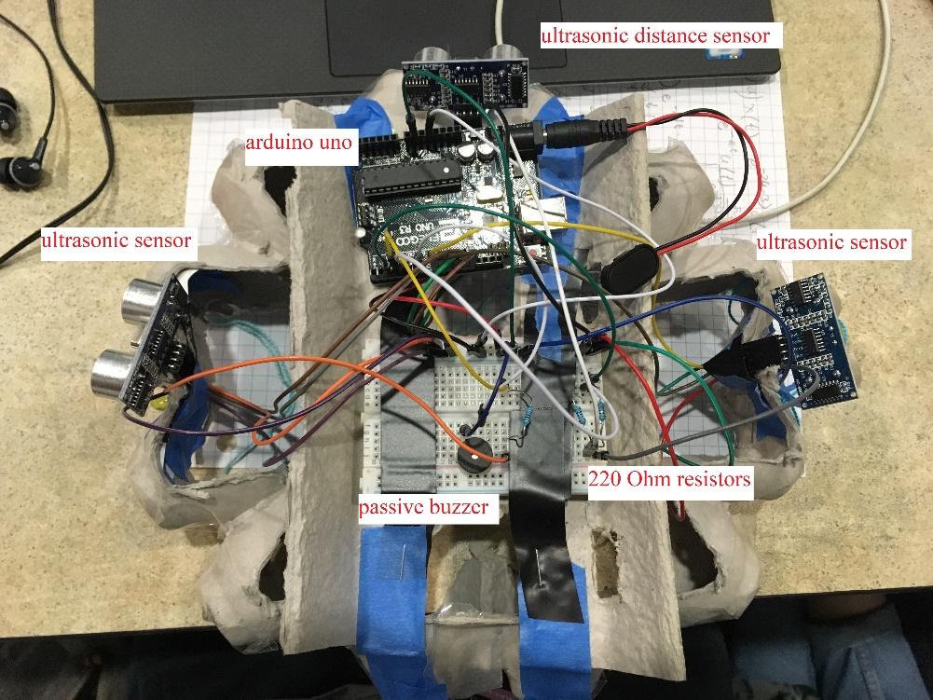

The C-ing Hat top down