An all-Python ecLand–CaMa-Flood chain: eclandpy on the LIAISE domain
Porting strategy, validation against the Fortran ecLand CY50R1 control, and results, 1988–2024. G. Balsamo, ECMWF, September 2026 — for N. Wedi and C. Kühnlein.

Summary
We ran the full LIAISE land–river chain entirely in Python: eclandpy — a GT4Py port of ecLand with cy50r1 physics, executed on one NVIDIA A100 — for the land surface over 37 years (1988–2024) on the 16×23 LIAISE grid, and CaMa-Flood-GPU (Kang, Yin & Yamazaki 2026) for river routing. Against the Fortran ecLand CY50R1 control run with identical forcing and ancillaries, surface temperature is indistinguishable (+0.05 °C, r = 0.99 over 37 years), evapotranspiration is 2 % low, and total runoff 21 % low — the one substantive physics gap, traced to a regionally coherent deep-soil-moisture divergence that domain means hide. Routed to the six GRDC gauges of the domain, the Python chain scores marginally better than the Fortran chain (median KGE −0.135 vs −0.155, r 0.45 vs 0.34, ahead in 15 of 25 station-years). The year-by-year restart mechanism built for eclandpy reproduces the Fortran restart state after ten chained years to within 0.1 K in soil temperature and 1–2 % in soil moisture. On this small domain the GPU is 2.9× faster than one CPU core but still ~4× slower than Fortran on four cores: 368 columns cannot fill an A100, so the port pays off at scale.

1. Porting strategy
The aim was a standalone Python land-surface model behaving like ecLand — same namelists, same NetCDF I/O, same physics — validated at every step against the Fortran, and coupled to the GPU reimplementation of CaMa-Flood so that the whole land–river chain runs in Python. Five principles carried the work:
- Reuse, don't re-derive. eclandpy drives the Fortran-twin-validated GT4Py kernels of ecland_porting (C. Kühnlein) unmodified through their own offline driver; eclandpy's own code is the I/O layer, the adapter, and what the port lacks.
- Close the cy48r1→cy50r1 gap surgically. Diffing two clean Fortran checkouts across every module on the real execution path found that most cy50r1 physics was already in the 'cy48r1' port; three genuine gaps were ported (RTF2 freezing curve, snow-cover fraction, vegetation tables) and the seven experimental hydrology flags kept off on both sides — a plain cy50r1 vs plain cy50r1 comparison.
- Validate on points before grids. PLUMBER2: 42 then all 170 flux-tower sites, scored against FLUXNET; Qle/Qh match Fortran within noise, NEE is the known weaker variable. Only then the first multi-point run ever attempted with this core — the LIAISE grid — and its 5-day check against Fortran.
- Build what the offline driver lacks. A restart chain (ecland_porting has none), diagnostic recorders, lat/lon on outputs so Python files are drop-ins for the Fortran-schema tools, and a coupling layer (eclandpy.cmfgpu) that mirrors cnt41s.F90's hand-over: −(Qs+Qsb), the weights, the advance loop.
- Keep the reference run as the arbiter. Every step is checked against the Fortran control: initial state, budgets, restart state, annual diagnostics, gauge skill. Where the Python chain is better or worse, we say so with the number.

2. What was built
eclandpy (repo gpbalsamo/eclandpy): the I/O layer for plumber2-ecland and LIAISE file conventions; the adapter onto ecland_porting's OfflineDriver; Phase 4a (six of the seven cy50r1 hydrology flags as compile-time-gated overrides, default off); a year-by-year restart chain; and eclandpy.cmfgpu, the coupling layer to CaMa-Flood-GPU — runoff hand-over, inpmat→npz weights, regional subsetting, the chained multi-year driver and discharge export — each a CLI, domain-agnostic, with LIAISE as the worked example.
ecland-porting (fork, branch cy50r1): three cy50r1 physics ports on top of C. Kühnlein's cleaned-up main (merged 2026-09-14): the RTF2 freezing-curve constant, the LESN09 snow-cover-fraction reformulation (a standing bug — the port matched neither cycle's default), and the vegetation tables.
liaise-ecland: the LIAISE configuration of all of it, the Fortran control run, and the archived CaMa-Flood-GPU driver scripts that produced every documented number.

3. Environments and lessons
- GPU needs its own environment: cupy-cuda12x 13.6 (14.x forces numpy≥2), nanobind 1.9.2, gcc 11 as nvcc host (nvcc rejects >11), CUDA 12.6, LD_LIBRARY_PATH for GLIBCXX_3.4.26, GT4PY_EXTRA_COMPILE_ARGS unset, ≥64 GB for the nvcc compile of the largest stencil, SLURM qos ng.
- gt4py compiles stencils lazily and re-reads their source from disk: editing model source under a live run recompiles and crashes it (cost us a 20-hour and a 2-hour run). Never touch the source tree while a job runs.
- stencil_validation went public during this work: the pmap-ifs shim eclandpy used lacked freeze() and get_stencil_id; the real package rejects the registry re-registration Phase 4a relied on and re-registers per instantiation. All three now handled; both backends pass single- and multi-driver tests.
- Sign conventions cost real effort: Qsb is a negative soil-column loss, so total runoff is −(Qs+Qsb); Qs−Qsb double-counts surface runoff and passed every plausibility check until compared with Fortran discharge.

4. Results: land surface vs the Fortran control
Domain means over the 235 active land points, all 37 common years. Precipitation identical confirms identical forcing; the runoff and root-zone deficits are the same signal.
 | eclandpy (GPU) | Fortran | bias | r
Precipitation, mm/yr | 812.7 | 812.7 | +0.0 | 1.000
Evapotranspiration, mm/yr | -654.5 | -668.3 | +13.8 | 0.955
Total runoff −(Qs+Qsb), mm/yr | 160.8 | 203.4 | -42.6 | 0.848
Surface T (AvgSurfT vs T2m), °C | 12.61 | 12.56 | +0.05 | 0.988
Root-zone soil moisture, kg/m² | 410.8 | 445.3 | -34.6 | 0.711

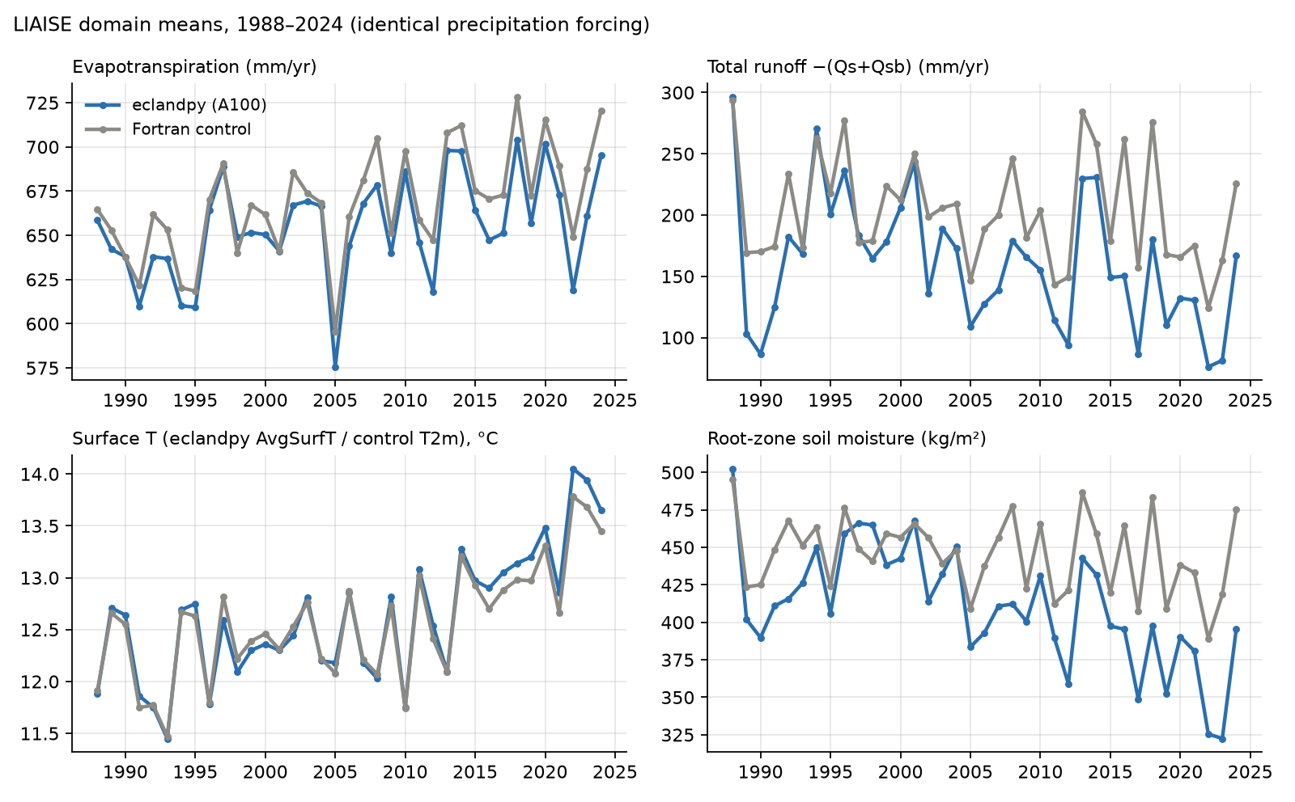
Figure 1. Annual domain means, eclandpy (blue) vs the Fortran control (grey). Both start from the same soilinit in 1988; the runoff and root-zone offsets establish within two years and then persist as an offset, not a drift.
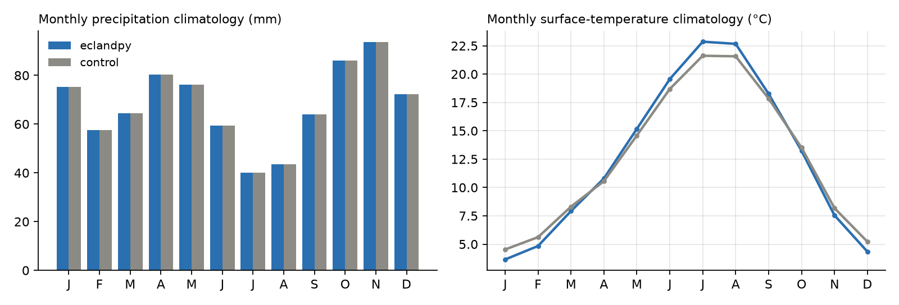
Figure 2. Climatology over 37 years. The larger temperature amplitude in eclandpy is the skin-vs-2 m distinction (AvgSurfT vs T2m), not a physics difference.

5. The restart chain, checked against the Fortran restart
ecland_porting has no restart; eclandpy pickles the driver's carried state (OfflineState, generically over its dataclass fields, plus the carbon accumulators) at each year boundary and re-injects it into a fresh driver. Checked at 1998-01-01 after ten chained years against the Fortran run's own restart_in.nc: identical at 1988 t=0 (the surfinit conversion is exact); AvgSurfT 276.96 vs 277.02 K; soil temperature within 0.1 K and soil moisture within 1–2 % in all four layers; one clean timestep across the 1997→1998 boundary. Two real differences: SWE 0.83 vs 0.56 and canopy water 0.22 vs 0.14 kg/m² (small, snow and interception), and the deep-layer divergence of §7.

6. Results: river discharge vs GRDC gauges
Runoff −(Qs+Qsb) routed by CaMa-Flood-GPU with river storage carried across all 37 years, scored on daily discharge at the six LIAISE gauges over the five benchmark years (Guadalope at Caspe excluded as a regulated river), against the Fortran ecLand + CaMa-Flood control chain.
 | eclandpy → CaMa-Flood-GPU | Fortran chain
median KGE | -0.135 | -0.155
median NSE | -1.003 | -1.181
median correlation r | 0.451 | 0.342
median PBIAS, % | -42.4 | -35.5
station-years won on KGE | 15 of 25 | 10 of 25

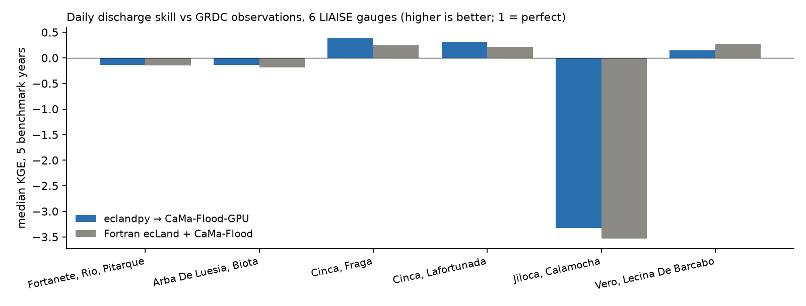
Figure 3. Median KGE per gauge. Both chains are poor in absolute terms on this domain; the Python chain is marginally better correlated and drier.

7. Known gaps and next steps
- Deep-layer (1.9 m) soil moisture diverges regionally after ~2 years — eclandpy drier on the Duero plateau, wetter on the Mediterranean and Cantabrian coasts; 35 of 235 cells by >100 kg/m². The runoff and root-zone offsets follow from it. Next: locate when and where it develops in the L4 time series.
- No T2m/D2m diagnostic in eclandpy (surfpp_ctl_mod's per-tile 2 m scheme is unported); AvgSurfT stands in, which also explains the larger seasonal amplitude in the climatology.
- Two Fortran coupling switches are unported and off in the reference: LWEVAP (lake-tile potential evaporation extracted from floodplain storage — CaMa-Flood-GPU has no evaporation sink) and LROSPLIT (surface/sub-surface passed separately — equivalent while LGDWDLY is off).
- The land-ice tile is dead code in the port (InputBinder hardcodes pcil = 0), harmless on LIAISE; NEE remains the weakest PLUMBER2 variable.
- Performance case must be made at scale: at 368 columns per-step cost is launch latency; CaMa-Flood-GPU's own benchmarks run at 17,675×N columns. Batching the 170 PLUMBER2 sites into one domain is the natural test.

8. Performance
configuration | per year | per step | 37 years
Fortran ecLand CY50R1, 1 node, 4 OpenMP threads | 2.56 min | ~8.8 ms | 1 h 35 m (measured)
eclandpy, gt:cpu_kfirst, 1 CPU core | 30.5 min | ~109 ms | ~19 h
eclandpy, gt:gpu, 1× NVIDIA A100 | 10.6 min | 31 ms | 6.5 h (measured, incl. resume)

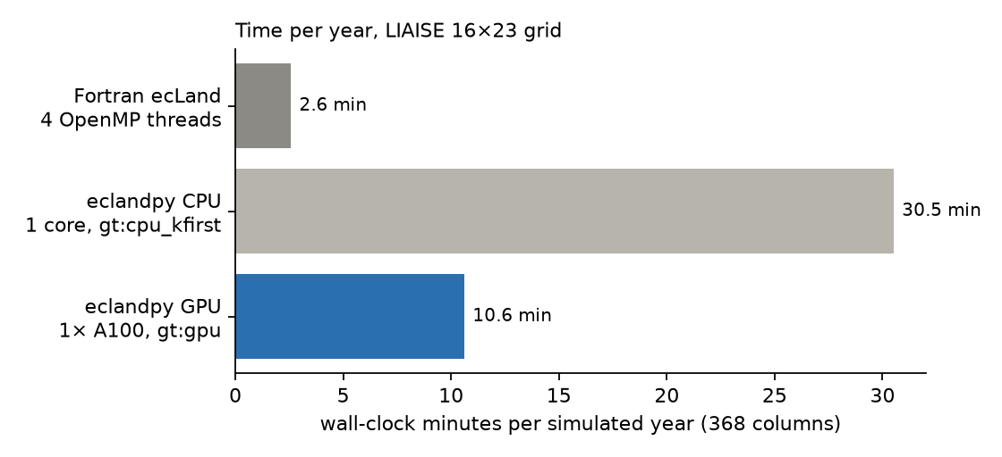
Figure 4. Wall-clock per simulated year on the 368-column LIAISE grid.

9. Reproducing this work
liaise-ecland/eclandpy_bridge/README.md gives the four commands (prepare inputs, land run, routing chain, dashboard) and both environments; eclandpy/README.md the coupling CLIs. Dashboards: sites.ecmwf.int/pad/liaise/eclandpy/ beside /pad/liaise/control/; sites.ecmwf.int/pad/plumber2/dashboards/ for PLUMBER2.
repository | role
github.com/gpbalsamo/eclandpy | the land model + eclandpy.cmfgpu coupling layer (this work: 4e35128 and later)
github.com/gpbalsamo/liaise-ecland | LIAISE configuration, Fortran control, eclandpy_bridge/ (93fae86 and later), the archived CaMa-Flood-GPU drivers
github.com/gpbalsamo/ecland-porting, branch cy50r1 | the three cy50r1 physics ports on top of C. Kühnlein's main (merged 29e6152)
github.com/Kshy0/CaMa-Flood-GPU + Kshy0/hydroforge | the routing model, unmodified
github.com/stubbiali/stencil-validation (public since 2026-09-14) | the stencil framework at ecland-porting's pinned commit

