Eq. 7.29 on p. 101, boundary layer heat conductance for one surface (face) of a rectangular, flat plate with length *d*:

$$g_{H}=\frac{0.664\hat{ρ}D_{H}{Re}^{1/2}{Pr}^{1/3}}{d}$$

7,36

CLM calibration paper (Dagon et al., 2020). Specifically in section 2.3...

<https://ascmo.copernicus.org/articles/6/223/2020/>

Dagon, K., Sanderson, B. M., Fisher, R. A., & Lawrence, D. M. (2020). A machine learning approach to emulation and biophysical parameter estimation with the Community Land Model, version 5. *Advances in Statistical Climatology, Meteorology and Oceanography*, *6*(2), 223–244. https://doi.org/10.5194/ascmo-6-223-2020

2.3 Using observations to inform PFT-specific parameter ranges

For some parameters that vary with PFT, we can improve estimates of plausible ranges by incorporating additional observational data. We can then define uncertainty ranges for a single parameter that vary in their bounds and widths across PFTs. The first parameter we constrain is dleaf, the characteristic dimension of leaves in the direction of wind flow. This parameter is relevant for boundary layer dynamics and relates to the structural form of the equation for leaf boundary layer resistance. The dleaf parameter has a constant fixed value across PFTs in the default CLM5 configuration but in the real world would likely vary by PFT. We use the TRY plant trait database (Kattge et al., 2011) to identify a dataset with concurrent measurements of leaf width and PFT-relevant information (e.g., leaf type, phenology, growth form). The TRY database included only one dataset with adequate leaf width measurements and enough information to associate the measurements with CLM PFTs. The particular dataset we use is from Northeast China (Prentice et al., 2011), which includes a total of 409 usable measurements of leaf width, each of which we assign to a CLM PFT. Some measurements are applied across multiple CLM PFTs based on the lack of biome variation in the dataset. Because we are utilizing measurements from one geographic location, we may not be adequately capturing biome variation (e.g., tropical versus temperate versus boreal PFTs), and this may impact the results. However, it is likely that this variation is small relative to other types of PFT variation (e.g., phenology) which we are able to capture using this dataset. Using the equations of Campbell and Norman (1998), which relate leaf width to dleaf by a leaf shape-dependent factor, we produce PFT-dependent uncertainty bounds for dleaf (Table S6). These minimum and maximum values are then applied consistently across all PFTs for the minimum and maximum dleaf perturbation simulations, respectively.

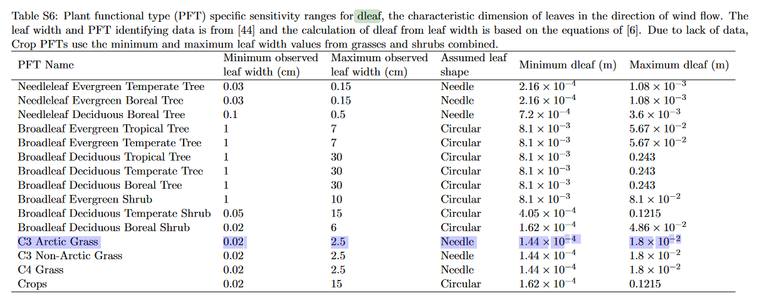

7.12 Determining the Characteristic Dimension of an Object

“For circular disks and various leaf shapes, the characteristic dimension is more difficult to determine since the width varies with distance along the leaf. The leaf can be divided into a large number of rectangular pieces, each with its own characteristic dimension, and these can be summed, with appropriate weighting, to give a characteristic dimension in terms of a measurable dimension of the leaf. For forced convection the characteristic dimension is computed from:

$$d={\left\{\frac{\int_{o}^{l}{d\left(y\right)dy}}{\int_{o}^{l}{\sqrt{d\left(y\right)dy}}}\right\}}^{2}$$

Where *l* is the length of the leaf perpendicular to the wind and *d(y)* indicates the variation of the leaf width with distance along the length of the leaf. […] Typically, however, a factor around 0.7 converts maximum dimension in the direction of wind flow to characteristic dimension. This is also a typical ratio of the area of a leaf to the product of its length and width.”