AgriLeafCare
Rice Leaf Disease Detection System

USER MANUAL

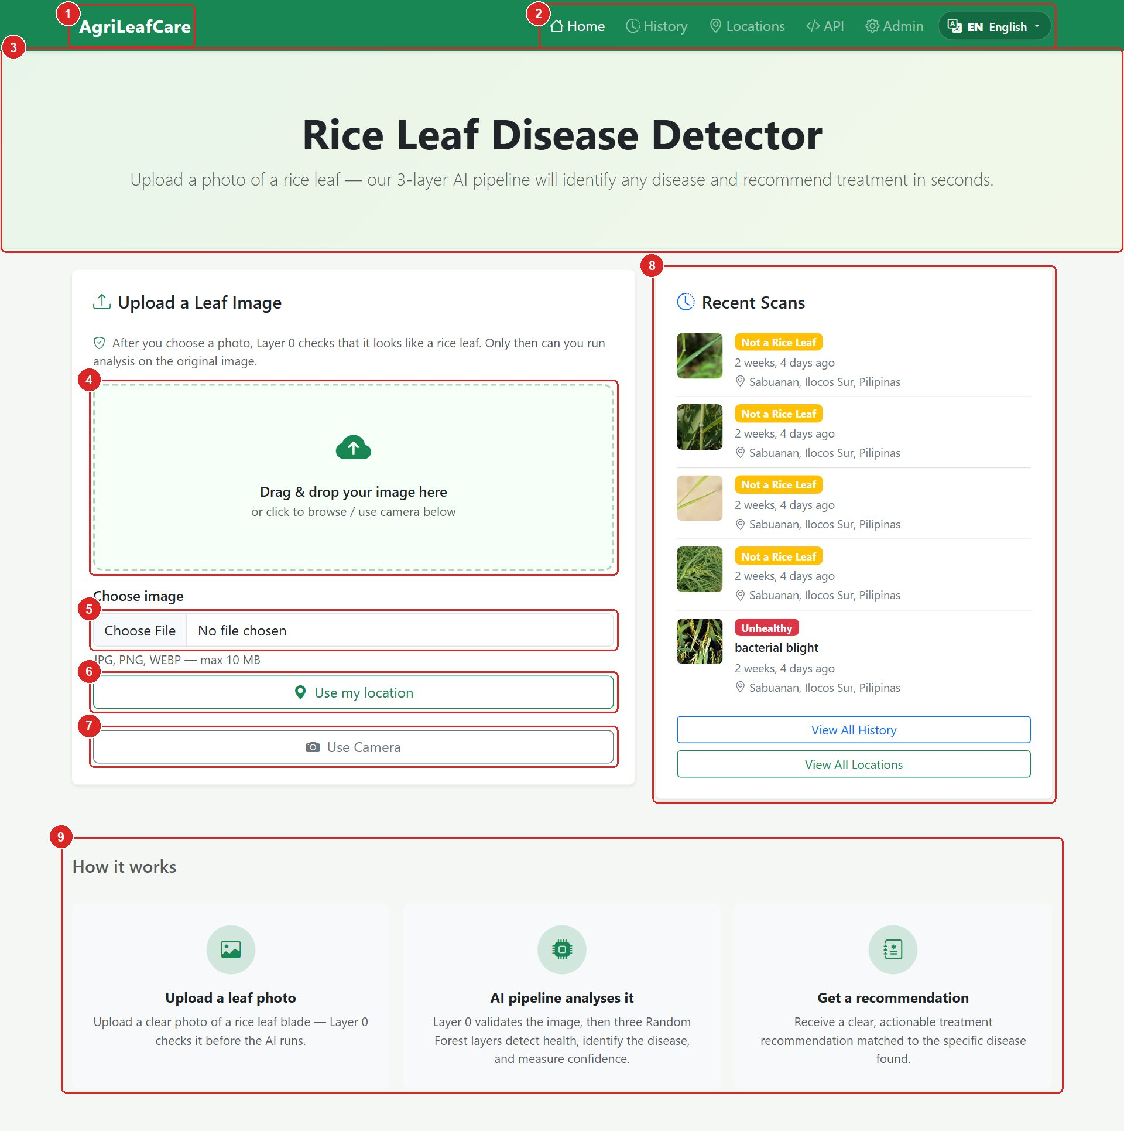

Version 1.0 · September 09, 2026
For farmers, agricultural technicians and system administrators

Contents
1. Introduction 4
1.1 Who this manual is for 4
1.2 What the system can detect 4
1.3 What you need 4
1.4 How a scan works 5
2. Getting Started 6
2.1 The home page 6
2.2 The navigation bar 7
2.3 Choosing your language 7
3. Scanning a Rice Leaf 8
3.1 Taking a good photo 8
3.2 Step by step 8
3.3 When the leaf check is not sure 10
3.4 Unsupported files 11
4. Understanding the Result Page 13
4.1 Page overview 13
4.2 The verdict colours 14
4.3 Toolbar 15
4.4 Your leaf photo and At a glance 15
4.5 Recommendation and treatment guide 16
4.6 Printing a result 20
4.7 Other result types 21
5. Scan History 23
6. Captured Locations 26
7. Using AgriLeafCare on a Phone 31
8. Administrator Guide 33
8.1 Logging in 33
8.2 The dashboard 34
8.3 Site settings (home page text) 34
8.4 Managing leaf scans 36
8.5 Editing or deleting one scan 37
9. REST API (for developers) 39
10. Troubleshooting and FAQ 40
10.1 Glossary 40

How to read this manual. Screenshots carry red numbered markers. Each number matches a row in the legend table right below the picture, so you can find every button and panel on your own screen.

1. Introduction
AgriLeafCare is a web application that helps you find out whether a rice leaf is healthy or diseased. You take or upload a photo of one rice leaf, and the system's AI pipeline checks the image, decides if the leaf is healthy, names the disease when there is one, and gives a treatment guide aligned with PhilRice recommendations. The guide is available in English, Tagalog and Ilocano.

1.1 Who this manual is for
- Farmers and field workers who want a quick disease check from a phone photo (Sections 2–7).
- Agricultural technicians who review scan history and disease maps for an area (Sections 5 and 6).
- Administrators who manage the site text and scan records (Section 8).
- Developers who want to connect other software through the REST API (Section 9).

1.2 What the system can detect
The AI is trained on rice leaf images and recognises the following conditions:
Condition | Type | What you see on the leaf
Brown Spot  Cochliobolus miyabeanus (Bipolaris oryzae) | Fungal | • Small circular to oval brown spots with gray or tan centres on leaves  • Spots may enlarge and merge; severely infected leaves may dry  • Also seen on leaf sheaths and grains in bad outbreaks
Rice Blast  Pyricularia oryzae (Magnaporthe oryzae) | Fungal | • Diamond- or spindle-shaped spots with gray centre and brown margin (leaf blast)  • Rotten black node that may break (node/collar blast)  • Blank or partially filled grains; panicle may not emerge (neck/panicle blast)
Bacterial Leaf Blight  Xanthomonas oryzae pv. oryzae | Bacterial | • Water-soaked streaks along leaf margins that turn yellow then white/gray  • Leaves wilt and dry from the tip (kresek) on young plants  • Milky bacterial ooze from cut leaf — place in clear water to check
Healthy | — | No lesions; uniform green blade. The result gives crop-care reminders.

1.3 What you need
- A phone, tablet or computer with a modern web browser (Chrome, Edge, Safari or Firefox).
- An internet connection to reach the AgriLeafCare server (ask your administrator for the address, e.g. http://<server>:8000/).
- A clear photo of a single rice leaf, saved as JPG, PNG or WEBP and no larger than 10 MB.
- Optional: allow the browser to use your camera (to take the photo in the app) and location (to map where the leaf was found).

1.4 How a scan works
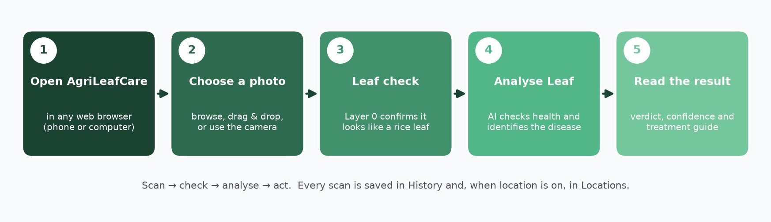
Figure 1. The five steps of a scan, from opening the app to reading the recommendation.
IMPORTANT | AgriLeafCare gives an AI-assisted suggestion. Always confirm a diagnosis and any pesticide use with your Municipal Agriculture Office (MAO) or a PhilRice technologist before treating the field.

2. Getting Started

2.1 The home page
Open the AgriLeafCare address in your browser. The home page is where every scan begins.
Figure 2. The home page with its main areas marked.
No. | Element | What it is / what it does
1 | Brand / Home link | Click the leaf logo or site name at any time to return to the home page.
2 | Navigation menu | Home, History, Locations, API and Admin. See Figure below for details.
3 | Headline banner | The title and tagline. Administrators can change this text (Section 8.3).
4 | Drop zone | Drag a photo file from your computer and drop it here, or click it to browse for a file.
5 | Choose image | Standard file picker. Accepts JPG, PNG and WEBP up to 10 MB.
6 | Use my location | Asks the browser for your GPS position so the scan can record where the leaf was photographed.
7 | Use Camera | Opens the device camera inside the page so you can photograph the leaf directly.
8 | Recent Scans | The five latest scans with their verdict badge, time and place. Click one to reopen its result.
9 | How it works | A three-step reminder: upload a leaf photo, the AI analyses it, you get a recommendation.

2.2 The navigation bar
Figure 3. The green navigation bar appears on every page.
No. | Element | What it is / what it does
1 | AgriLeafCare | Site name. Click to go to the home page.
2 | Home | The upload page (Section 3).
3 | History | All past scans with counters and filters (Section 5).
4 | Locations | Map, charts and ranked places where leaves were scanned (Section 6).
5 | API | Opens the machine-readable scan list in a new tab (Section 9).
6 | Admin | Opens the administrator login in a new tab (Section 8).
7 | Language menu | Switch the interface between English, Tagalog and Ilocano (Section 2.3).

2.3 Choosing your language
Click the language button at the right end of the navigation bar. Pick English, Tagalog or Ilocano. The choice is remembered on your device, and it changes the page text, the result verdicts and the treatment guides.
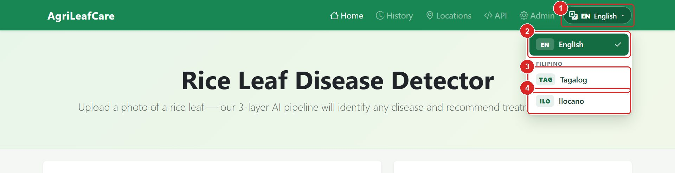
Figure 4. The language menu. (1) opens the menu; (2), (3) and (4) select a language.
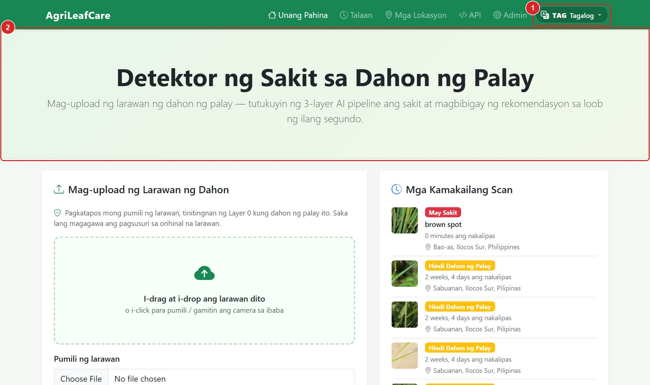 | 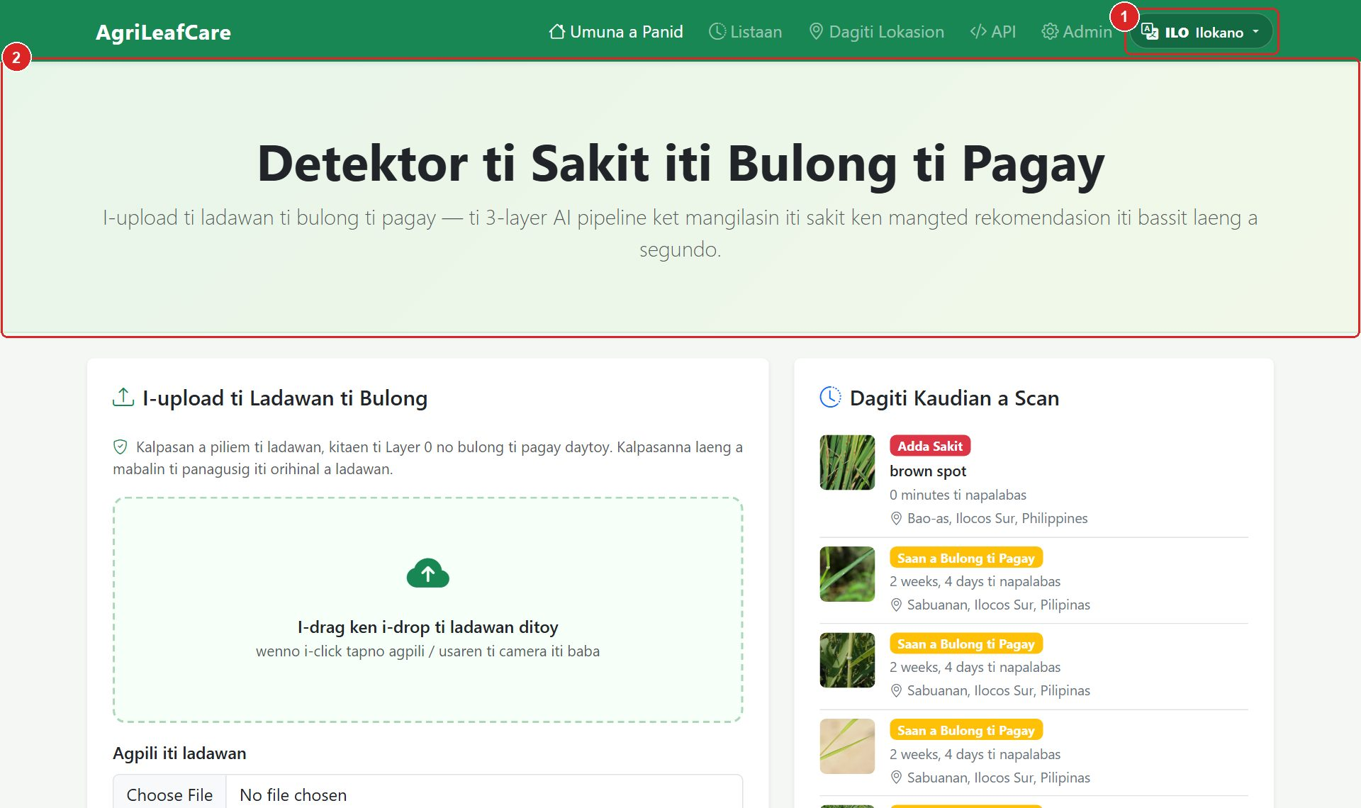
Figure 5. Home page in Tagalog (left) and Ilocano (right). Ilocano is the default language when no choice has been made yet.

3. Scanning a Rice Leaf

3.1 Taking a good photo
The quality of the photo decides the quality of the result. Follow these guidelines before you upload.
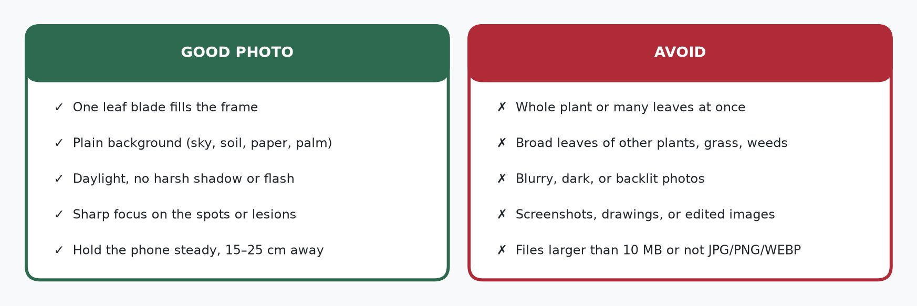
Figure 6. Photo guidelines: what makes a good leaf photo and what to avoid.

3.2 Step by step
- Open the Home page.
- Add the photo in one of three ways: click Choose image and pick a file; drag and drop the file onto the drop zone; or tap Use Camera, centre the leaf inside the frame guide and press Capture.
- Wait for the message Checking image… to finish. This is the Layer 0 leaf check: the system confirms the photo looks like a rice leaf before analysis.
- Optional: tap Use my location and allow the permission prompt so the place name and map are saved with the scan.
- Review the preview. If it is the wrong photo, press Remove photo or Choose a different image.
- Press the green Analyse Leaf button. Analysis takes a few seconds; do not close the page.
- Read the result page (Section 4).
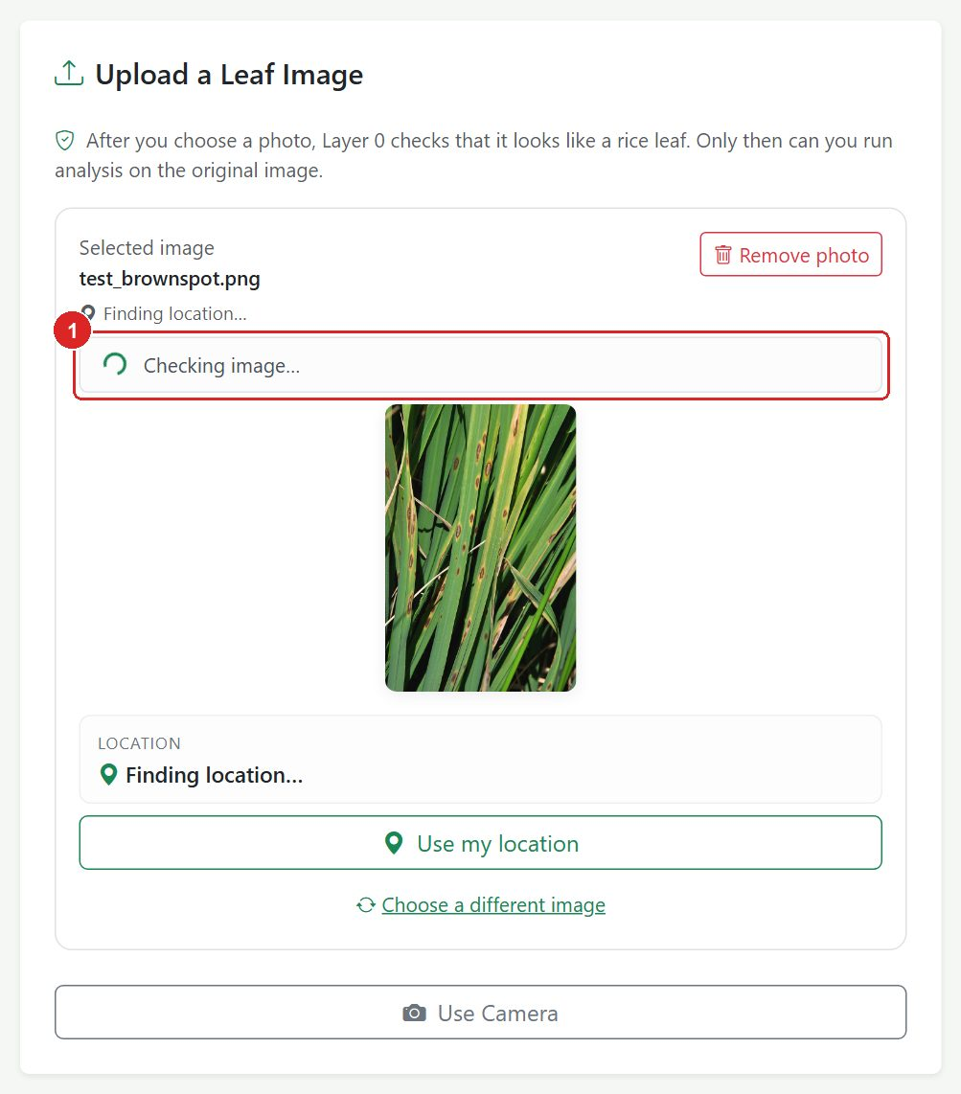
Figure 7. Right after you choose a photo, the leaf check runs (1). The Analyse button appears only when it finishes.
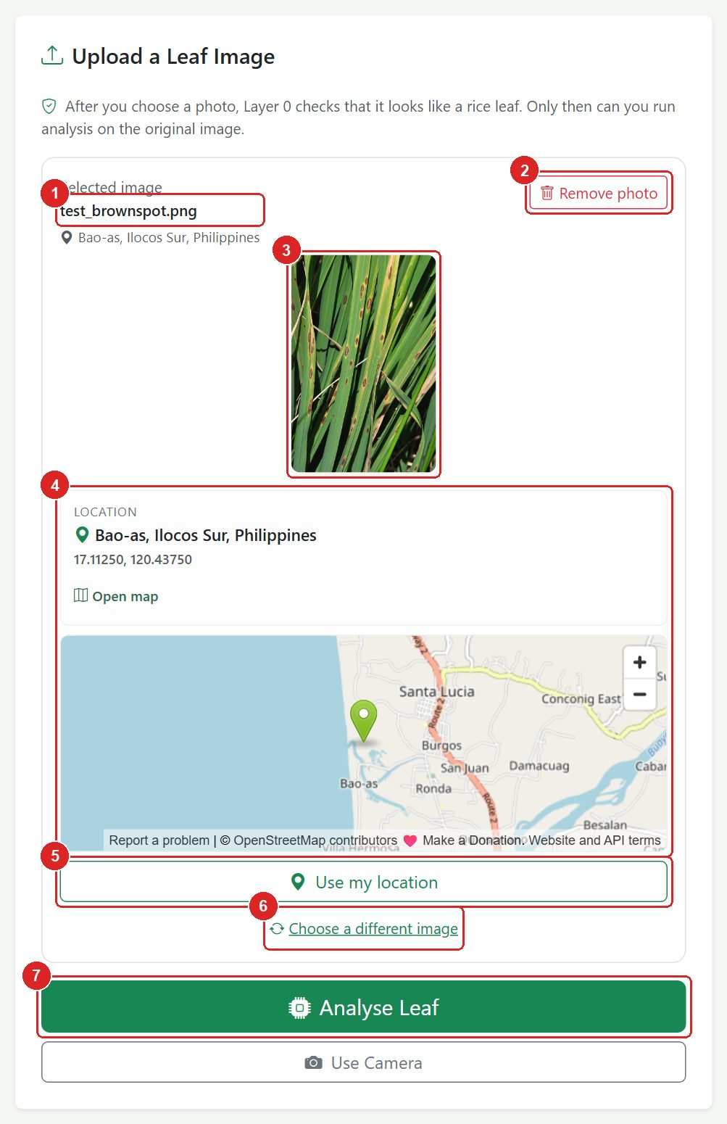
Figure 8. The preview panel once the leaf check has passed.
No. | Element | What it is / what it does
1 | Selected image | File name of the photo you chose.
2 | Remove photo | Clears the photo so you can start again.
3 | Preview | The exact image that will be analysed.
4 | Location card | Place name, coordinates and a small map when location was captured (from device GPS or photo GPS data).
5 | Use my location | Retry the GPS lookup if the location is missing or wrong.
6 | Choose a different image | Go back to the file picker without losing your place.
7 | Analyse Leaf | Starts the AI analysis. Only visible after the leaf check passes.

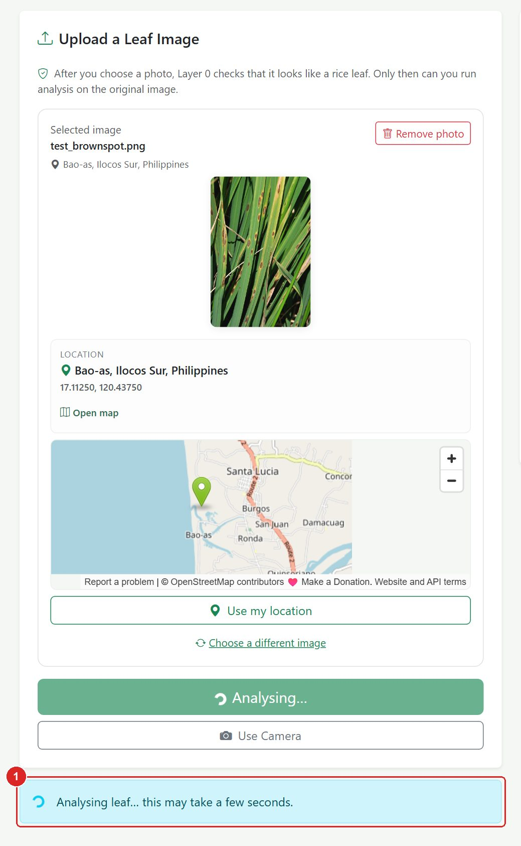
Figure 9. While the AI works, an 'Analysing leaf…' notice (1) is shown. Wait for the result page.
TIP | If you leave the home page before pressing Analyse, your selected photo is kept as a draft and restored when you come back. Use the New Scan button on other pages to discard it.

3.3 When the leaf check is not sure
If the photo does not clearly show a rice leaf, a yellow warning appears under the preview. You may still press Analyse Leaf, but the result will be less reliable. A better option is to retake the photo closer, in good light, with one leaf filling the frame.
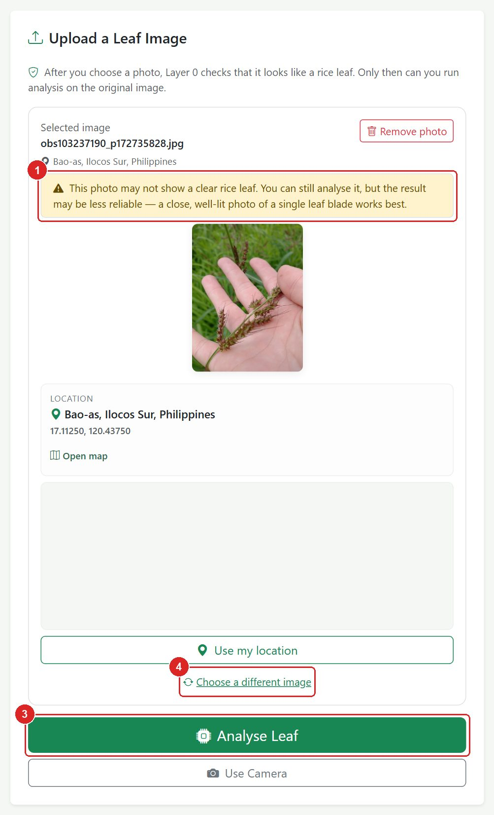
Figure 10. Leaf check warning (1). The Analyse button (3) is still available; (4) lets you choose a better photo.

3.4 Unsupported files
Files that are not images, or that are larger than 10 MB, are refused immediately with a red notice. Close the notice with the × button and pick a JPG, PNG or WEBP photo.
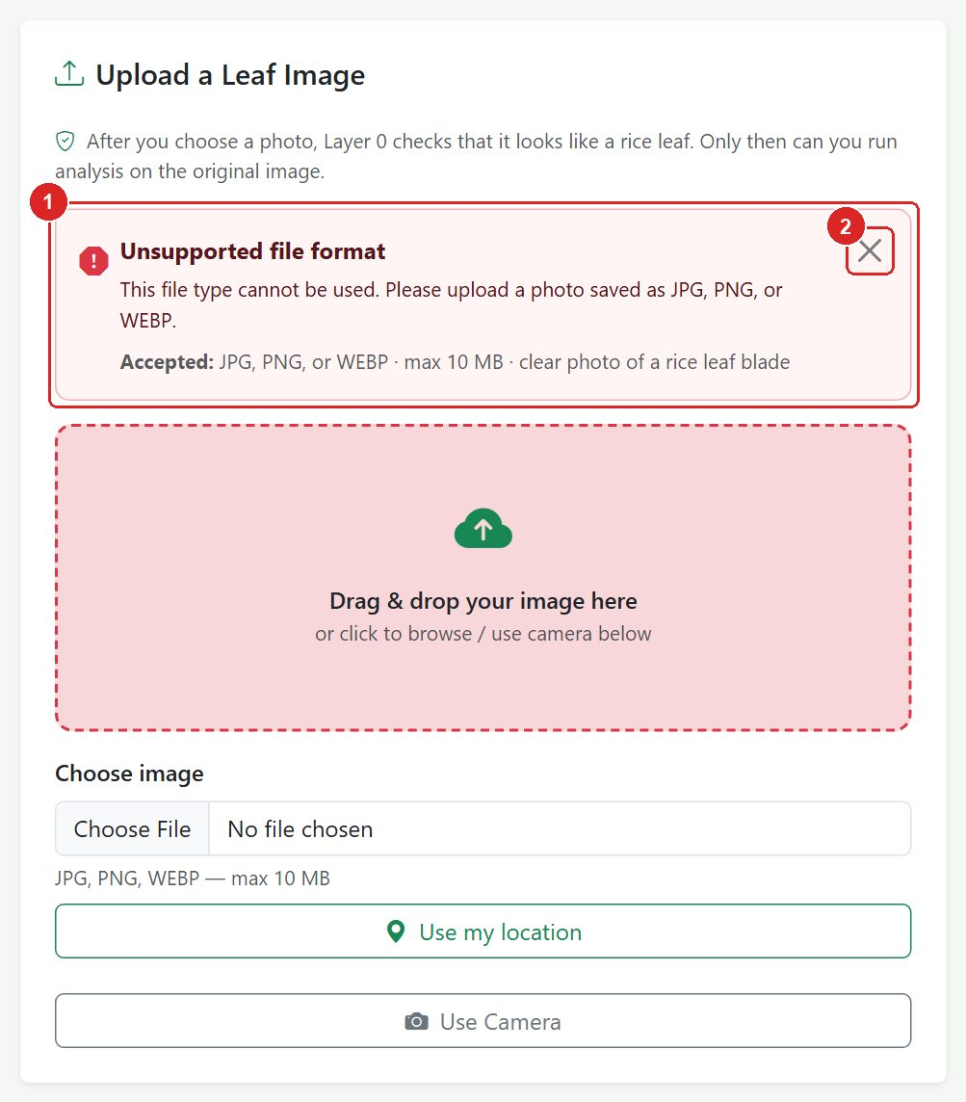
Figure 11. The upload error notice (1) with its close button (2).

4. Understanding the Result Page
After analysis you are taken to the result page. Every scan has its own page and its own number, so you can return to it later from History or Recent Scans.

4.1 Page overview
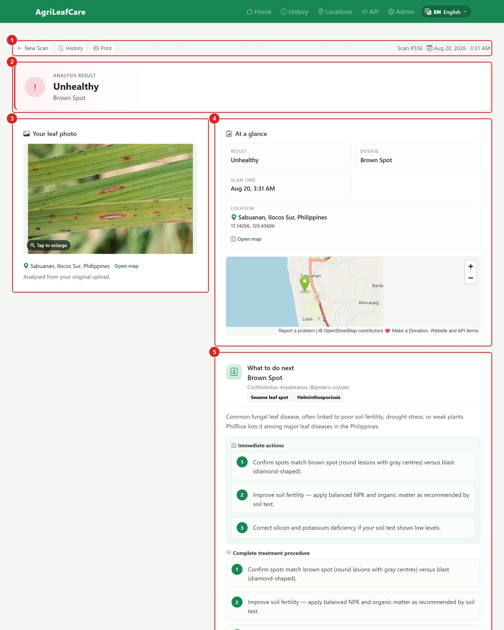
Figure 12. A complete result page for a diseased leaf. (part 1 of 2)
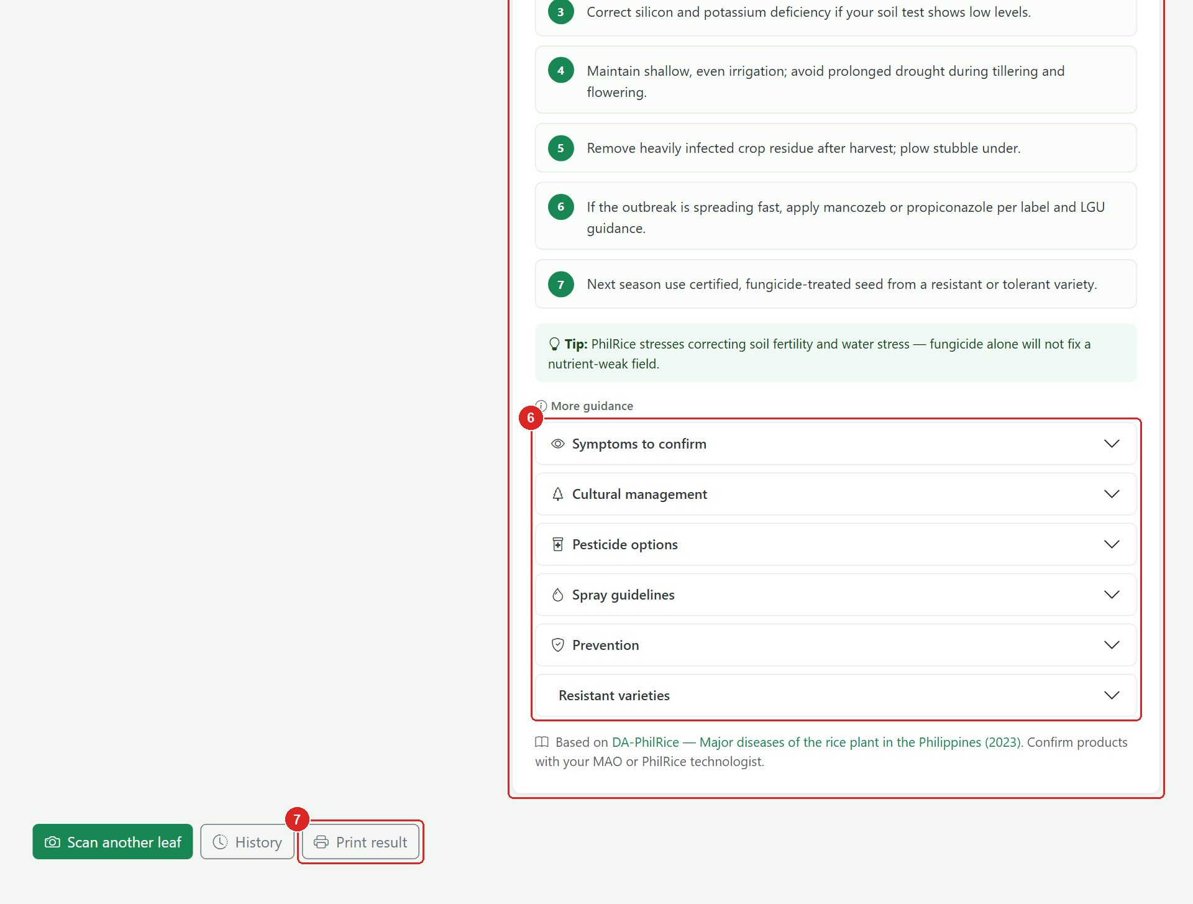
Figure 13. A complete result page for a diseased leaf. (part 2 of 2)
No. | Element | What it is / what it does
1 | Toolbar | New Scan, History and Print buttons plus the scan number and date.
2 | Verdict banner | The main answer: Healthy, Unhealthy (with the disease name), Not a Rice Leaf, or Unknown.
3 | Your leaf photo | The analysed photo and the place it was taken. Tap the photo to enlarge it.
4 | At a glance | Result, disease, scan time and location in one compact card.
5 | Recommendation | What this means and what to do next: immediate actions and the complete treatment procedure.
6 | More guidance | Expandable sections: symptoms, cultural management, pesticide options, spray guidelines, prevention, resistant varieties.
7 | Print result | Prints or saves the page as a clean report.

4.2 The verdict colours
Colour | Verdict | Meaning
 | Healthy | The leaf shows no sign of disease. The result includes upkeep advice for a healthy crop.
 | Unhealthy | A disease was detected. The disease name is shown under the verdict, with a full treatment guide.
 | Not a Rice Leaf | The photo does not look like a rice leaf, so no diagnosis was made. Retake the photo.
 | Unknown | The AI could not make a confident decision, or processing failed. Try a clearer photo.

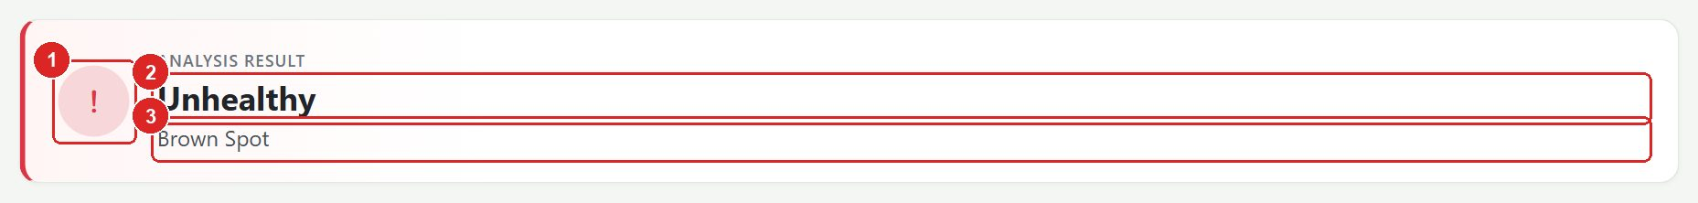
Figure 14. Verdict banner: (1) status icon, (2) verdict, (3) disease name.

4.3 Toolbar
Figure 15. Toolbar: (1) New Scan, (2) History, (3) Print, (4) scan number and date.

4.4 Your leaf photo and At a glance
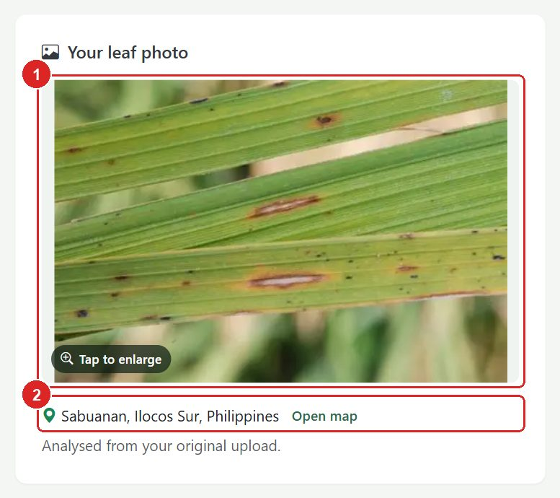
Figure 16. Your leaf photo (1) with the capture place and an 'Open map' link (2).
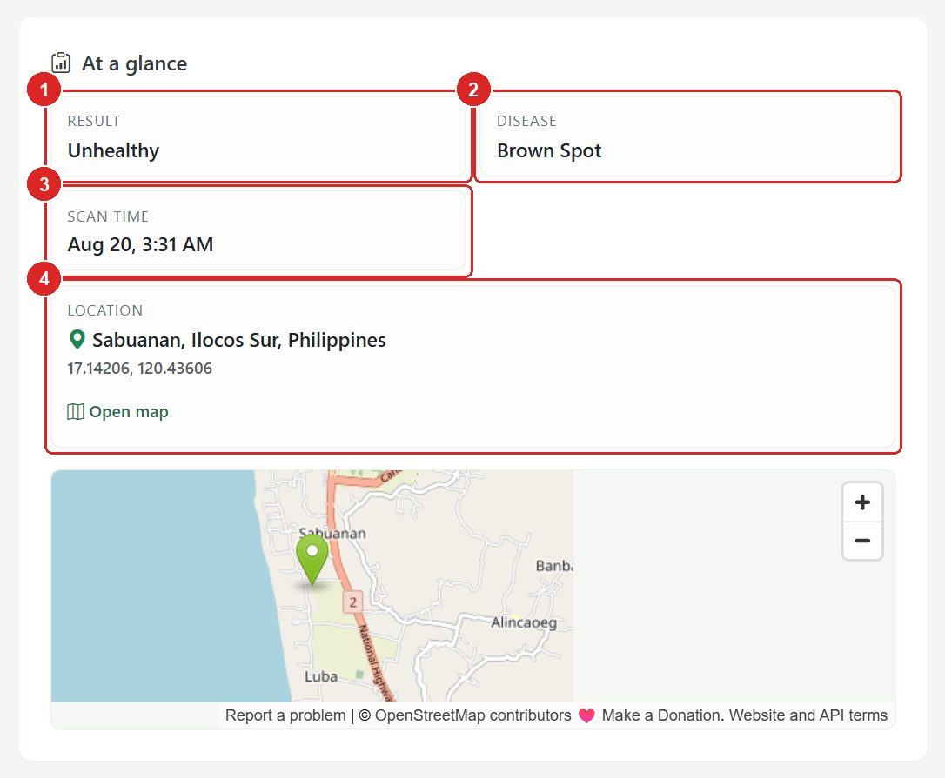
Figure 17. At a glance: (1) Result, (2) Disease, (3) Scan time, (4) Location.
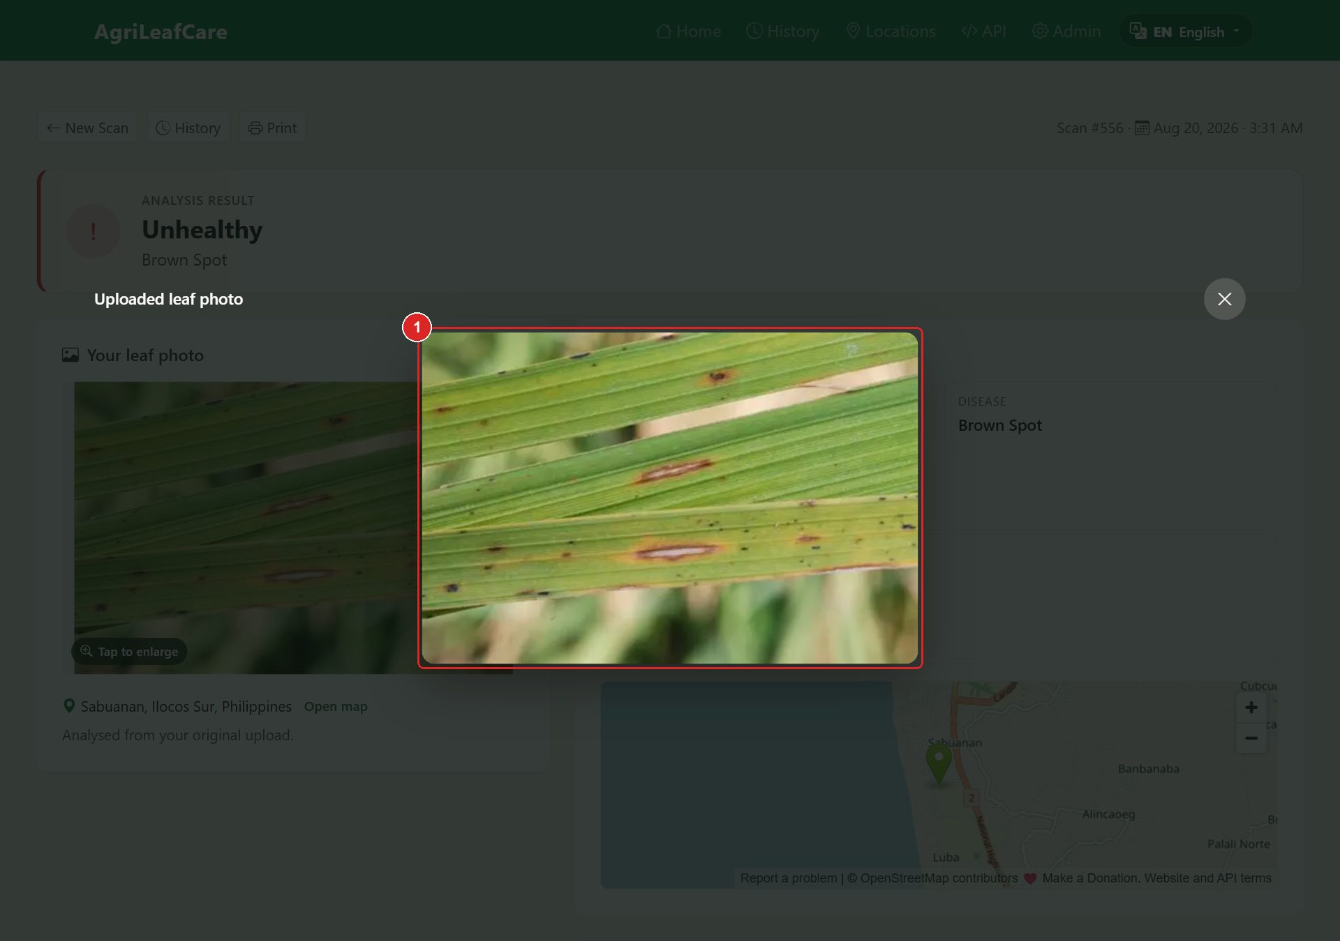
Figure 18. Tapping the photo opens a full-screen view (1). Press Escape or tap outside to close.

4.5 Recommendation and treatment guide
The recommendation card explains what the verdict means and lists the immediate actions and the complete treatment procedure for the detected disease. Below it, More guidance holds detailed sections you can open one at a time.
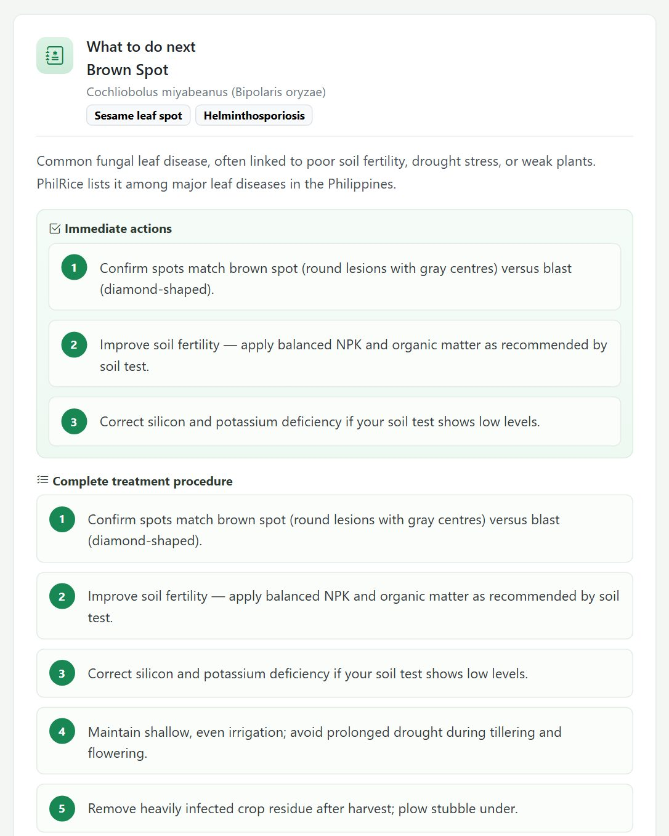
Figure 19. The Recommendation card with immediate actions and the complete procedure. (part 1 of 2)
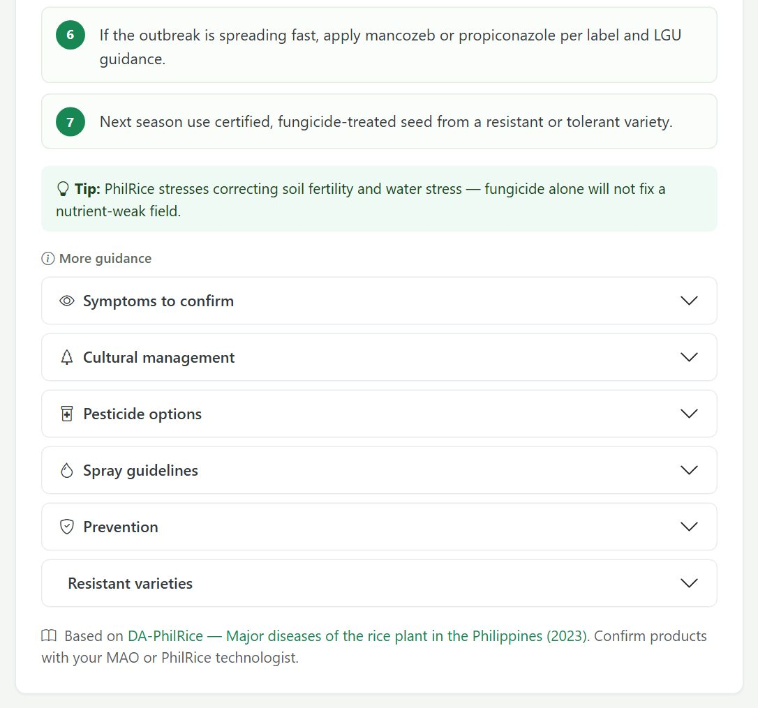
Figure 20. The Recommendation card with immediate actions and the complete procedure. (part 2 of 2)
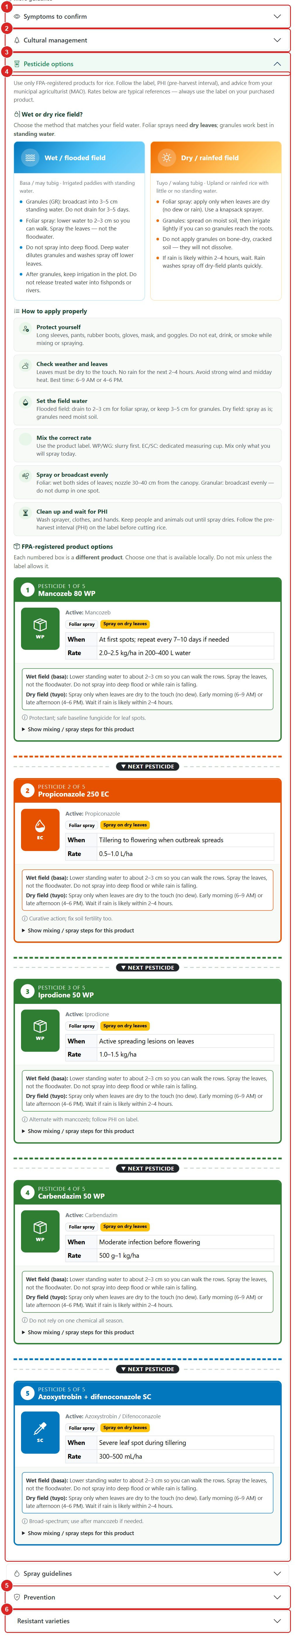
Figure 21. More guidance with the Pesticide options section open.
No. | Element | What it is / what it does
1 | Symptoms to confirm | Check these signs on the plant before treating.
2 | Cultural management | Non-chemical practices: water, fertiliser, sanitation, spacing.
3 | Pesticide options | FPA-registered products. Each numbered box is a different product; choose one available locally.
4 | Product details | Active ingredient, timing, rate, wet-field and dry-field instructions, and mixing / spray steps.
5 | Prevention | How to avoid the disease next season.
6 | Resistant varieties | Varieties to ask about at PhilRice or your MAO.

IMPORTANT | Rates in the guide are typical references. Always follow the label of the product you buy, respect the pre-harvest interval (PHI), and wear protective clothing when spraying.

4.6 Printing a result
Press Print in the toolbar (or at the bottom of the page). The browser's print dialog opens with a clean report layout that includes the site name, scan number, date and the recommendation. Choose a printer or 'Save as PDF'.
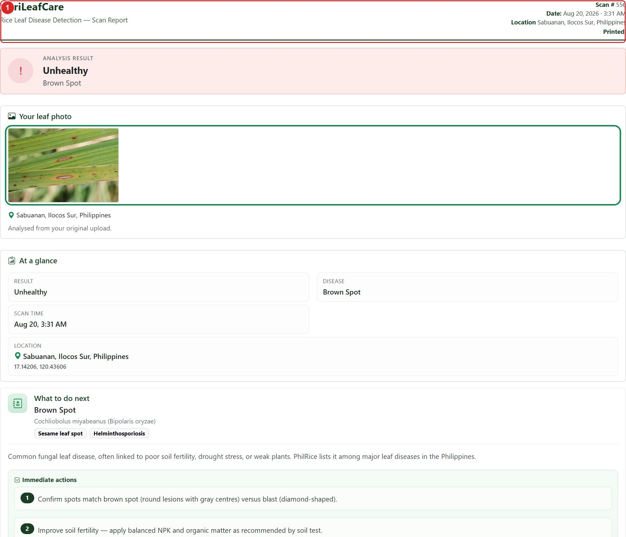
Figure 22. The print layout with its report header (1).

4.7 Other result types
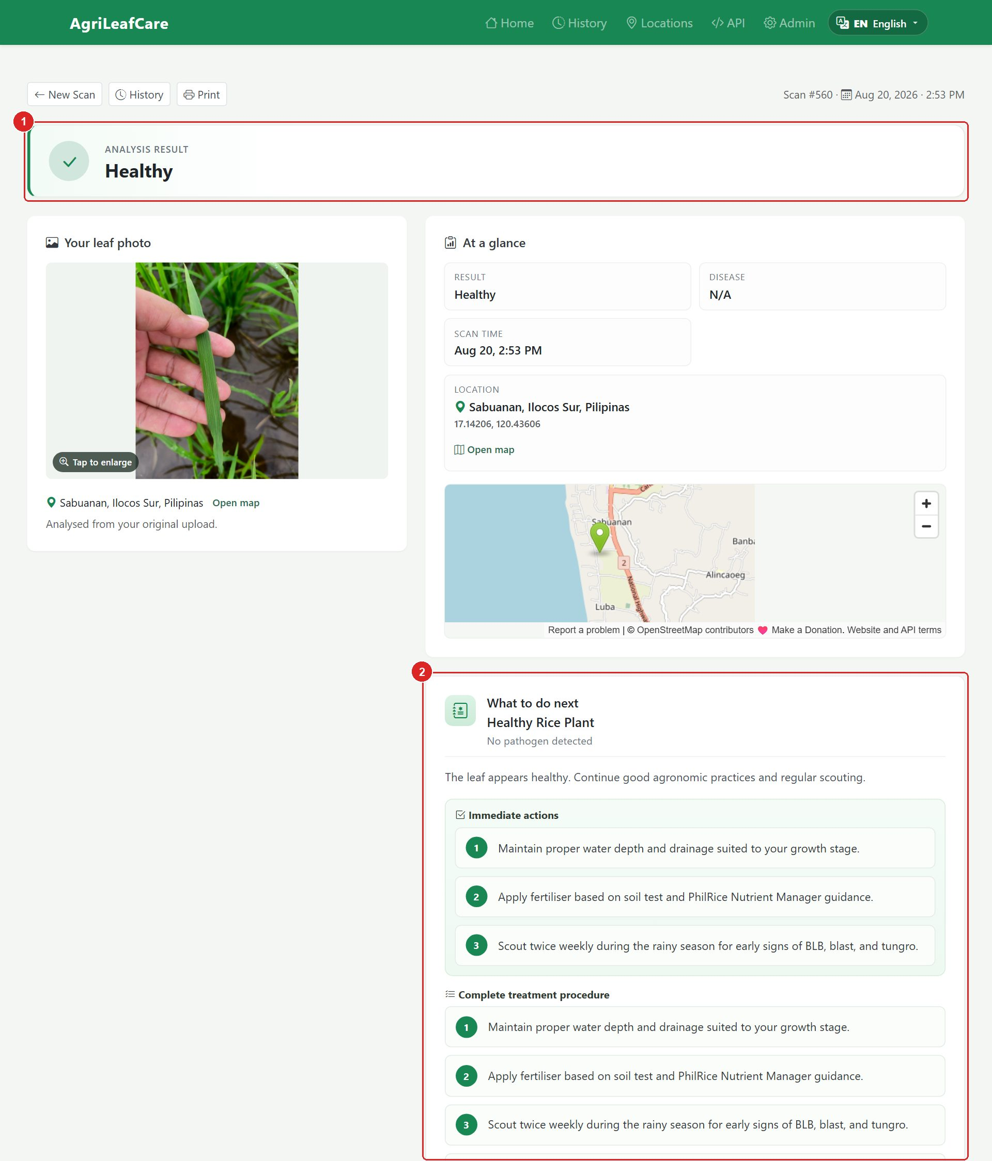
Figure 23. A healthy leaf: green verdict (1), care reminders (2) and the healthy-crop guide (3).
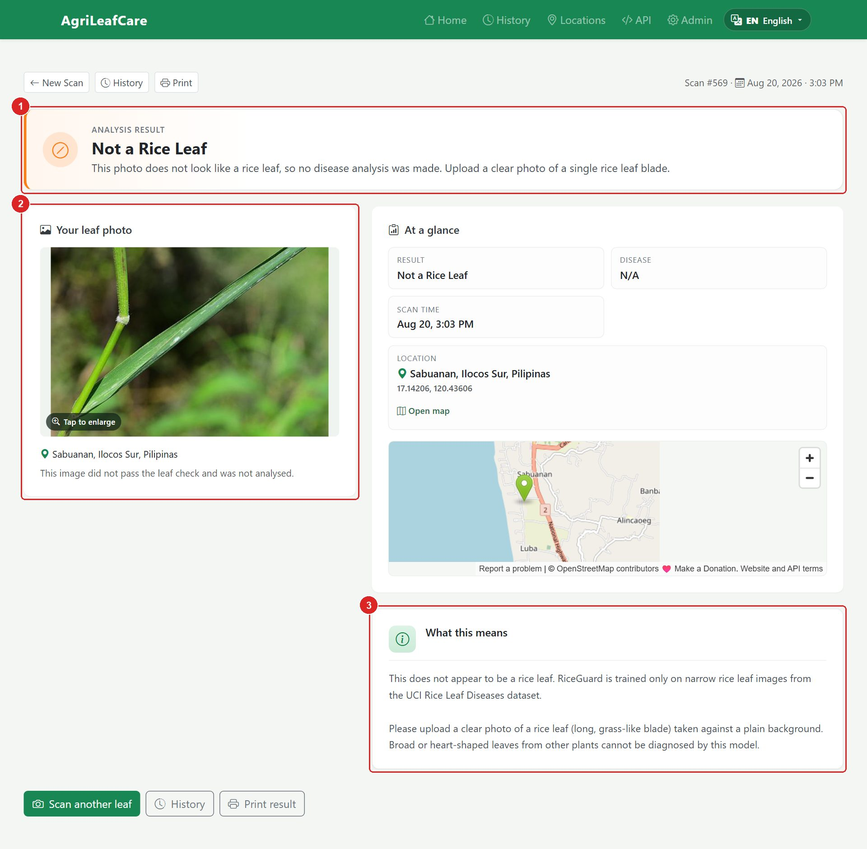
Figure 24. Not a rice leaf: yellow verdict (1), the original photo (2), and advice to retake the photo (3). No disease analysis is made.

5. Scan History
Click History in the navigation bar to see every scan stored on the server, newest first.
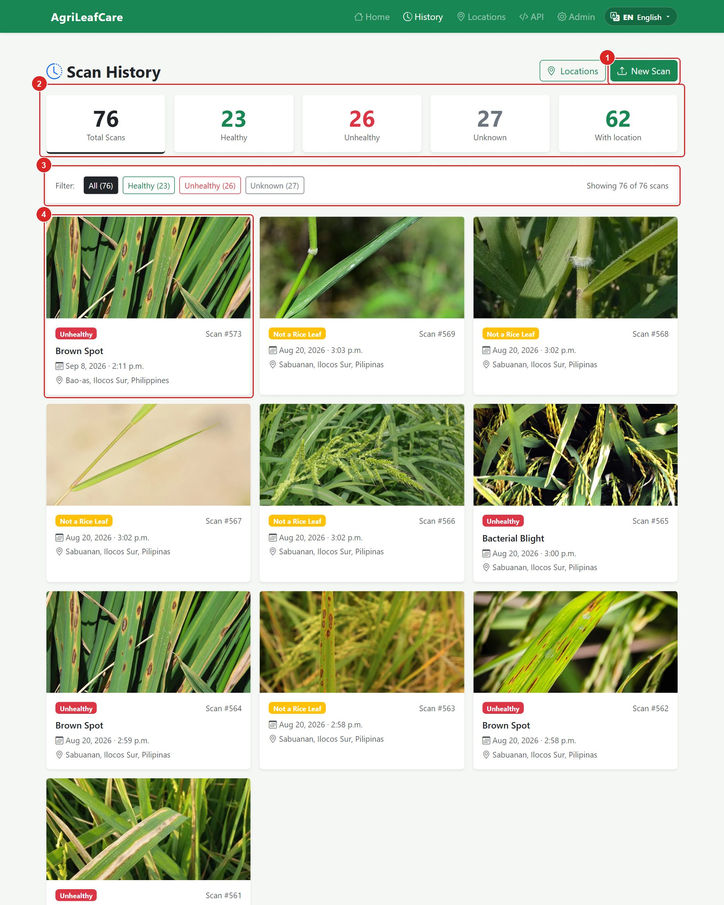
Figure 25. The Scan History page. (part 1 of 2)
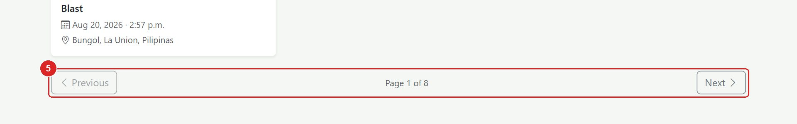
Figure 26. The Scan History page. (part 2 of 2)
No. | Element | What it is / what it does
1 | New Scan | Go back to the home page and start a fresh scan.
2 | Counters | Total scans, Healthy, Unhealthy, Unknown, and scans with a saved location. Click a counter to filter.
3 | Filter bar | Quick filters: All, Healthy, Unhealthy, Unknown (the number in brackets is the count).
4 | Scan card | Photo, verdict badge, disease, date and place. Click the card to open the result page.
5 | Pagination | Ten scans per page. Use Previous / Next to move between pages.

Figure 27. Filter bar: (1) All, (2) Healthy, (3) Unhealthy, (4) Unknown.
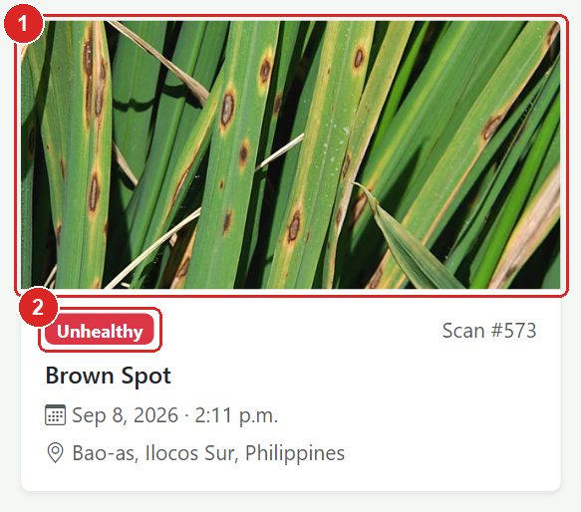
Figure 28. A scan card: (1) the photo, (2) the verdict badge.
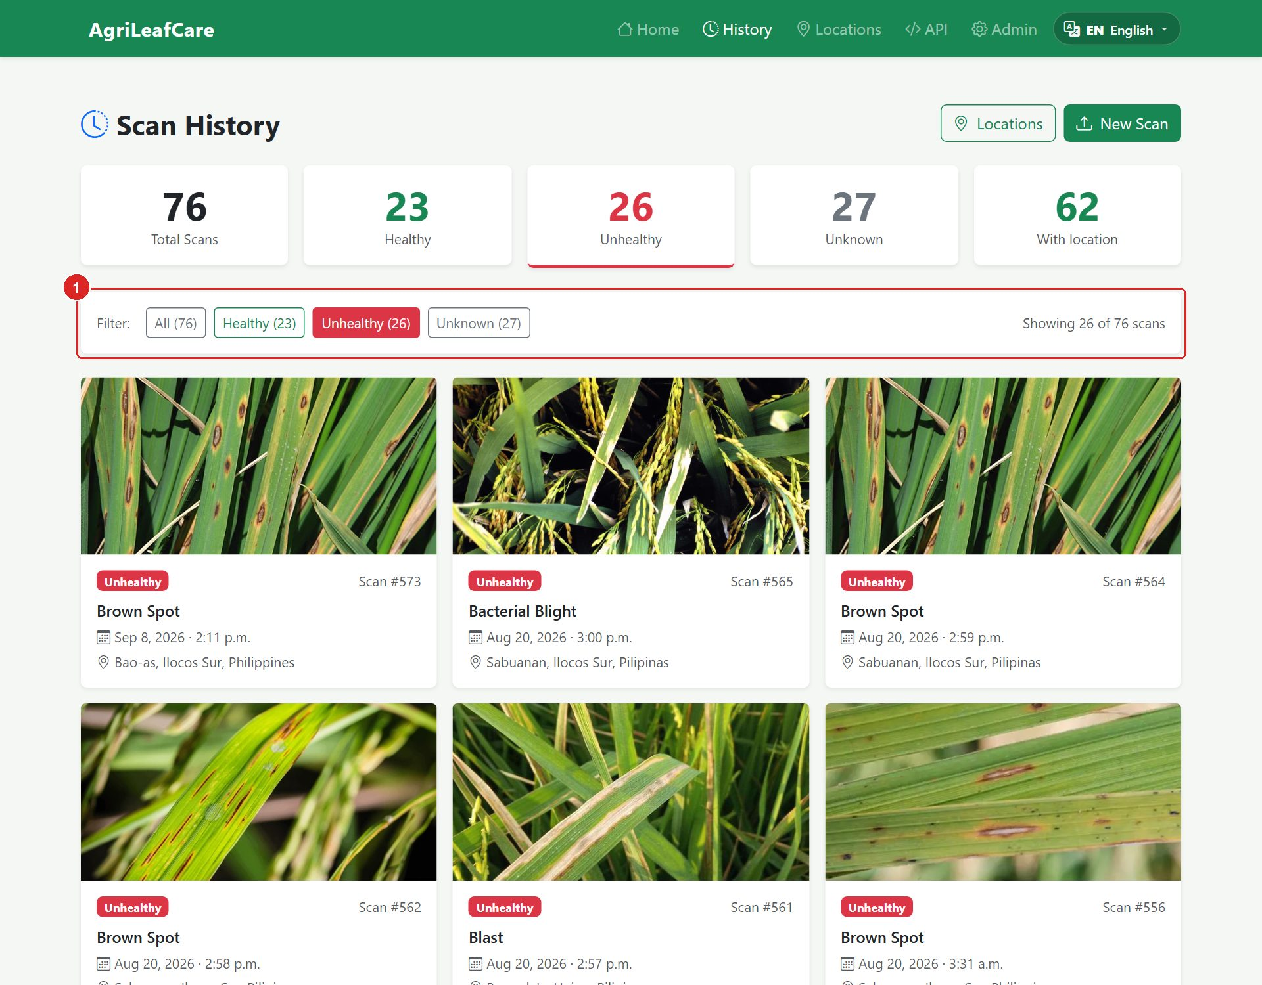
Figure 29. History filtered to Unhealthy scans. The active filter button (1) is highlighted.

6. Captured Locations
When a scan was made with location on, AgriLeafCare records where the leaf was photographed. The Locations page turns those records into a field map and simple charts, which helps technicians spot where diseases are appearing.
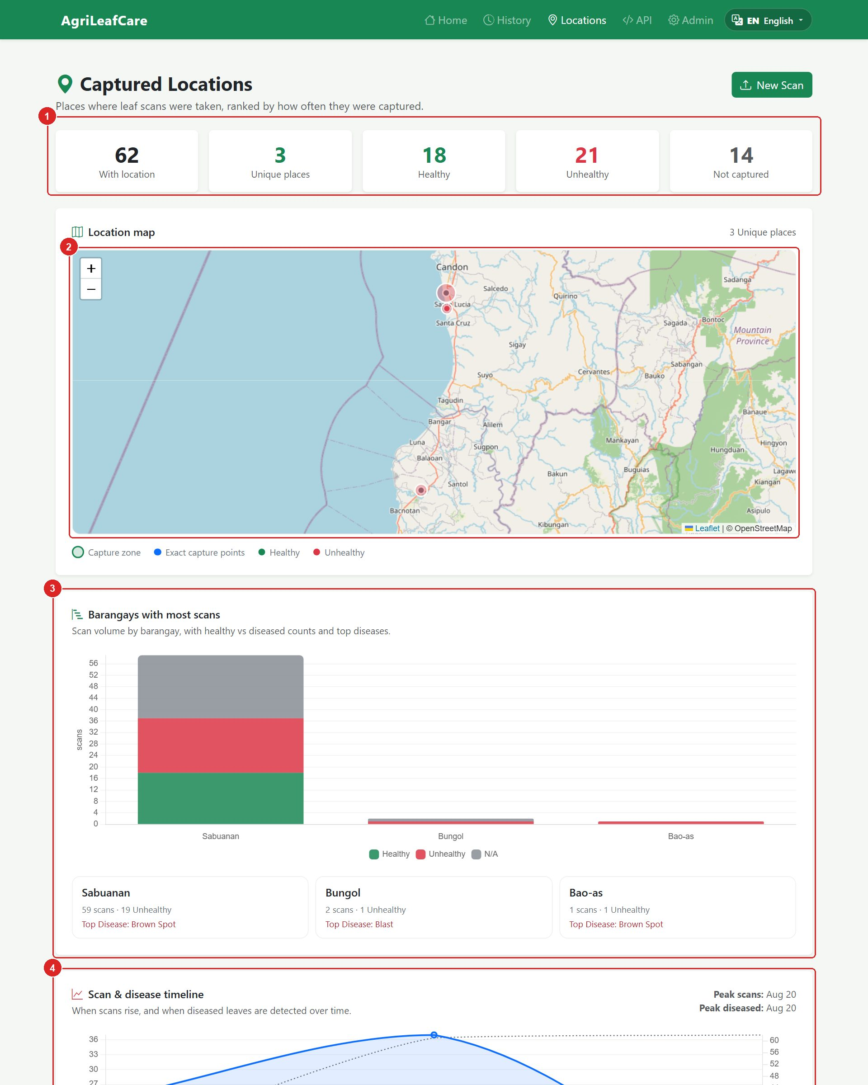
Figure 30. The Locations page. (part 1 of 2)
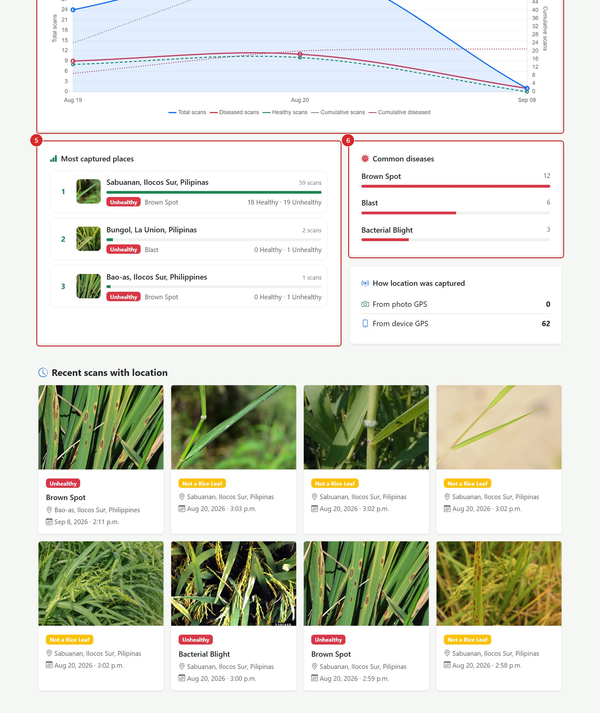
Figure 31. The Locations page. (part 2 of 2)
No. | Element | What it is / what it does
1 | Counters | Total scans, scans with location, scans without, unique places, healthy and unhealthy counts.
2 | Location map | Interactive map. Circles are capture zones; dots are exact capture points, coloured by verdict. Click a marker for details.
3 | Barangays with most scans | Bar chart of scan volume per barangay, with healthy vs diseased counts and the top disease.
4 | Scan & disease timeline | Line chart of scans and diseased detections over time (by hour, day or week depending on the span).
5 | Most captured places | Ranked list of places. Click a place to see only its scans.
6 | Common diseases | Which diseases appear most often among located scans.
7 | How location was captured | From device GPS versus from the photo's own GPS data (EXIF).

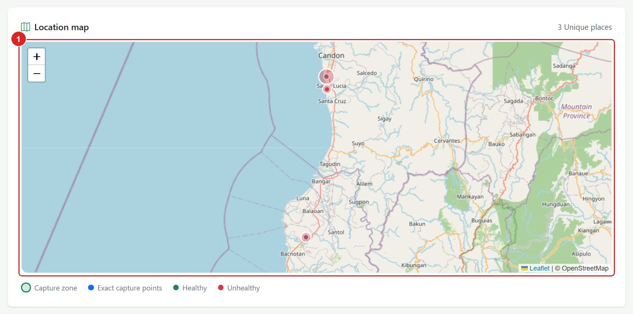
Figure 32. The location map (1). Zoom with the + / − buttons or the mouse wheel; drag to pan.
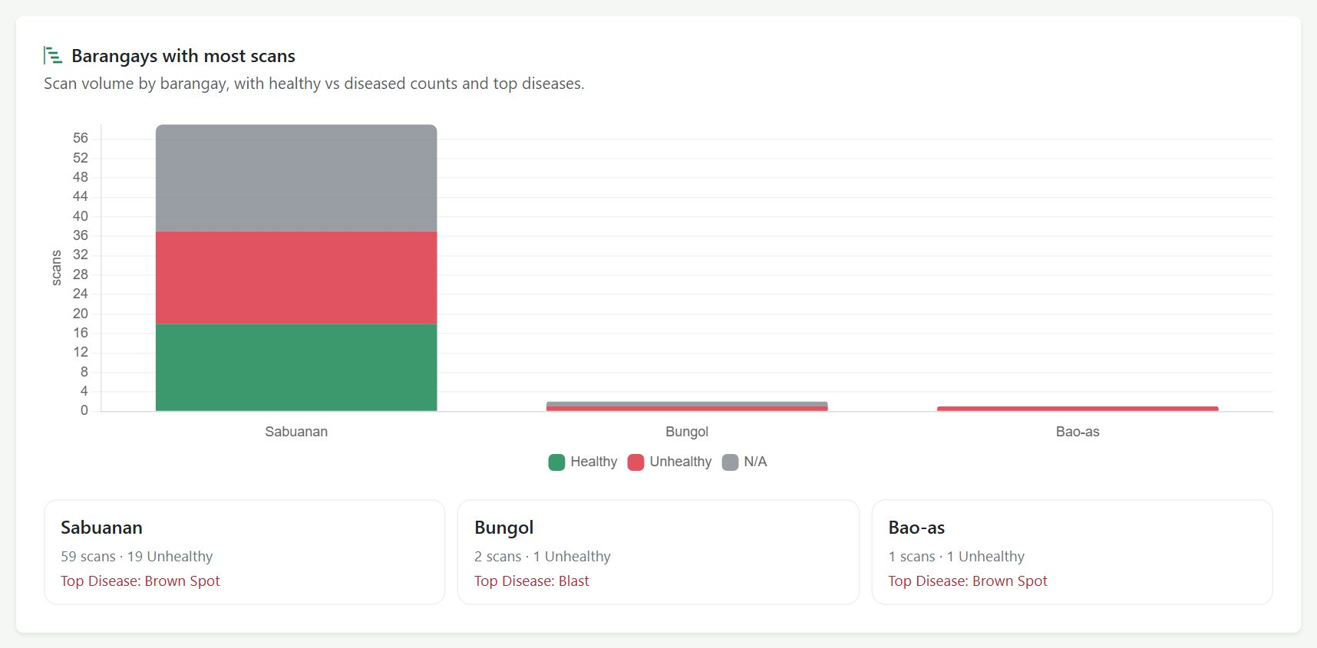
Figure 33. Barangays with most scans.
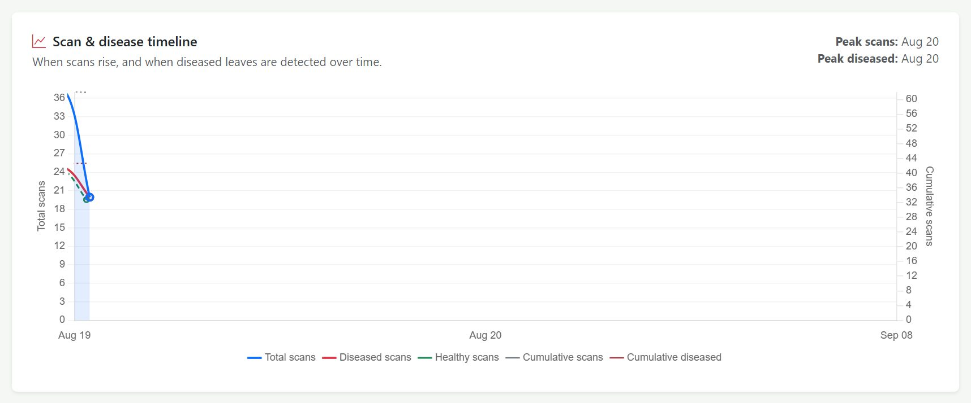
Figure 34. Scan and disease timeline.
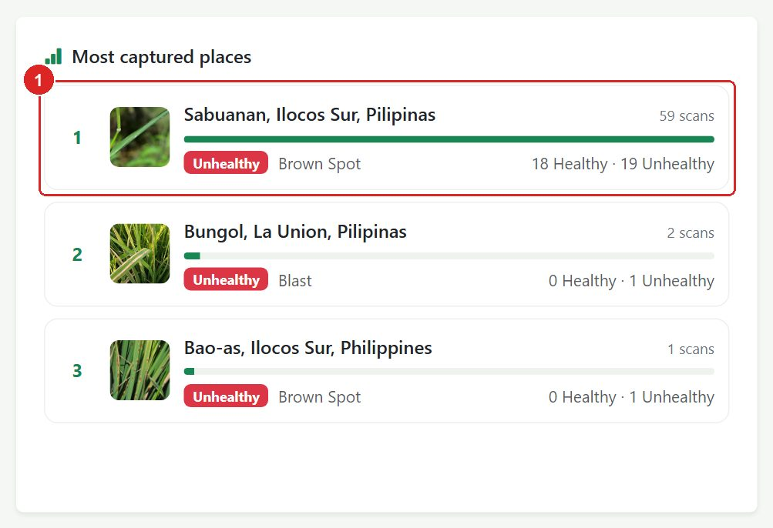
Figure 35. Most captured places. Click a place name (1) to open its detail view.
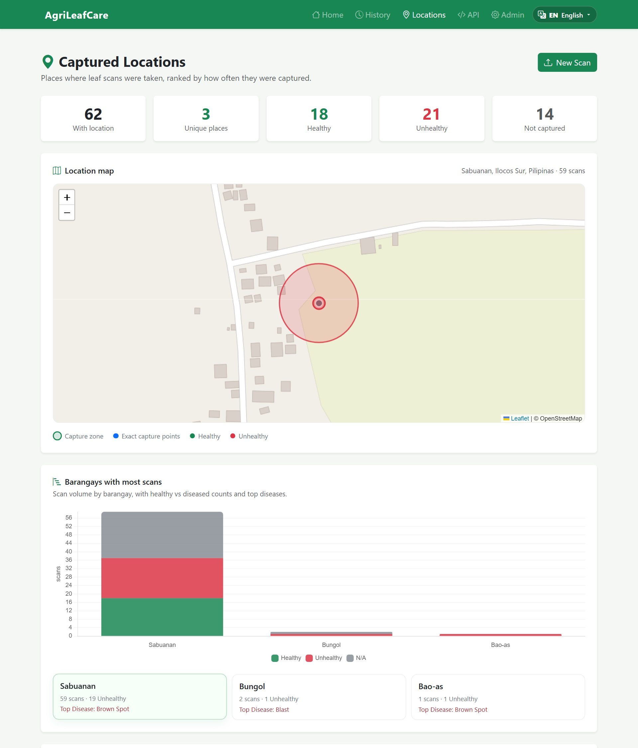
Figure 36. A single place selected: the map, timeline and scan cards are limited to that place. Use 'All places' to go back.
NOTE | Location is only recorded when you allow the browser's location prompt, or when the photo already contains GPS data. Scans without location still appear in History.

7. Using AgriLeafCare on a Phone
The site adapts to small screens. On a phone the menu collapses behind a three-line menu button, the camera opens in full screen, and the location hint is shown under the form.
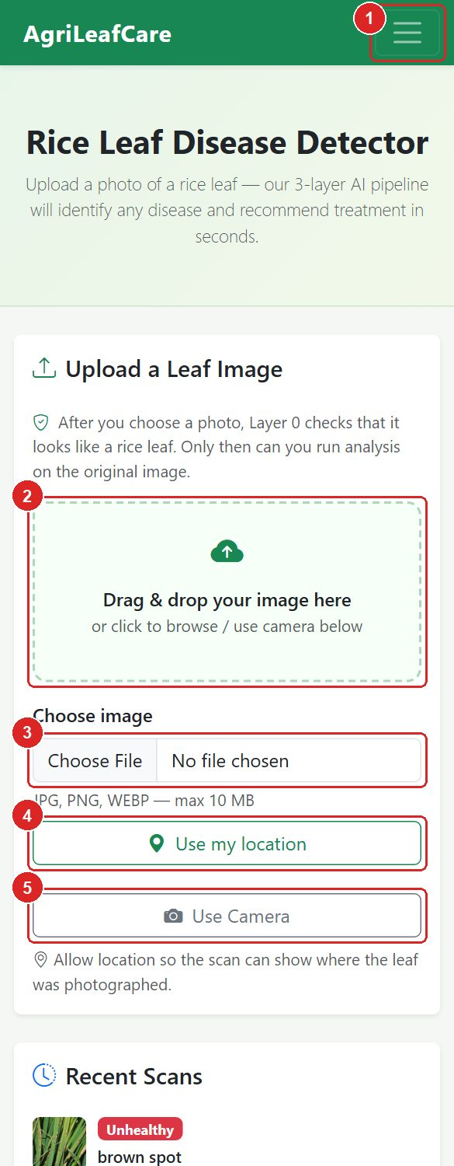 | 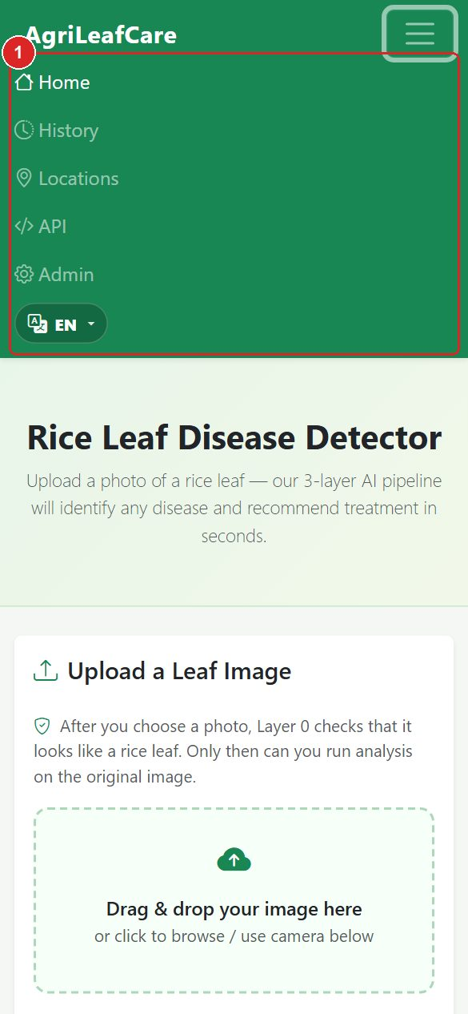
Figure 37. Home page on a phone (left) and the expanded menu after tapping the three-line button (right).
No. | Element | What it is / what it does
1 | Menu button (three lines) | Opens the navigation links and the language menu.
2 | Drop zone | Tap to browse for a photo from the gallery.
3 | Choose image | On most phones this offers 'Camera' or 'Files'.
4 | Use my location | Allow the location prompt so the scan is mapped.
5 | Use Camera | Opens the rear camera inside the page; centre the leaf in the guide box and tap Capture.

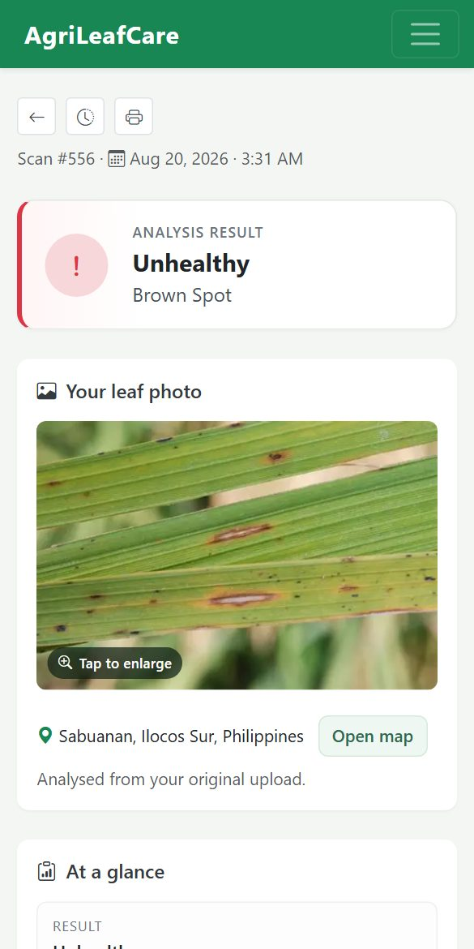 | 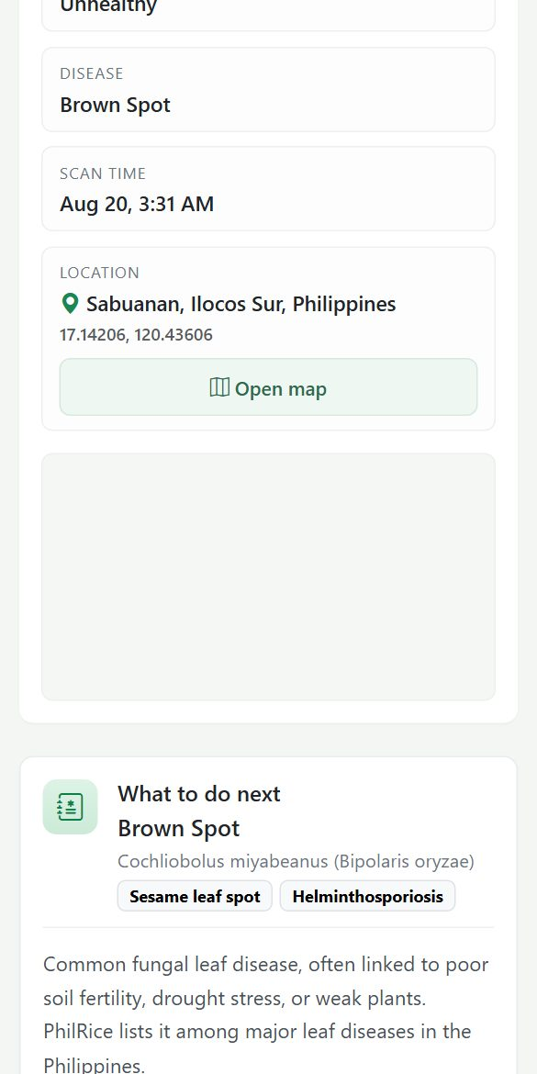 | 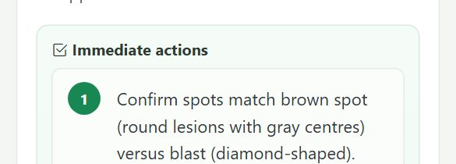
Figure 38. A result page on a phone: the panels stack vertically (read left to right).
IMPORTANT | For the camera and location to work, the site must be opened over HTTPS or on the same computer (localhost). Browsers block camera and GPS on plain HTTP addresses from other devices.

8. Administrator Guide
The administration panel is for staff accounts only. It lets you change the home page text and review, edit or delete scan records.

8.1 Logging in
- Click Admin in the navigation bar, or open /admin/ on the server address.
- Enter your staff username (1) and password (2).
- Press Log in (3).
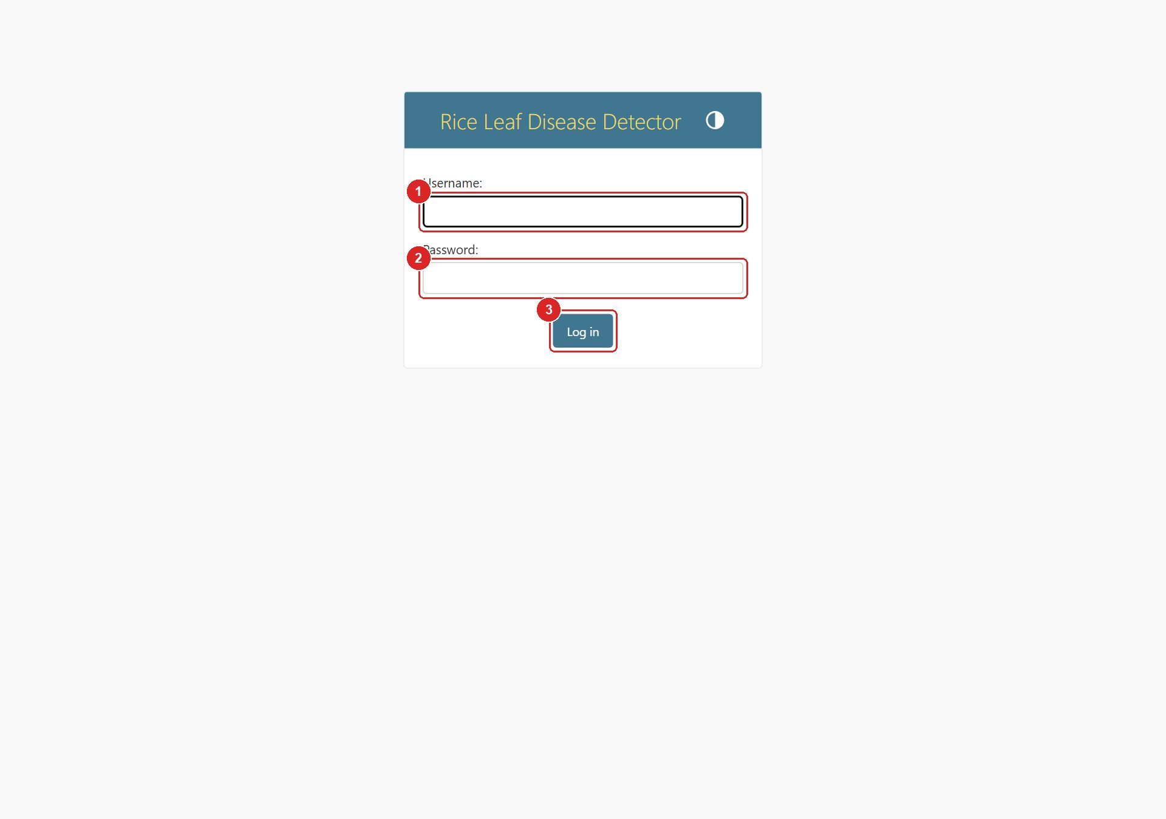
Figure 39. The administrator login page.
NOTE | Accounts are created by the system owner with the command python manage.py createsuperuser. Never share your password. Use Log out (top right) when you finish.

8.2 The dashboard
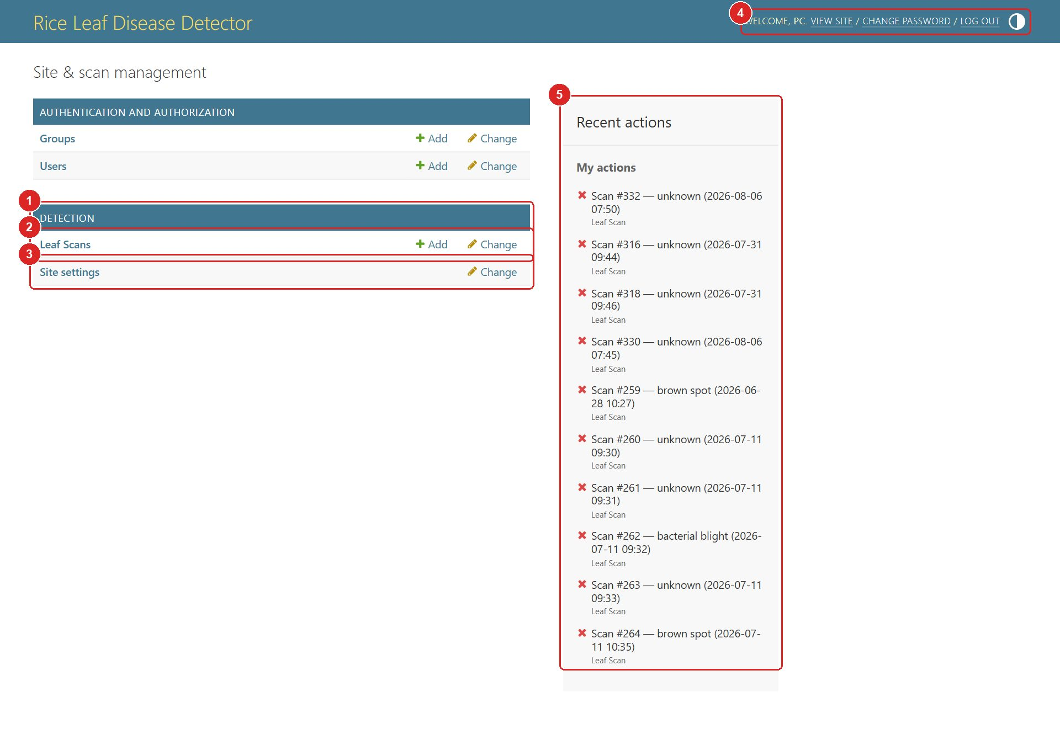
Figure 40. The admin dashboard.
No. | Element | What it is / what it does
1 | Detection app | The two things you can manage: Leaf Scans and Site settings.
2 | Leaf Scans | Open the list of all scans. 'Add' creates a record manually (rarely needed).
3 | Site settings | Change the headline, tagline and site name shown on the home page.
4 | User tools | Your username, 'View site' (opens the public pages), change password, and Log out.
5 | Recent actions | Your latest edits in the admin, for quick access.

8.3 Site settings (home page text)
- On the dashboard click Site settings.
- Edit the Hero title (1), Hero tagline (2) and Site brand (3).
- Press Save (4). The public home page shows the new text immediately (English interface only; Tagalog and Ilocano use their built-in translations).
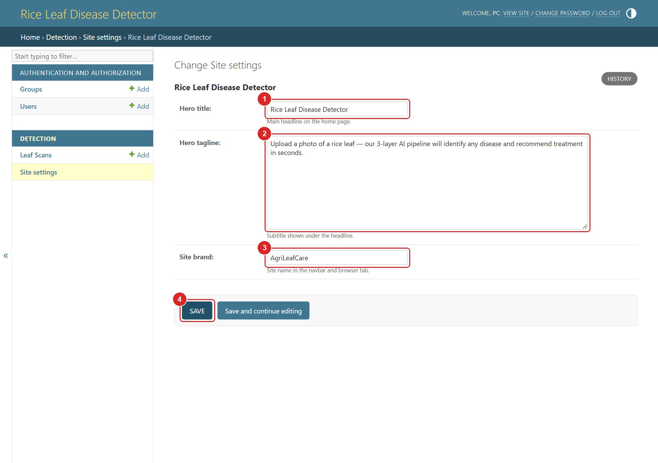
Figure 41. Editing the site settings.

8.4 Managing leaf scans
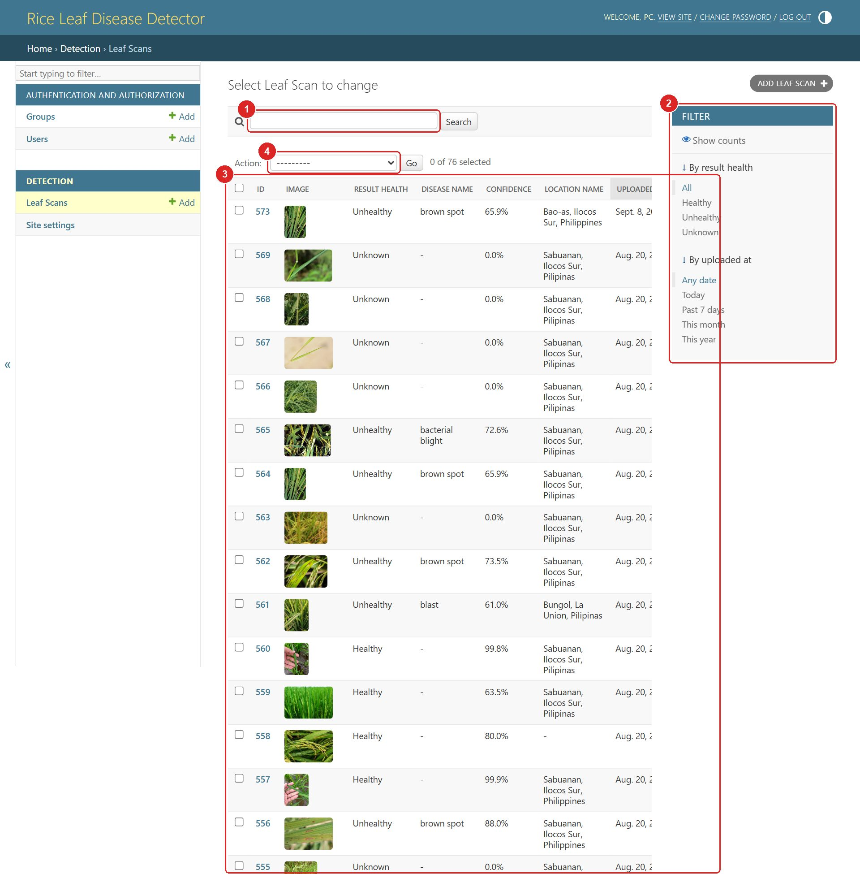
Figure 42. The Leaf Scans list.
No. | Element | What it is / what it does
1 | Search | Search by disease name, recommendation text or place name.
2 | Filters | Filter by result (Healthy / Unhealthy / Unknown) or by upload date.
3 | Scan list | One row per scan: ID, thumbnail, result, disease, confidence, place and date. Click the ID to open it.
4 | Actions | Tick rows, choose 'Delete selected Leaf Scans', then press Go to delete several scans at once.
5 | Paging | Move between pages when the list is long.

8.5 Editing or deleting one scan
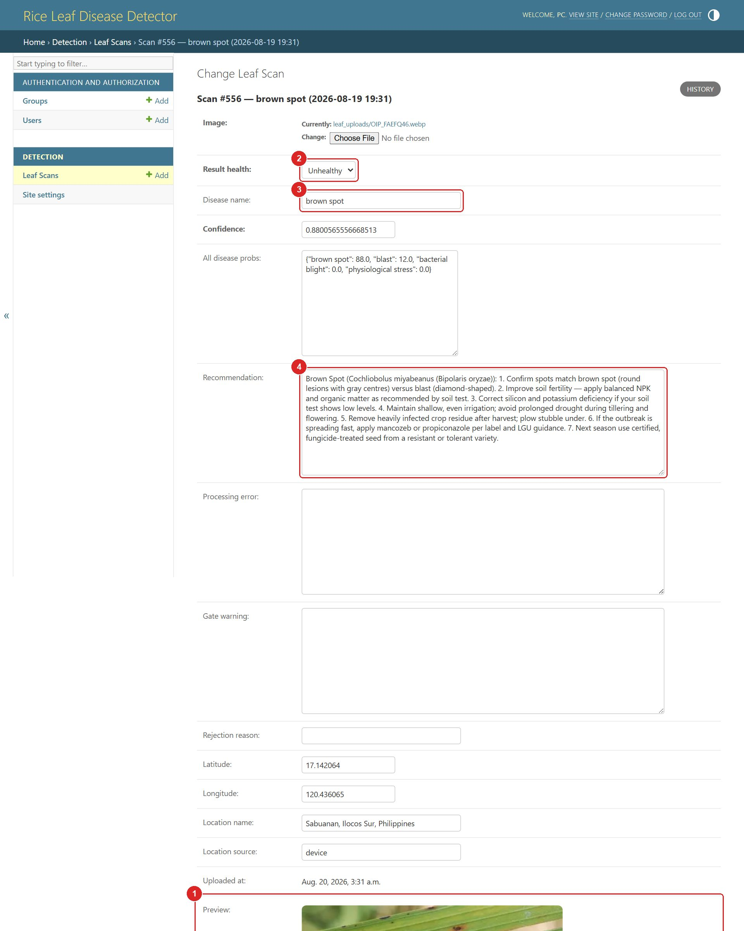
Figure 43. A single scan in the admin. (part 1 of 2)
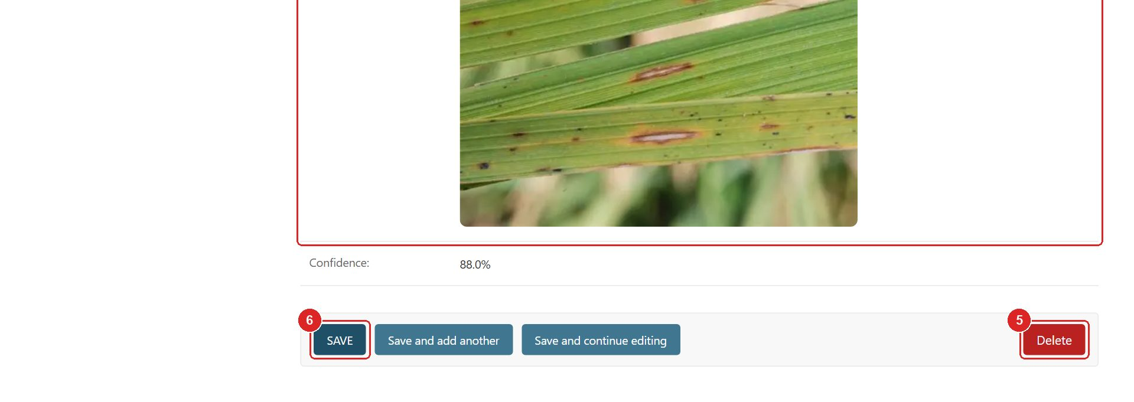
Figure 44. A single scan in the admin. (part 2 of 2)
No. | Element | What it is / what it does
1 | Preview | The uploaded photo (read-only).
2 | Result health | Healthy / Unhealthy / Unknown. Correct it here if a technician confirms a different verdict.
3 | Disease name | Free text, e.g. 'brown spot', 'blast', 'bacterial blight'.
4 | Recommendation | The stored recommendation text shown on the public result page.
5 | Delete | Removes the scan and its photo permanently. A confirmation page appears first.
6 | Save | Save changes. 'Save and continue editing' keeps the page open.

IMPORTANT | Deleting a scan cannot be undone. Export or note down anything you need before deleting.

9. REST API (for developers)
Other software can use AgriLeafCare through a small JSON API. The API link in the navigation bar opens a browsable version of the scan list where you can try requests from the browser.
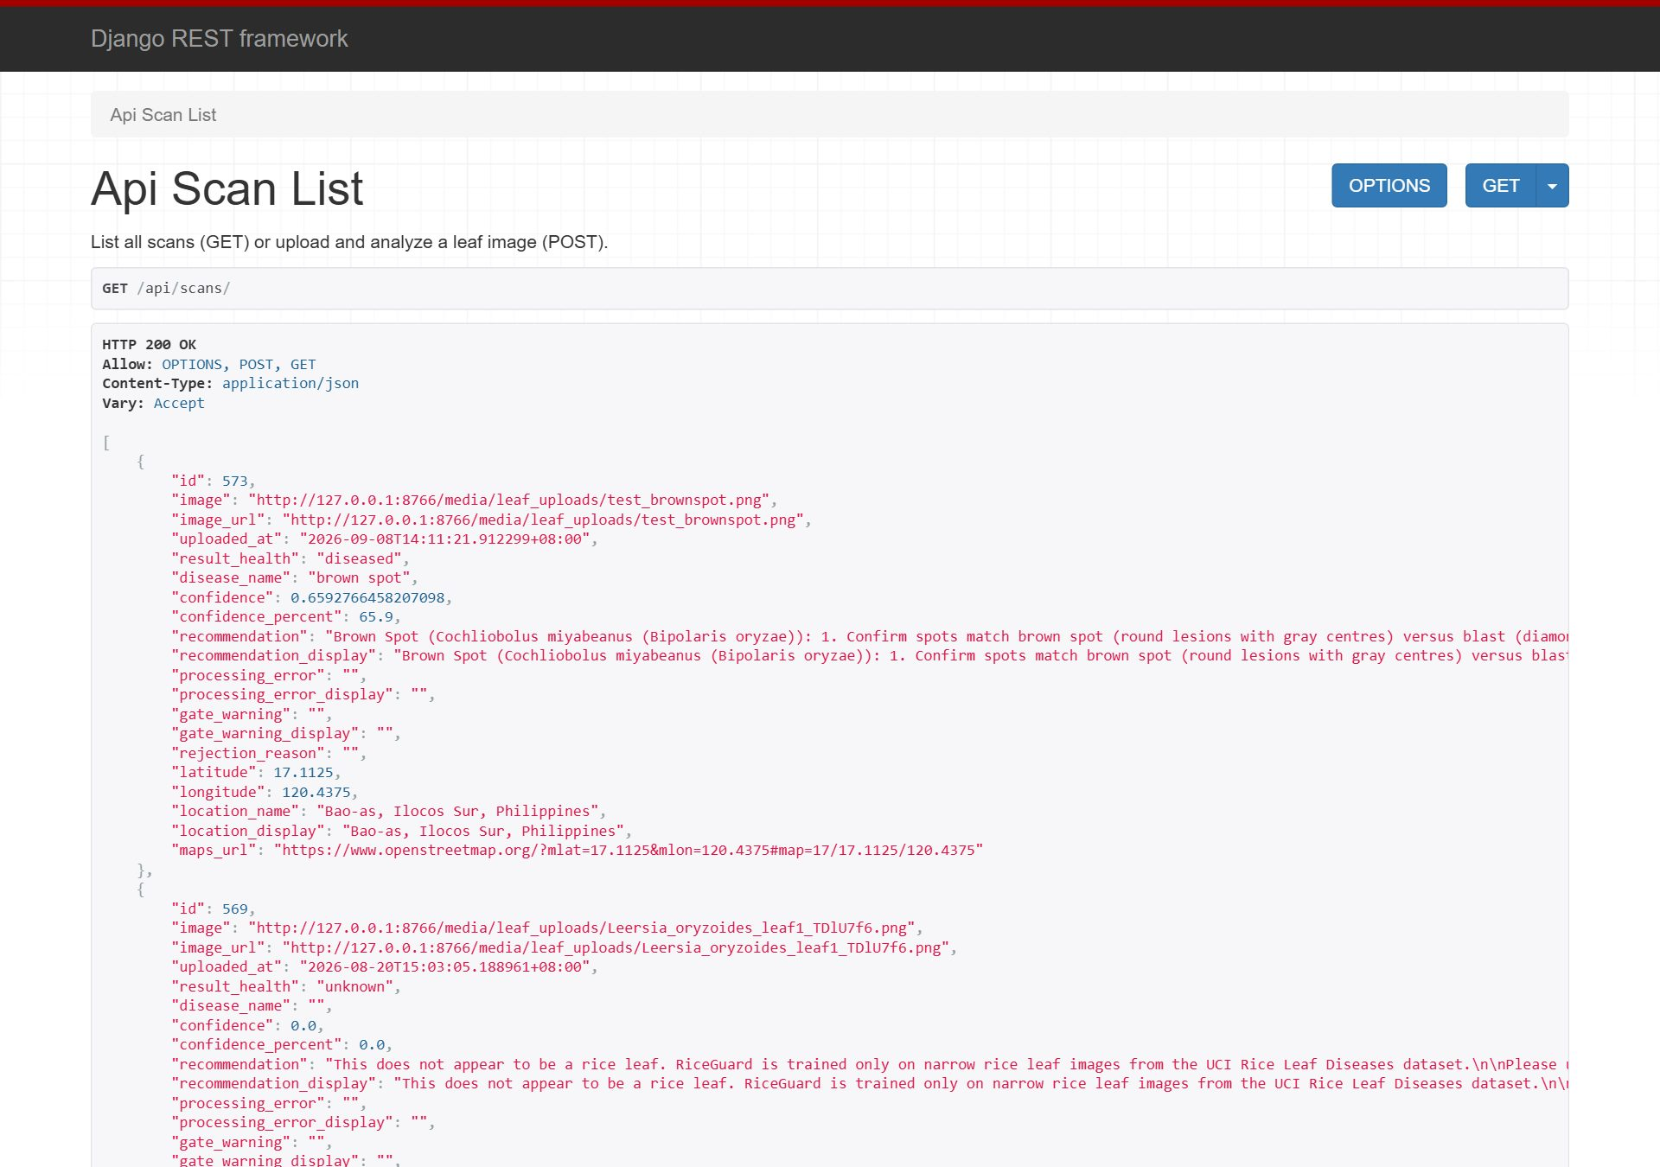
Figure 45. The browsable API page for the scan list.
Method and path | Purpose
GET /api/scans/ | List all scans as JSON. Add ?health=healthy, diseased or unknown to filter.
GET /api/scans/<id>/ | One scan: verdict, disease, confidence, probabilities, recommendation, location and image URL.
POST /api/scans/ (or /api/scan/) | Upload a photo as multipart form field image; optional latitude / longitude. Returns the analysed scan.
POST /api/validate-layer0/ | Run only the rice-leaf check on an image and get a warning if it does not look like a rice leaf.
POST /api/locate/ | Turn GPS coordinates (or a photo's EXIF data) into a place name.
GET /lang/<en|fil|ilo>/ | Set the interface language cookie.

Example with curl:
curl -X POST http://<server>:8000/api/scans/ -F "image=@leaf.jpg" -F "latitude=17.11" -F "longitude=120.43"

10. Troubleshooting and FAQ
What you see | Why it happens | What to do
Unsupported file format | The file is not JPG, PNG or WEBP (for example HEIC, PDF or a document). | Convert or re-save the photo as JPG or PNG, then upload again.
File is too large | The image is over 10 MB. | Use a smaller photo or lower the camera resolution.
This photo may not show a clear rice leaf | The Layer 0 leaf check is not confident. | Retake: one leaf, close up, plain background, good light. You may still analyse, but expect a less reliable result.
Not a Rice Leaf verdict | The photo shows another plant, a whole field, or an unrelated object. | Photograph a single rice leaf blade and scan again.
Unknown verdict | The AI could not decide confidently, or the top two diseases were too close. | Take a sharper, closer photo of the affected area.
Location: Not captured | Location permission was refused, GPS is off, or the page is not on HTTPS. | Turn on GPS, allow the browser prompt, and press 'Use my location' again.
Camera not available | The browser has no camera permission, or the page is on plain HTTP. | Allow the camera in the browser settings, or choose a photo from the gallery instead.
Analysis could not finish | The connection dropped while the server was working. | Check the network and press Analyse Leaf again.
Scan not found | The scan was deleted by an administrator or the link is wrong. | Open History and pick the scan from the list.
Page shows Ilocano text | No language was chosen yet; Ilocano is the default. | Use the language menu to switch to English or Tagalog.

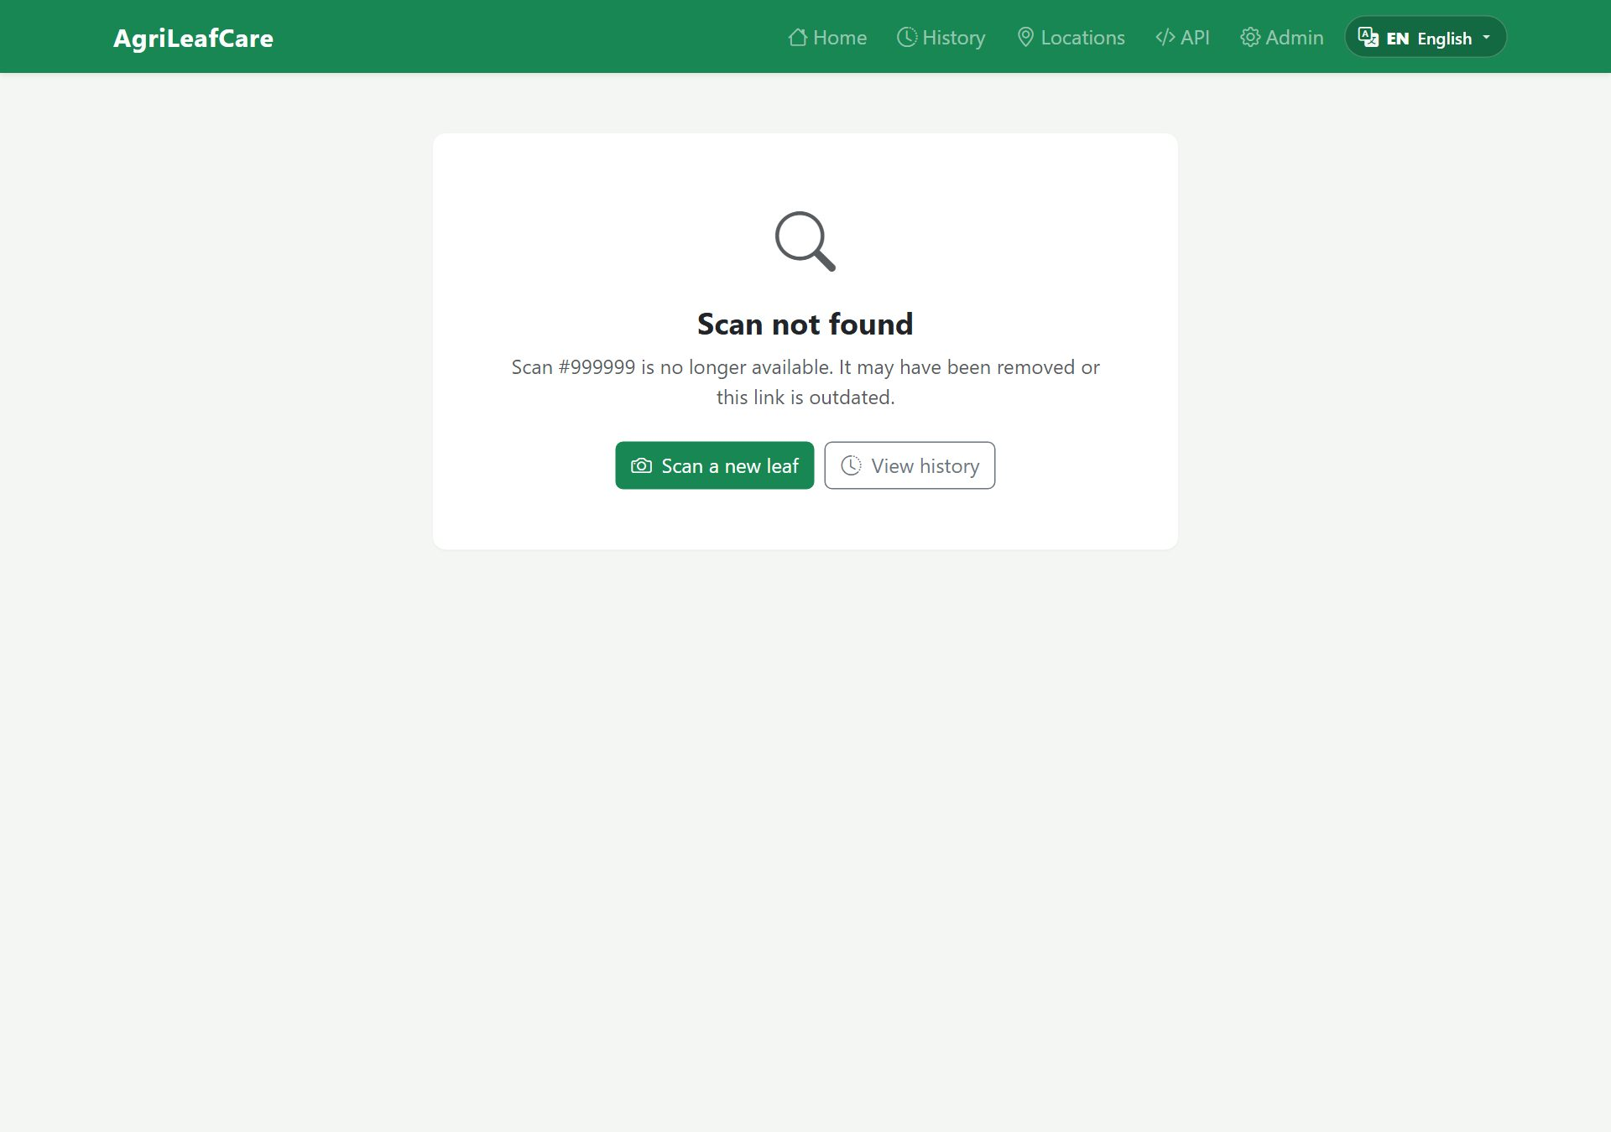
Figure 46. The 'Scan not found' page offers links to scan a new leaf or open History.

10.1 Glossary
Term | Meaning
Layer 0 / leaf check | The first stage that verifies the photo looks like a rice leaf before any diagnosis.
Confidence | How sure the AI is about its answer, from 0% to 100%. Higher is better.
Verdict | The main result: Healthy, Unhealthy, Not a Rice Leaf, or Unknown.
FPA | Fertilizer and Pesticide Authority — only FPA-registered products are listed in the guide.
PHI | Pre-harvest interval: the days you must wait between the last spray and harvest.
MAO | Municipal Agriculture Office — your local source for confirmation and advice.
PhilRice | Philippine Rice Research Institute, whose recommendations the treatment guides follow.
EXIF GPS | Location information some cameras store inside the photo file.

