Wifi Network Operation Management System (NOMS WIFI) Modul Admin

2019



4k

|  |  |  |  |  |
| --- | --- | --- | --- | --- |
|  |  |  |  |  |
|  |  |  |  |  |
|  |  |  |  |  |
|  |  |  |  |  |
|  |  |  |  |  |

~~Zx wersgd~~

*AMAL COPYRIGHT*

The information contained in this document is the copyright of PT Telekomunikasi Indonesia, Tbk – TELKOM and is issued in confidence only for the purpose for which it is supplied. It must not be reproduced, in whole or in part, or used for tendering or any other purposes except under an agreement with or with the consent in writing of PT Telekomunikasi Indonesia, Tbk - TELKOM and then only on the AL COPYRIGHT

The information contained in this document is the copyright of PT Telekomunikasi Indonesia, Tbk – TELKOM and is issued in confidence only for the purpose for which it is supplied. It must not be reproduced, in whole or in part, or used for tendering or any other purposes except under an agreement with or with the consent in writing of PT Telekomunikasi Indonesia, Tbk - TELKOM and then only on the AL COPYRIGHT

The information contained in this document is the copyright of PT Telekomunikasi Indonesia, Tbk – TELKOM and is issued in confidence only for the purpose for which it is supplied. It must not be reproduced, in whole or in part, or used for tendering or any other purposes except under an agreement with or with the consent in writing of PT Telekomunikasi Indonesia, Tbk - TELKOM and then only on the AL COPYRIGHT

The information contained in this document is the copyright of PT Telekomunikasi Indonesia, Tbk – TELKOM and is issued in confidence only for the purpose for which it is supplied. It must not be reproduced, in whole or in part, or used for tendering or any other purposes except under an agreement with or with the consent in writing of PT Telekomunikasi Indonesia, Tbk - TELKOM and then only on the AL COPYRIGHT

The information contained in this document is the copyright of PT Telekomunikasi Indonesia, Tbk – TELKOM and is issued in confidence only for the purpose for which it is supplied. It must not be reproduced, in whole or in part, or used for tendering or any other purposes except under an agreement with or with the consent in writing of PT Telekomunikasi Indonesia, Tbk - TELKOM and then only on the AL COPYRIGHT

The information contained in this document is the copyright of PT Telekomunikasi Indonesia, Tbk – TELKOM and is issued in confidence only for the purpose for which it is supplied. It must not be reproduced, in whole or in part, or used for tendering or any other purposes except under an agreement with or with the consent in writing of PT Telekomunikasi Indonesia, Tbk - TELKOM and then only on the AL COPYRIGHT

The information contained in this document is the copyright of PT Telekomunikasi Indonesia, Tbk – TELKOM and is issued in confidence only for

the purpose for which it is supplied. It must not be reproduced, in whole or in part, or used for tendering or any other purposes except under an agreement with or with the consent in writing of PT Telekomunikasi Indonesia, Tbk - TELKOM and then only on the AL COPYRIGHT

The information contained in this document is the copyright of PT Telekomunikasi Indonesia, Tbk – TELKOM and is issued in confidence only for the purpose for which it is supplied. It must not be reproduced, in whole or in part, or used for tendering or any other purposes except under an agreement with or with the consent in writing of PT Telekomunikasi Indonesia, Tbk - TELKOM and then only on the AL COPYRIGHT

The information contained in this document is the copyright of PT Telekomunikasi Indonesia, Tbk – TELKOM and is issued in confidence only for the purpose for which it is supplied. It must not be reproduced, in whole or in part, or used for tendering or any other purposes except under an agreement with or with the consent in writing of PT Telekomunikasi Indonesia, Tbk - TELKOM and then only on the AL COPYRIGHT

The information contained in this document is the copyright of PT Telekomunikasi Indonesia, Tbk – TELKOM and is issued in confidence only for the purpose for which it is supplied. It must not be reproduced, in whole or in part, or used for tendering or any other purposes except under an agreement with or with the consent in writing of PT Telekomunikasi Indonesia, Tbk - TELKOM and then only on the AL COPYRIGHT

The information contained in this document is the copyright of PT Telekomunikasi Indonesia, Tbk – TELKOM and is issued in confidence only for the purpose for which it is supplied. It must not be reproduced, in whole or in part, or used for tendering or any other purposes except under an agreement with or with the consent in writing of PT Telekomunikasi Indonesia, Tbk - TELKOM and then only on the AL COPYRIGHT

The information contained in this document is the copyright of PT Telekomunikasi Indonesia, Tbk – TELKOM and is issued in confidence only for the purpose for which it is supplied. It must not be reproduced, in whole or in part, or used for tendering or any other purposes except under an agreement with or with the consent in writing of PT Telekomunikasi Indonesia, Tbk - TELKOM and then only on the AL COPYRIGHT

The information contained in this document is the copyright of PT Telekomunikasi Indonesia, Tbk – TELKOM and is issued in confidence only for the purpose for which it is supplied. It must not be reproduced, in whole or in part, or used for tendering or any other purposes except under an agreement with or with the consent in writing of PT Telekomunikasi Indonesia, Tbk - TELKOM and then only on the AL COPYRIGHT

The information contained in this document is the copyright of PT Telekomunikasi Indonesia, Tbk – TELKOM and is issued in confidence only for the purpose for which it is supplied. It must not be reproduced, in whole or in part, or used for tendering or any other purposes except under an agreement with or with the consent in writing of PT Telekomunikasi Indonesia, Tbk - TELKOM and then only on the AL COPYRIGHT

The information contained in this document is the copyright of PT Telekomunikasi Indonesia, Tbk – TELKOM and is issued in confidence only for the purpose for which it is supplied. It must not be reproduced, in whole or in part, or used for tendering or any other purposes except under an agreement with or with the consent in writing of PT Telekomunikasi Indonesia, Tbk - TELKOM and then only on the AL COPYRIGHT

The information contained in this document is the copyright of PT Telekomunikasi Indonesia, Tbk – TELKOM and is issued in confidence only for the purpose for which it is supplied. It must not be reproduced, in whole or in part, or used for tendering or any other purposes except under an agreement with or with the consent in writing of PT Telekomunikasi Indonesia, Tbk - TELKOM and then only on the AL COPYRIGHT

The information contained in this document is the copyright of PT Telekomunikasi Indonesia, Tbk – TELKOM and is issued in confidence only for the purpose for which it is supplied. It must not be reproduced, in whole or in part, or used for tendering or any other purposes except under an agreement with or with the consent in writing of PT Telekomunikasi Indonesia, Tbk - TELKOM and then only on the AL COPYRIGHT

The information contained in this document is the copyright of PT Telekomunikasi Indonesia, Tbk – TELKOM and is issued in confidence only for the purpose for which it is supplied. It must not be reproduced, in whole or in part, or used for tendering or any other purposes except under an agreement with or with the consent in writing of PT Telekomunikasi Indonesia, Tbk - TELKOM and then only on the AL COPYRIGHT

The information contained in this document is the copyright of PT Telekomunikasi Indonesia, Tbk – TELKOM and is issued in confidence only for the purpose for which it is supplied. It must not be reproduced, in whole or in part, or used for tendering or any other purposes except under an agreement with or with the consent in writing of PT Telekomunikasi Indonesia, Tbk - TELKOM and then only on the AL COPYRIGHT

The information contained in this document is the copyright of PT Telekomunikasi Indonesia, Tbk – TELKOM and is issued in confidence only for the purpose for which it is supplied. It must not be reproduced, in whole or in part, or used for tendering or any other purposes except under an agreement with or with the consent in writing of PT Telekomunikasi Indonesia, Tbk - TELKOM and then only on the AL COPYRIGHT

The information contained in this document is the copyright of PT Telekomunikasi Indonesia, Tbk – TELKOM and is issued in confidence only for the purpose for which it is supplied. It must not be reproduced, in whole or in part, or used for tendering or any other purposes except under an agreement with or with the consent in writing of PT Telekomunikasi Indonesia, Tbk - TELKOM and then only on the AL COPYRIGHT

The information contained in this document is the copyright of PT Telekomunikasi Indonesia, Tbk – TELKOM and is issued in confidence only for the purpose for which it is supplied. It must not be reproduced, in whole or in part, or used for tendering or any other purposes except under an agreement with or with the consent in writing of PT Telekomunikasi Indonesia, Tbk - TELKOM and then only on the AL COPYRIGHT

The information contained in this document is the copyright of PT Telekomunikasi Indonesia, Tbk – TELKOM and is issued in confidence only for the purpose for which it is supplied. It must not be reproduced, in whole or in part, or used for tendering or any other purposes except under an agreement with or with the consent in writing of PT Telekomunikasi Indonesia, Tbk - TELKOM and then only on the AL COPYRIGHT

The information contained in this document is the copyright of PT Telekomunikasi Indonesia, Tbk – TELKOM and is issued in confidence only for the purpose for which it is supplied. It must not be reproduced, in whole or in part, or used for tendering or any other purposes except under an agreement with or with the consent in writing of PT Telekomunikasi Indonesia, Tbk - TELKOM and then only on the AL COPYRIGHT

The information contained in this document is the copyright of PT Telekomunikasi Indonesia, Tbk – TELKOM and is issued in confidence only for the purpose for which it is supplied. It must not be reproduced, in whole or in part, or used for tendering or any other purposes except under an agreement with or with the consent in writing of PT Telekomunikasi Indonesia, Tbk - TELKOM and then only on the AL COPYRIGHT

The information contained in this document is the copyright of PT Telekomunikasi Indonesia, Tbk – TELKOM and is issued in confidence only for the purpose for which it is supplied. It must not be reproduced, in whole or in part, or used for tendering or any other purposes except under an agreement with or with the consent in writing of PT Telekomunikasi Indonesia, Tbk - TELKOM and then only on the AL COPYRIGHT

The information contained in this document is the copyright of PT Telekomunikasi Indonesia, Tbk – TELKOM and is issued in confidence only for the purpose for which it is supplied. It must not be reproduced, in whole or in part, or used for tendering or any other purposes except under an agreement with or with the consent in writing of PT Telekomunikasi Indonesia, Tbk - TELKOM and then only on the AL COPYRIGHT

The information contained in this document is the copyright of PT Telekomunikasi Indonesia, Tbk – TELKOM and is issued in confidence only for the purpose for which it is supplied. It must not be reproduced, in whole or in part, or used for tendering or any other purposes except under an agreement with or with the consent in writing of PT Telekomunikasi Indonesia, Tbk - TELKOM and then only on the AL COPYRIGHT

The information contained in this document is the copyright of PT Telekomunikasi Indonesia, Tbk – TELKOM and is issued in confidence only for the purpose for which it is supplied. It must not be reproduced, in whole or in part, or used for tendering or any other purposes except under an agreement with or with the consent in writing of PT Telekomunikasi Indonesia, Tbk - TELKOM and then only on the AL COPYRIGHT

The information contained in this document is the copyright of PT Telekomunikasi Indonesia, Tbk – TELKOM and is issued in confidence only for the purpose for which it is supplied. It must not be reproduced, in whole or in part, or used for tendering or any other purposes except under an agreement with or with the consent in writing of PT Telekomunikasi Indonesia, Tbk - TELKOM and then only on the AL COPYRIGHT

The information contained in this document is the copyright of PT Telekomunikasi Indonesia, Tbk – TELKOM and is issued in confidence only for the purpose for which it is supplied. It must not be reproduced, in whole or in part, or used for tendering or any other purposes except under an agreement with or with the consent in writing of PT Telekomunikasi Indonesia, Tbk - TELKOM and then only on the AL COPYRIGHT

The information contained in this document is the copyright of PT Telekomunikasi Indonesia, Tbk – TELKOM and is issued in confidence only for the purpose for which it is supplied. It must not be reproduced, in whole or in part, or used for tendering or any other purposes except under an agreement with or with the consent in writing of PT Telekomunikasi Indonesia, Tbk - TELKOM and then only on the AL COPYRIGHT

The information contained in this document is the copyright of PT Telekomunikasi Indonesia, Tbk – TELKOM and is issued in confidence only for the purpose for which it is supplied. It must not be reproduced, in whole or in part, or used for tendering or any other purposes except under an agreement with or with the consent in writing of PT Telekomunikasi Indonesia, Tbk - TELKOM and then only on the AL COPYRIGHT

The information contained in this document is the copyright of PT Telekomunikasi Indonesia, Tbk – TELKOM and is issued in confidence only for the purpose for which it is supplied. It must not be reproduced, in whole or in part, or used for tendering or any other purposes except under an agreement with or with the consent in writing of PT Telekomunikasi Indonesia, Tbk - TELKOM and then only on the AL COPYRIGHT

The information contained in this document is the copyright of PT Telekomunikasi Indonesia, Tbk – TELKOM and is issued in confidence only for the purpose for which it is supplied. It must not be reproduced, in whole or in part, or used for tendering or any other purposes except under an agreement with or with the consent in writing of PT Telekomunikasi Indonesia, Tbk - TELKOM and then only on the condition that this note be included in such reproduction.

# Document Control

## Version History

|  |  |  |  |
| --- | --- | --- | --- |
| Version | Date | Author | Change Description |
| v.0.0.1 | 29 Juli 2019 |  | Init Draft |
|  |  |  |  |

**Document Information**

|  |  |
| --- | --- |
| File Name | Location |
| Inventory Readiness | Google drive |

## Related Documents

|  |  |  |
| --- | --- | --- |
| Document # | Document Title | Location |
|  |  |  |
|  |  |  |

**References**

|  |  |
| --- | --- |
| Document Title | Location |
|  |  |
|  |  |

## Contributors

|  |  |
| --- | --- |
| Contributor Name | Responsibility |
|  |  |
|  |  |

|  |  |
| --- | --- |
|  |  |
|  |  |
|  |  |
|  |  |
|  |  |

**Approvals**

|  |  |  |  |
| --- | --- | --- | --- |
| Name | Title, Department | Signature | Date |
|  |  |  |  |
|  |  |  |  |

## Access to application

|  |  |
| --- | --- |
| Access | Link |
| Production | https://noms.wiﬁ.id:9977 |
| Development |  |

|  |  |
| --- | --- |
|  |  |



dipra



Document Control Version History

Document Information Related Documents References Contributors [Approvals](https://docs.google.com/document/d/1K-FutYE1MuxxyTyAHHgF6R8OD7xvbGi_/edit#heading%3Dh.4d34og8)

Access to application Contents

Menu Login

Menu Utama

Preference Management

{Category

Query Daftar Category Category -> New Category Category -> Edit

Category -> Add Reference Object

Category -> Add Reference Object - New Reference Object - None

Category -> Add Reference Object - New Reference Object - Object Role Category -> Add Reference Object - New Reference Object - Object Type Category -> Add Reference Object - New Reference Object - Object Model Category -> Add Reference Object - New Reference Object - Dynamic Value

-**Loading terooooossss**

}

Reference Object

Query Daftar Reference Obje Reference Object -> Edit

Reference Object -> New Reference Object Reference Object -> New Reference Object -> None

Reference Object -> New Reference Object - Object Role Reference Object -> New Reference Object -> Object Type Reference Object -> New Reference Object -> Object Model Reference Object -> New Reference Object -> Dynamic Value

Specification

Query Daftar Specification Specification -> Edit

Specification -> New Specification Manufacturer

Query Daftar Manufacturer Manufacturer - Edit

Manufacturer -> Add Network Type Manufacturer -> New Manufacturer Manufacturer -> New Manufacturer

Network Access Management NE - NMS Association

{ NE - Association - Network Element Registration -Network target UIMax NE - Association - Network Element Registration -Network target NOMS

-filter pencarian sudah tak berfungsi sama sekali

}

NE - Association - List Network Element

List Network Element - Query Daftar Network Element List Network Element - Edit

Network Access Control

Network Access Control - Network User Access Registration - Network Target UImax Network Access Control - Network User Access Registration - Network Target NOMS Network Access Control - List Network User Access

List Network User Access - Quer Daftar Network User Access

List Network user access - Edit

General Command Definition -> Create General Command General Command -> Create General Command Name General Command -> Command Group Registration General Command -> Create Authorization Class

General Command Definition -> List General Command General Command List - Query Daftar Command List General Command List - Edit General Command

Network Command Definition -> Create Network Command Network Command Definition -> Network Command Registration Network Command Registration -> General Command

Network Command Definition -> New Group Network Command Definition -> New Auth Class

Network Command Definition -> List Network Command Network Command Definition -> List Network Command Network Command List - Query daftar network command List Network Command List - Edit

# Menu Login

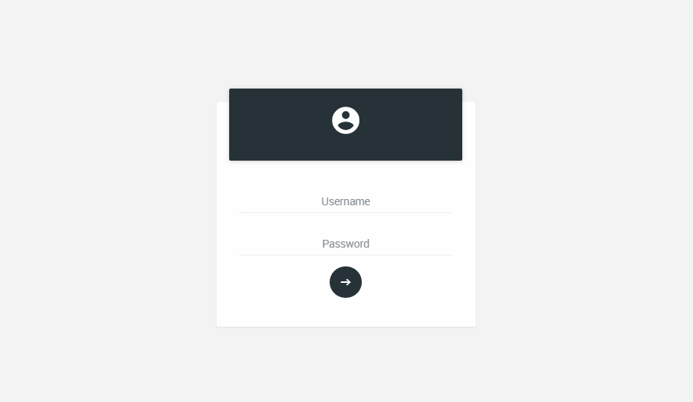

Untuk dapat masuk ke aplikasi, isikan username dan password (gunakan username & password) yang sudah terdaftar di NOMS Wiﬁ (Wiﬁ Network Operation Management System), kemudian klik sign In.

# Menu Utama

Arahkan kursor ke pojok kiri atas dari caption *“WIFI-NOMS”*, untuk menampilkan daftar menu-menu yang ada di aplikasi.

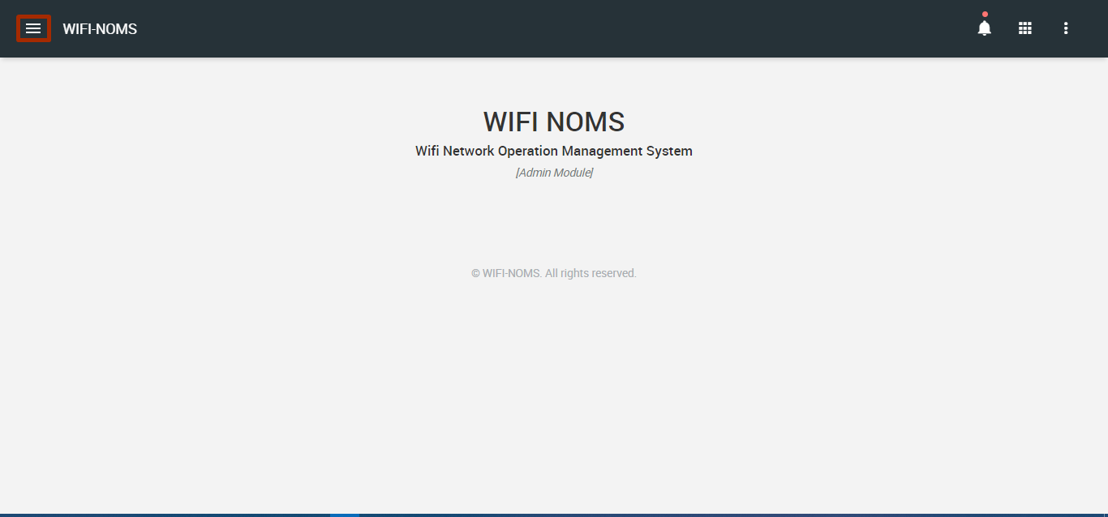

* 1. **Preference Management**

Untuk mengakses menu preference management, arahkan kursor pada pojok kiri atas dari caption *“NOMS-WIFI”*, dan selanjutnya pilih *“Preference Management”* , setelah menu diatas dipilih, maka window akan menampilkan daftar menu yang ada di dalam menu *“Preference Management”* seperti terlihat pada gambar di bawah ini.

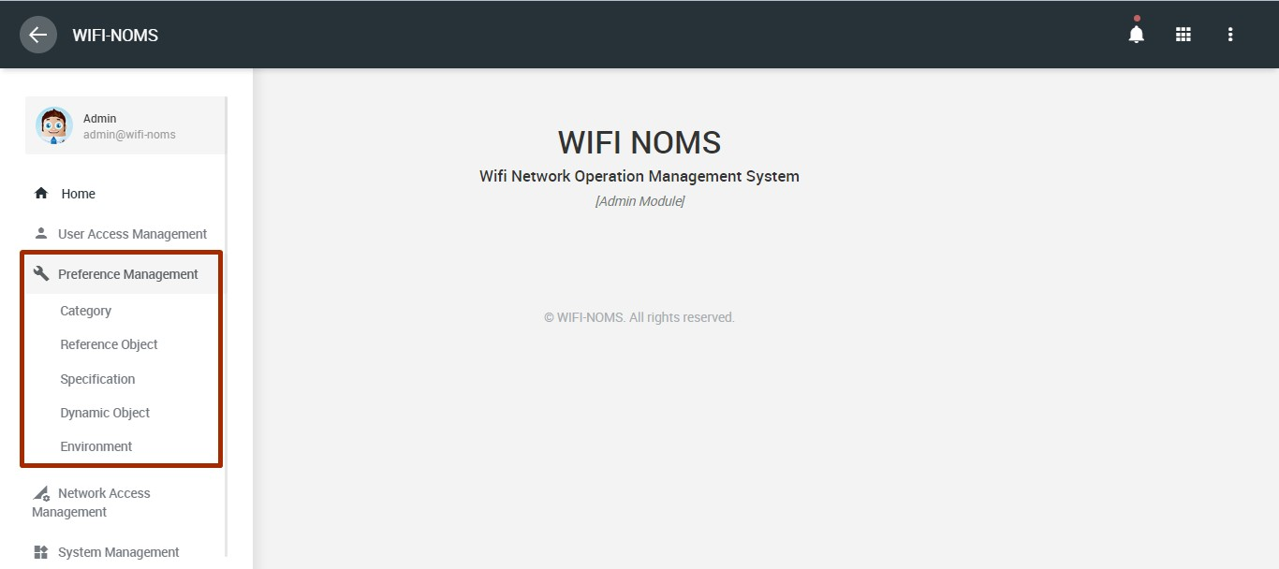

* + 1. **Category**

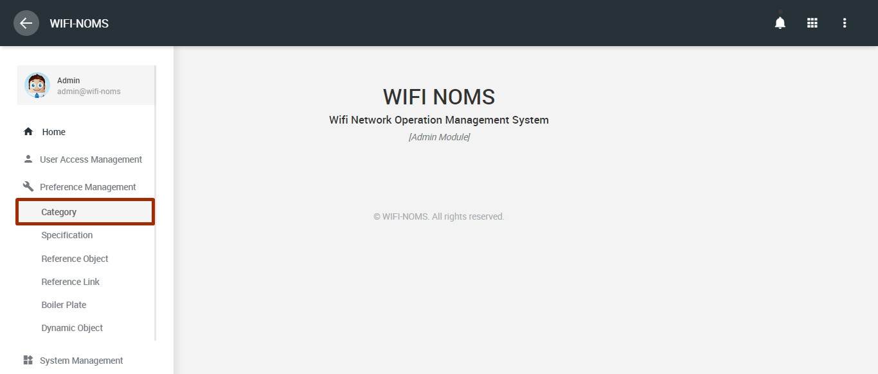

Pada menu preference management pilih *“category”*, setelah menu dipilih, maka window

akan menampilkan list data *“category”* yang ada dalam aplikasi, akan terlihat seperti pada gambar di bawah ini.

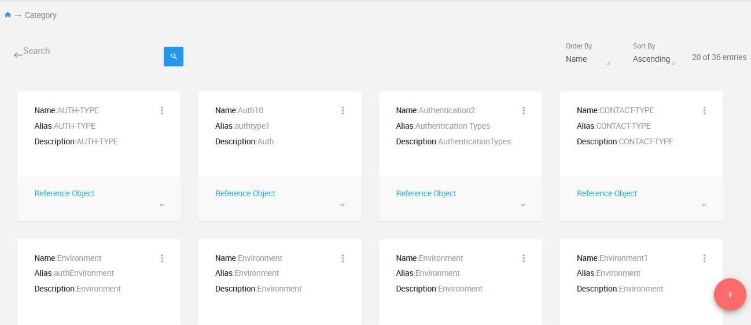

1. **Query Daftar Category**

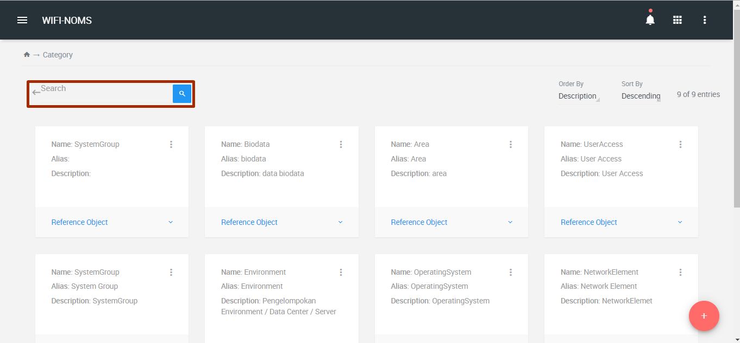

Untuk query data pada daftar list *“category”* masukan nama yang akan di cari di dalam kolom search berdasarkan nama category yang diinginkan misal *“****Network Elemen****”* diikuti tombol ***ENTER*** hasilnya akan terlihat seperti gambar dibawah

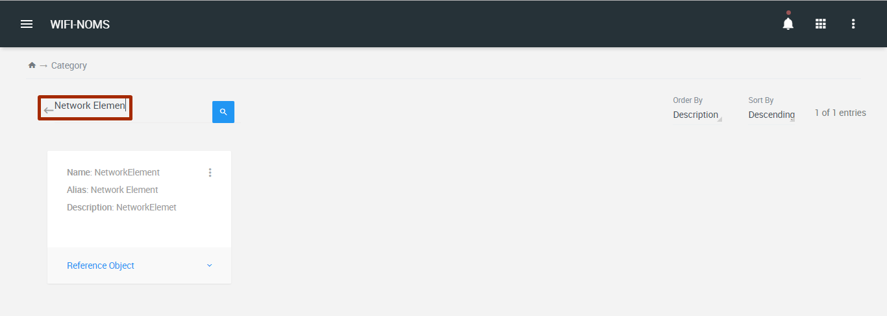

#### Category -> New Category

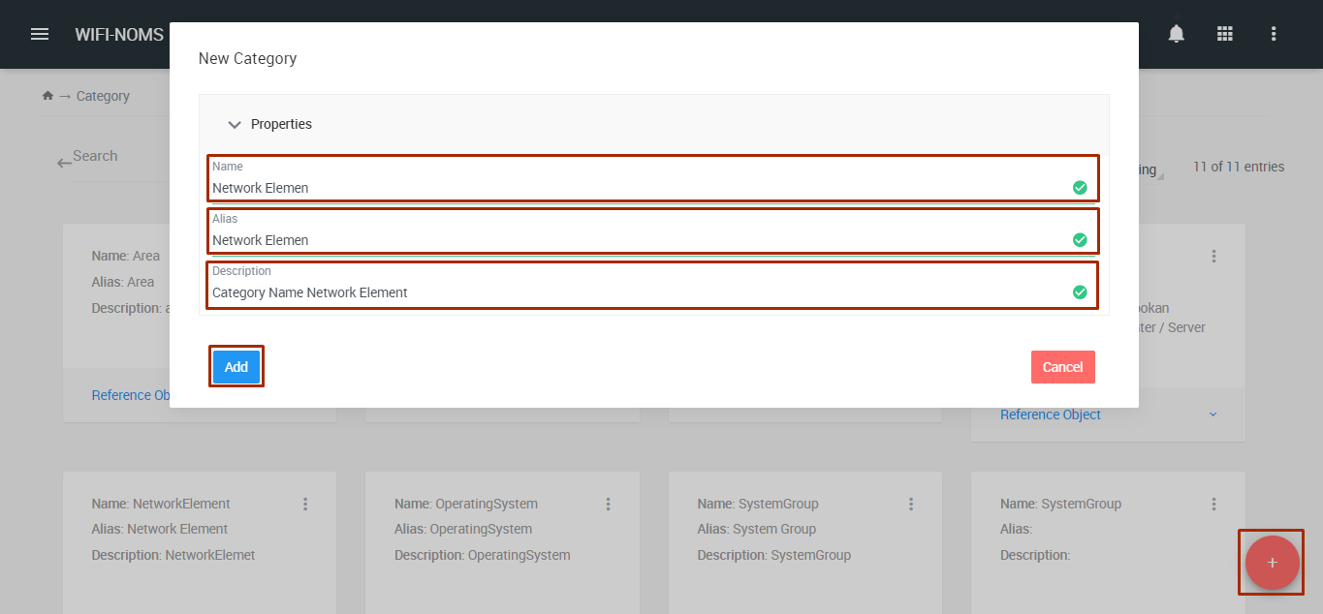

Untuk menambah suatu *“category”* baru, klik icon add yang di pojok kiri bawa pada halaman list category, maka window akan menampilkan halaman *“new category”*. Pada tampilan *“new category, input nama category yang akan ditambahkan, input alias nama dari category dan input description”*, kemudian klik button *“add”*.

#### Category -> Edit

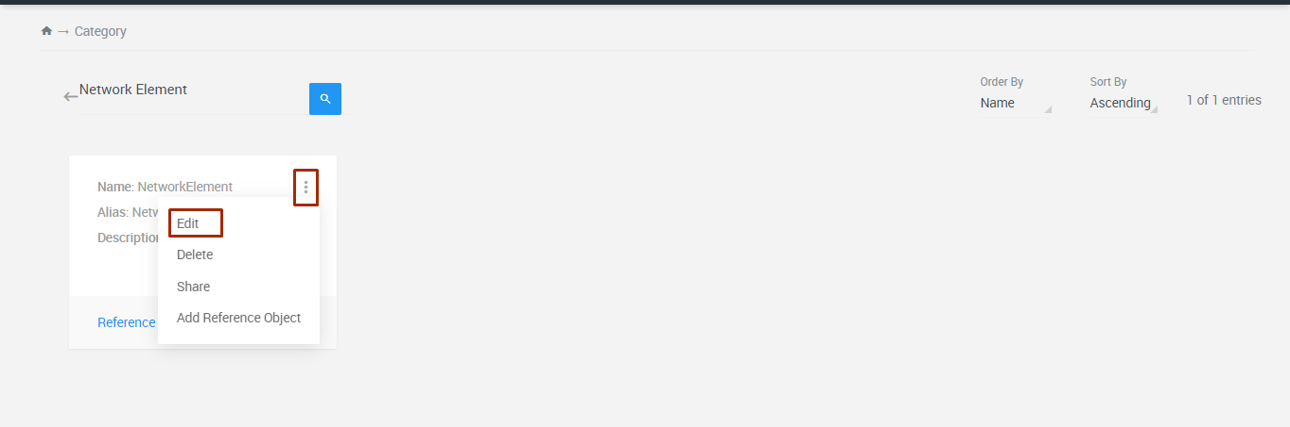

Untuk edit suatu *“category”* klik icon *“action bar”* di sebelah kanan atas data card category, maka window akan menampilkan halaman edit dari category yang akan di edit.

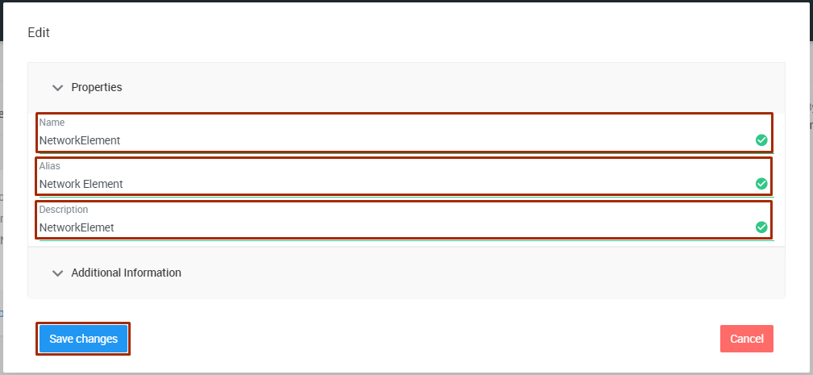

Pada form edit, pilih ﬁeld yang akan di edit, kemudian klik button “Save Change) untuk

menyimpan perubahan ﬁeld yang di edit dari category.

#### Category -> Add Reference Object

Untuk menambah suatu *“reference object”* dari menu *“category”* klik icon *“action bar”* di sebelah kanan atas nama category, maka window akan menampilkan halaman *“new reference object”* dari category yang akan di tambahkan reference object.

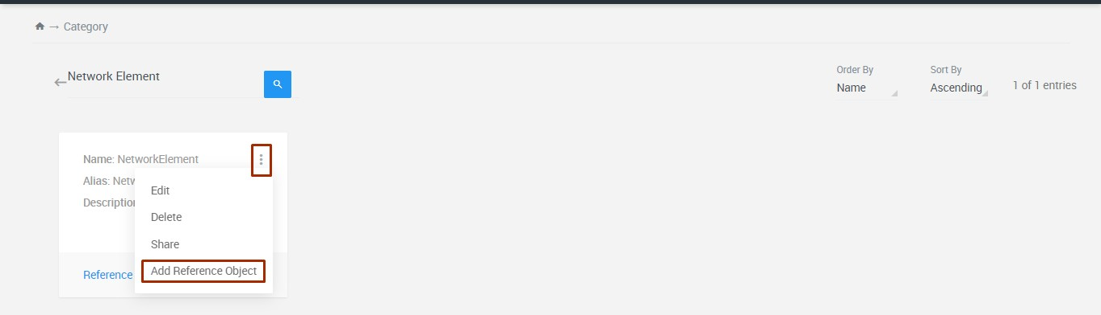

#### Category -> Add Reference Object - New Reference Object - None

Pada halaman *“new reference object”* pilih node label *“none”*, input value reference objek dari node label none, input display name dan input description. Kemudian klik button *“add”* untuk membuat reference object baru dengan node label *“none”*

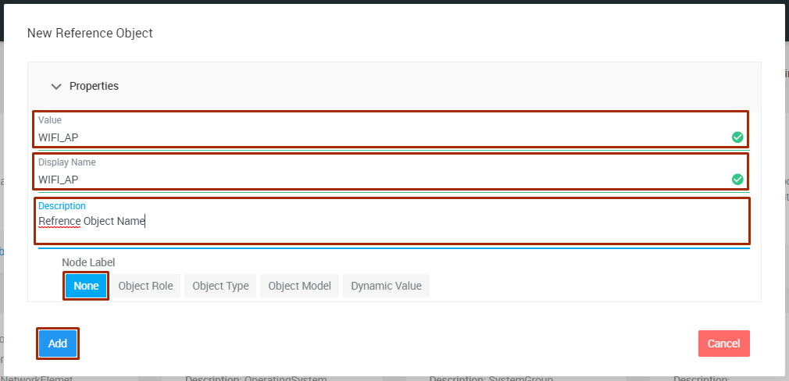

#### Category -> Add Reference Object - New Reference Object - Object Role

Pada halaman *“new reference object”* pilih node label *“object role”,* input value reference objek dari node label object role, input display name dan input description. Kemudian klik button *“add”* untuk membuat reference object baru dengan node label *“object role”*

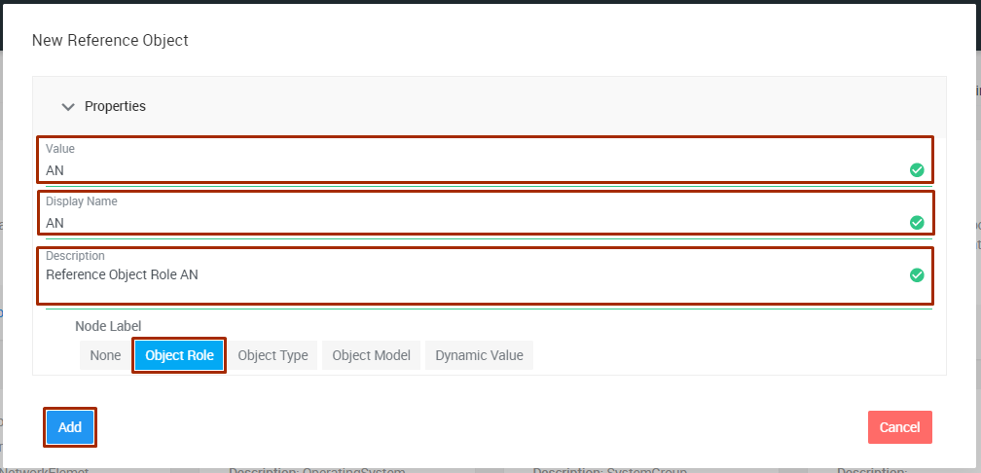

#### Category -> Add Reference Object - New Reference Object - Object Type

Pada halaman *“new reference object”* pilih node label *“object type”*, input value reference objek dari node label object type, input display name dan input description. Kemudian pilih *“object role”* dari object type tersebut, lalu klik button *“add”* untuk membuat reference object baru dengan node label *“object type”*

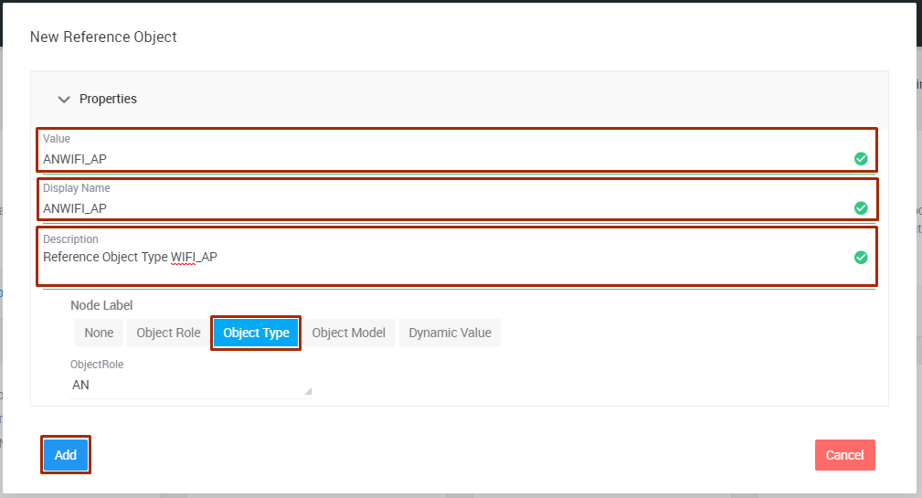

#### Category -> Add Reference Object - New Reference Object - Object Model

Pada halaman *“new reference object”* pilih label node *“object model”*, input value reference objek dari node label object model, input display name dan input description. Kemudian pilih *“object type”* dari object model tersebut, lalu klik button *“add”* untuk membuat reference object baru dengan node label *“object model”*

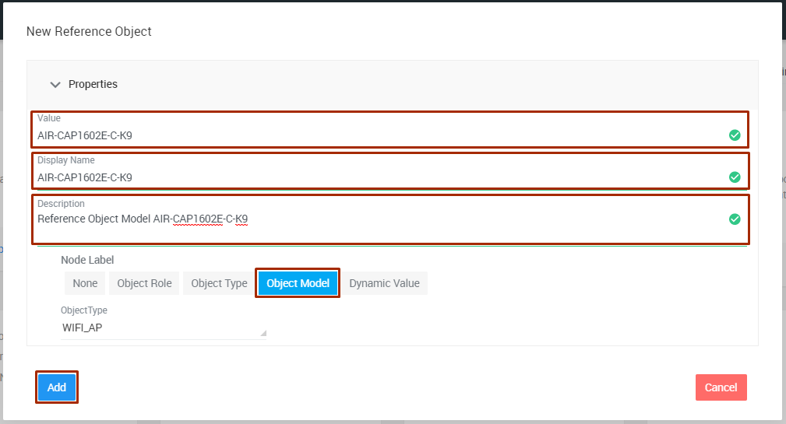

#### Category -> Add Reference Object - New Reference Object - Dynamic Value

Pada halaman *“new reference object”* pilih node label *“dynamic value”*, input value reference objek dari node label dynamic value, input display name dan input description. Kemudian pilih *“dynamic object”* dari dynamic value tersebut, lalu klik button *“add”* untuk membuat reference object baru dengan node label *“dynamic object”*

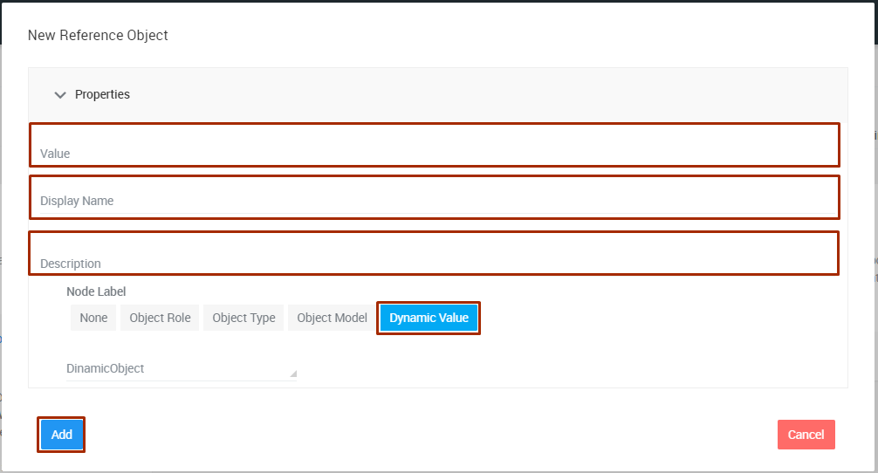

### Reference Object

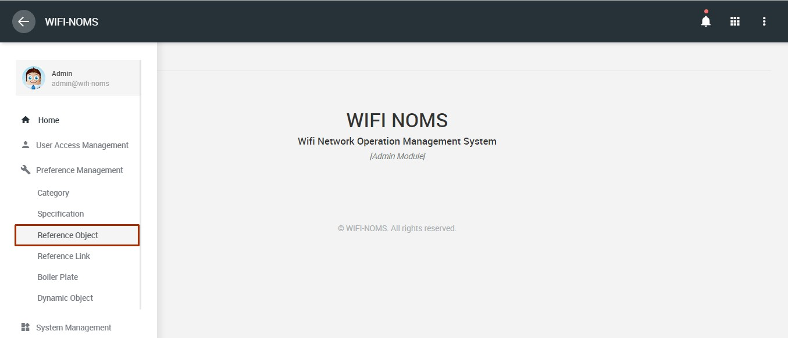

Pada menu *“preference management”* pilih *“reference object*, setelah menu dipilih, maka window akan menampilkan list data *“reference object”* yang ada dalam aplikasi, akan terlihat seperti pada gambar di bawah ini.

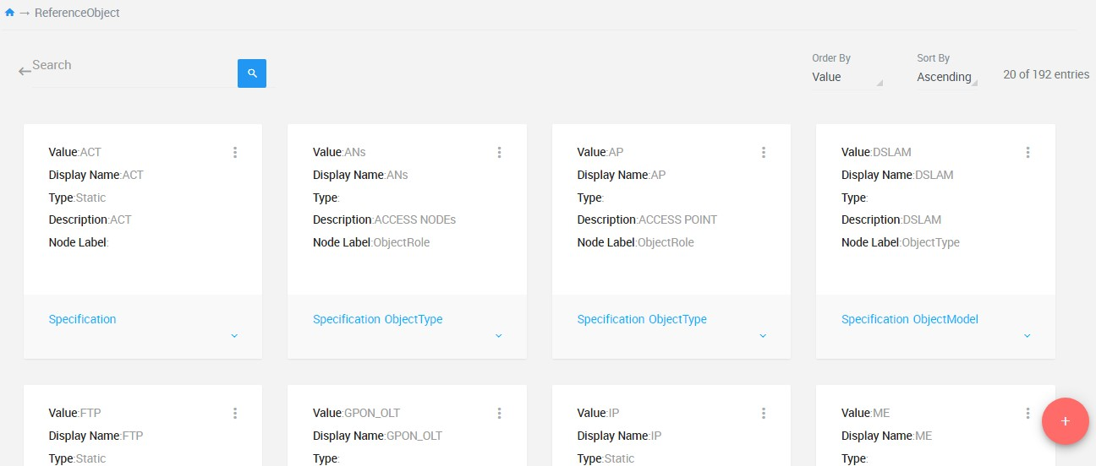

#### Query Daftar Reference Obje

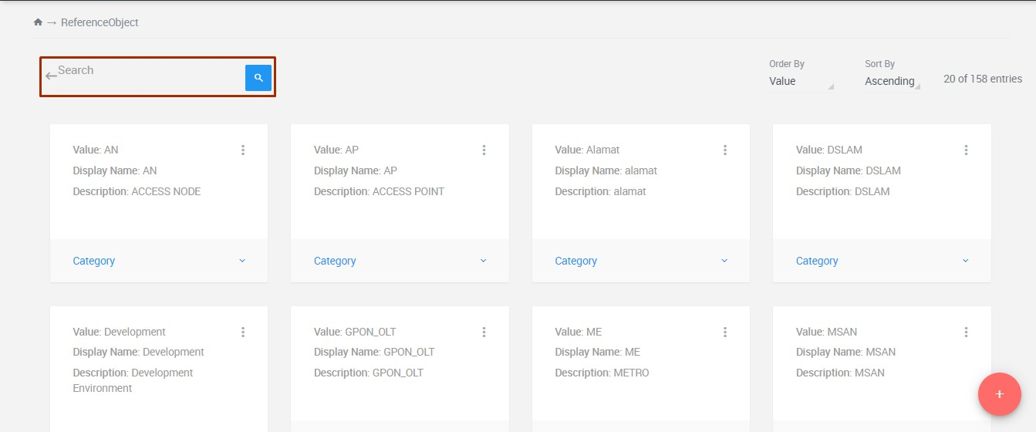

Untuk query data pada daftar list *“reference object”* masukan nama yang akan di cari di dalam kolom search berdasarkan nama *“reference object”* yang diinginkan misal *“****WIFI_AP****”* diikuti tombol ***ENTER*** hasilnya akan rlihat seperti gambar di bawah

#### Reference Object -> New Refrence Object -> None

Pada halaman *“new reference object”* untuk menambah reference object baru dengan *“node label none”.* Maka langkah-langkah yang harus dilakukan adalah pilih “category*”*, input value reference objek dari node label none, input display name dan input description. Kemudian klik button *“add”* untuk membuat reence obj