COMMON ISSUES AND SOLUTIONS FOR MENINGIOMA SEGMENTATION

**ISSUE 1 – Thin rim of edema that doesn’t exist**

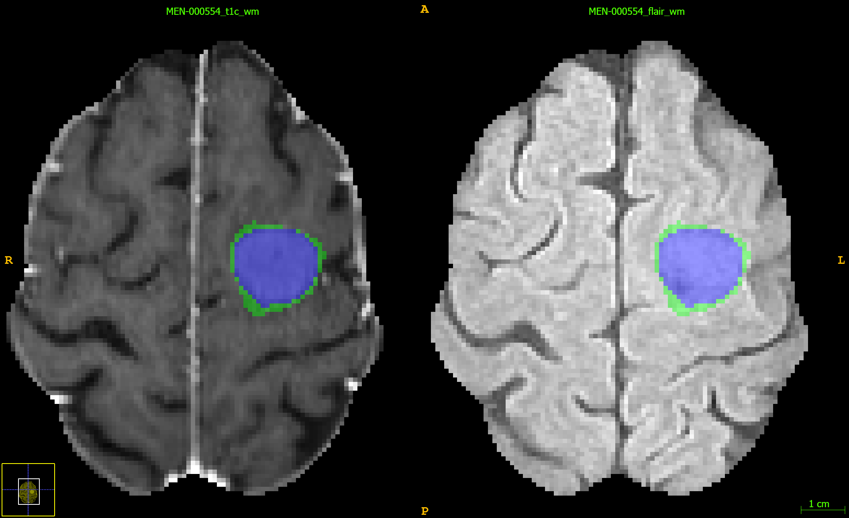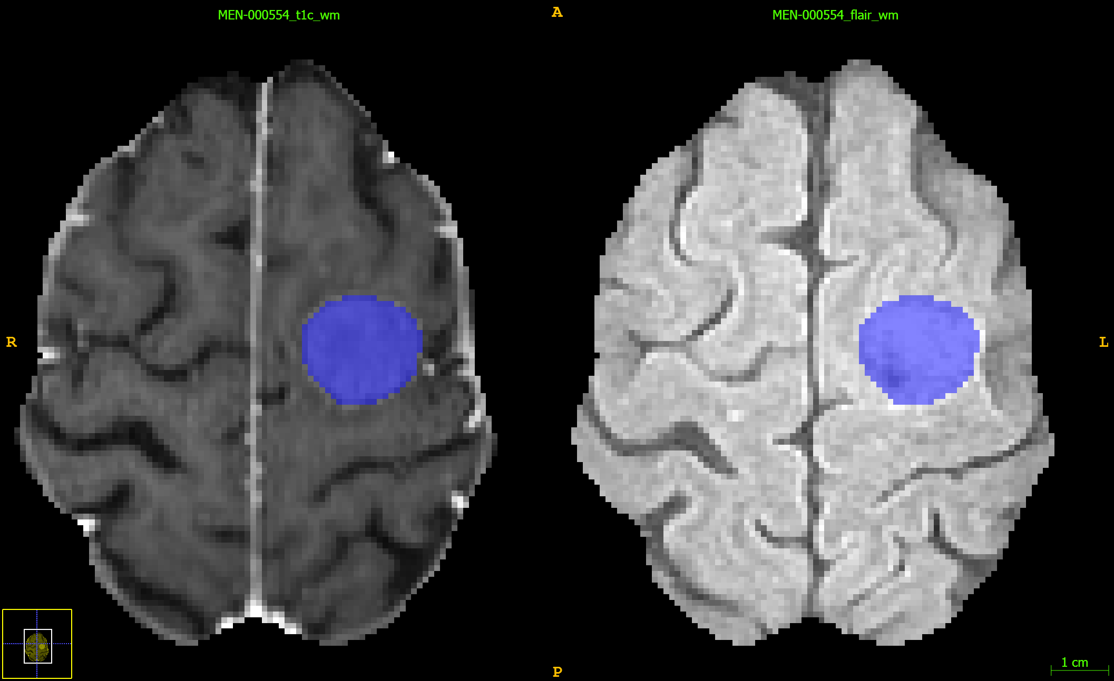

SOLUTION: Remove edema label. This can be done with a single click of a large spherical (3D) brush.

**ISSUE 2 – Missed small convexity meningioma**

SOLUTION: Add this as enhancing tumor. Note, there may be multiple! Always check for an extra small convexity meningioma. Don’t worry about labels outside the brain, they will be removed! This can help you label convexity meningiomas quicker.

**ISSUE 3 – Improper classification of non-enhancing tumor**

SOLUTION: All non-enhancing tumor, including hyperostosis, cystic spaces, and areas of intrinsic T1 hyperintensity should be included in the non-enhancing tumor compartment.

**ISSUE 4 – Edema bleeds into periventricular FLAIR abnormalities**

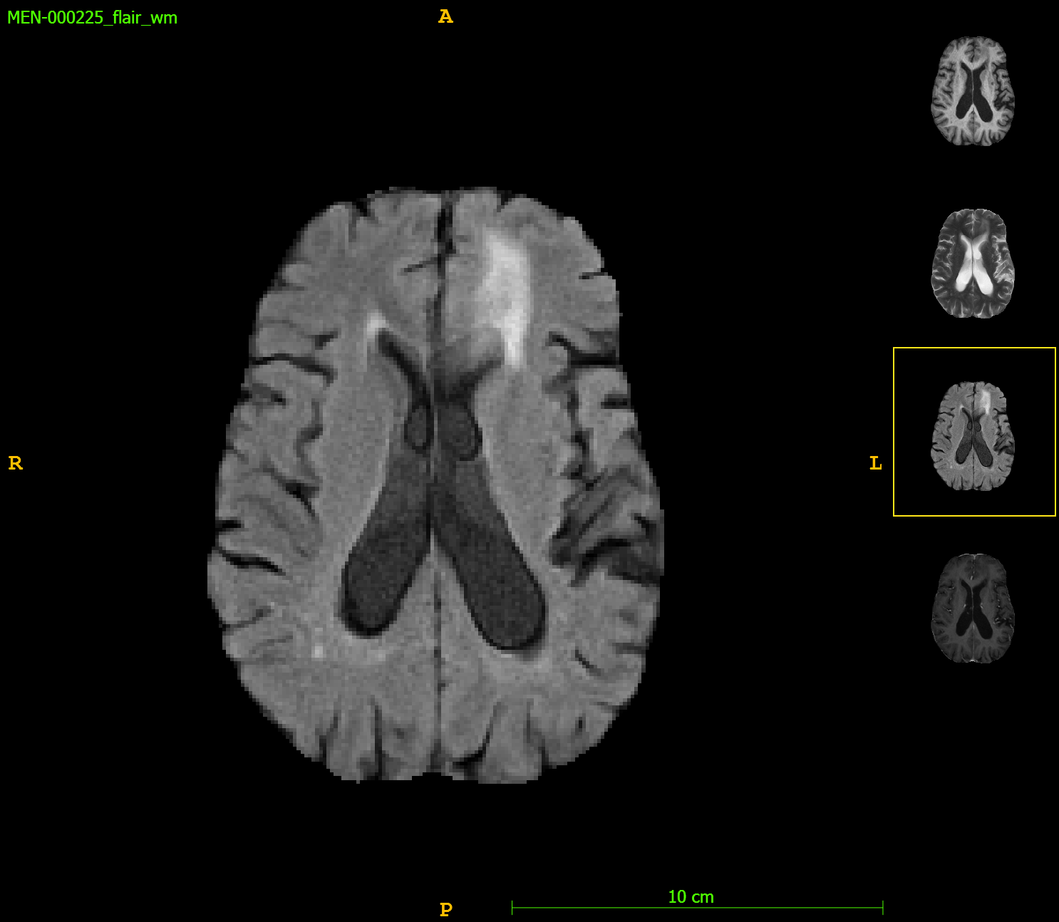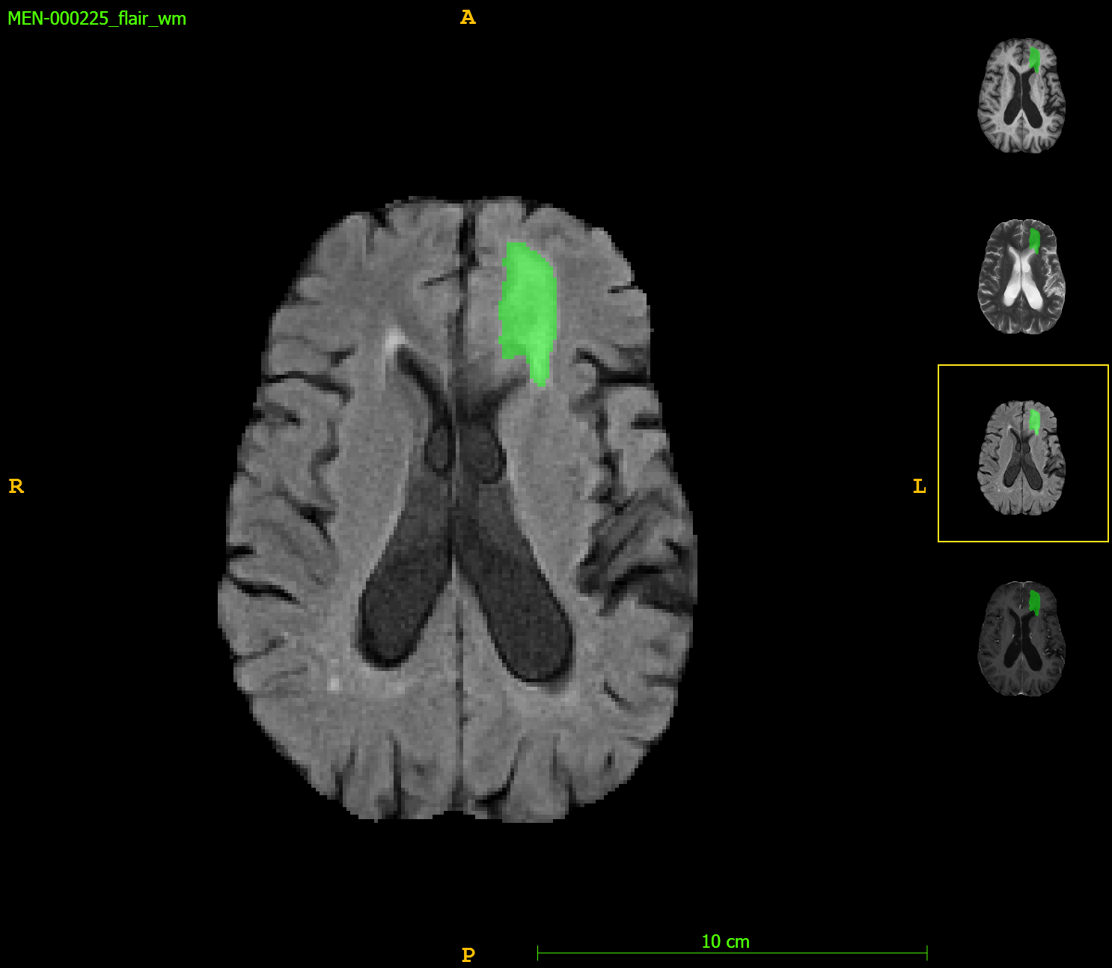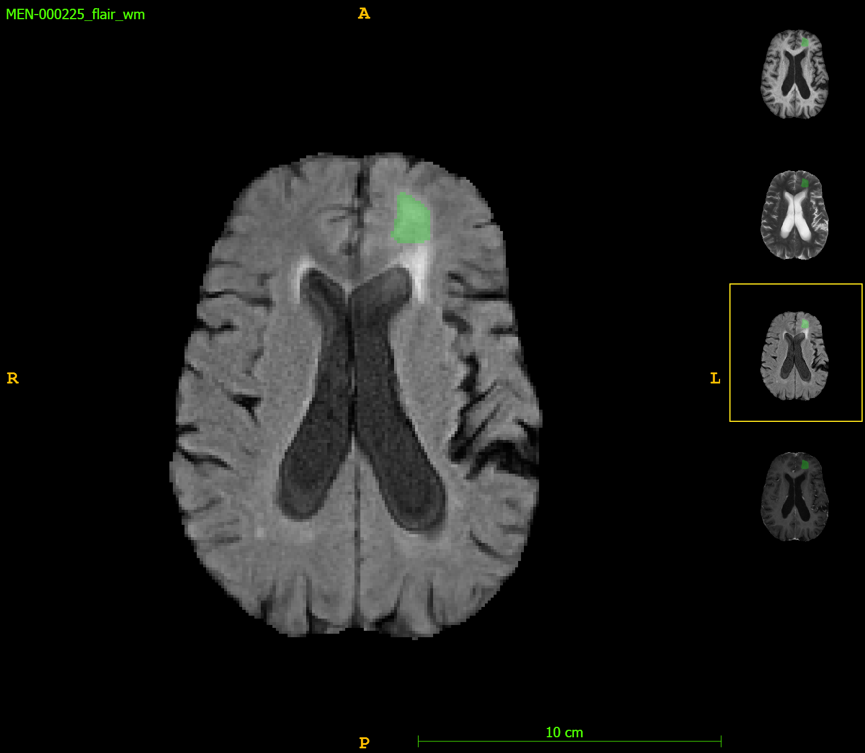

SOLUTION: Use your best judgment to separate edema from non-tumor related FLAIR signal abnormalities.