e-Library System

This document contains e-Library system functionality with screen-shots

# Registration:

User can resister to the system using registration page, this page asks for only email-id from the user, further information about the user can be filled using user profile information.

User verification is performed by the library administrator, after the verification process user can access various functionalities based on the rights provided by library administrator.

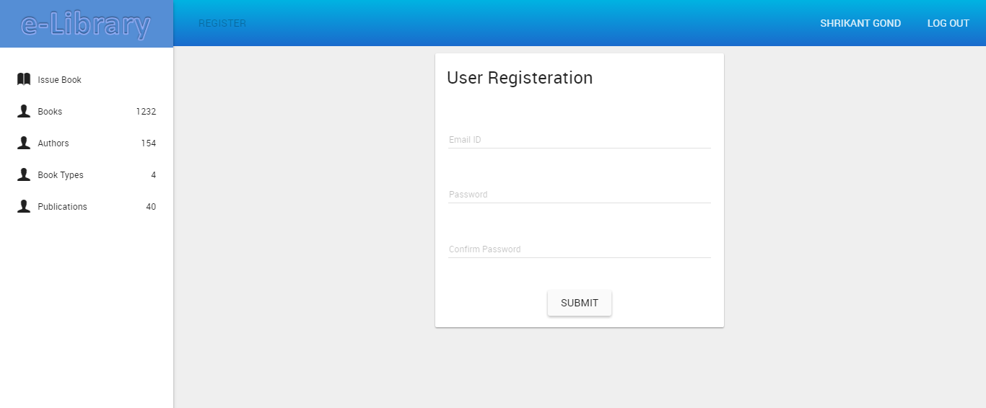

Figure: user registration screen.

# Login :

Login module contains user login screen for all the users of the system i.e. all the persons with library subscription (readers) and library staff.

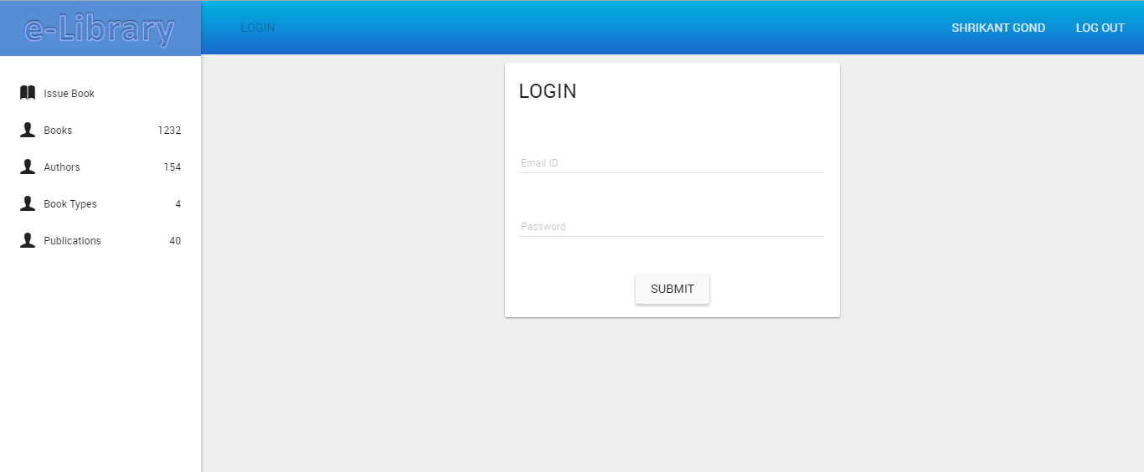

Figure: user login screen.

# Change password:

Change password screen can be used to change the password of current logged in user.

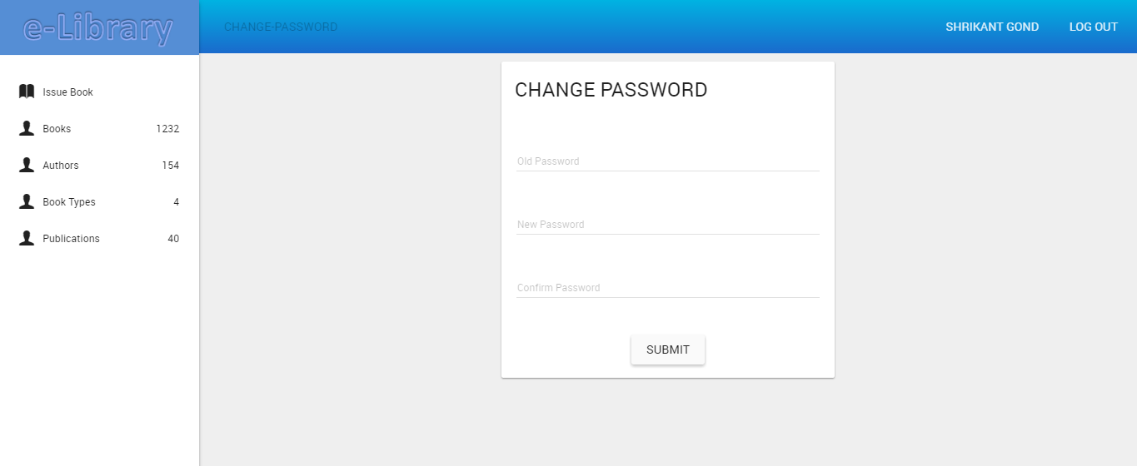

Figure: change password screen.

# Forgot password:

Change password screen can be used to change the password of current logged in user.

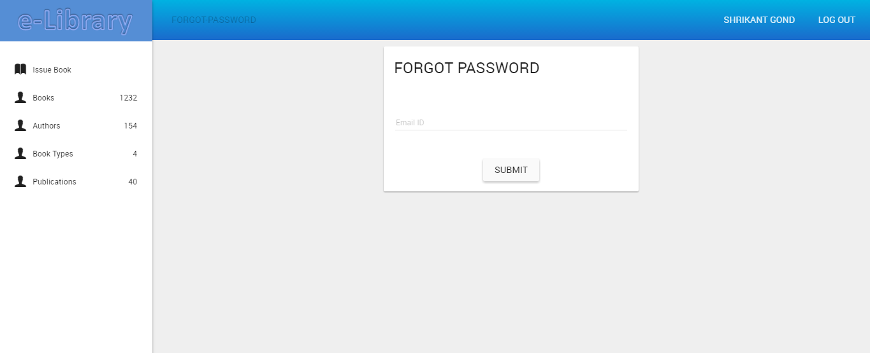

Figure: forgot password screen.

# Books:

Book master contains list of all the books in the library, this module contains various features like adding book, editing book information, deleting a book.

User can search for book from the search box provided.

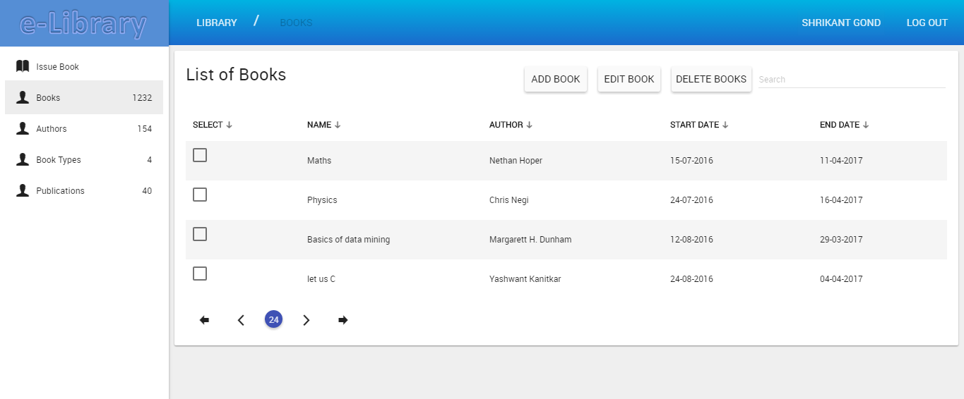

Figure: list of books screen.

# Add Book:

Clicking on the Add Book will redirect to this screen, this screen takes information about the book.

Book information contains following fields:

Book Type, Author, Publication, Name, ISBN, Edition, Year, Price, Quantity, Available stock.

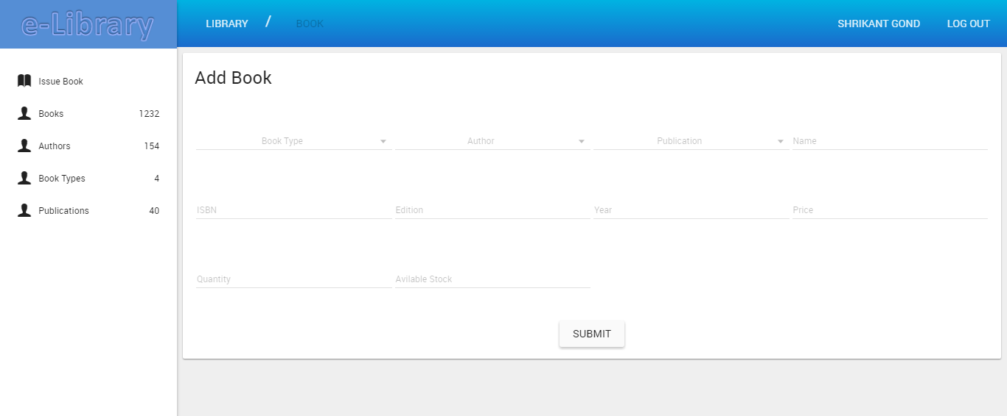

Figure: add book screen.

Library administrator can add books to system which will then listed to the list of book screen, depending on the quantity , books can be issued to readers once the available books stock become 0 , the books will not be issued to user.

# Authors:

Author master contains list of all the authors in the library, this module contains various features like adding author, editing author information, deleting an author.

User can search for author from the search box provided.

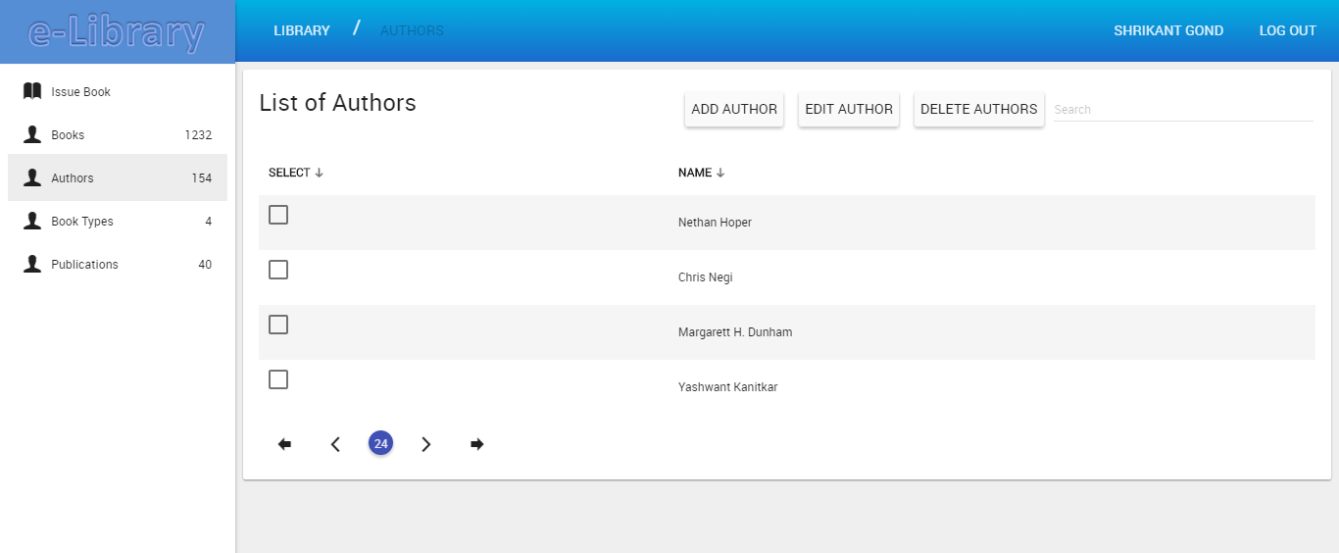

Figure: authors screen.

Library administrator can add authors to system which will then listed to the list of authors screen, author can be associated to the book.

# Add Author:

Clicking on the Add Author will redirect to this screen, this screen takes information about the author.

Author information contains following fields:

Author Name

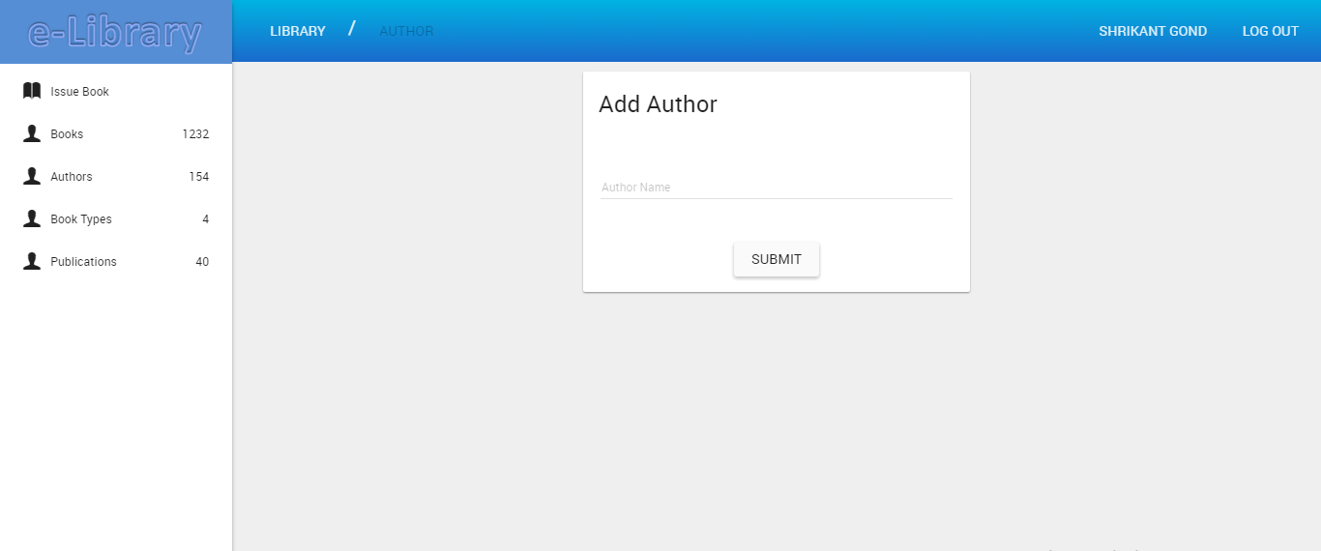

Figure: add author screen.

Library administrator can add authors to system which will then listed to the list of authors screen, this author then can be associated with the book at the time of adding/editing the book to the system.

# Book Types:

Book Type master contains list of all the Book Type s in the library, this module contains various features like adding Book Type, editing Book Type information, deleting a Book Type.

User can search for Book Type from the search box provided.

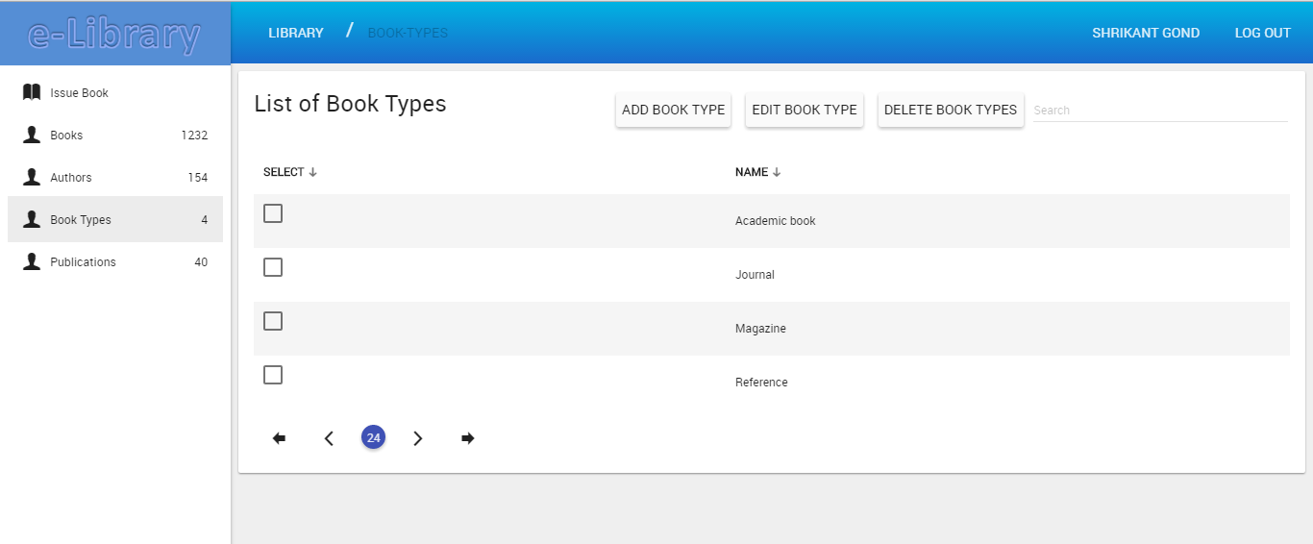

Figure: Book Types screen.

Library administrator can add Book Types to system which will then listed to the list of Book Types screen, Book Type can be associated to the book.

# Add Book Type:

Clicking on the Add Book Type will redirect to this screen, this screen takes information about the Book Type.

Book Type information contains following fields:

Book Type Name

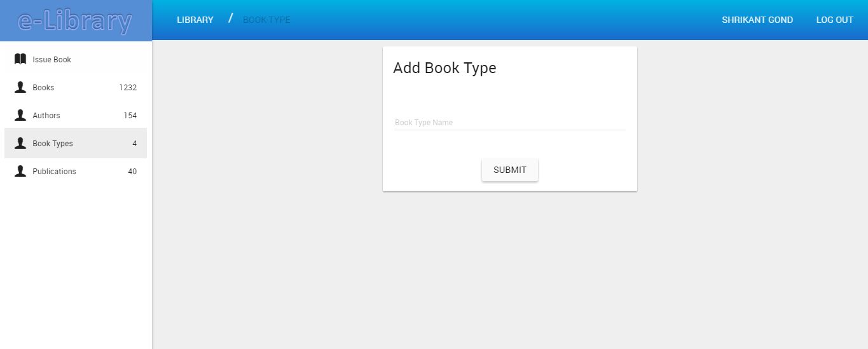

Figure: add Book Types screen.

Library administrator can add Book Types to system which will then listed to the list of Book Types screen, this author then can be associated with the book at the time of adding/editing the book to the system.

# Publications:

Publication master contains list of all the Publications in the library, this module contains various features like adding Publication, editing Publication information, deleting a Publication.

User can search for Publication from the search box provided.

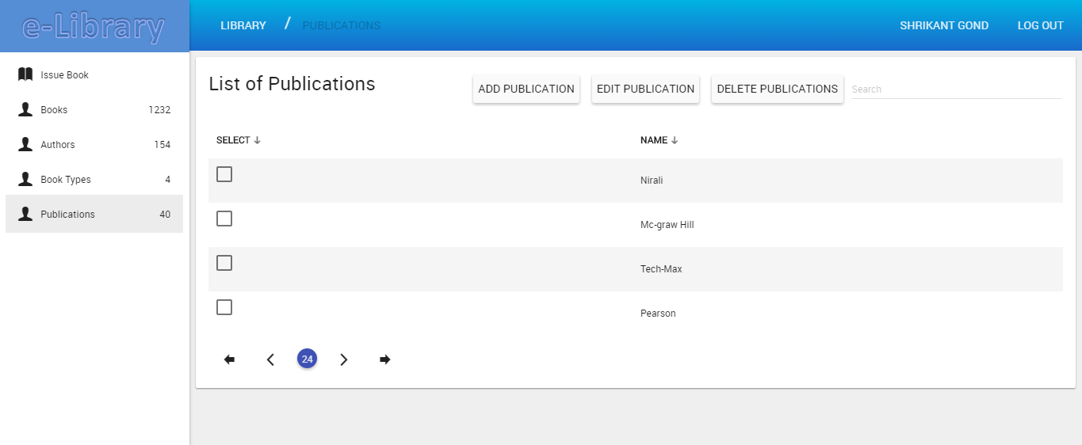

Figure: Publications screen.

Library administrator can add Publications to system which will then listed to the list of Publications screen, Publication can be associated to the book.

# Add Publication:

Clicking on the Add Publication will redirect to this screen, this screen takes information about the Publication.

Publication information contains following fields:

Publication Name

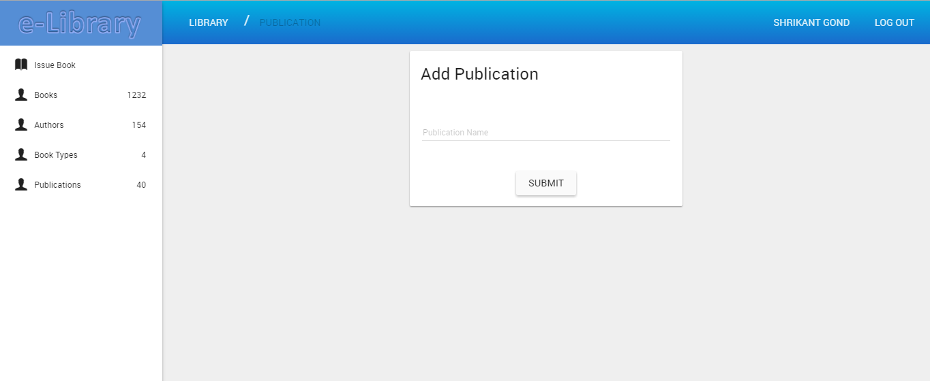

Figure: add Publication screen.

Library administrator can add Publications to system which will then listed to the list of Publications screen, this Publication then can be associated with the book at the time of adding/editing the book to the system.

# Issue book:

Clicking on the Issue book will redirect to this screen, this screen allows library administrator to issue books to users.

From select book drop down, administrator can select book to issue to the user, validation error will be shown if the book is already issued.

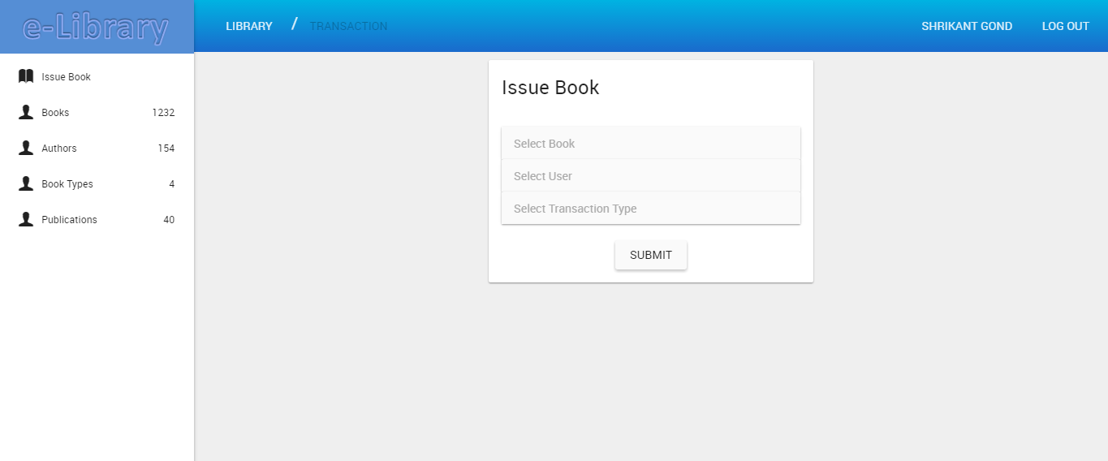

Figure: issue book screen.

Transaction type will contain transactions such as issuing a book , returning a book , adding purchase entry against the lost book etc.

# Responsive layout for all the screen types:

The complete application is responsive and can be used with wide range of devices like desktops mobiles laptops, tablets etc.

Below are some of the screens which shows the responsive layout of the system.

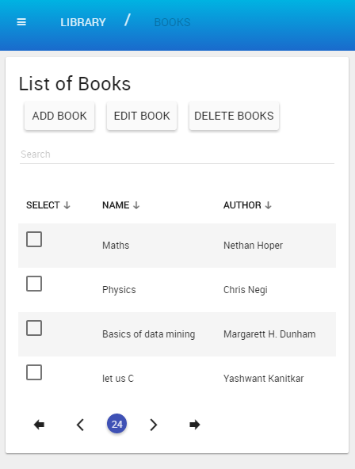

Figure: responsive layout sample screen.

