POWER BI IN HEALTHCARE ANALYTICS

What is Power BI?

Power BI is a collection of software services, applications and connectors that are used in conjunction to turn various datasets into understandable, visually captivating and actionable insights

Introduction to Power BI in Healthcare

As with any other pillar-forming sector in a community and the world at large, the healthcare sector receives and accumulates ridiculous amounts of continuously evolving data as a result of ever-changing developments such as new drug trials, novel disease strains, undiscovered genetic mutations, unexplored treatment methodologies and numerous other factors.

Benefits of Power BI Use in Healthcare

Power BI is beneficial to the healthcare sector for a number of reasons.

1. **User-Friendliness**: Power BI offers a user friendly experience to both tech-savvy and non-technical users. It’s drag and drop features makes creating visuals and dashboards less tedious.
2. **Visualizations**: Power BI also offers a wide range of visualization options and gives users everything needed to create captivation graphical representations of data. It is very popular among users who prioritize visual communication as it offers a variety of visualization possibilities. This makes medical data presentation and understanding easy and eye-catching.
3. **Integration**: Power BI grants users the ability to aggregate data from various data sources as an integration feature. It offers compatibility with a wide range of data sources and promises a hitch-free integration process with the Microsoft ecosystem. As a result of this, medical data from different sources at different times of collation can be pooled and analyzed within the same environment.
4. **Custom Calculations**: Power BI allows its users to create custom calculations using DAX (Data Analysis Expressions). This feature makes custom calculations easier and helps provide more insight to a dataset.

Improving Healthcare Data Management with Power BI

Data management refers to the maintenance of data throughout its lifecycle. It involves various activities such as data ingestion, integration, cleansing, transformation, storage, retrieval, analysis and visualization. Power BI contributes to this process by providing an environment for integration, cleansing, transformation and visualization. This greatly improves the quality of information gotten from datasets because it ensures the creation of relevant presentations free from discrepancies.

Leveraging Power BI for Decision Making Regarding Patient Care and Outcomes

Creating captivating and easily understood reports using visualizations in Power BI enables efficient decision making by providing healthcare service providers with actionable insights thereby improving the quality of healthcare. For example, if a presentation made using Power BI shows that a particular treatment regimen is most effective against a specific strain of virus strain, it means that implementing that treatment regimen as a first line of defense for similar cases would save time and might be more cost effective as well.

Regulatory Compliance and Data Security with Power BI

It is of worthy note that medical records and healthcare data is classified as Personally Identifiable Information (PII) and as a result, steps must be taken to ensure confidentiality when dealing with this category. Power BI, like many other business intelligence platforms, places a significant emphasis on data security and compliance with regulations to ensure that sensitive information is protected.

Power BI achieves data security by implementing the following:

1. **Data Encryption**: Encryption refers to converting plain text into an unreadable format. Power provides encryption for data both in transit and at rest. This ensures that the data packet cannot be read or understood by unauthorized individuals without the decryption key.
2. **Access Controls and Authentication**: Power BI integrates with various identity providers to allow organizations manage user access. This means that users are only able to access the data the organization has granted them authorization to access.
3. **Role-Based Security**: In conjunction with ‘Access Controls and Authorization’, Power BI allows administrators to define roles give permissions to control access to datasets, reports and dashboards based on those defined roles.
4. **Data Masking**: Power BI supports data masking, which allows health organizations to make sensitive data obscure within reports and dashboards.
5. **Compliance**: Power complies with various industry standards and regulations such as Health Insurance Portability and Accountability Act of 1996 (HIPAA) and the General Data Protection Regulation (GDPR).

Successful Implementations of Power BI in Healthcare

Some of the notable implementations of Power BI in the healthcare sector include:

1. **The Covid-19 Dashboard**

This dashboard helps us understand the spread of COVID-19, the mortality rate, the recovery rate and other important related details.

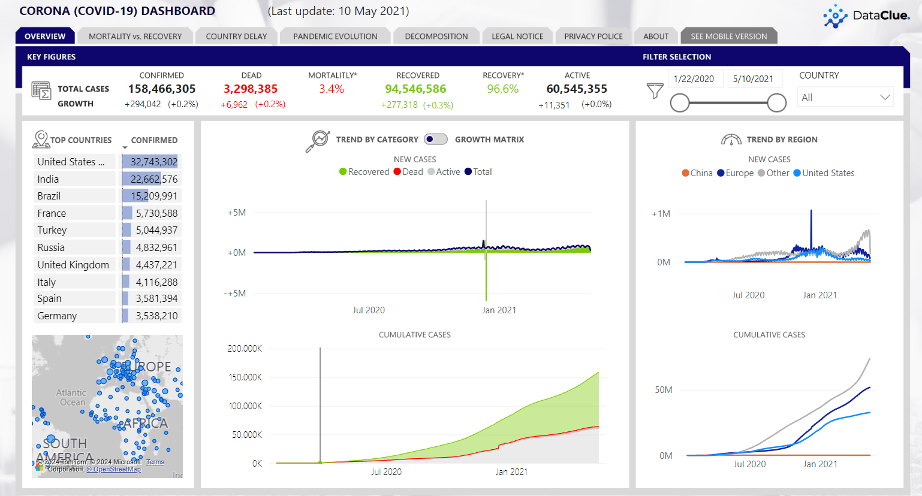

1. **The Point-Of-Care Early Infant Diagnosis (POC EID) Dashboard.**

The POC EID dashboard makes clear the impact of point-of-care early HIV diagnosis in infants. The POC EID project was conducted for nine African countries – Cameroon, Côte d’Ivoire, Kenya, Lesotho, Mozambique, Rwanda, Eswatini, Zambia and Zimbabwe. This dashboard provides insight of the impact which point-of-care testing has in contrast to conventional methods.

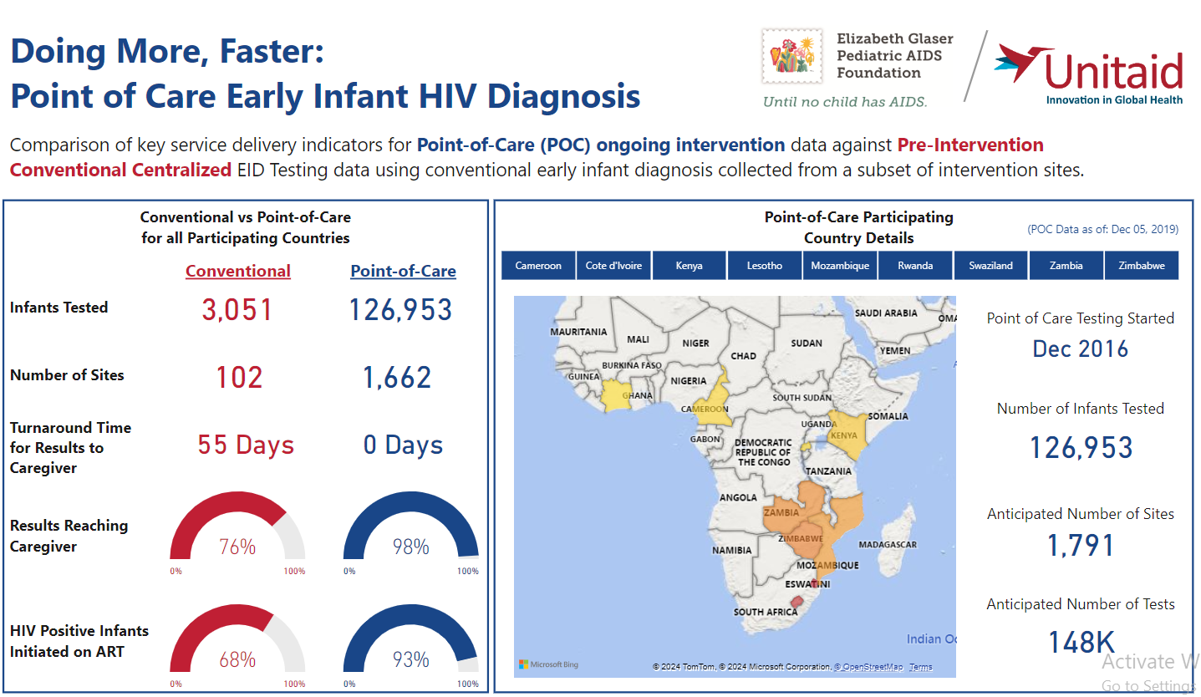

Conclusion

Like any other industry, the future of the healthcare industry is dependent on informed decision-making and Power BI has emerged as one of the leading analytics tools empowering CTOs, CIOs, and other decision-makers to unlock the potential of their data. Power BI with its predictive analytics, numerous visualization and compliance features enables healthcare institutions stay competitive in the constantly changing environment which we find ourselves today. As the healthcare industry strives for evolution, incorporating Power BI can be an invaluable resource to navigate challenges and opportunities alike while achieving greater heights in terms of operational efficiency, improving patient care and driving sustainable growth.

Submitted by:

Edwin Owarume

[owarume@gmail.com](mailto:owarume@gmail.com)

References:

<https://www.quora.com/How-does-Power-BI-ensure-data-security-and-compliance-with-regulations#:~:text=Power%20BI%2C%20like%20many%20other%20business%20intelligence%20and%20analytics%20platforms,the%20platform%20with%20their%20data>

<https://www.datacamp.com/blog/9-power-bi-dashboard-examples>

<https://www.damcogroup.com/blogs/how-power-bi-applications-forge-the-future-of-healthcare>