
EE490A/BIO490AL
Senior Project – Milestone Report 2
Report Information
Project Title | Adjustable Arm Prosthetic
Team Name | Team Straw Hats
Course / Section | EE490A/BIO490AL
Instructor / Advisor | Peter Han/ Airs Lin
Milestone 2 | Create a circuit diagram and schematics/ telescoping rod/ fingers/ and AAP
Reporting Period (Start – End) | 1/20/26 - 2/2/2026
Submission Date | 2/2/2026
Team Members + Roles (Name – Role – Responsibilities) List all members | Basel Abumailish: Biomaterial/ 3D design  James Briscoe: 3D design/ Part production/ QA  Eric Carlos: Circuit & Schematic Design/ Software/ Hardware/ Coding

1. Executive Summary (½ page max)
Briefly describe:
This milestone was intended to finalize the mechanical and electrical designs of the Adjustable Arm Prosthetic (AAP) and begin system verification. The planned objectives included completing the final designs for the fingers, forearm, and self-lacing spool; verifying proper finger operation and cable routing; finalizing the layout of circuit components; completing base firmware to operate the system reliably; and developing a base schematic for the AAP electronics.
During this milestone, significant progress was made toward these goals. The mechanical designs for the fingers, forearm structure, and self-lacing spool were refined beyond the initial base models. Finger operation was partially verified through physical testing, which confirmed basic motion but revealed limitations in joint range and smoothness that will be addressed in the next iteration. Cable routing for the hand was redesigned to run internally, reducing the risk of snagging or damage during operation. The layout of the circuit components was further developed, and multiple configurations were evaluated to support motor control, emergency stop functionality, and proper power distribution.
On the electrical and software side, base firmware was implemented and tested in simulation to verify motor actuation and control logic. While the code successfully drives the motors, further refinement is needed to support multiple motors and integrate safety features such as an emergency stop. A preliminary schematic for the AAP was completed, validating component selection and confirming the architecture's feasibility.
The primary outcomes of this milestone include validating the overall mechanical layout, confirming the need for internal cable routing for durability, and identifying the need for improved finger-joint mechanics and refined motor-control logic. Although some verification tasks revealed design limitations, these findings provided critical insight and informed clear next steps. Compared to the original Gantt Chart, the project remains largely on schedule, with minor delays attributed to iterative design corrections rather than major setbacks. Overall, the milestone objectives were substantially achieved, and the project is well-positioned to move into full system integration and functional testing.
Authorship: Eric Carlos, Basel Abumailish, James Briscoe

2. Milestone Objectives and Success Criteria
Planned Objectives (from project plan):
- Objective 1: Finish creation of functional mechanical models for the AAP, including fingers, forearm structure, and self-lacing spool
- Objective 2: Verify functional operation of finger motion and internal cable routing through testing and design iteration.
- Objective 3: Complete electrical system design, including base circuit schematic and firmware required to operate motors safely and reliably.
Success Criteria / Acceptance Tests (measurable):
- Finger joints articulate smoothly without overextension
- Palm geometry supports joint integration and internal routing
- Bracket design supports actuator alignment without interference
- Circuit schematics support actuator control and safety expansion
- Mechanical subsystems interface correctly without geometric or clearance conflicts

Authorship: Eric Carlos, Basel Abumailish, James Briscoe

3. Work Completed This Period
Completed Tasks
Task | Owner | Date Completed | Notes / Evidence
Circuit Design V2 | Eric Carlos | 1/20/2026 - 2/2/2026 | https://github.com/ecarlos03/Senior_Project.git
Schematics diagram V2 | Eric Carlos | 1/20/2026 - 2/2/2026 | https://github.com/ecarlos03/Senior_Project.git
Working Model of Adjustable Rod | James Briscoe | 1/20/2026 - 2/2/2026 | Pictures below
Working Model of Fingers | James Briscoe | 1/20/2026 - 2/2/2026 | Pictures below
Working model of a hand | James Briscoe | 1/20/2026 - 2/2/2026 | Pictures below
Biomaterial study | Basel Abumailish | 1/20/2026 - 2/2/2026
Base Finger Design V2 | Basel Abumailish | 1/20/2026 - 2/2/2026 | Pictures below

Deliverables Produced

Electronic components were measured and inserted into the prosthetic arm's design.

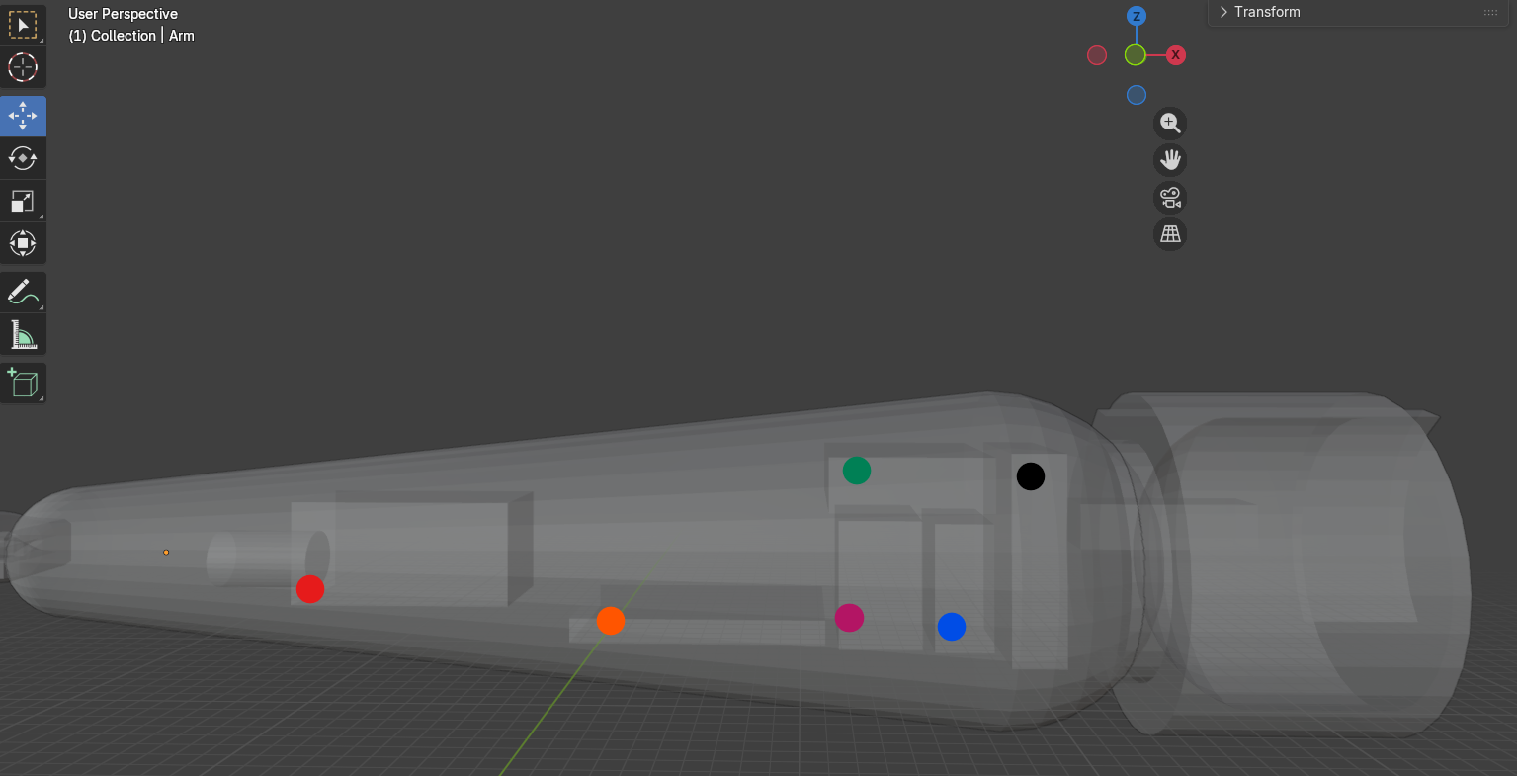

Red: Linear actuator
Orange: Breadboard
Purple: Motor Driver
Green: Arduino Board
Blue: Micro Server
Black: Battery Pack

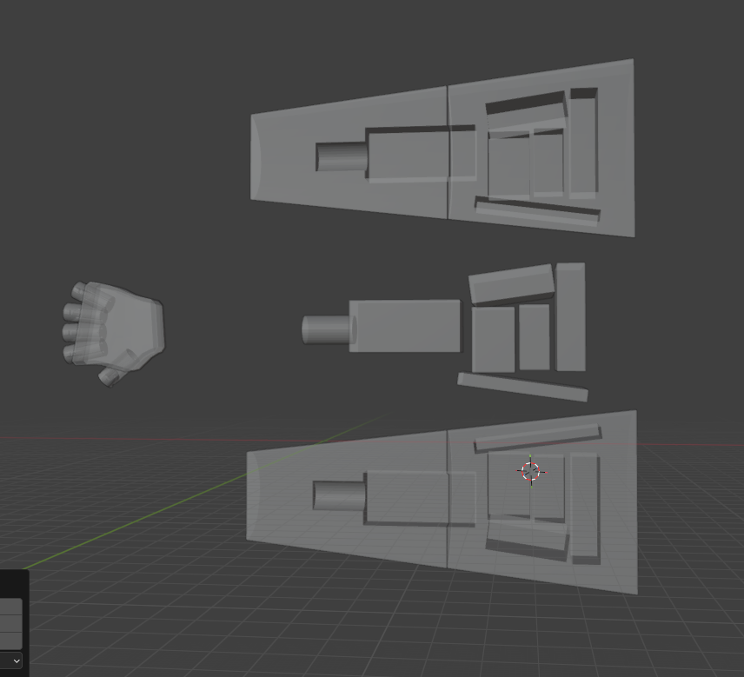 Model of arm with perforations for electronic components
V1 test print of the hand V2 model
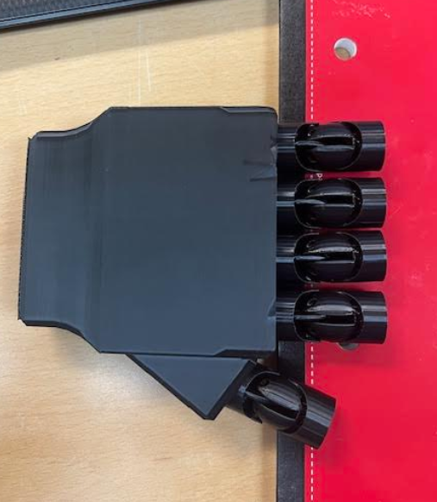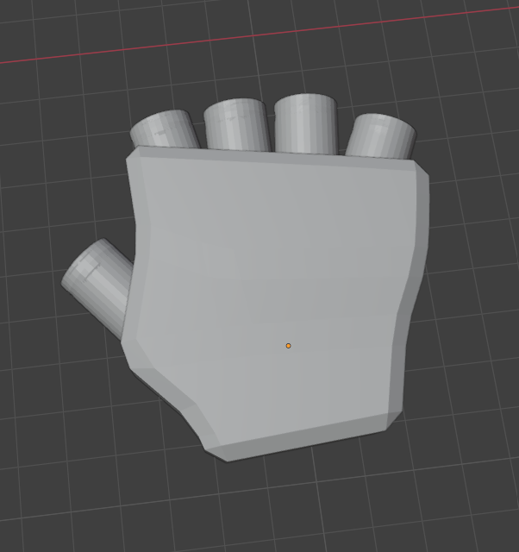

V2 model with cable runs
V5 knuckle model
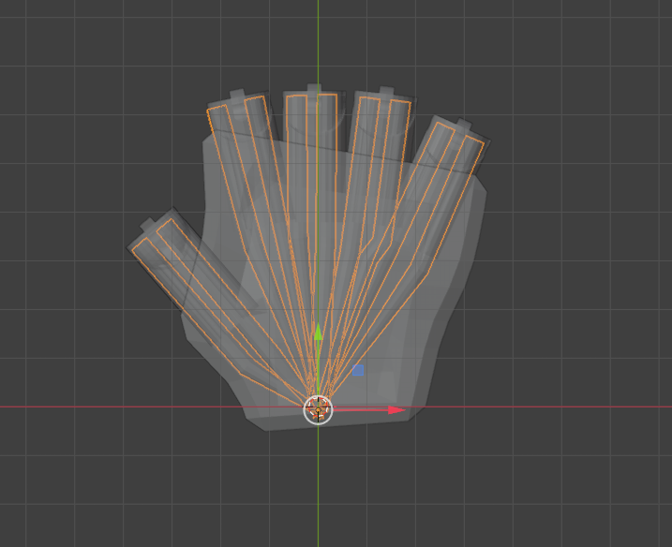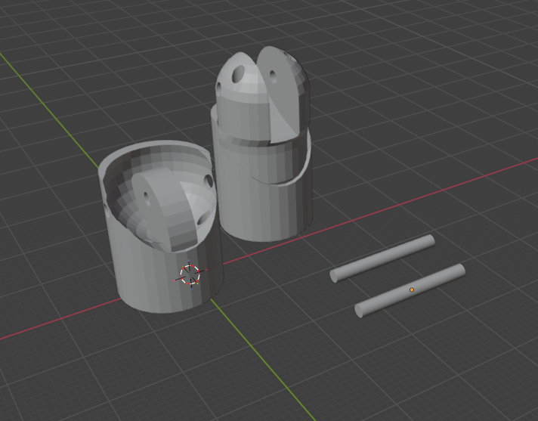

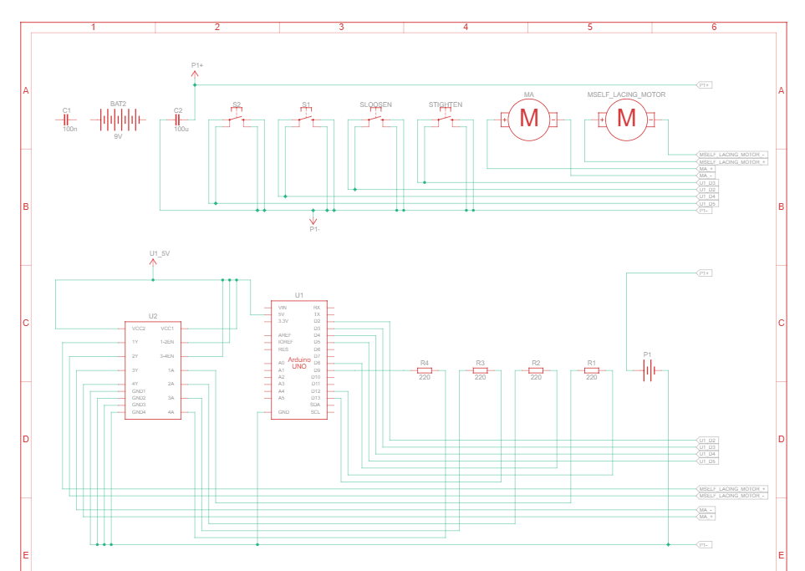

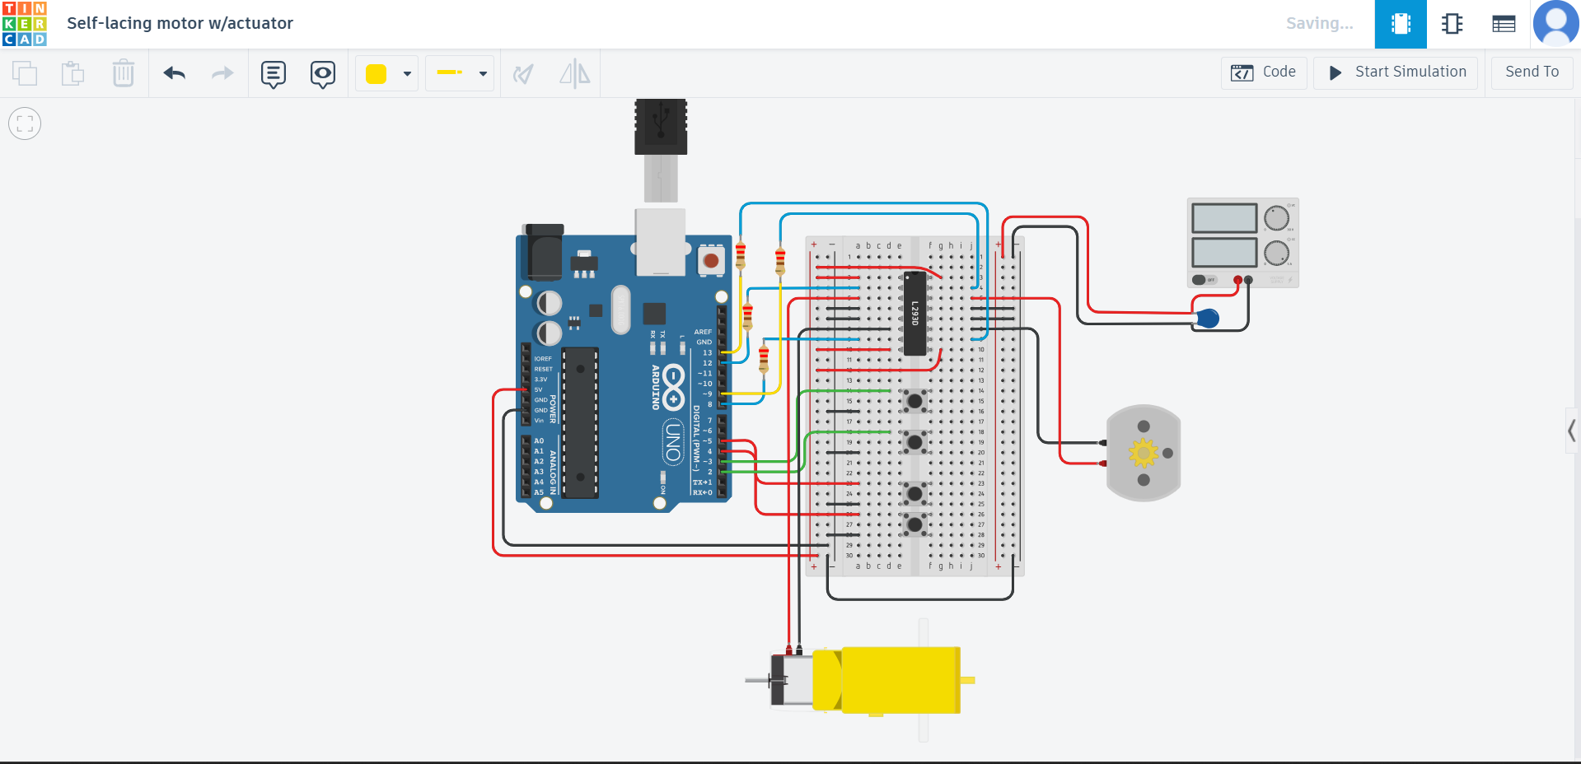
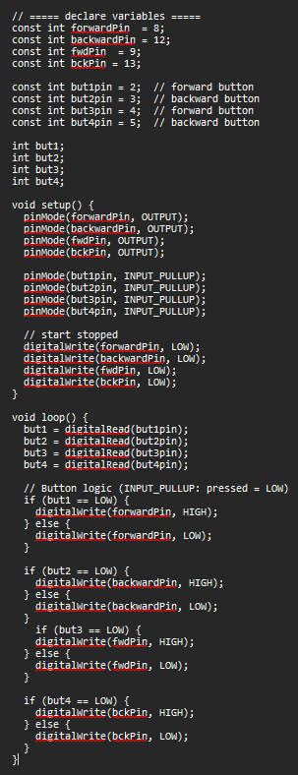

4. Technical Progress (EE and Biomedical -Focused)
4.1 Requirements and System Design Updates

During this milestone, no major system requirements were changed, but several design decisions were clarified to better support integration and testing. Finger joint requirements were finalized to allow smoother articulation while preventing overextension during operation. Internal cable routing was confirmed as a system requirement based on durability, usability, and reduced risk of cable damage. Electrical system requirements were reviewed to ensure the design can support multiple motors and future safety features, such as an emergency stop, without major redesigns.
Authorship: Eric Carlos, Basel Abumailish, James Briscoe
4.2 Hardware Design Progress
Mechanical hardware development continued with a focus on improving functionality and ease of integration. Finger joint designs were tested and adjusted to improve range of motion and overall stability. Internal cable paths were added to the finger and palm models to reduce exposed wiring and improve reliability during repeated use.
Work also continued on the actuator mounting bracket to ensure proper alignment and secure placement within the forearm. Basic fit checks were performed using early models to verify that all components can fit within the arm housing without interference and with enough space for wiring and fasteners.

Authorship: Eric Carlos, Basel Abumailish, James Briscoe
4.3 Firmware / Software Progress
Base firmware was developed and tested using Tinkercad to verify basic motor control and actuator response. The code successfully demonstrated simple actuation and control logic in the simulated environment. This testing helped identify areas where the firmware needs to be expanded to support multiple actuators and added safety features.
Current firmware development is focused on improving structure and readability while preparing the code for future additions, including emergency stop logic and more advanced control behavior. Firmware testing remains ongoing as features are added.

Authorship: Eric Carlos, Basel Abumailish, James Briscoe
4.4 Integration Progress
Integration progress during this milestone focused on ensuring that mechanical and electrical subsystems will work together once assembled. Mechanical interfaces between the fingers, palm, and forearm were reviewed to confirm proper alignment and motion. Electrical interfaces, including power distribution and control signals, were checked to ensure compatibility between the microcontroller, motor drivers, and actuators.
At this stage, integration is still partial. While the full system has not yet been physically assembled, compatibility has been confirmed through layout planning, Tinkercad simulations, and design reviews. These steps help reduce integration issues in later stages of the project.

Authorship: Eric Carlos, Basel Abumailish, James Briscoe

5. Test and Validation Results
Tests Performed This Milestone
Test Name | Setup /  Procedure | Expected  Result | Actual Result | Pass/Fail | Evidence
Knuckle test | Verify the test print will bend properly | The finger will bend 90 degrees | Finger bends 90 degrees | Pass | Pictures below
Extending rod test | Verify the rod extends and locks | Rod will lock in place | Rod locks in place | Pass | Pictures below
Hand line test | Verify that the hand line tracks will accept the line | The line will feed through the lines without any issues | The line did not feed | Fail | The line did not feed through the hand due to the complex line system. Tracks have been adjusted for V2
Circuit and code testing | Verify the motor works function correctly | Both motor to fully operate with separate pushbuttons | Both motors fully operational | Pass | https://www.tinkercad.com/things/9xbxp7S8sui-stunning-densor-lahdi/editel?returnTo=https%3A%2F%2Fwww.tinkercad.com%2Fdashboard&sharecode=pdxN6xqbHzvbWUb-jwRgsX_Wkafkh5XKnd7g4CzMi0I

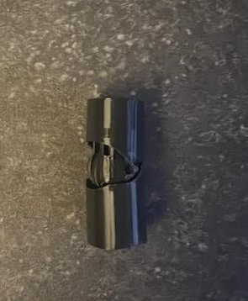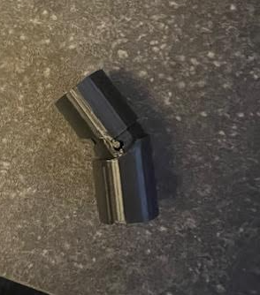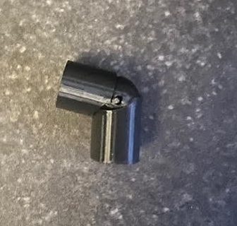
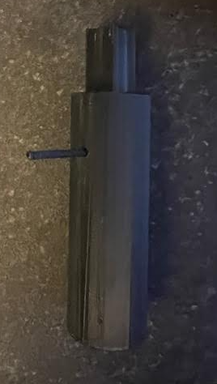

6. Issues, Risks, and Mitigations
Issues Encountered (this milestone)
Issue | Impact | Owner | Status | Resolution / Next Steps
Parts not fitting into the arm | High | James | Completed | Adjusted layout from original design to ensure all components will fit.
The actuator motor is still not operating | High | eric | complete | Get a separate motor functional
Coding | High | Eric | complete | Get coding to operate actuator motor

Project Risks (ongoing) (List authorship)
Risk | Likelihood  (L/M/H) | Severity (L/M/H) | Mitigation Plan | Trigger / Watch Item
Actuator not creating enough tension to close the fingers | L | M | Test with a variation of weights | Physical testing

7. Schedule and Milestone Status
Milestone Status: ☐ On Track ☐ At Risk ☐ Behind
Planned vs Actual
Item | Planned Date | Actual Date | Variance | Notes
Finger design | 2/1/26 | 2/1/26
Forearm layout | 2/1/26 | 2/1/26
Hand Layout | 2/1/26 | 2/1/26
Base Coding | 2/1/26 | 2/1/26
Base Schematic | 2/1/26 | 2/1/26

8. Team Contribution Summary

Member | Contributions to this milestone | Hours (est.)
Eric Carlos | Circuit schematics, firmware development, actuator control | 20
James Briscoe | Forearm layout, finger design, extending rod testing, | 20
Basel Abumailish | Biomaterial study, self-lacing bracket development, coordination | 20

9. Next Steps (Next Milestone Plan)
Top Priorities for Next Period
- Complete palm integration with finalized finger joints
- Refine the actuator bracket and begin mechanical integration
- Expand firmware to support safety
- integrate sensors for emergency stop

Planned Tests / Demos
- Mechanical fit testing
- Expanded actuator control testing
- Physical circuit testing
11. Appendix
An advisor design review was held during this milestone to go over the current status of the Adjustable Arm Prosthetic and get feedback on the overall design direction. The team presented the mechanical design progress, including completed finger joints, early palm models, and ongoing bracket development for actuator mounting. Electrical design progress and coding work were also reviewed at a high level.
The advisor did not raise any major concerns with the current mechanical or electrical approach. Feedback focused mainly on continuing steady progress, maintaining clear documentation, and finalizing schematic details as integration moves forward. Coding progress was acknowledged as being on the right track, with remaining work centered on refinement and integration rather than redesign.
Overall, the advisor review confirmed that the project is progressing appropriately and that the current design direction supports the planned integration and testing goals for the next milestone.

