EE490BL/BIO490BL Weekly Meeting Minutes
Adjustable Arm Prosthetic

Meeting Details
Date | [2026-02-22] | Time | 5:00 PM to 6:00 PM
Location | [Online] | Advisor | Mr. Lin
Recorder | Basel Abumailish | Meeting Type | Advisor Design Review
Attendees | Basel Abumailish, James Briscoe, Eric Carlos, Airs Lin | Optional | N/A
Pre-reads | All past | Recording | N/A
Reference | N/A | Repository | https://github.com/ecarlos03/Senior_Project

Purpose / Objectives
The purpose of this week’s work was to transition from simulation-based validation to physical hardware implementation. The main objective was to begin physical wiring of the microcontroller, motor driver, and motors, and verify that the system operates correctly outside of Tinkercad simulation. Additional goals included organizing wiring for improved reliability and preparing for full subsystem integration.

Agenda
- Begin physical wiring of the electrical subsystem
- Verify motor control using real hardware
- Debug wiring and power distribution issues
- Discuss the integration timeline with the mechanical subsystem
- Plan next steps for actuator integration and safety logic

Links (Google Doc to share or GitHub links)
https://github.com/ecarlos03/Senior_Project.git
https://www.tinkercad.com/things/9xbxp7S8sui-self-lacing-motor-wactuator/editel?returnTo=https%3A%2F%2Fwww.tinkercad.com%2Fdashboard&sharecode=pdxN6xqbHzvbWUb-jwRgsX_Wkafkh5XKnd7g4CzMi0I

Key Updates / Context
- Transitioned from simulation testing to physical hardware wiring
- Wired the microcontroller to the motor driver and verified the power connections
- Successfully tested forward and reverse motor control on physical hardware
- Cleaned up wiring layout to improve grounding and stability
- Identified and resolved minor startup instability
- Began planning actuator integration into the full system
- Discussed implementation of emergency stop logic
- Project progressing toward full mechanical-electrical integration

Discussion Notes
This week focused primarily on physical hardware implementation. The microcontroller was wired to the motor driver on a breadboard, and power connections were established using the selected battery supply. Initial testing verified that motors respond to forward and reverse inputs, consistent with previous simulation results.
Some wiring issues were encountered during early testing, including loose connections and minor instability during startup. These issues were resolved by reorganizing wiring, verifying common ground connections, and securing jumper leads to reduce noise and signal interference.
The team discussed upcoming integration steps, including physically mounting electronics into the forearm housing and incorporating the actuator. Emergency stop logic and safety considerations were also discussed as upcoming firmware priorities.

Decisions Items
Item | Decision | Owner | Rationale / Notes
D-1 | Maintain current role distribution and parallel development approach | Team | Roles are clearly defined and support steady progress across mechanical and electrical tasks

Action Items
Item | Action | Owner | Due | Priority | Status | Notes / Link
1 | Continue coding, actuator testing, and maintain documentation for advisor review | Eric Carlos | 2026/02/15 | P1 | In progress | [Doc link or notes]
2 | Continue palm modeling using the completed finger joint geometry | James Briscoe | 2026/02/15 | P1 | In progress
3 | Continue bracket design for actuator mounting and alignment | Basel Abumailish | 2026/02/15 | P1 | In progress

Risks / Blockers
- Risk 1: Electrical noise or unstable grounding
– Impact: Medium
– Mitigation: Maintain common ground, shorten jumper lengths, and secure wiring
- Risk 2: Mechanical-electrical integration conflicts
– Impact: Medium
– Mitigation: Conduct staged integration and test fit electronics before permanent mounting
- Risk 3: Actuator overload during physical testing
– Impact: Medium
– Mitigation: Implement current limits and emergency stop logic

Open Questions
- What is the final mounting configuration for electronics within the forearm housing?
- How will battery placement affect weight distribution?
- What is the final integration timeline for full system assembly?

Latest Schematic Diagram Updates:
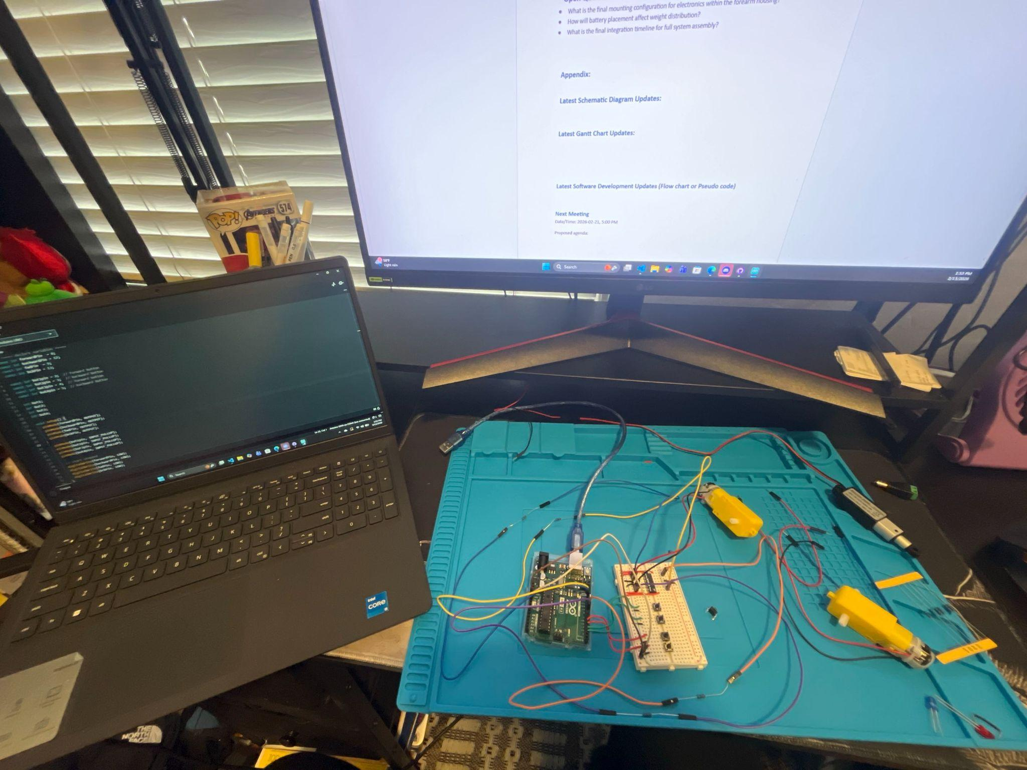

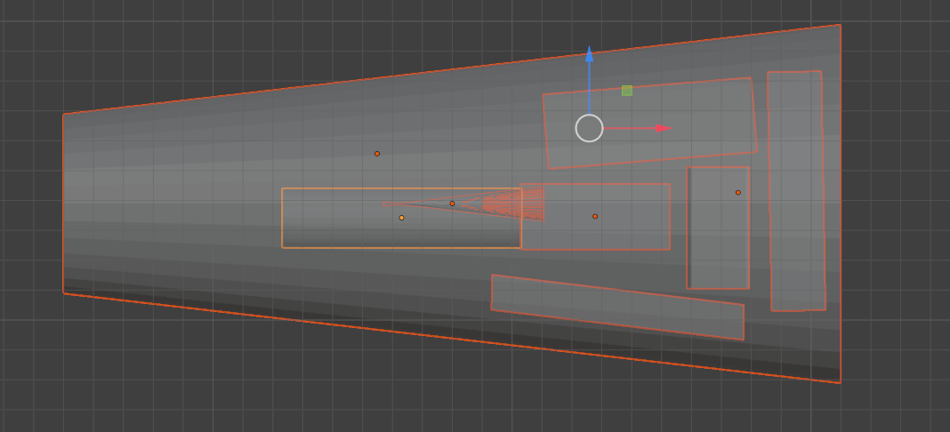
The basic prosthetic shell was received by Eric this week, and he verified that some of the cavities were off by about 3-5 mm. Adjustments have been made to the design.

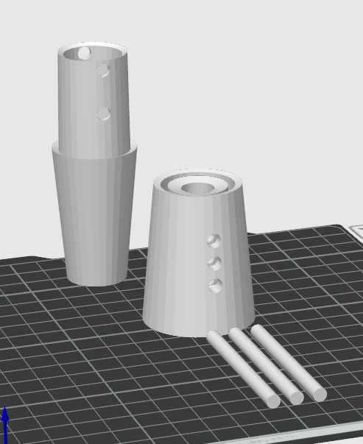 The adjusting rod idea was applied to the arm so that the whole arm can extend properly. A miniature test print was created and verified to function.

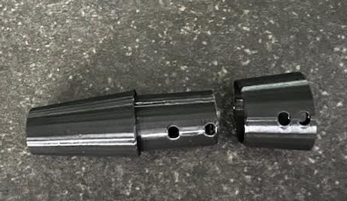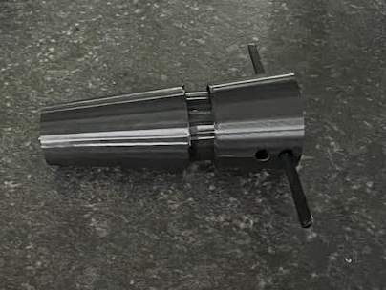
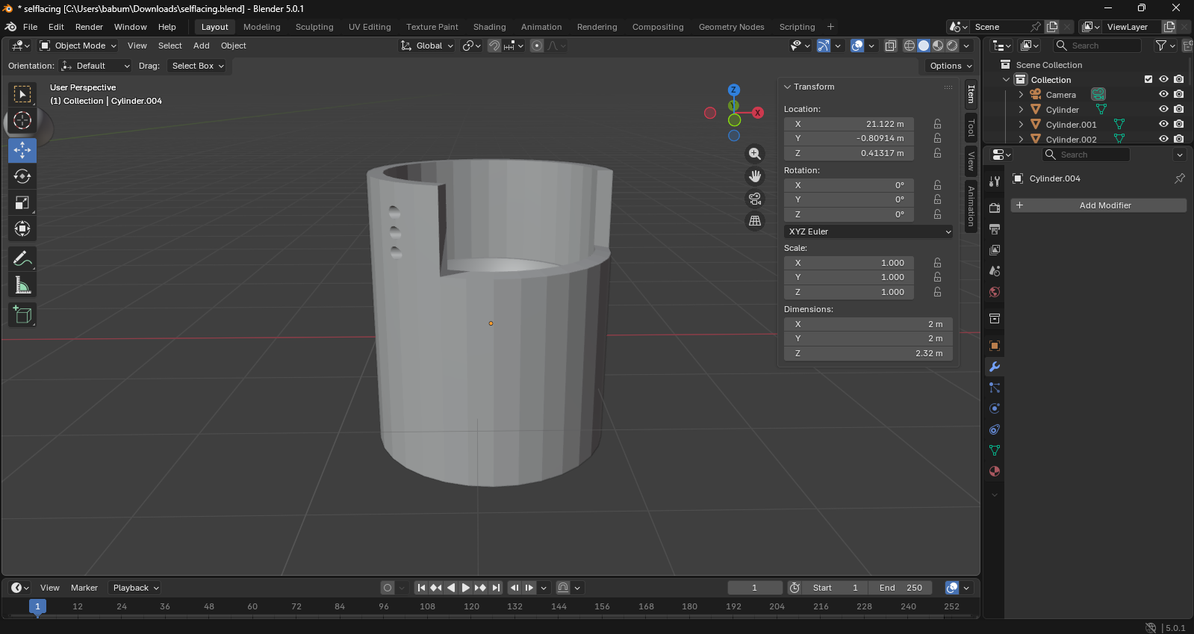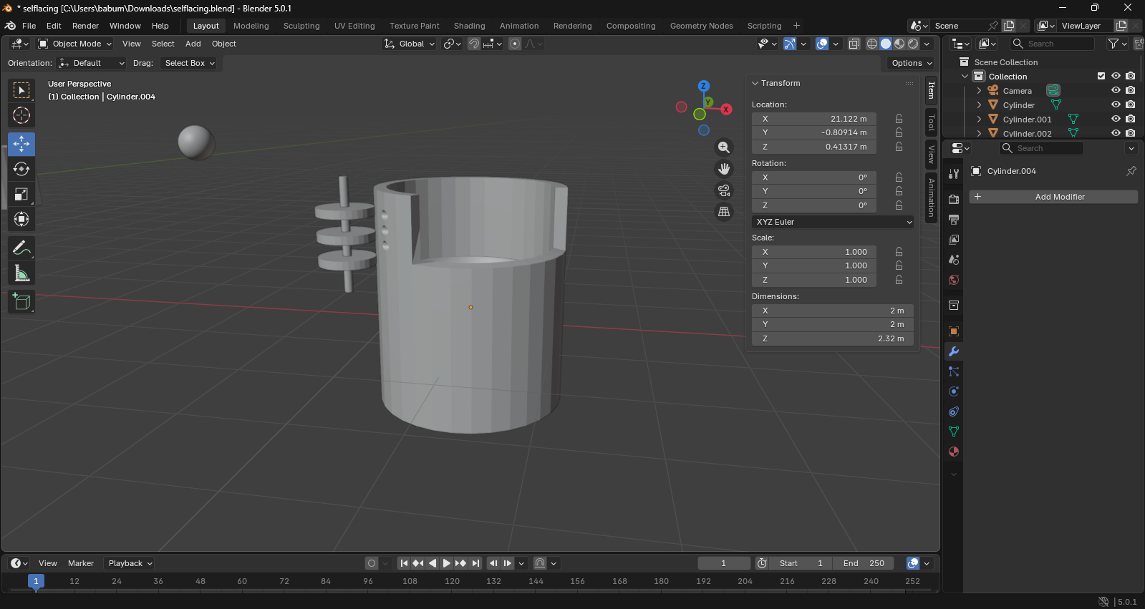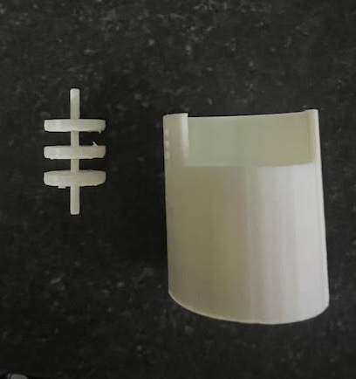
Self-lacing bracket is underway as well

Latest Gantt Chart Updates:
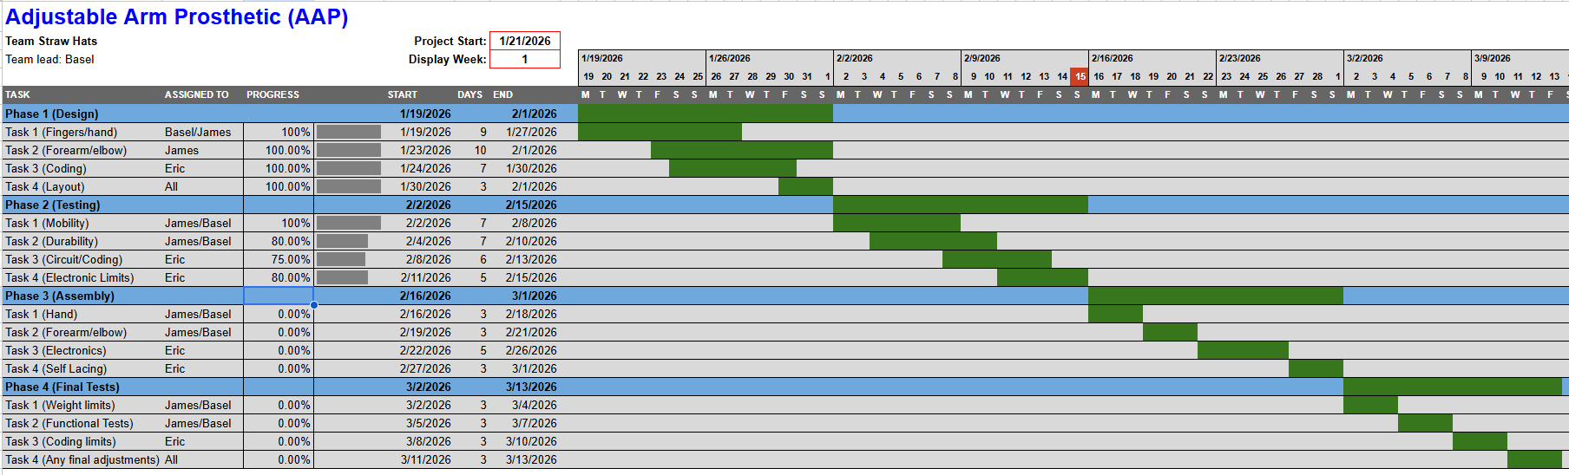

Latest Software Development Updates (Flow chart or Pseudo code)
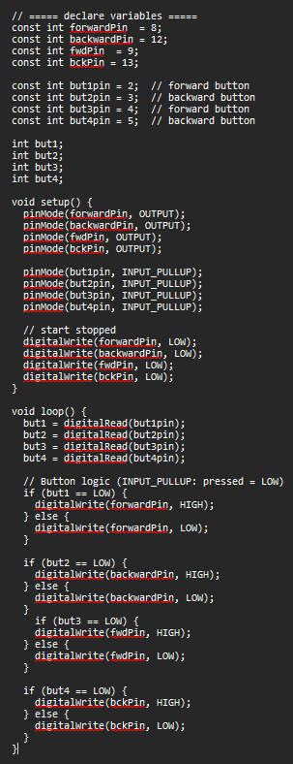

Next Meeting
Date/Time: 2026-02-28, 5:00 PM
Proposed agenda:
- Review the mounted electronics progress
- Test emergency stop firmware
- Evaluate actuator integration status
- Confirm readiness for subsystem integration
Pre-work:
- Updated firmware with safety logic
- Mounted electronics layout draft
- Revised bracket design model

