EE490B/BIO490BL

Senior Project – Milestone Report 3

Report Information
Project Title | Adjustable Arm Prosthetic
Team Name | Straw Hats
Course / Section | EE490/BIO490BL
Instructor / Advisor | Peter Han/ Airs Lin
Milestone 3
Reporting Period (Start – End)
Submission Date
Team Members + Roles (Name – Role – Responsibilities) List all members | Basel Abumailish: Biomaterial research/3D modeling  James Briscoe: Biomechanics/ 3D model/ 3D Printing  Eric Carlos: Electrical/ Software/ Circuit Design

1. Executive Summary (½ page max)
Briefly describe:
This milestone focused on validating both the software and hardware systems of the adjustable prosthetic arm to ensure alignment with design expectations and simulation results. Significant progress has been made in confirming system functionality, mechanical reliability, and overall design readiness.The coding architecture was thoroughly verified to ensure accurate motor control, input response, and overall system performance. Hardware testing was conducted to confirm that physical components operate consistently with prior simulation models. This validation step reduces integration risk and increases confidence in real-world performance. Final design specifications for the arm were reviewed and confirmed, incorporating improvements identified during earlier prototyping phases. Mechanical durability and functional testing of the prosthetic hand were completed to evaluate strength, range of motion, and reliability under repeated use. These tests informed refinements that enhance long-term performance and structural integrity. Additionally, the overall arm layout was updated to improve component placement, optimize internal spacing, and support better weight distribution. These changes contribute to improved ergonomics, manufacturability, and maintainability. Overall, this milestone demonstrates substantial progress toward a fully integrated, functional, and durable prosthetic system, positioning the project for the next phase of development and testing.

2. Milestone Objectives and Success Criteria
Planned Objectives (from project plan):
- Objective 1: Validate software functionality and verify hardware performance to ensure the physical system operates as intended and aligns with design specifications.
- Objective 2: Initiate full system integration by assembling and interfacing all mechanical, electrical, and software components into a unified prototype.
- Objective 3: Evaluate range of motion and structural limits of 3D printed components through functional and stress testing to assess mechanical performance and ability.

Success Criteria / Acceptance Tests (measurable):
- Criterion 1: Confirm that hardware operates identical to simulation
- Criterion 2: Confirm components all fit their proper space and there aren't any obstructions
- Criterion 3: Confirm movement of design operates properly and verify no print issues (holes, weak spots, or scale issues)

3. Work Completed In This Period
Completed Tasks
Task | Owner | Date Completed | Notes / Evidence
Finger design complete | James Briscoe |  | Adjusted previous finger joint to ensure lines stay within finger and hand housing.
Code tested with hardware | Eric Carlos |  | Work on code. Physical testing had one motor working with correct inputs
Began integration of electronics | Eric Carlos |  | Physical wiring testing to see if both motos work with correct inputs.
Forearm design adjusted and verified | James Briscoe |  | Test forearm was delivered to Eric and components were tested in compartments and adjustments were made to allow better fit
Telescoping design finalized and tested | James Briscoe |  | Switched from telescoping rod to adjusting entire forearm to add more stability. Verified operation of test print
Self lacing cogs and cup design | Basel Abumailish
Poster Design | Basel Abumailish

4. Technical Progress (EE and Biomedical -Focused)

4.1 Requirements and System Design Updates
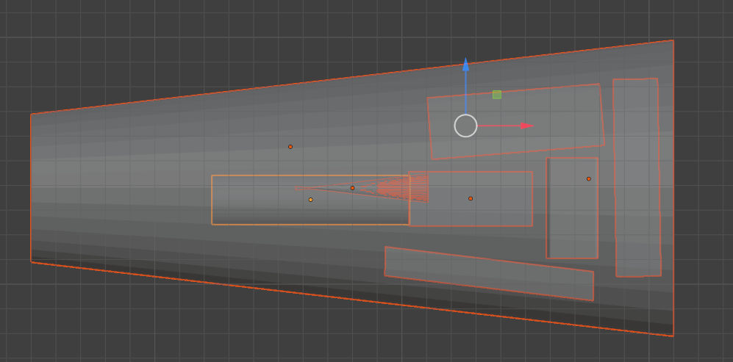
The test print was received by Eric and some components (battery pack, arduino uno, and linear actuator) were 2mm bigger than their specified slots. The arm layout was adjusted to correct the size issue with some of the components. Also the micro servo was removed and added through coding.
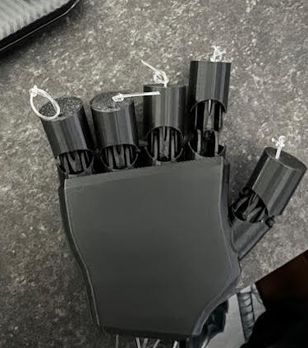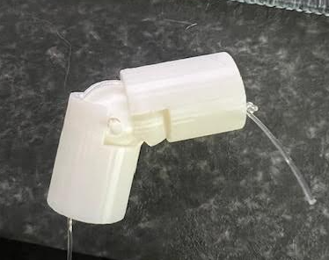
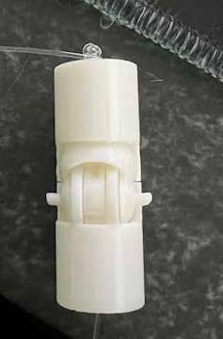 Original Knuckle(black) had too many gaps for external debris to get caught in and the line was exposed which could cause error or line breakage while using. The knuckle was remodeled and verified to bend to 90 degrees like its previous knuckle with less spacing and line exposure.
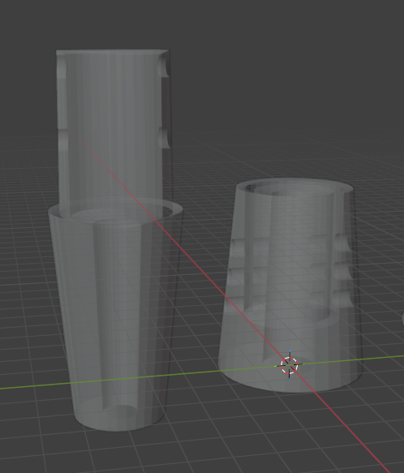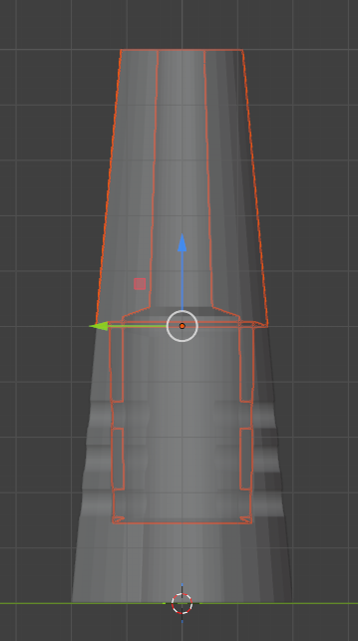
Additionally telescoping rods were implemented into the arm design to have the entire arm extended as a single piece instead of utilizing two separate rods in the arm to create more stability with the arm and less structural points of failure.

4.2 Hardware Design Progress
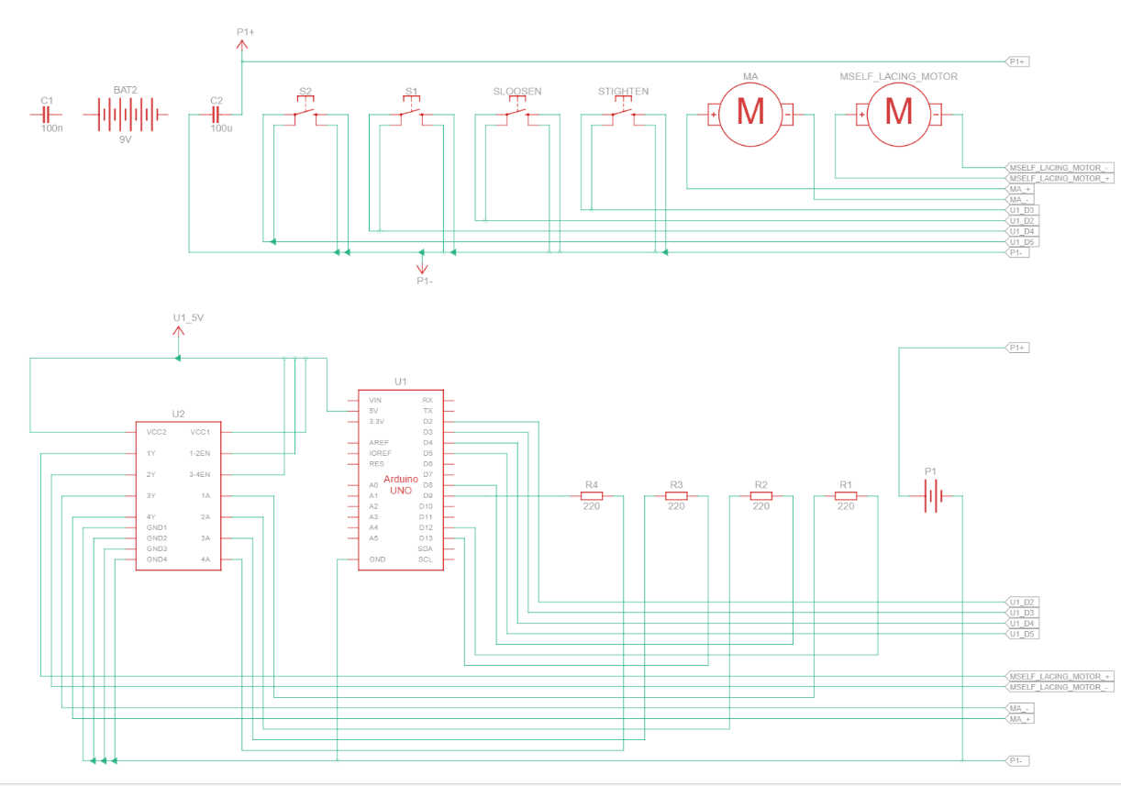
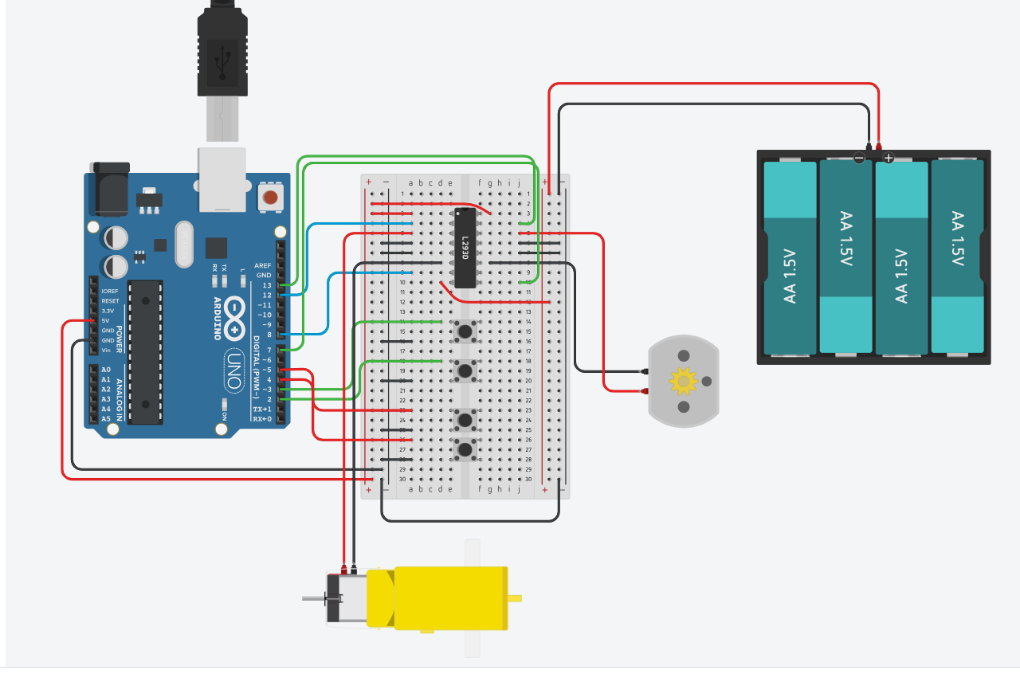

4.3 Firmware / Software Progress
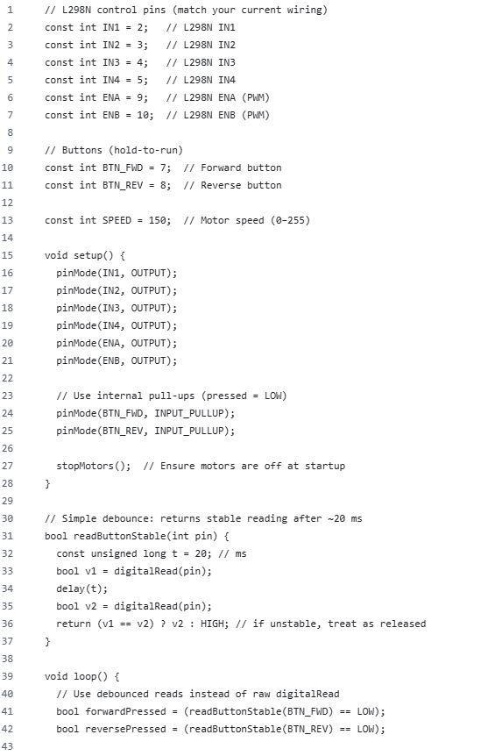

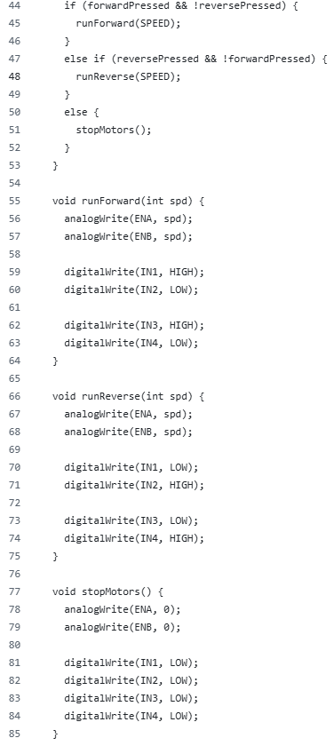

4.4 Integration Progress
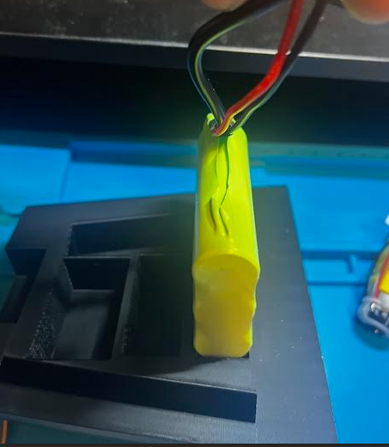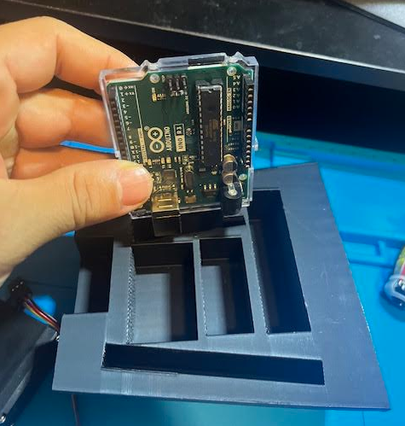
Battery and arduino boards were off by 2mm. Designs have been updated to ensure they will fit properly within the arms design.
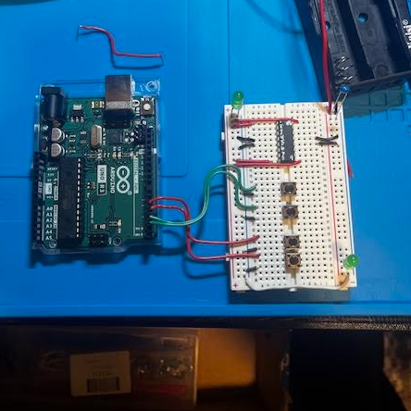 Circuit testing has been ongoing verifying the hardware operates as it does in simulation. All components are operating properly except the second motor which is having some issues with its forward and reverse functionality. Eric is getting assistance from Mr. Han and Mr. Lin to correct this error.

5. Test and Validation Results
Tests Performed This Milestone
Test Name | Setup / Procedure | Expected Result | Actual Result | Pass/Fail | Evidence
Software test | Code to work for both motors during physical testing | Buttons to work for both motors | One motor works with inputs the other does not | pass/fail | Physical test
Integration Test | Housing for components | Physical components fit in housing | Did not fit in housing | fail | Physical test
Finger Test | Cables were inserted into the finger and verified they weren't exposed and could bend the joint | Finger able to bend and no cables exposed | Finger able to bend without exposed cables | Pass | Picture posted above (white knuckle)
Extending arm test | Print new design and verify it pairs together and will lock into place as designed | Arm will extend and lock into place | Arm extended and locked into place | Pass | Picture below
Physical wiring testing | Wire physical components for testing | Both motors to work with correct inputs | One motor works and the other is continuous | fail | Physical test

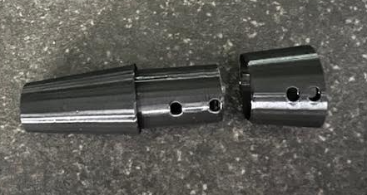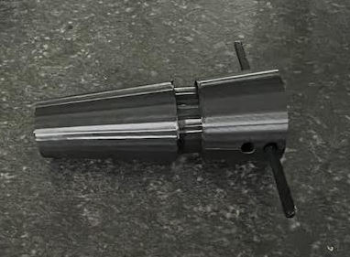
Test prints verify on a small scale that the design operates properly.
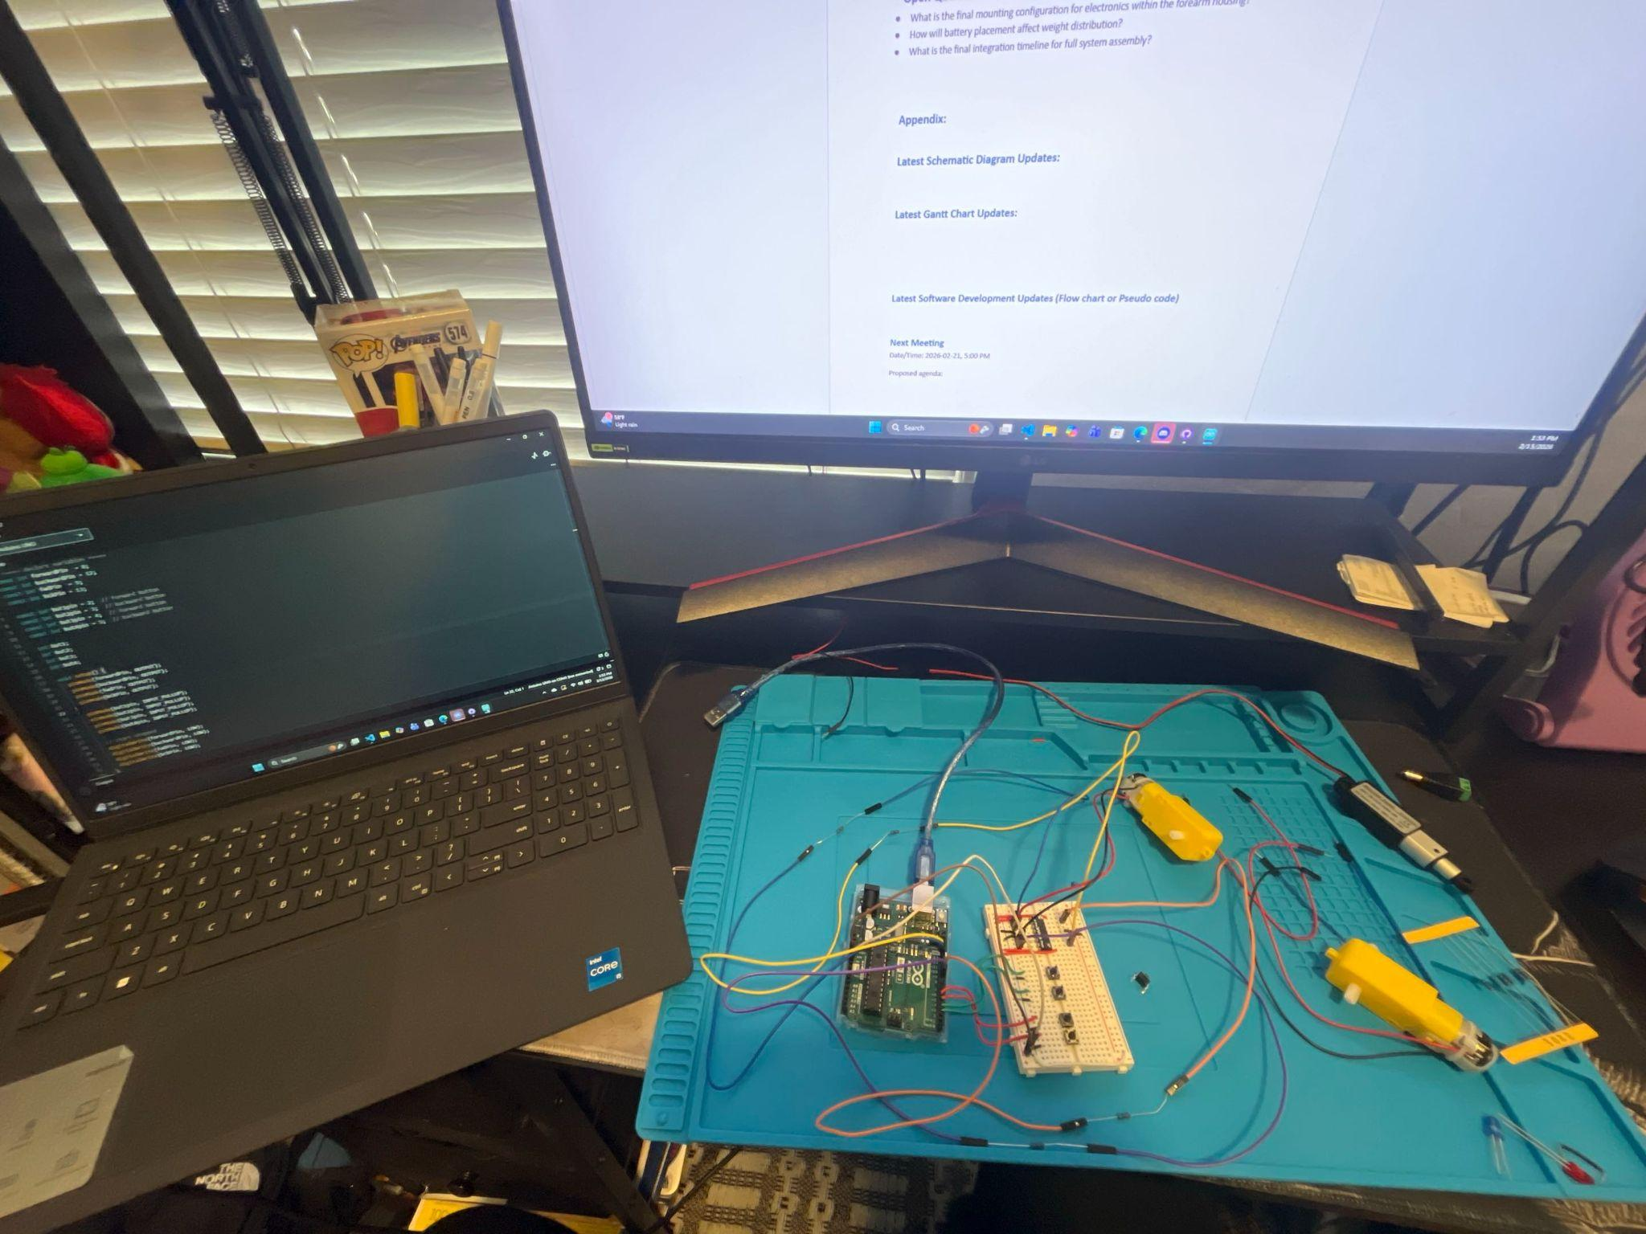

6. Issues, Risks, and Mitigations
Issues Encountered (this milestone)
Issue | Impact | Owner | Status | Resolution / Next Steps
Cable system for finger was exterior | Possible failure of fingers | James Briscoe | Resolved | Redesigned the knuckle to contain the line while still maintaining proper motion
Extending rods would cause too big of gap in the arm | Decreased structural integrity | James Briscoe | Resolved | Designed forearm to have telescoping design incorporated to entire arm
Second motor not working properly | Stops progress of physical implementation | Eric carlos | Ongoing | Speak with my han or lin to get second motor working with correct inputs
Code Progress | Work of code because 2 inputs are not working as intended | Eric carlos | Ongoing | Not sure if it is physical wiring issue or code issue on why my 2nd motor is not working
Project Risks (ongoing)
 |  |  | Mitigation Plan | Trigger / Watch Item

7. Schedule and Milestone Status
Milestone Status: ☐ On Track ☐ At Risk ☐ Behind
Planned vs Actual
Item | Planned Date | Actual Date | Variance | Notes
Gantt / Timeline Update (brief)
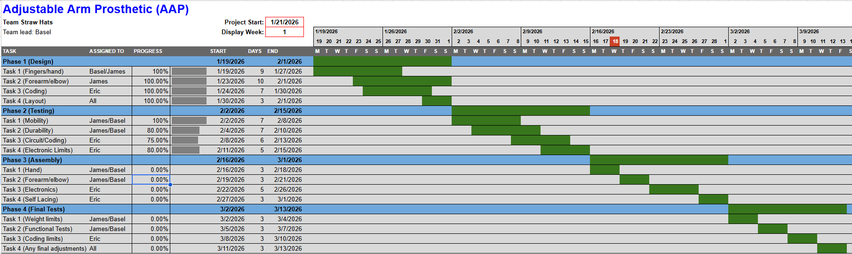

8. Week 3 preliminary demonstration plan
The school would like you to provide a preliminary demonstration in week 3. Please provide a plan about what you will demonstrate.
- Demonstrate hardware operation of motors currently operating.
- Demonstration of software operating with simulation.
- Demonstration of 3D model operation and how the electronics will be incorporated
- Demonstrate adjustability of the prosthetic.

10. Poster Design Initiative

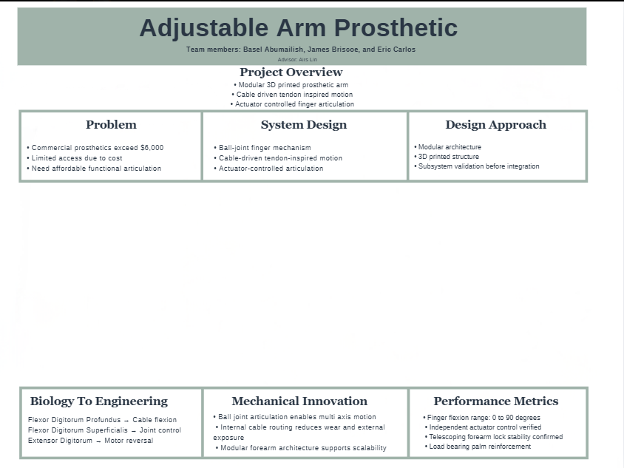
Final schematics and 3D design will be added in the middle section once they are completed.

11. Mathematical expression and physics involvement
Please show any related math equations and physics that should be applied to design during your development.

12. Team Contribution Summary
Member | Contributions This Milestone | Hours (est.)
Basel Abumailish
James Briscoe | Finger redesign, extending rod arm integration, biomechanical research, 3D model printing, 3D model testing, forearm layout adjustment
Eric Carlos | Circuit schematics, firmware development, actuator control, physical wiring

13. Next Steps (Next Milestone Plan)
Top Priorities for Next Period
- FInal integration of all components
- Final design and part production
- Final testing and adjustments
Planned Tests / Demos
- Test: ____________________________
- Demo: ____________________________
Dependencies / Help Needed
- Assistance with code and components for second motor issue from Mr. Lin or Mr. Han

14. Appendix
Include any supporting items such as:
- Team lead sequence and present team lead
- Updated block diagram
- Schematics / PCB snapshots
- Key equations or calculations (briefly reviewed again)
- Software framework
- Datasheets for critical components
- Risk details
- Meeting notes / decisions log

