EE490BL/BIO490BL Weekly Meeting Minutes
[Adjustable Arm Prosthetic]
Meeting Details
Date [2026-03-01] Time [5:00-6:00]
Location [Zoom] Advisor [Mr.lin]
Recorder [Airs Lin / James Briscoe]
Meeting Type [online] Attendees [Names] James, Basel, Eric
https://github.com/ecarlos03/Senior_Project
Pre-reads [Links / Docs] Recording N/A Reference [Links / Docs]

Purpose / Objectives
This week’s objectives focused on advancing full integration between the electrical and mechanical subsystems to ensure seamless communication and coordinated functionality. Efforts focused on troubleshooting and diagnosing issues with the second motor, identifying root causes, and implementing corrective actions to achieve consistent, reliable performance. Additional testing was conducted to evaluate the physical and mechanical limits of the system, including structural integrity, range of motion, and operational constraints under load. Finally, the overall system layout was reviewed, refined, and solidified to optimize component placement, wiring management, and overall design efficiency in preparation for continued development and testing.
Agenda
- Review mounted electronics progress
- Evaluate actuator integration status
- Confirm readiness for subsystem integration
- Verify motor issue has been resolved
Key Updates/ Context
- Fixed secondary motor function
- Updated electronic layout for the arm
- Verified structural integration of all prosthetic parts
- Verified wiring tracks for components
- Planning for full subsystem integration this week

Links (Google Doc to share or GitHub links)
https://github.com/ecarlos03/Senior_Project.git
https://www.tinkercad.com/things/9xbxp7S8sui-self-lacing-motor-wactuator/editel?returnTo=https%3A%2F%2Fwww.tinkercad.com%2Fdashboard&sharecode=pdxN6xqbHzvbWUb-jwRgsX_Wkafkh5XKnd7g4CzMi0I
Please foresee how you want to demonstrate your final project on Friday, week 5 (March 13th). Write your plan below.
The upcoming testing phase will focus on validating the functional performance and real-world usability of the prosthetic system. A primary objective is to evaluate finger articulation and grip capability by demonstrating the prosthetic’s ability to grasp, hold, and lift objects weighing up to 10 pounds. This testing will assess grip strength, motor responsiveness, load distribution across the fingers, and overall structural integrity under applied weight. Emphasis will also be placed on consistent actuation, object stability during lifting, and repeatability of motion.
In addition, we will demonstrate the integration and operation of the self-lacing motor system by connecting the prosthetic hand to a simulated upper arm assembly. This demonstration will verify mechanical compatibility, motor synchronization, cable tensioning performance, and system responsiveness when mounted to a full arm structure. The goal is to confirm that the motorized tensioning system performs reliably within a complete assembly rather than as a standalone component.
Finally, the adjustability features of the prosthetic will be presented to highlight its adaptability for growing users and long-term daily use. This includes showcasing the extension mechanism, ease of modification, secure locking features, and ergonomic considerations for everyday activities. We will also demonstrate typical day-to-day functions such as grasping common household objects to illustrate practical usability, comfort, and durability under routine conditions.
In addition to the mechanical and structural evaluations, the electronic systems will undergo comprehensive testing to ensure reliable performance and accurate signal processing. This phase will focus on validating both input channels to confirm that control signals are properly received, interpreted, and translated into consistent motor output. Testing will include verifying sensor responsiveness, signal stability, calibration accuracy, and synchronization between input sources. We will also assess power management, wiring integrity, and overall system reliability under repeated use. The objective is to ensure that both inputs function correctly and cohesively, enabling precise, responsive control of the prosthetic in real-world applications.

Decisions Items
Item | Decision | Owner | Rationale / Notes
D-1 | Maintain current role distribution and parallel development approach | Team | Roles are clearly defined and support steady progress across mechanical and electrical tasks

Action Items
Item | Action | Owner | Due | Priority | Status | Notes / Link
1 | Continue coding, actuator testing, and maintain documentation for advisor review | Eric Carlos | 2026/03/07 | P1 | In progress | [Doc link or notes]
2 | Continue modeling and subsystem integration | James Briscoe | 2026/03/07 | P1 | In progress
3 | Continue bracket design for actuator mounting and alignment | Basel Abumailish | 2026/03/07 | P1 | In progress
4 | Fixed Second motor function with correct inputs | Eric Carlos | 2026/03/07 | P1 | In progress

Risks / Blockers
• Risk 1: Second motor control working during physical testing
– Impact: low Back on track and now able to implement in prosthetic
– Mitigation: Implement servo motor into code
• Risk 2: Wiring-related instability or signal interference
– Impact: Medium
– Mitigation: Maintain common ground reference, shorten jumper wires, secure connections, and test under load conditions
• Risk 3: Component fit and enclosure constraints during final integration
– Impact: Medium
– Mitigation: Perform staged fit testing before permanent mounting, verify updated CAD dimensions, and adjust internal layout if necessary
• Risk 4: Motor stall or overcurrent during physical testing
– Impact: Medium to High (risk of driver or motor damage)
– Mitigation: Implement current monitoring logic and automatic shutoff if current exceeds safe threshold
• Risk 5: Weight imbalance due to battery placement
– Impact: Medium (affects ergonomics and usability)
– Mitigation: Evaluate battery position within forearm housing and test balance during assembly
Engineering Logbook Review (Please share a snippet of your Engineering Logbook below). Individual work should be shown.

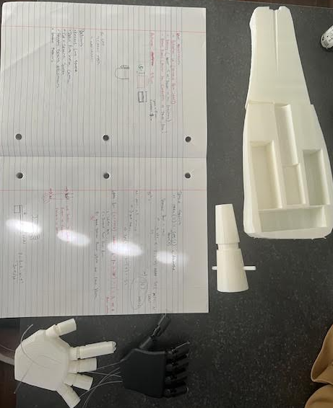

Latest Schematic Diagram Updates: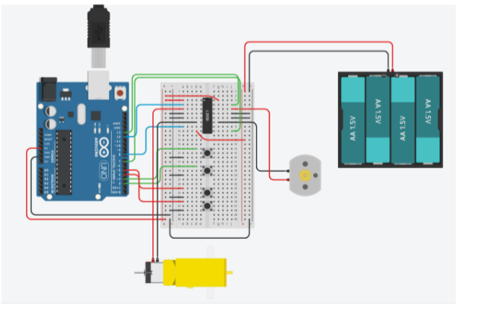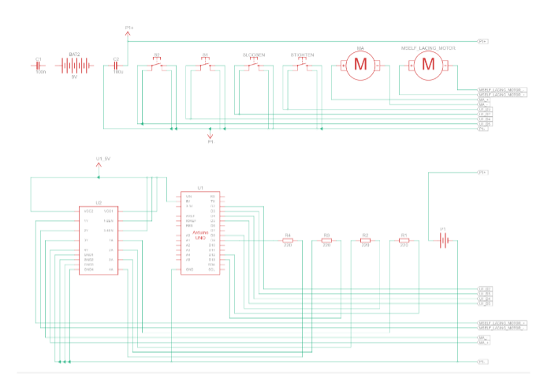
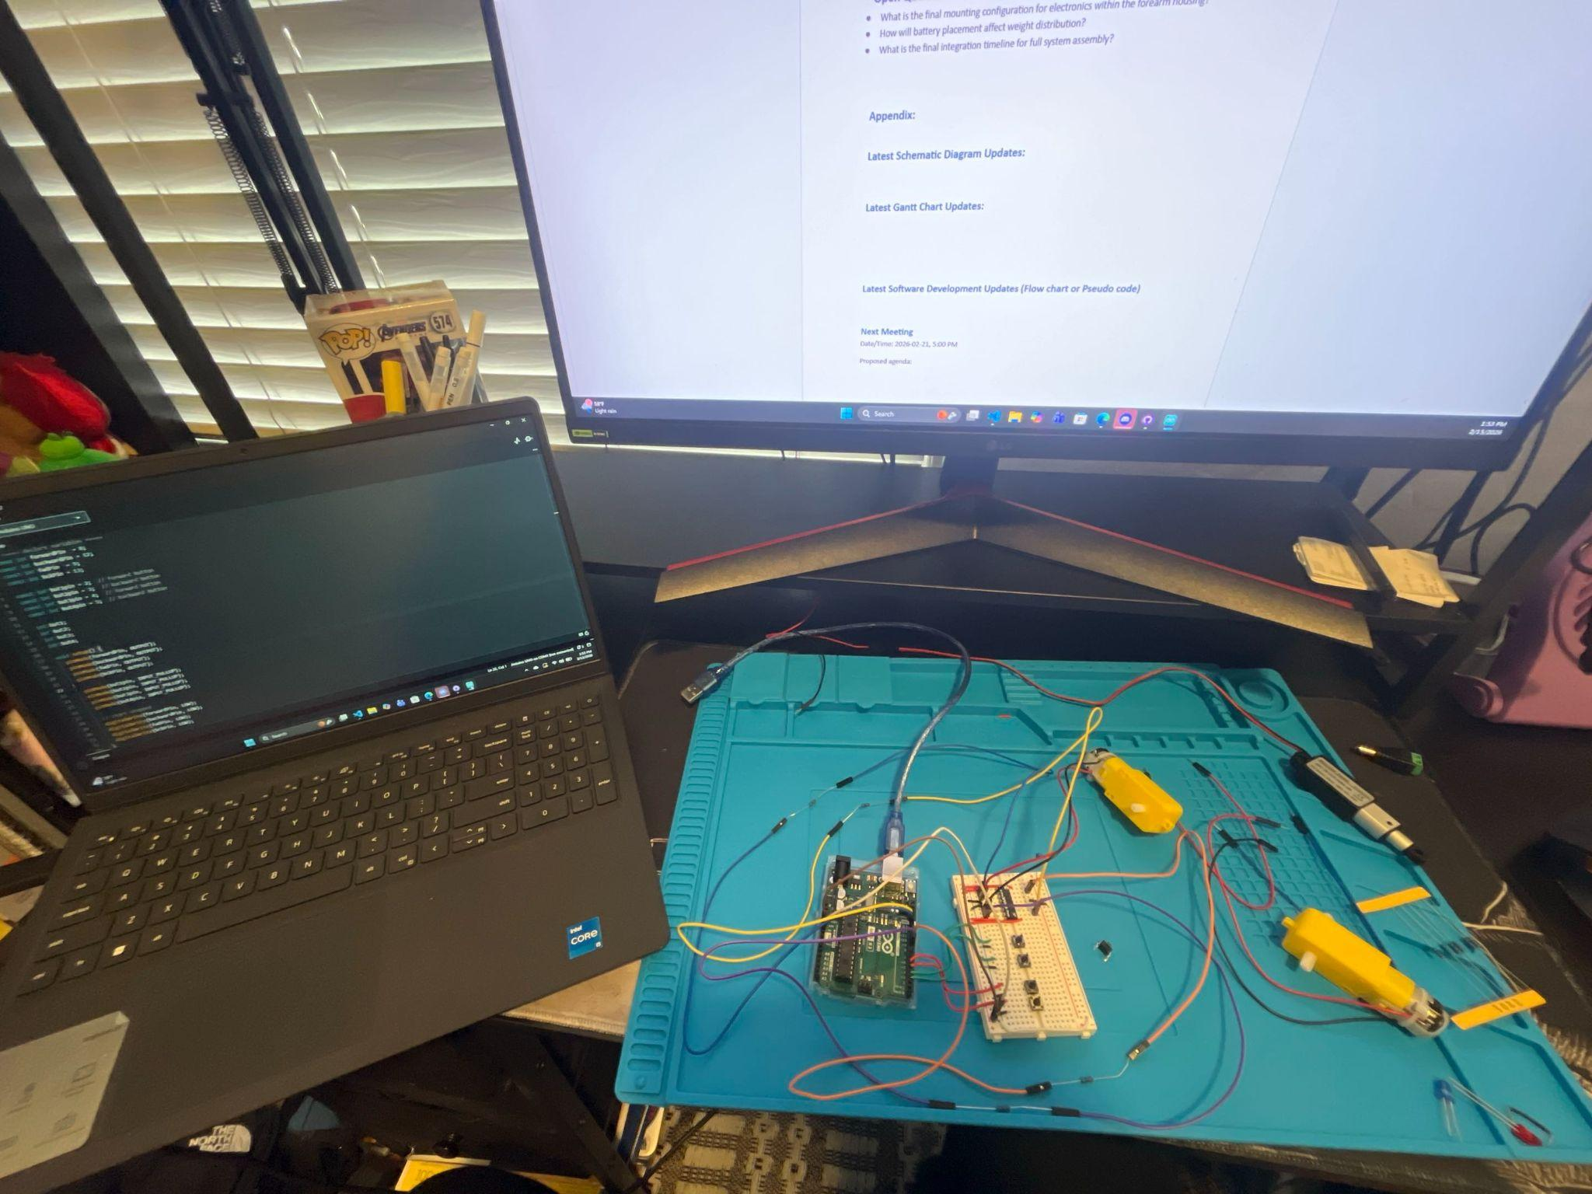

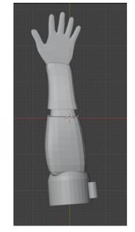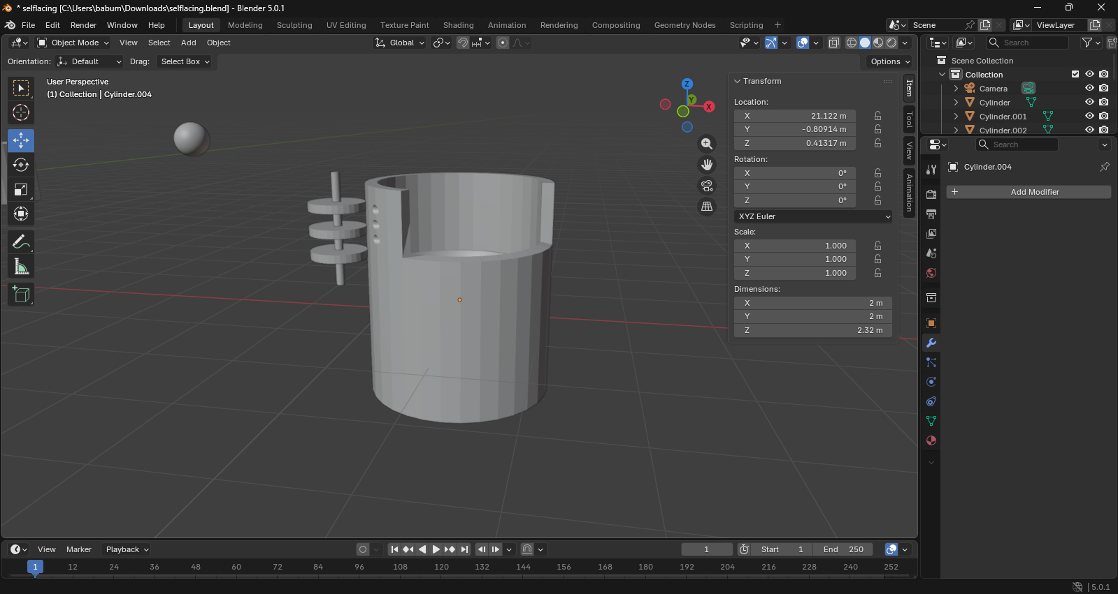
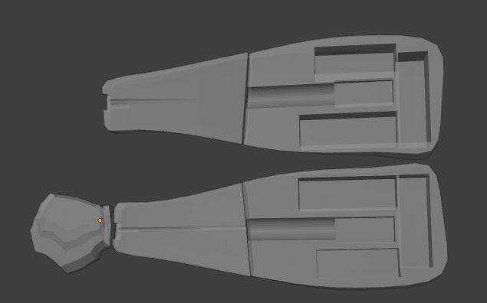

Current Gantt Chart
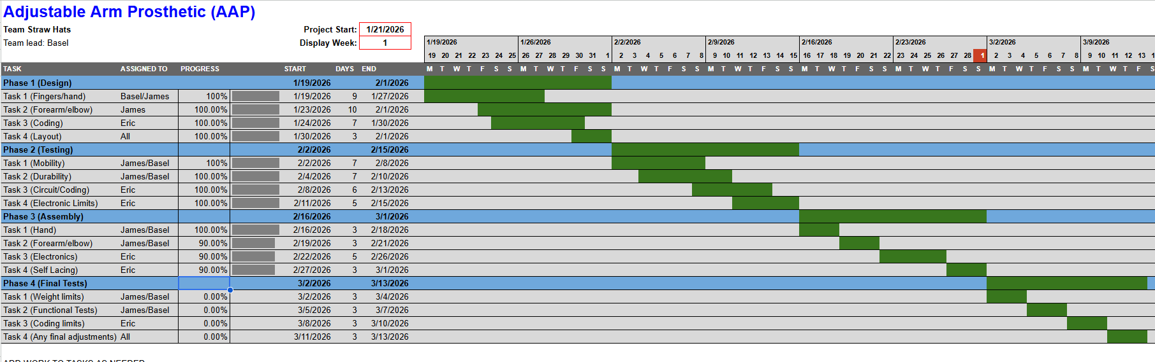
We are currently on track with the Gantt chart. There is a slight delay on the integration part due to the electronics being up north, but they will arrive this week and allow for full system integration.
Updates (Flow chart or Pseudo code)
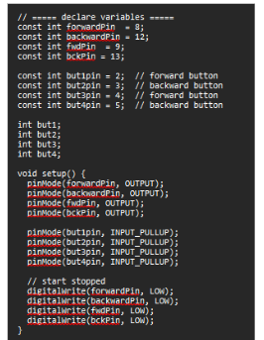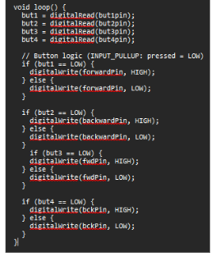
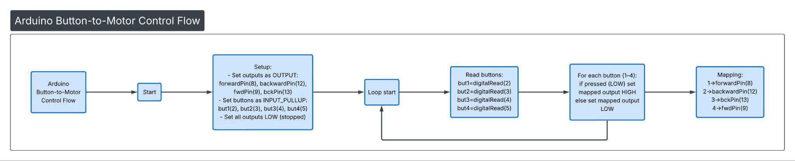

Next Meeting
Date/Time: 2026-03-07, 5:00 PM
Proposed agenda:
- Review system Integration
- Review physical limit tests
- Review any adjustments needed
Pre-work:
- Updated firmware with safety logic
- Mounted electronics layout draft
- Revised bracket design model

