**MINISTRY OF SCIENCE AND HIGHER EDUCATION OF THE RUSSIAN Federation**

Federal State Budgetary Educational Institution of Higher Education

"Kazan National Research Technical University named after A. N. Tupolev-KAI"

(KNRTU-KAI)

Institute of Computer Technologies and Information Security

**Department of Computer Systems**

Report № 5

**«Proteus Virtual System Modeling (VSM)**

**Part I. Some Logic Function Design**

**Part II. Delay Loops Applications Flasher & Counter »**

**«Architecture of embedded systems»**



Student 4167 Edwin G. Carreno

(group number) (signature, data) (full name)

Associate professor of the computer systems’ department Daria V. Shirshova

Grade

(signature, data)

Kazan 2021

**Content**

1. Part I tasks.
2. Part II tasks.
3. Control Questions.
4. Summary.
5. **Part I tasks – Some Logic Function Design**
6. Write an assembly program to achieve the addition/subtraction of two numbers entered to port B and display the result on port A.

For this laboratory practice, the following program allows to the user add and subtract two binary number entered in the Port B (first number in least significant nibble, and second number most significant nibble). Any user can choose the operation using the signal in the 4th pin of the Port A, zero for subtraction and one for addition.

|  |
| --- |
| ;====================================================================  ; Main.asm file generated by New Project wizard  ;  ; Created: Sun Apr 20 2021  ; Processor: PIC16F84A  ; Compiler: MPASM (Proteus)  ;====================================================================  ;====================================================================  ; DEFINITIONS  ;====================================================================  #include p16f84a.inc ; Include register definition file  ;====================================================================  ; VARIABLES  ;====================================================================  CBLOCK 0x20  FIRSTNUMBER  SECONDNUMBER  endc  ;====================================================================  ; RESET and INTERRUPT VECTORS  ;====================================================================  ; Reset Vector  RST code 0x0  goto start  ;====================================================================  ; CODE SEGMENT  ;====================================================================    start:  BSF STATUS, RP0 ; select Register Bank 1  MOVLW 0x10 ; Setting Output direction  MOVWF TRISA    MOVLW 0x77 ; setting Input direction RB[2:0] and RB[2:0] or 0b0111_0111  MOVWF TRISB    BCF STATUS, RP0  goto Loop    Loop:    ; extracting first number from PORTB --> PORTB[3:0]  MOVF PORTB, W  ANDLW 0x07  MOVWF FIRSTNUMBER    ; extracting second number from PORTB --> PORTB[7:4]  MOVF PORTB, W  ANDLW 0x70  MOVWF SECONDNUMBER  SWAPF SECONDNUMBER, W  MOVWF SECONDNUMBER    ;decision making about operation  BTFSC PORTA,4  goto addition  goto substraction    goto Loop    addition:  MOVF FIRSTNUMBER, W  ADDWF SECONDNUMBER, W  MOVWF PORTA  goto Loop    substraction:  MOVF FIRSTNUMBER, W  SUBWF SECONDNUMBER, W  MOVWF PORTA  goto Loop  END  ;==================================================================== |

1. Simulate the program using the circuit shown in figure via Proteus software. Verify it operates properly when simulated.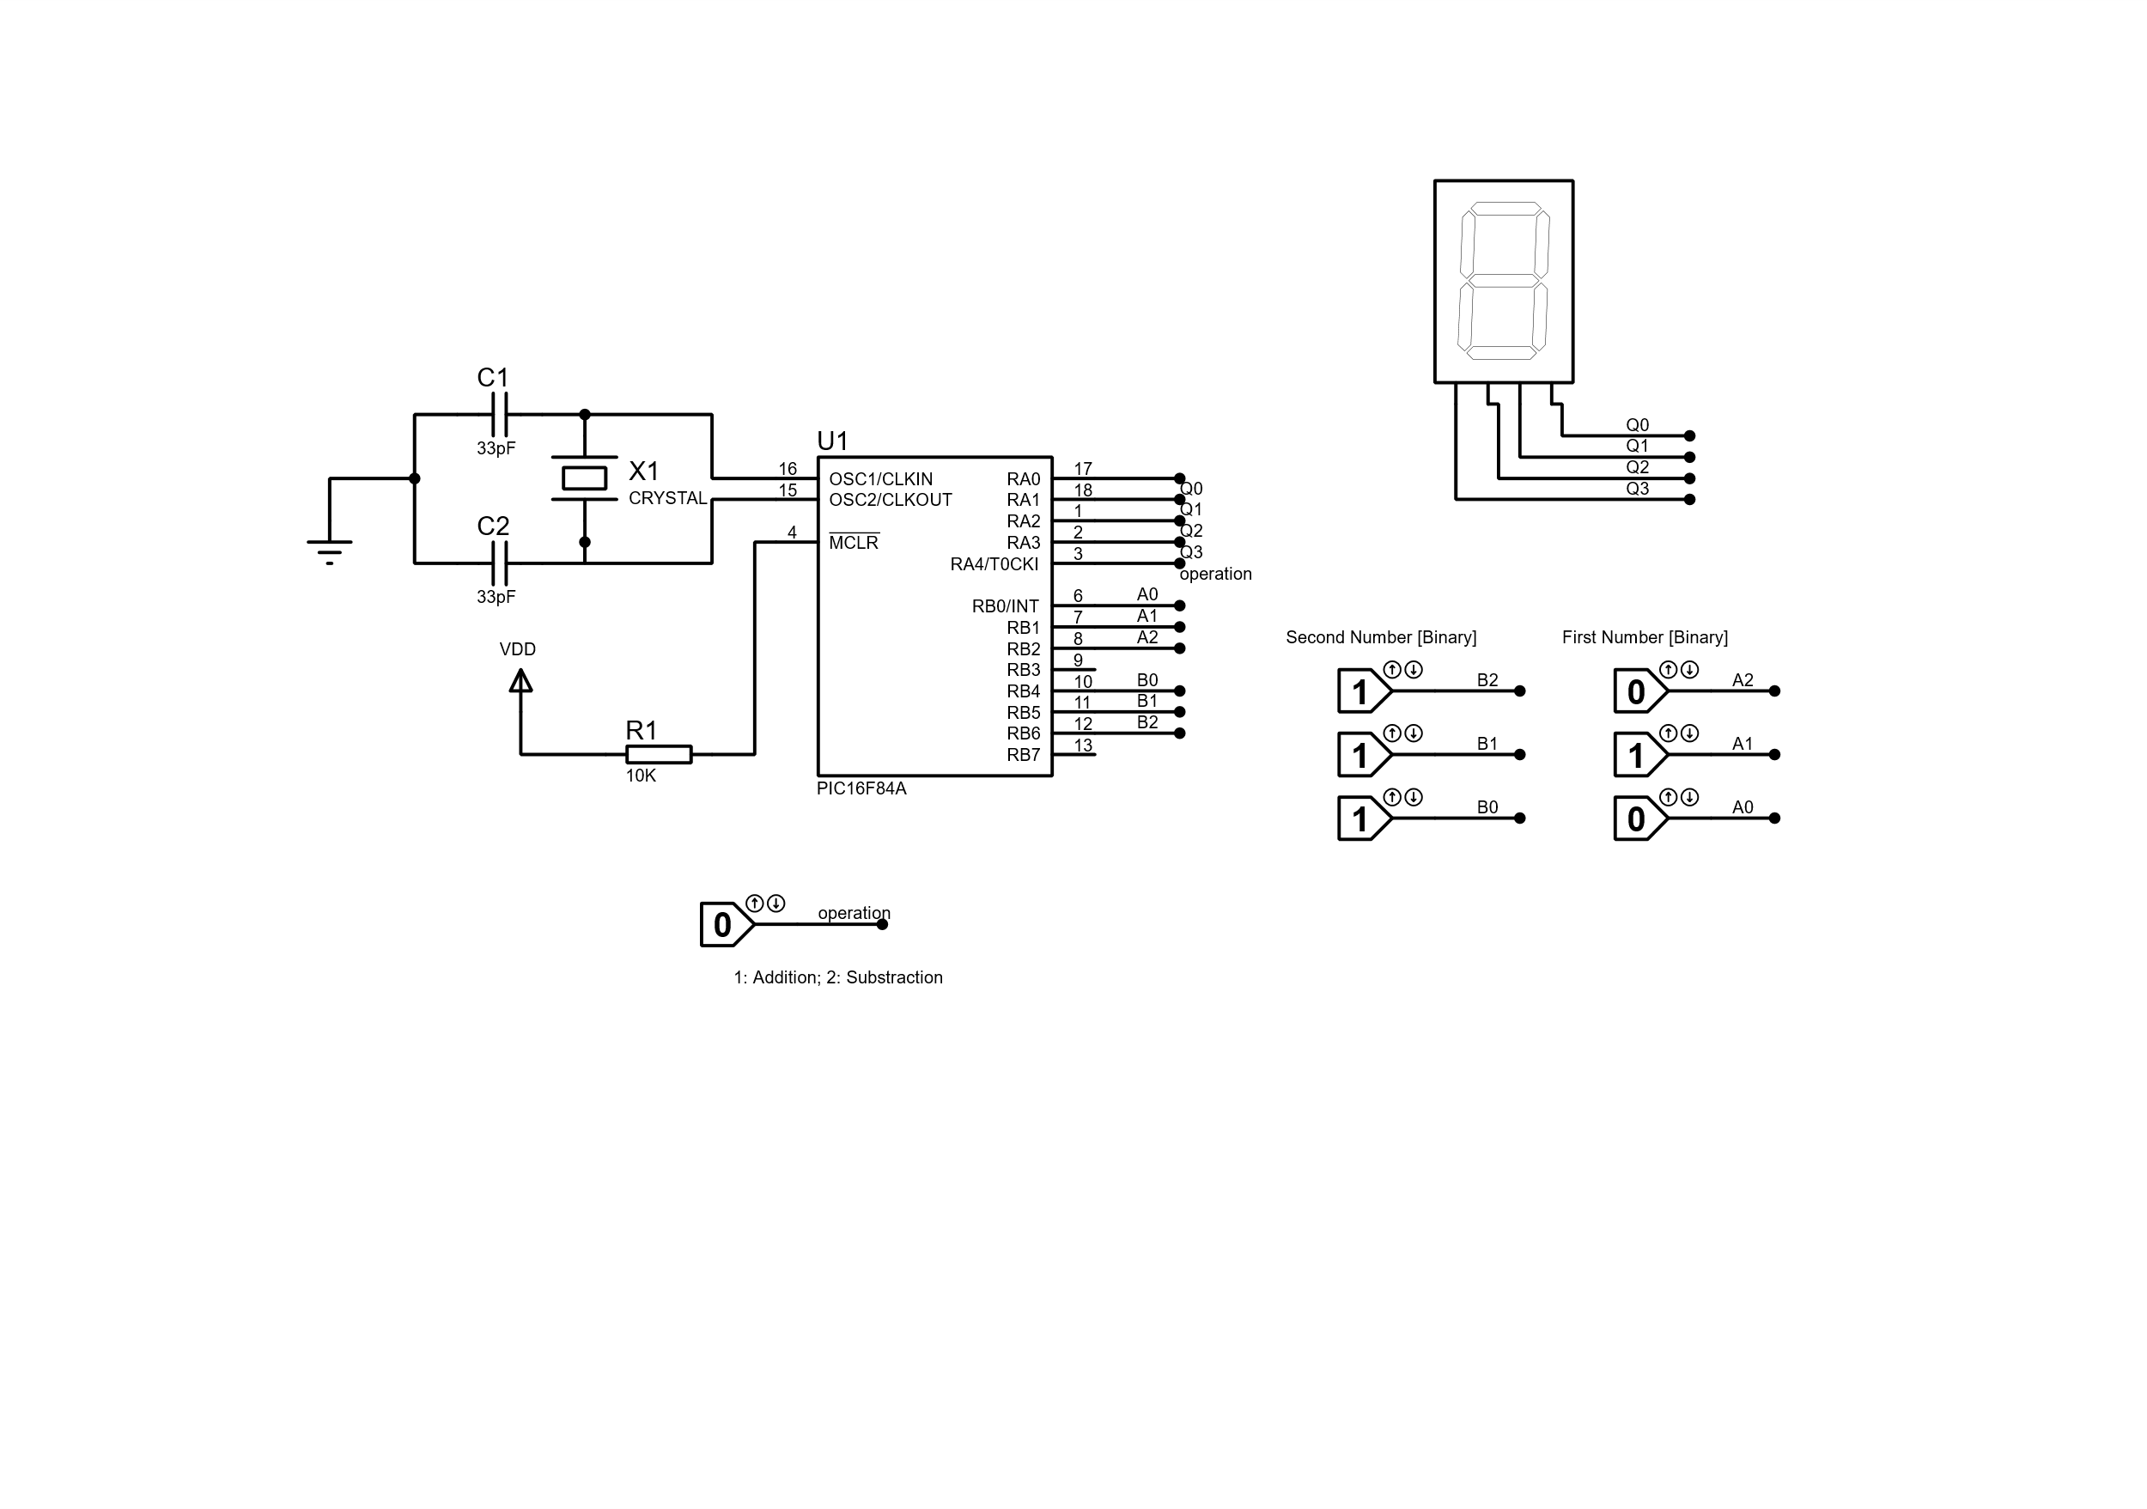

Figure 1. Schematic diagram for laboratory 5, addition and subtraction of binary numbers.

**Addition**

Figure 2. Addition of two numbers, first number is 7 and second number is 2, the result is 9.

Figure 3. Subtraction of two numbers, first number is 7 and second number is 2, the result is 5.

1. Program a PIC16F84A using the QL2006 programmer.
2. Build the circuit using the programmed PIC16F8A and then observe its operation. Demonstrate the circuits operation to the instructor.
3. **Part II tasks – Delay Loops Applications Flasher & Counter**

**Flasher**

1. Write an assembly program to make a Flasher on RB0 (Hint: Use the Delay Subroutine).

|  |
| --- |
| ;====================================================================  ; Main.asm file generated by New Project wizard  ;  ; Created: Sun May 9 2021  ; Processor: PIC16F84A  ; Compiler: MPASM (Proteus)  ;====================================================================  ;====================================================================  ; DEFINITIONS  ;====================================================================  #include p16f84a.inc ; Include register definition file  ;====================================================================  ; VARIABLES  ;====================================================================  ;====================================================================  ; RESET and INTERRUPT VECTORS  ;====================================================================  ; Reset Vector  RST code 0x0  goto Start  ;====================================================================  ; CODE SEGMENT  ;====================================================================  PGM code  Start:  BSF STATUS, RP0 ; select Register Bank 1  MOVLW 0x00 ; Setting Output direction  MOVWF TRISB    BCF STATUS, RP0  MOVLW 0x00  MOVWF PORTB  goto Loop    Loop:  MOVF PORTB, W  XORLW 0x01  MOVWF PORTB  goto Delay  goto Loop  Delay:  MOVLW .255  MOVWF 0CH  LOOP1  MOVLW .255  MOVWF 0DH  LOOP0  NOP  DECFSZ 0DH, F  GOTO LOOP0  DECFSZ 0CH, F  GOTO LOOP1  GOTO Loop  ;====================================================================  END |

1. Simulate the program using the circuit shown in figure via Proteus software. Verify it operates properly when simulated.

Figure 4. Digital signal captured by the integrated oscilloscope.

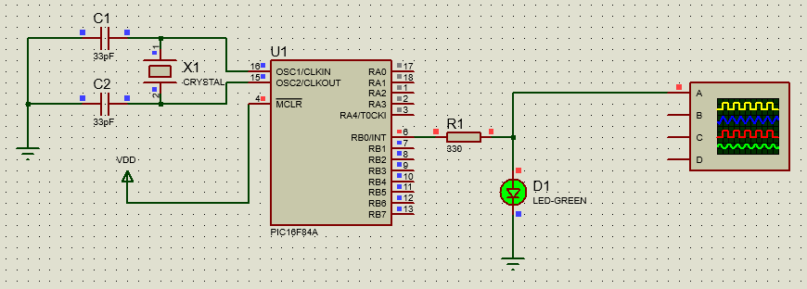

Figure 5. High state at the RB0 output.

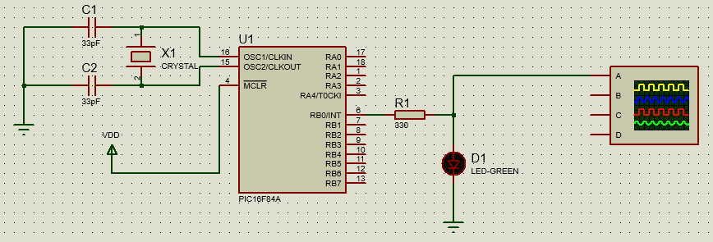

Figure 6. Low state at the RB0 output.

1. Program a PIC16F84A using the QL2006 programmer.
2. Build the circuit using the programmed PIC16F84A and then observe its operation. Demonstrate the circuits operation to the instructor.

**Counter**

1. Write an assembly program to make a Counter (0-9) on Port A. RB0 (Hint: use the delay subroutine).

|  |
| --- |
| ;====================================================================  ; Main.asm file generated by New Project wizard  ;  ; Created: Sun Apr 20 2021  ; Processor: PIC16F84A  ; Compiler: MPASM (Proteus)  ;====================================================================  #include p16f84a.inc ; Include register definition file  ;====================================================================  ; VARIABLES  ;====================================================================  CBLOCK 0x20  COUNTNUMBER  endc  ;====================================================================  ; RESET and INTERRUPT VECTORS  ;====================================================================  ; Reset Vector  RST code 0x0  goto Start  ;====================================================================  ; CODE SEGMENT  ;====================================================================  PGM code  Start:  BSF STATUS, RP0 ; select Register Bank 1  MOVLW 0x10; Setting Output direction  MOVWF TRISA    BCF STATUS, RP0  GOTO Loop    Loop:  CLRF COUNTNUMBER    INNERLOOP  MOVF COUNTNUMBER,0  MOVWF PORTA  CALL DELAY  INCF COUNTNUMBER, 1  MOVF COUNTNUMBER, 0  XORLW .10  BTFSS STATUS, Z  GOTO INNERLOOP  GOTO Loop    DELAY:  MOVLW .255  MOVWF 0CH  LOOP1  MOVLW .255  MOVWF 0DH  LOOP0  NOP  DECFSZ 0DH, F  GOTO LOOP0  DECFSZ 0CH, F  GOTO LOOP1  RETURN  ;====================================================================  END |

1. Simulate the program using the circuit shown in figure via Proteus software. Verify it operates properly when simulated.

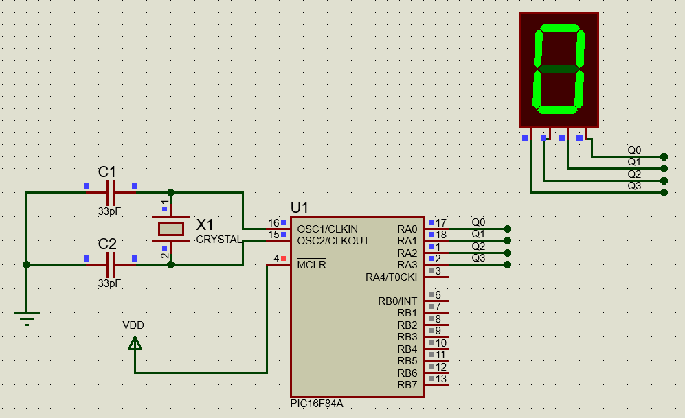

Figure 7. Output value at PORTA

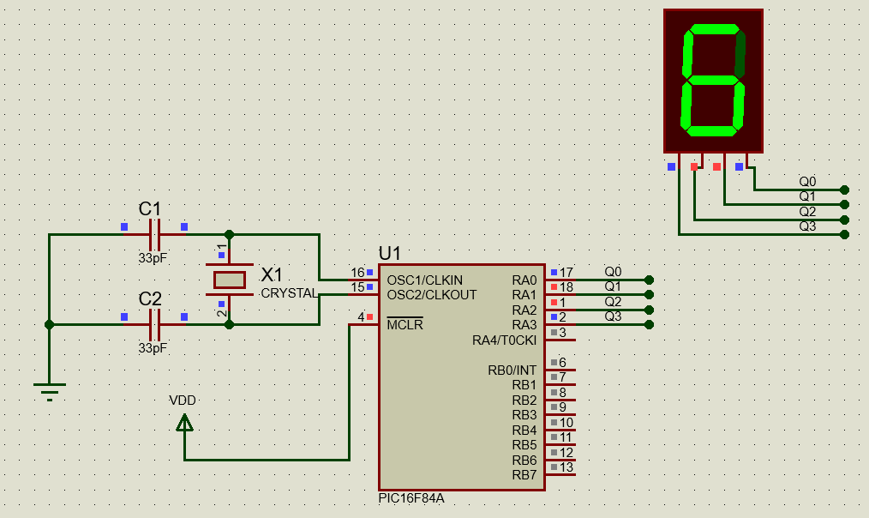

Figure 8. Output value at PORTA

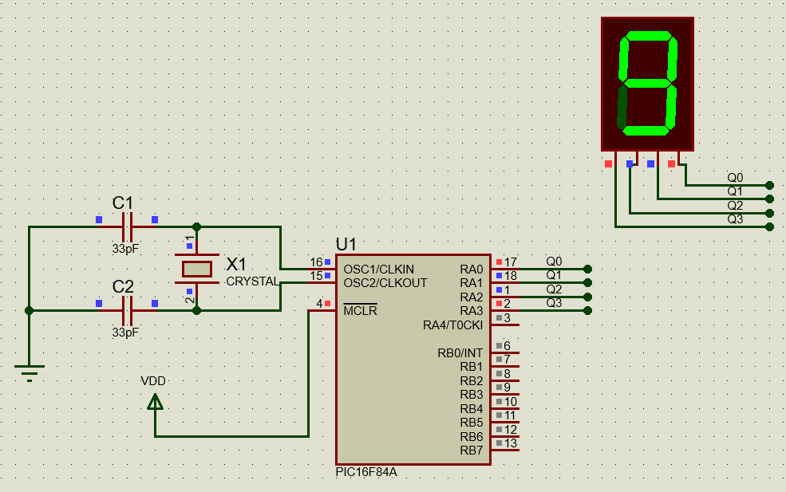

Figure 9.Output value at PORTA

1. Program a PIC16F84A using the QL2006 programmer.
2. Build the circuit using the programmed PIC16F84A and then observe its operation. Demonstrate the circuits operation to the instructor. Present your results in a lab report including a copy of the source codes.

Those codes are as a attached files with this report. However, they can be consulted at: github.com/ecarrenolozano/ArchitectureEmbeddedSystems2021

1. **Control Questions**
   1. How to write the addition function?

In C language you could use the operator +, but in assembler you need the ADDWF, or the INCF if your intention is adding1 to one register.

* 1. What is the method of masking?

The idea of masking is utilizing some subsets of a register without affecting the remaining bits you are not interested in use. This is a method that allow to treat bits independently.

* 1. How many methods do you know generating Delay in PIC16F84A?

Two methods, creating delays with loops in general and using timers.

* 1. What are these methods?

Loops: this method is inefficient, and it consist of generate empty operations and “waste time” doing nothing. The time wasted is considered a delay.

Timer: this method creates interruptions once an internal and precise counter reaches an overflow condition.

1. **Summary**

For this laboratory practice the main purpose was getting started with the Assembly language for microcontrollers. A variety of circuits were tested in Proteus, the personal computer abstract microcontroller capabilities and it is able to simulate the Instruction Set Architecture of the chosen microcontroller (PIC16F84A) and to generate the expected outputs for each circuit.