**MINISTRY OF SCIENCE AND HIGHER EDUCATION OF THE RUSSIAN Federation**

Federal State Budgetary Educational Institution of Higher Education

"Kazan National Research Technical University named after A. N. Tupolev-KAI"

(KNRTU-KAI)

Institute of Computer Technologies and Information Security

**Department of Computer Systems**

Report № 6

**«Proteus Virtual System Modeling (VSM)**

**PART I. TMR0 Application Counter Using TMR0.**

**PART II. EEPROM Memory Application »**

**«Architecture of embedded systems»**



Student 4167 Edwin G. Carreno

(group number) (signature, data) (full name)

Associate professor of the computer systems’ department Daria V. Shirshova

Grade

(signature, data)

Kazan 2021

**Content**

1. Part I. TMR0 Application Counter Using TMR0.
2. EEPROM Memory Application.
3. Control Questions.
4. Summary.
5. **Part I. TMR0 Application Counter Using TMR0**

**TMR0**

1. Write an Assembly program to make a counter using TMR0; the counter should increment its value on every 2 pushbuttons on RA4.

|  |
| --- |
| ;====================================================================  ; Main.asm file generated by New Project wizard  ;  ; Created: Sun Apr 22 2021  ; Processor: PIC16F84A  ; Compiler: MPASM (Proteus)  ;====================================================================  ;====================================================================  ; DEFINITIONS  ;====================================================================  #include p16f84a.inc ; Include register definition file  ;====================================================================  ; VARIABLES  ;====================================================================  ;====================================================================  ; RESET and INTERRUPT VECTORS  ;====================================================================  ; Reset Vector  RST code 0x0  goto Start  ;====================================================================  ; CODE SEGMENT  ;====================================================================  PGM code  Start  BCF STATUS, RP0 ; Selecting bank 1  CLRF PORTA ; Clearing register PORTA  CLRF PORTB ; Clearing register PORTB  CLRF TMR0 ; Clearing register TMR0    BSF STATUS, RP0 ; Selecting bank 0  MOVLW 0x10  MOVWF TRISA ; Setting PORTA.4 as Input  MOVLW 0xF0  MOVWF TRISB ; Setting PORTA[3:0] as Output  MOVLW 0x20  MOVWF OPTION_REG ; Choosing a prescaler 1:2  BCF STATUS, RP0 ; Selecting bank 1    Loop  MOVFW TMR0  MOVWF PORTB ; Transfering value of TMR0 to PORTB  goto Loop  ;====================================================================  END |

1. Simulate the program using the circuit shown in figure via Proteus software. Verify it operates properly when simulated.

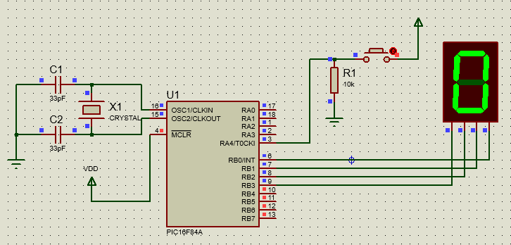

Figure 1. Counter using TMR0 and prescale 1:2. The pushbutton has been pressed 0 times.

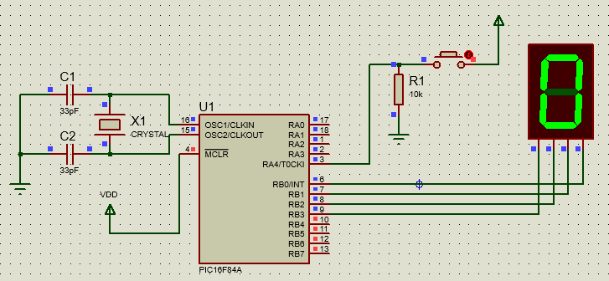

Figure 2. Counter using TMR0 and prescaler 1:2. The pushbutton has been pressed 1 time.

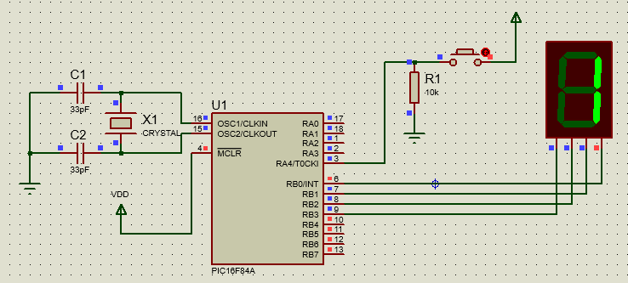

Figure 3.Counter using TMR0 and prescale 1:2. The button has been pressed 2 times.

1. Program a PIC16F84A using the QL2006 programmer.
2. Build the circuit using the programmed PIC16F84A and the observe its operation. Demonstrate the circuits operation to the instructor.

**Watchdog Timer (WDT)**

1. Write an Assembly program to make a counter using WDT; the counter should increment its value on every one single pushbutton on RA4, and also counts from 0 to 99.

|  |
| --- |
| ;====================================================================  ; Main.asm file generated by New Project wizard  ;  ; Created: Sun Apr 22 2021  ; Processor: PIC16F84A  ; Compiler: MPASM (Proteus)  ;====================================================================  ;====================================================================  ; DEFINITIONS  ;====================================================================  #include p16f84a.inc ; Include register definition file  ;====================================================================  ; VARIABLES  ;====================================================================  CBLOCK 0x20  CACHETIMER  TENS  ENDC  ;====================================================================  ; RESET and INTERRUPT VECTORS  ;====================================================================  ; Reset Vector  RST code 0x0  goto Start  ;====================================================================  ; CODE SEGMENT  ;====================================================================  Start:  BCF STATUS, RP0 ; Select Bank 0  CLRF PORTA ; Initialize PORTA  CLRF PORTB ; Initialize PORTB  CLRF TMR0 ; Initialize TMR0  BSF STATUS, RP0 ; Select Bank 1  MOVLW 0x10 ; Set RA[3:0] as outputs and RA4 as input  MOVWF TRISA    MOVLW 0xF0 ; Set RB[3:0] as outputs  MOVWF TRISB  MOVLW 0x78 ; Configure TMR0 to be used by the watchtimer  MOVWF OPTION_REG    BCF STATUS, RP0 ; Select Bank 0  Loop:  MOVFW TMR0 ; Capturing TMR0  MOVWF CACHETIMER ; Save TMR0 to CACHETIMER  MOVLW 0x00  MOVWF TENS  counting  MOVLW 0x0A ; Subtract 10 from 0x0C  SUBWF CACHETIMER, F  BTFSS STATUS, C ; Display "tens" and "units" if "units" < 0  GOTO display  INCF TENS, F ; Increment "tens" and repeat  GOTO counting    display  MOVLW 0x0A ; Adjust "units" (units < 0)  ADDWF CACHETIMER, F  MOVFW TENS ; Display "tens"  MOVWF PORTA  MOVFW CACHETIMER ; Display "units"  MOVWF PORTB  GOTO Loop  ;========================================================================  END |

1. Simulate the program using the circuit shown in figure via Proteus software. Verify it operates properly when simulated.

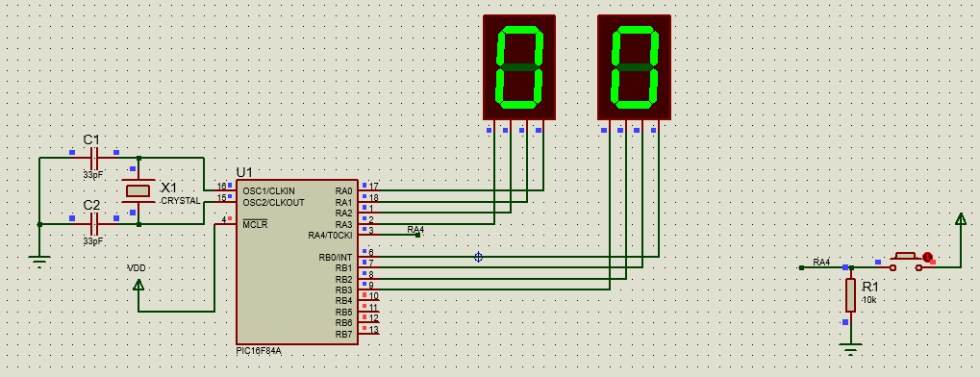

Figure 4. Counter using WDT. The pushbutton has been pressed 0 times.

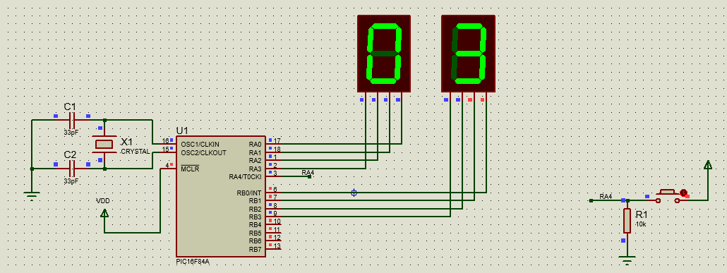

Figure 5. Counter using WDT. The pushbutton has been pressed 3 times.

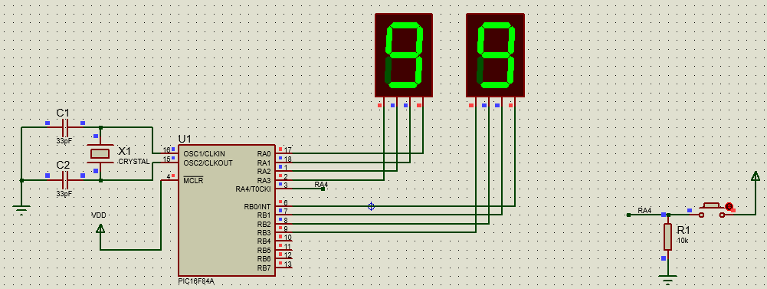

Figure 6. Counter using WDT. The pushbutton has been pressed 99 times.

1. Program a PIC16F84A using the QL2006 programmer.
2. Build the circuit using the programmed PIC16F8A and then observe its operation. Demonstrate the circuits operation to the instructor. Present your results in a lab report including a copy of the source codes.
3. **EEPROM Memory Application**
4. Write an assembly program to fill all the EEPROM Memory locations with 7. Hint: Build an external Macro called EEPROM_WRITE and EEPROM_READ takes two parameters the data and the address to achieve the writing and reading ; then call it in the main program.

|  |
| --- |
| ;====================================================================  ; Main.asm file generated by New Project wizard  ;  ; Created: Sun Apr 22 2021  ; Processor: PIC16F84A  ; Compiler: MPASM (Proteus)  ;====================================================================  ;====================================================================  ; DEFINITIONS  ;====================================================================  #include p16f84a.inc ; Include register definition file  ;====================================================================  ; VARIABLES  ;====================================================================  CBLOCK 0x20  MEMADDRESS  MEMDATA  ENDC  ;====================================================================  ; RESET and INTERRUPT VECTORS  ;====================================================================  ; Reset Vector  RST code 0x0  goto Start  ;====================================================================  ; CODE SEGMENT  ;====================================================================  Start:  BSF STATUS, RP0 ; Selecting Bank 1  MOVLW 0x1F ; Setting RA[4:0] as inputs  MOVWF TRISA  MOVLW 0xE0 ; Setting RB[4:0] as outputs  MOVWF TRISB    BCF STATUS, RP0 ; Selecting Bank 0  EEPROM_READ MACRO ADDRESS, INFO  BCF STATUS, RP0  MOVF ADDRESS, W ; Setting EEPROM Address  MOVWF EEADR  BSF STATUS, RP0  BSF EECON1, RD  BCF STATUS, RP0  MOVF EEDATA, W  MOVWF INFO  endm  EEPROM_WRITE MACRO ADDRESS, INFO  BCF STATUS, RP0  MOVF ADDRESS, W  MOVWF EEADR  MOVF INFO, W  MOVWF EEDATA  BCF STATUS, RP0  BCF INTCON, GIE ; Disabling interruptions  BSF STATUS, RP0  BSF EECON1, WREN ; Enable Write  MOVLW 0x55 ; Write 55h  MOVWF EECON2  MOVLW 0xAA ; Write AAh  MOVWF EECON2  BSF EECON1, WR    WRITE  BTFSS EECON1, EEIF  GOTO WRITE    BCF EECON1, EEIF  BCF STATUS, RP0  BSF INTCON, GIE ; Enabling interruptions  endm  Loop:  BCF STATUS, RP0  MOVLW 0x10 ; Setting memory address  MOVWF MEMADDRESS    MOVF PORTA, W ; Capturing Data to store  MOVWF MEMDATA    EEPROM_WRITE MEMADDRESS, MEMDATA ; Writing invoke  EEPROM_READ MEMADDRESS, MEMDATA ; Reading invoke  MOVFW MEMDATA  MOVWF PORTB  GOTO Loop  ;========================================================================  END |

1. Write an assembly program to take the data existed on PORT A and display it on PORT B; first, the data must be taken from PORT A and stored in the EEPROM address location 0x10, and then be taken again from EEPROM and be displayed on PORT B.

* Done in the step *a*.

1. Simulate the program using the circuit shown in figure Proteus software. Verify it operates properly when simulated.

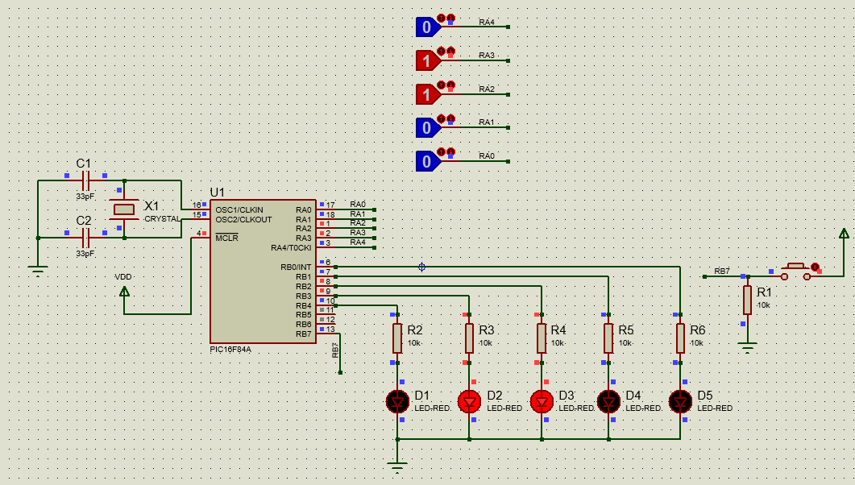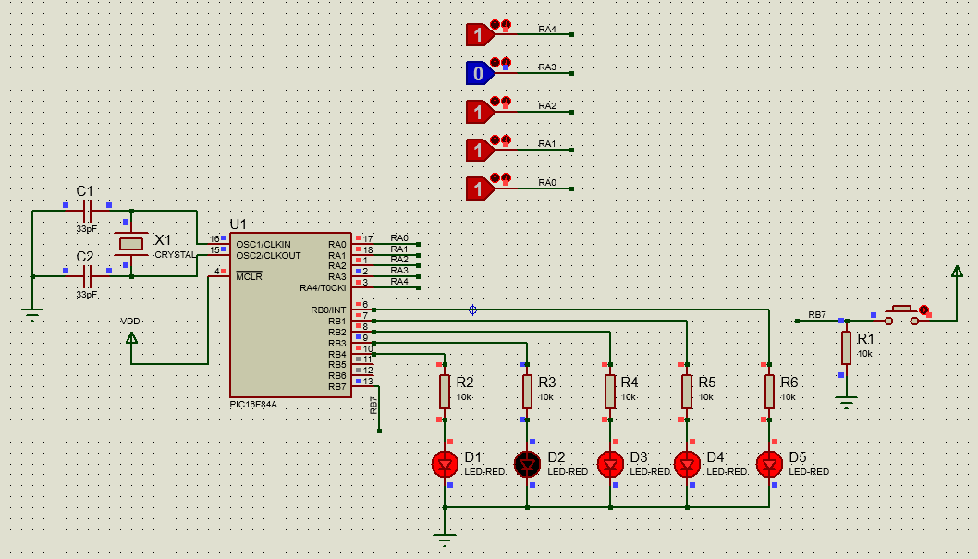

Figure 7. Performing R/W operations in the embedded EEPROM for the PIC16F84A.

1. **Control Question**
   1. What is a timer?

It is a peripheral with capabilities of counting over time, restarting, and capturing rising/falling edges in external signals. Additionally, could interrupt the microcontroller CPU in order to perform actions that are a priority.

* 1. Why do we need timers?

In order to perform precise operations related to time. A timer allows to the microcontroller perform unattended operations and interrupt the processor in case it requires priority.

* 1. What is the Option Control Register?

It is the register that allows to the programmer to configure the TIMER embedded into the microcontroller. Some options you could find are prescaler selections bits and timer source.

* 1. What is EEPROM memory?

It is Non-volatile memory that allows to the microcontroller, in this case, to store data that could be critical for some applications such as settings in a medical device or the temperature in a vaccine refrigeration system that could suffer of constant electrical outages.

1. **Summary**

In this practice we continue with the usage of assembly language as a programming tool to configure microcontroller peripherals such as a timer. On the other hand, it is important to be careful with the appropriate usage of the Instruction Set for the microcontroller, sometimes Proteus do not inform errors and you as engineer do not has an easy starting point for debugging your design. Always, you must have the datasheet as a reference.