Patterns

Ernesto Carrera

6/10/2017

## Purpose:

The purpose of this document is to validate the relationship between the square footage of the properties against their sales price.

We plot the variables in logarithmic scale to smooth the curve. However, after doing the transformation there are several outliers in the data as the plot below exhibits:

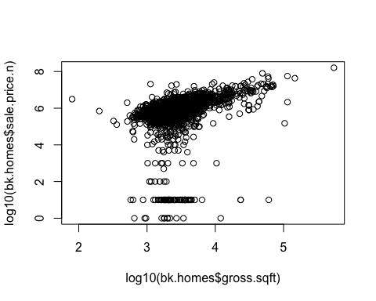

After removing the outliers we can see the exptected relationship between gross square feet and Sale price. The higher the square feet the higher the sale price 