ERD with Crow’s Foot Notation
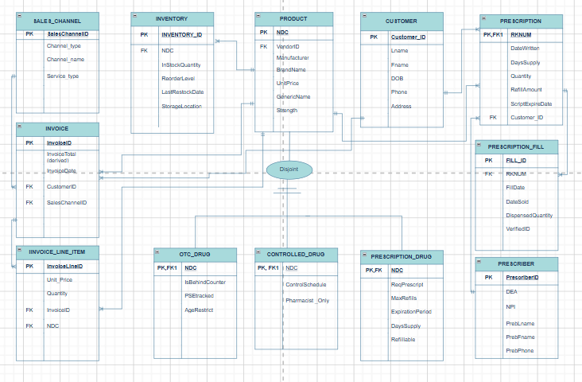

SQL Dump
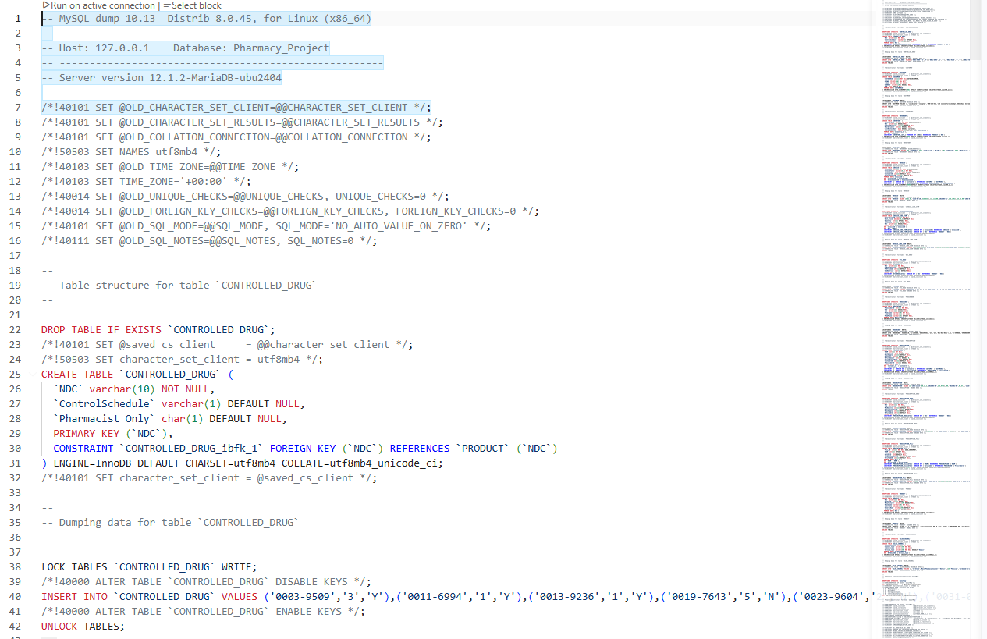

Output of SQL Query: Specific Inventory of Customer Name & Date of Purchase
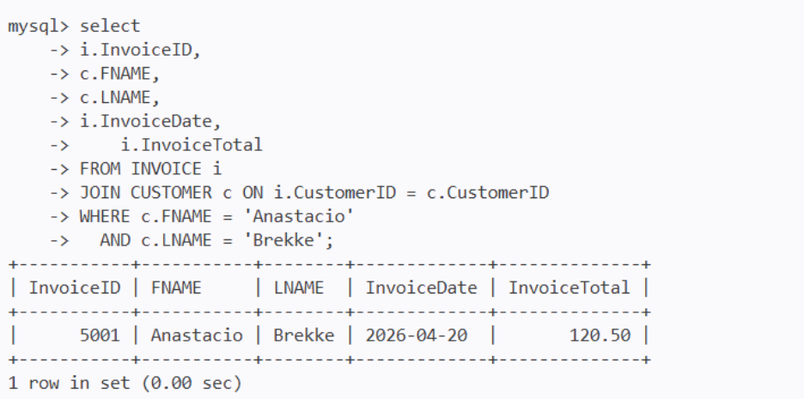

Output of SQL Query: Current Inventory of Products Sold on Date Range
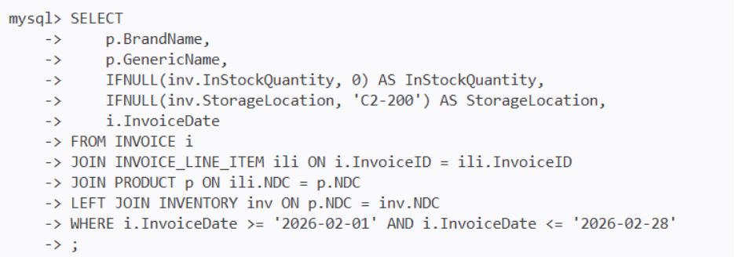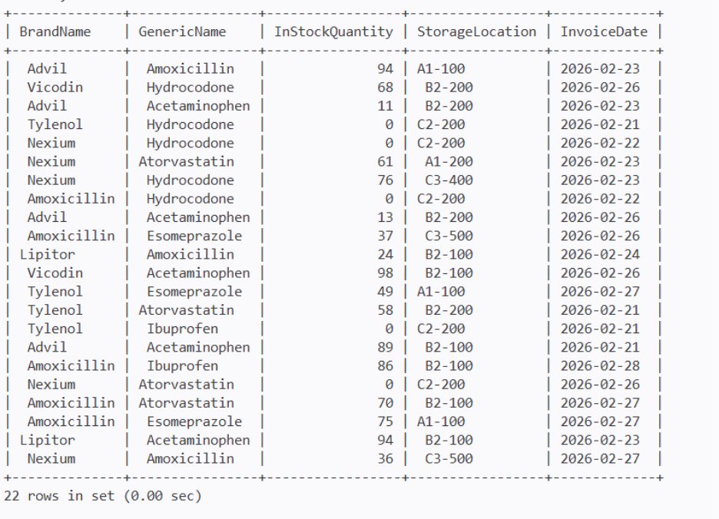

Output of SQL Query: Current Inventory of Products that Match Product Type
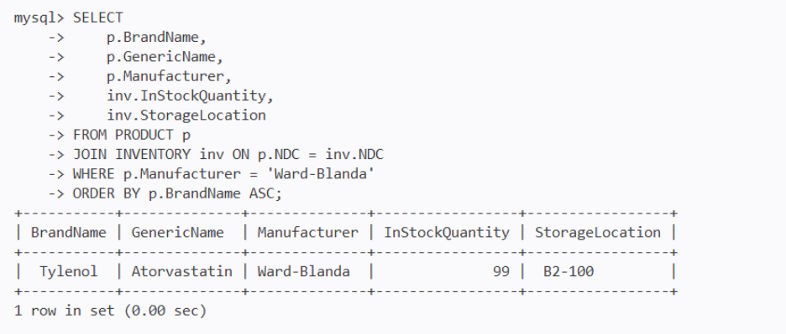

Output of SQL Query: Allows User to Pass Value to Join 3 Tables
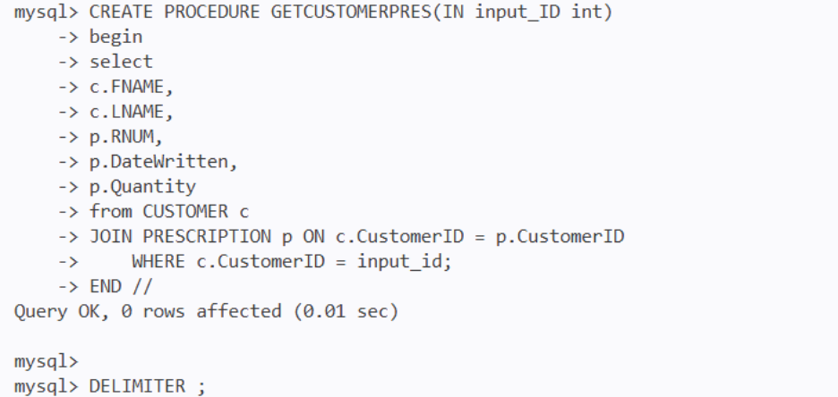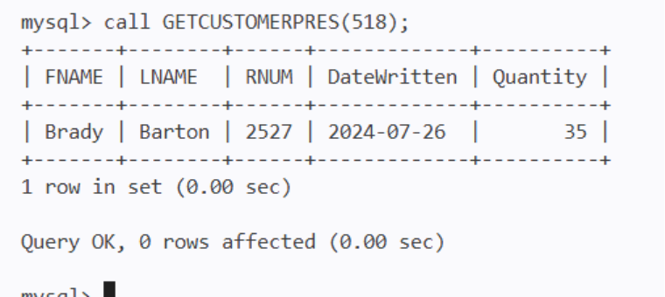

SQL Code: Inserted New Product into the Product table
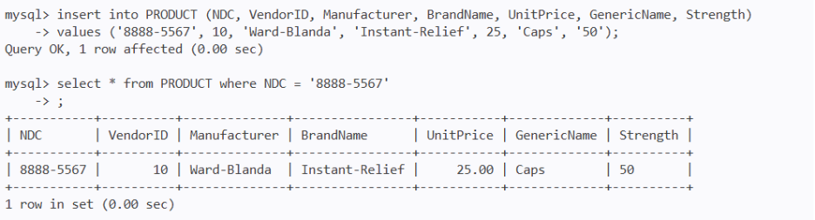

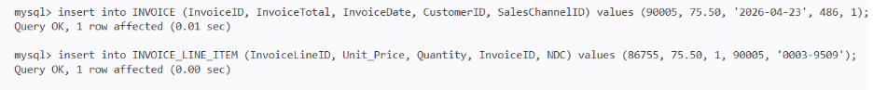
SQL Code: Generated New Invoice

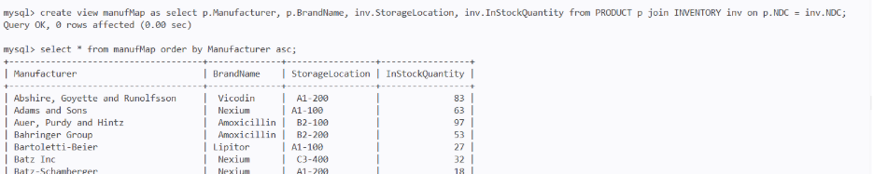
SQL Code: Output Virtual Table

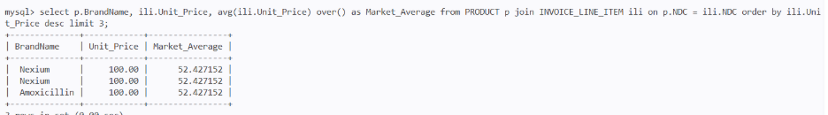
SQL Query: Frequency Distribution of Customers

SQL Subquery: Arithmetic Operations & Aliases
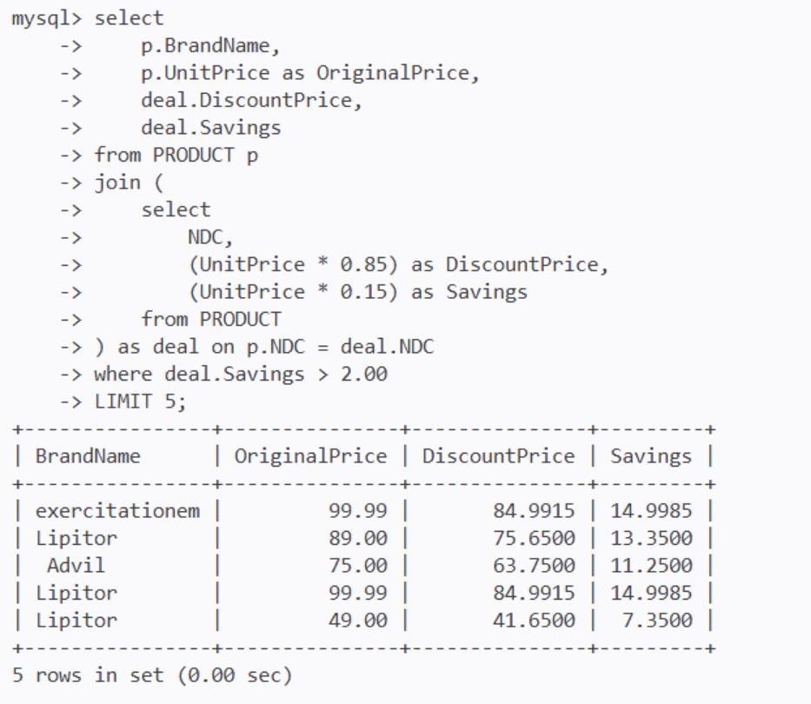

SQL Code: Joined 5 Tables that Match Boolean Conditions
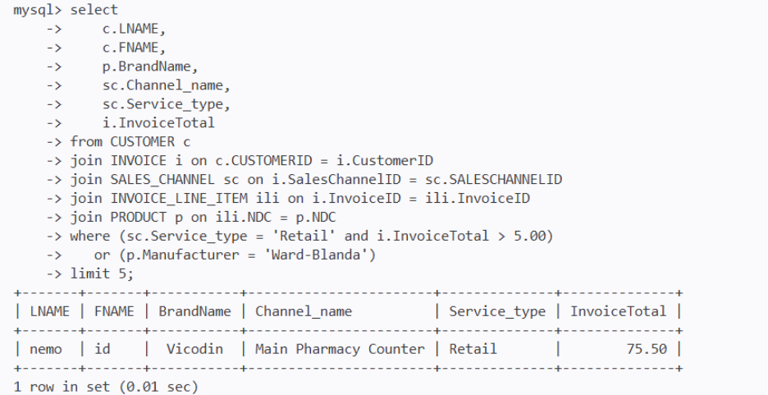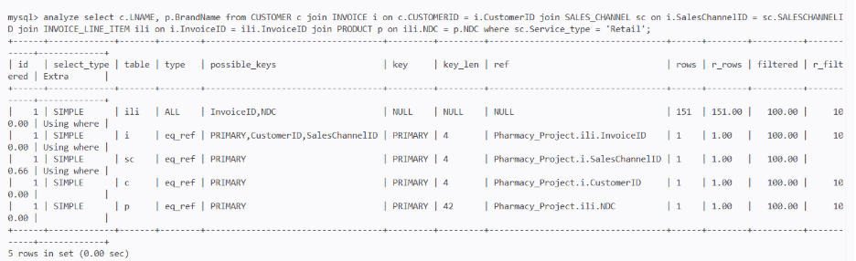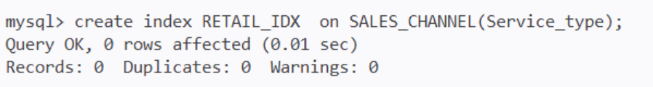

Data Dictionary of Tables
