CS555/455 Summer 2017

Assignment 3
Due on July 31 (by 11:59pm)

Part A: Detection of Region of Interest (50%)

- Description: In this part, you are required to design an algorithm to detect abnormal cells in a medical image.

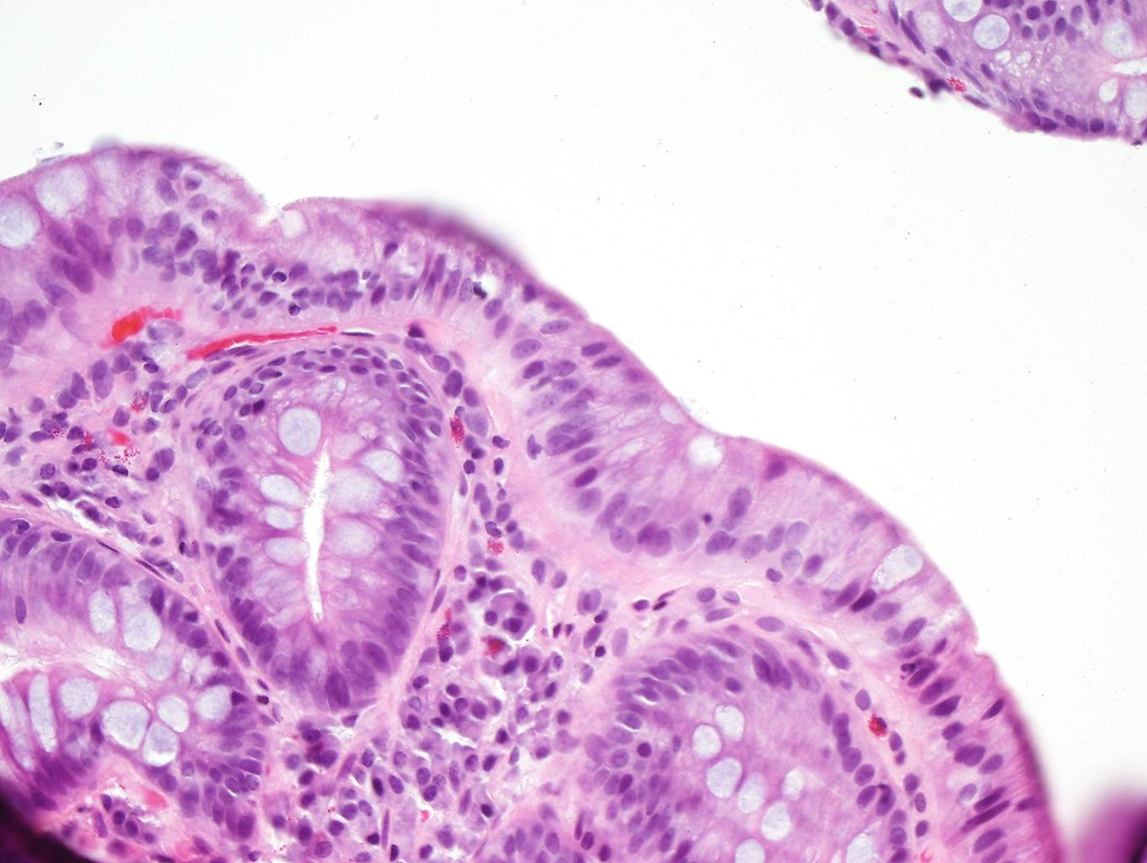
Abnormal Cells

The above image shows the abnormal cells in brighter intensity and relatively bigger regions. Your program is required to label these regions and count the number of abnormal cells automatically.

Hint: you may consider using color information and morphological operation to process the image.

Part B: Classification of Texture Pattern (50%)
- Description: In this part, you are required to design an algorithm to classify the image (shown below) into three classes (or three patterns).

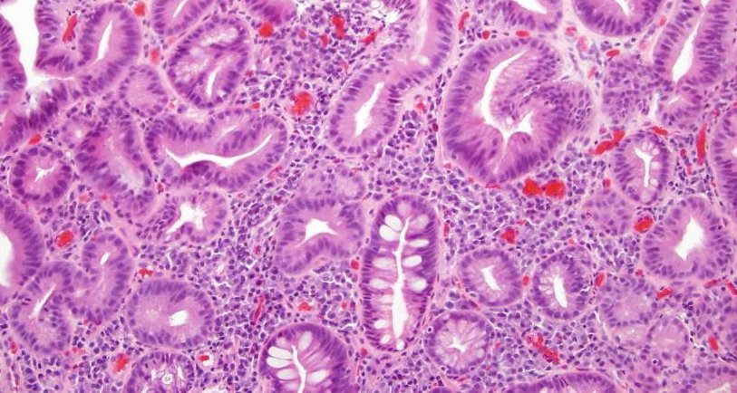
Example: Boundary of group cells

This image shows three patterns (or classes) as follows:

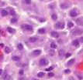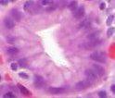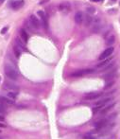
Class 1 Class 2 Class 3

Your program should be able to
(1) detect the boundary of the group cell (see an example of above image);
(2) classify and label the above three classes automatcially.

Hint:
- Apply color information, morphological operation, and/or edge detection to process the image.
- For above three classes, each one has its unqiue feature (e.g., average, variance, DCT components, histogram, grey scale texture, edges, or wavelet components, etc.) You may consider using those features as a template to match the features in the image.
- The image could be dividied into a set of small blocks (e.g., 8*8, 16*16, etc.) you may consider classify each block to one of the three classes based on the above-mentioned unique features using the Nearest Neighbor calssfier.

