New Delhi, India

March 31, 2025

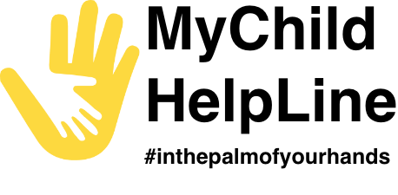

SETUP NOTIFICATION SERVICE

*MyChild Helpline*

**Introduction**

This guide outlines the process to configure and send notifications to mobile app users using Firebase Cloud Messaging (FCM).

**Steps to send notifications**

Set up Firebase by using a service account key JSON file.

1. Firebase setup
2. Contantfile configuration
3. Node schedule setup (npm package) – Node Schedule is a flexible cron-like and not-cron-like job scheduler for Node.js. It allows you to schedule jobs for execution at specific dates.

* Setup Node Schedule: ***$ npm install node-schedule***

## Contantfile configuration

File Name:*serviceAccountKey.json*

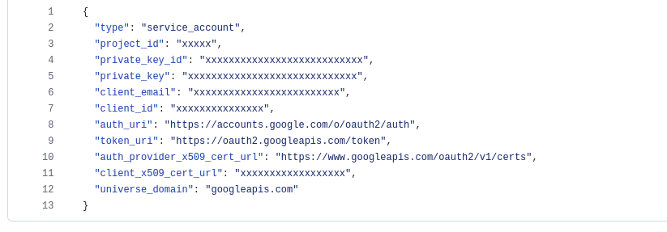File Path:*/constantfile/serviceAccountKey.json*

## Service to brodcast notification to mobile app

File Name**:** *broadcastService.js*

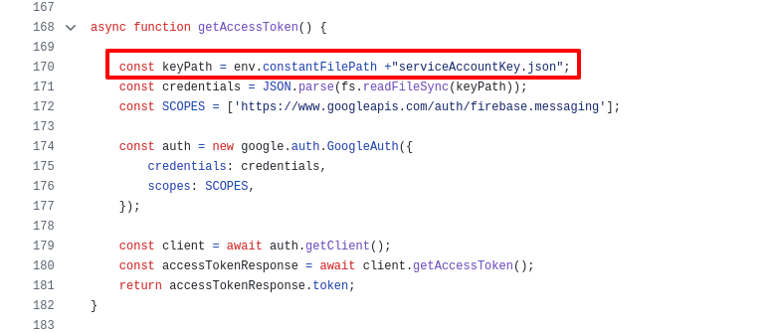File Path*:-/services/broadcastService.js*

## Dataimport env path setup

Update **.env** file with below variable to fetch credential

*CONSTANT_FILE_PATH=/var/www/html/project/constantfile/*

-----------------=-----------**END OF THE DOCUMENT**---------------------