Push Notification Service : Adding a New Provider

1. Create a new provider file under

project_root/src/utils/PushService/providers/

1. Implement the INotificationService interface

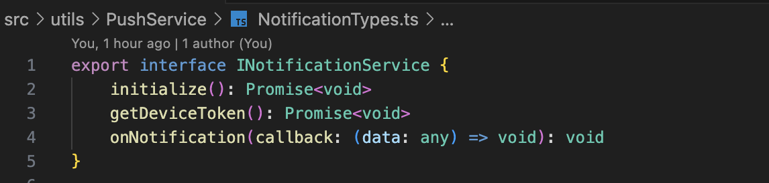

1. Register the new provider in project_root/src/utils/PushService/[NotificationServiceFactory.ts](http://notificationservicefactory.ts)

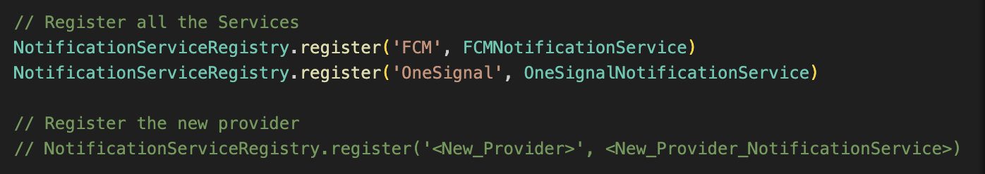

1. Update the NOTIFICATION_PROVIDER value in config.ts

