Observations made teaching MATH 122 – University Calculus I, Fall 2019,
utilizing August 6, 2019 version.

- Since a lot of the problems involve parameters, I emphasized to my class that in a problem, they need to decide what is a fixed number and what is a variable. I keep re-emphasizing this. A good place to put this in might be somewhere around Example 1 on p. 14. We can emphasize that in example 1, $s$ is a fixed number, while $x$ is a variable. In general, we can get in the habit of pointing this out, at least in the beginning. Students often complain about using letters instead of numbers. I explain that I would rather see $s$ than a number like $\frac{\sqrt{7}}{52-\frac{\sqrt{3}}{2}}$. I think the biggest problem they have is not with letters, but in recognizing what is a fixed number in a problem and what is a variable. We can emphasize this in this section more, in both the examples and the PIC’s.
I have added some comments to this example. Agree that we should mention this frequently, especially at the beginning. – Bud 1/19/20

- After PIC # 6, we mention that Fermat’s Method has a fundamental flaw, but don’t mention what it is. Should we say that at one point we are dividing by $h$, and then later setting $h=0$? We can emphasize that mathematicians such as Fermat and his contemporaries were aware of this flaw, but the fact that this technique was producing
I have re-written some of section 3.1 to address this. – Bud 1/19/20

- In looking at Descartes’ Method of Normals example # 4 (p. 20), I again emphasized that in the problem, $a$ is a fixed number. In fact, when we are looking at the equation of the circle centered at $(a,0)$, $a$ is a fixed number. Later in the problem, we will treat $a$ as a variable when we look for the circle that hits only once. I emphasized this to my class, and I think this is a major flaw in teaching algebra to students that leads to much confusion.
I see your point but I’m not sure we want to add anything to the text here as it would disrupt the flow of the explanation. Might be better to leave it to the instructors to make this point – Bud 1/19/20
I thought about this some more and decided you’re right. This needs to be addressed in the text too, I’ve added a passage on “Notation” talking about the difference between parameters and variables. That passage is somewhere in this chapter but I’m not sure where I put it. It is clearly marked though. – Bud 2/14/20

- The equations in PIC # 11 on p. 22 are messed up.
Corrected. It wouldn’t hurt to check them again to make sure I got them right. – Bud 1/19/20

- Before mentioning ESWL after PIC #14 (p. 26), do we want to mention that the reflective property of an ellipse is seen in whispering galleries. We can even ask if the reader has been in a whispering gallery, where one stands in one particular spot in a room, speaks normally, and a person in another specific spot can hear that person. Such a whispering gallery is in Grand Central Station in NYC.
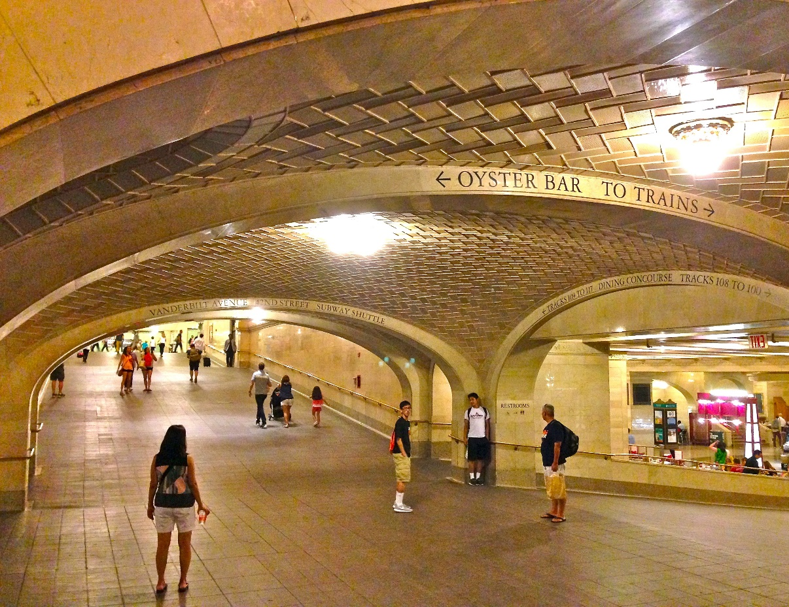

https://www.google.com/search?q=whispering+gallery+grand+central+station+new+york&source=lnms&tbm=isch&sa=X&ved=0ahUKEwiIz-zRysPkAhUGzlkKHVy2BiUQ_AUIEigB&biw=862&bih=706#imgdii=318hZkw2ibU6uM:&imgrc=_cEPWsaUSMR9yM:

  - Good idea. There is also a whispering gallery in the Capitol building in DC, and a story about congressmen of opposite parties listening to each others plans. We should look up the details and work them in somehow. -- Bud 10/10/19
  - The more I thought about this the more I realized that the reflection of light/sound could be used more productively than we had been using it. As I type this I am finishing up a fairly substantial re-write of that part of this chapter. As I finish I will also add a passage about “whispering galleries.” – Bud 2/14/20

If one stands at one focus of the elliptical dome and speaks, then a person at the other focus can hear it. Then we can get into the property being used in ESWL.

- In Practice exercise 4.1.1 f, do we want to specify that $r$ is a constant? Same with 4.1.1g. Do we want to specify that the coefficients are constants?
Done. <ecb5 2/16/20>

- On p. 44 in the paragraph right before you differentiate $y=\sqrt{x}$, you have $d\left(x^{\frac{1}{2}}\right)=\frac{1}{2}⋅\frac{1}{x^{\frac{1}{2}}}=\frac{1}{\sqrt{2x}}$ instead of $\frac{1}{2\sqrt{x}}dx$. Right before PIC # 20 on p. 44, should probably put in the step $\frac{dy}{dx}=\sqrt{2}\left(\frac{1}{2\sqrt{x}}\right)=\frac{1}{\sqrt{2x}}$

  - Done. <ecb, 10/10/19>

- In Problem in Context #20 on p. 44, the reference to Problem ?? needs to be changed to Example # 4 Descartes’ Method of Normals in Section 3.2. Should it also mention that in Example 4, we were looking at $\frac{dy}{dx}$ when $x=2$?
This sort of problem occurs several places. I need to devise a general scheme for references of this sort. I will begin working on that. Until I have a general scheme this will have to wait. <ecb 2/16/20>
I think I have this fixed now. If you ever see the ?? again please let me know. It shouldn’t happen. ecb 3/8/20

- In PIC # 21 on p. 44, get rid of part a. Restate part b as Show $dy=d\left(x^{\frac{p}{q}}\right)=\frac{p}{q}x^{\frac{p}{q}-1}dx$. It probably wouldn’t hurt to have a specific example as a part b in that problem, say

b. Use the formula derived in part a to compute $d\left(\sqrt[3]{x^{4}}\right)$.
Done. <ecb, 2/16/20>

- Example 7 on p. 45 has a typo in it. $x^{3/2}$ changed to $x^{-\frac{3}{2}}$.
  - Fixed <ecb, 10/10/19>

