Observations teaching University Calculus I – Fall 2019
Part 2

- At the end of Section 4.2 (p. 47 of 6, August 2019 version), in the definition of a derivative, should we mention that a derivative is a ratio of differentials. Could this serve as a definition? We essentially say this, but kind of beat around the bush on it. I was thinking about this when trying to think of how to explain what a second derivative is. This is what I said to students in the context of looking at the paragraph before the hanging chain problem where we introduce the second derivative
This is a great observation. We’ve been looking for the right time/place to define the derivative, as apposed to differentials, and I think this is it. I have inserted a new section called “Slopes, Velocities and Tangents” where we define the derivative and use it to tie these three ideas together. This is a first draft of the section so it will undoubtedly have to be edited, but I think this improves the development considerably.

I have modified the Hanging Chain problem as you’ve indicated below.
ecb5 3/8/20
With this in mind, should we split PIC #26 on the catenary into two parts? The first part can be the part a to obtain $\frac{dy}{dx}=\frac{ws}{H}$. We can then do something like this.

The problem with the previous problem is that we really don’t know anything about $s$. However, we do know something about $ds$. Here we will exploit an important aspect of differentials which we introduced with regard to slope, but now we will restate it in this context. On an infinitely small scale, we can think of the curve and the tangent line as being interchangeable. The fancy term for this is “local linearity,” but all this means that on an infinitely small scale the curve and tangent line are indistinguishable. This was utilized by Leibniz, who referred to a “differential” triangle. If we consider the following “infinitesimal triangle,” we have

$$ds$$
$$dy$$

$$dx$$

Infinitesimal as it may be, we can use the Pythagorean Theorem on it, obtaining $ds=\sqrt{{\left(dx\right)}^{2}+{\left(dy\right)}^{2}}$. The value of this comes to light as we finish our analysis of the catenary. But before that we need to look about differentiating $\frac{dy}{dx}$. At this point, it is more notational than anything.
Given $y=x^{3}+5x-7$, we can differentiate to get $dy=3x^{2}dx+5dx$ which provides the derivative $\frac{dy}{dx}=3x^{2}+5$ which is a finite quantity (not a differential). Differentiating again, we get $d\left(\frac{dy}{dx}\right)=6x dx$. This leads to the derivative $\frac{d\left(\frac{dy}{dx}\right)}{dx}=6x$. This derivative of a derivative is called the second derivative and is typically denoted by $\frac{d^{2}y}{dx^{2}}$. Later this will play an important role when we look at velocity and acceleration, but for now, we will treat it as more a comment on notation.

Now you can put in the rest of PIC # 26.

Problem in Context.

- Show that the hanging chain curve must satisfy the differential equation

$$\frac{d^{2}y}{dx^{2}}=\frac{w}{H}\frac{ds}{dx}=\frac{w}{H}\sqrt{1+{\left(\frac{dy}{dx}\right)}^{2}}$$

(b) Show that the general parabola $y = ax^{2} +bx+c$ does not satisfy this differential equation (and so Galileo was mistaken!)

(c) Show that, in fact no nonzero polynomial $y = a_{0}+a_{1}x+a_{2}x^{2}+…+a_{n}x^{n}$ satisfies the equation of the catenary. [Hint: Suppose it did satisfy the equation. If we were to square both sides of the equation, what would be the degree of each side?]

- Students appreciated practice problem 4.2.11 (p. 51 in Sept 20 version) in class as they can relate to a cell signal. By the way, we mentioned that the strength is measured in decibels – a student mentioned that it could be measured in bars. It turns out that there is no standard for bars for companies so we can stick with decibels. We then went on to problem 4.2.12 and I mentioned that instead of illumination, this could have also been two cell towers and you could be talking about the strength of a signal again. I’m not sure if we want to change it or mention it. Furthermore, 4.2.11 was fine where it is (utilizing the quotient rule), but it might be better to move 4.2.12 to after the chain rule. It is doable without the chain rule, but it is cumbersome without it.
I have added a couple of footnotes about decibels and illumination vs. cell signal. We can decide later if we want to keep them, keep them as footnotes, or delete them altogether. You comment about moving 4.3.11 to after the Chain Rule is rendered moot by our recent decision to hold off on naming the Chain Rule until the theory sections.
ecb5, 3/8/20

- The diagram in PIC #27 on Spin Casting (p. 58 on Sept 20, 2019) is messed up The red arrow should point up and the lengths of each should be positive. In the paragraph right under it, the magnitudes should be $mg$ and $mxω^{2}$ should not have any negative signs on them (they are magnitudes). Part of the problem for students is to determine that the slope of the normal should be negative. Here is what I gave to students as a revision.

MATH 122 Fall 2019
Possible Test # 1 Question

This is a revision of Problem in Context #27

Consider a cylinder partially filled with a liquid which is rotating with an angular velocity of $ω$ radians per second. Of course, in such a setting the middle will go down and the sides will go up as in the diagram below.

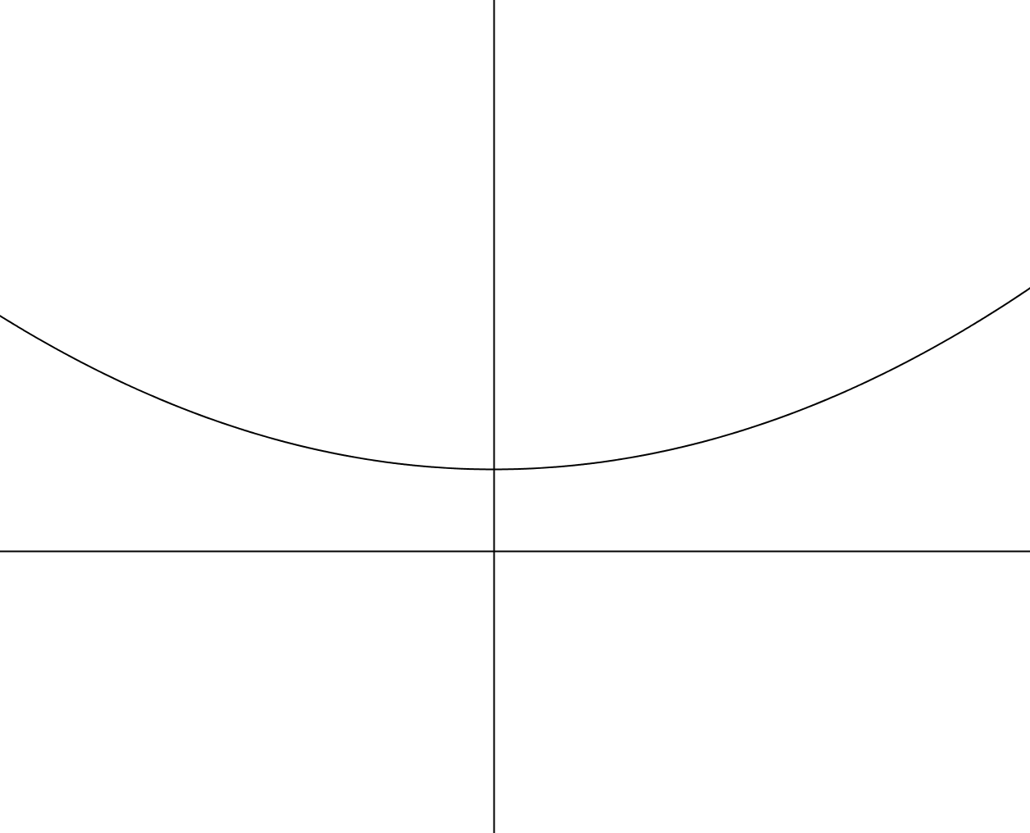
$$y$$
$$(x,y)$$
$$x$$

Our task is to find the shape of the surface of the liquid (that is the shape of the above curve which will be rotated around the $y$ axis. If we consider a point mass $m$ at point $(x,y)$on the surface, then the force from the liquid which keeps that point elevated is perpendicular to the surface. (Think about a hose with a hole in it. The water sprays out in a stream perpendicular to the hose.)

If we separate that force into its vertical and horizontal components, then we get the following diagram.
The (magnitude of) the vertical component is $mg$, where $g$ is the acceleration due to gravity. This is the force needed to counter the weight of the particle. The horizontal force has a magnitude of $mxω^{2}.$ This is the centripetal force which is keeping the particle moving in a circle around the axis. [We will see why this is the centripetal force later, but for now, take it on faith.]
$$(x,y)$$

Use the above information to show that the curve must satisfy the differential equation

$$\frac{dy}{dx}=\frac{ω^{2}}{g}x$$

and that the curve satisfying this must be a parabola.

[Note: The above principle is used by the Steward Observatory Mirror Laboratory at the University of Arizona to spin cast parabolic mirrors for large reflective telescopes. [See http://mirrorlab.as.arizona.edu/ for information about spin casting large telescope mirrors.]
This has been corrected. All indicated changes have been made. 3/8/20, ecb

- In Practice Problem 4.2.1 a. on p. 63 of September 20 version, the two circles hit at the origin where the slope of one is zero the other is infinite. The other parts (b,c,d) are ok. Should we get rid of part a? I’m even rethinking the whole section on orthogonal curves. Should we keep that part in there or just refer to the fact that Roberval’s method demonstrated the reflective properties already? Also the spacing is messed up between the two families of curves.
I’ve fixed the formatting, but I’ve left the passage in for now because I haven’t had a chance to look at it closely yet. My suspicion is that it is ok, but might be better used somewhere else. I’ll mark it with a footnote so we don’t forget to look at it again.

As for problem 4.2.1, I’ve rearranged the parts so that the one with the infinite slope is last. I don’t think we should shy away from problematic things (like infinite slopes). They can serve as a bridge to the theory section if we’re clever. ecb5, 3/8/20

