Observations while teaching MATH 122 F 2019 # 3
Week of Sept 30, 2019

- In PIC # 30, should we use capital letters for the coefficients in the cubic equation $y=Ax^{3}+Bx^{2}+Cx+D$? This way there would be no confusion between $D$ and the differential operator d. Also, there are some typos in there. I have a revision of that with these changes. Also, should we be concerned about the diagrams at this point?

We will use this problem to model the flight path of a plane landing and determine how far out the plane should start its descent. Since the plane is starting from a horizontal position and is ending in a horizontal position then using a curve like a parabola doesn’t make much sense. The next simplest curve to do this would be a cubic polynomial $y=Ax^{3}+Bx^{2}+Cx+D.$ Below is a section of that curve depicting the flight path (not to scale) with the plane starting initially at the point $P(L,H)$ and the airport $Q$ at the origin.

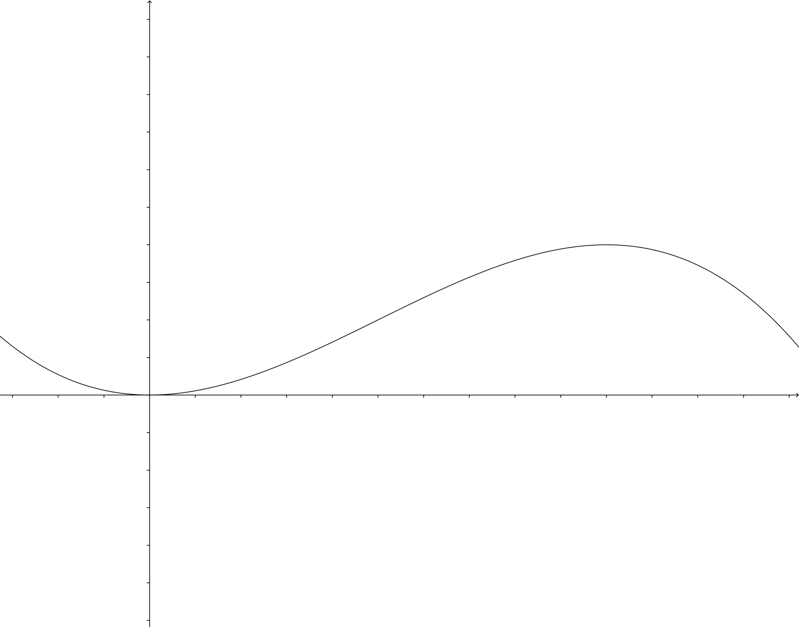
$$H$$
$$L$$
$$P(L,H)$$
$$Q(0,0)$$

- Find an equation relating $dy$ and $dx$.

- Use the fact that $(0,0)$ lies on the curve to show that $D=0$ and use the fact that the tangent of the curve at $(0,0)$ is horizontal to show that $C=0$.

- Use the fact that $P$ lies on the curve and that the path starts out horizontal at $P$ to determine the values of $A$ and $B$ in terms of $L$ and $H$.

- Suppose the pilot must maintain a constant horizontal speed of $v\frac{meters}{sec}$ (so that $\frac{dx}{dt}=-v$) and that the maximum vertical acceleration cannot exceed $k\frac{meters}{\sec^{2}}$ (so that $\left|\frac{d^{2}y}{dt^{2}}\right|≤k$). Show that under these restrictions

$$\frac{6Hv^{2}}{L^{2}}≤k$$

- Suppose that initially $H=10000 meters$, $v=100\frac{meters}{sec}$ , $k=.1\frac{meters}{\sec^{2}}$ (which is approximately 1% of the acceleration due to gravity). Find what $L$ must be (in kilometers)?

Done. ecb 10/10/19

- In Problem 4.2.15 on p.52-53 of Sept 20 version, the class and I were looking at part c with the Tschirnhausen cubic $27y^{2}=\left(1-x\right){\left(8+x\right)}^{2}$. The students and I agreed that there should be a graph of it included. Here it is

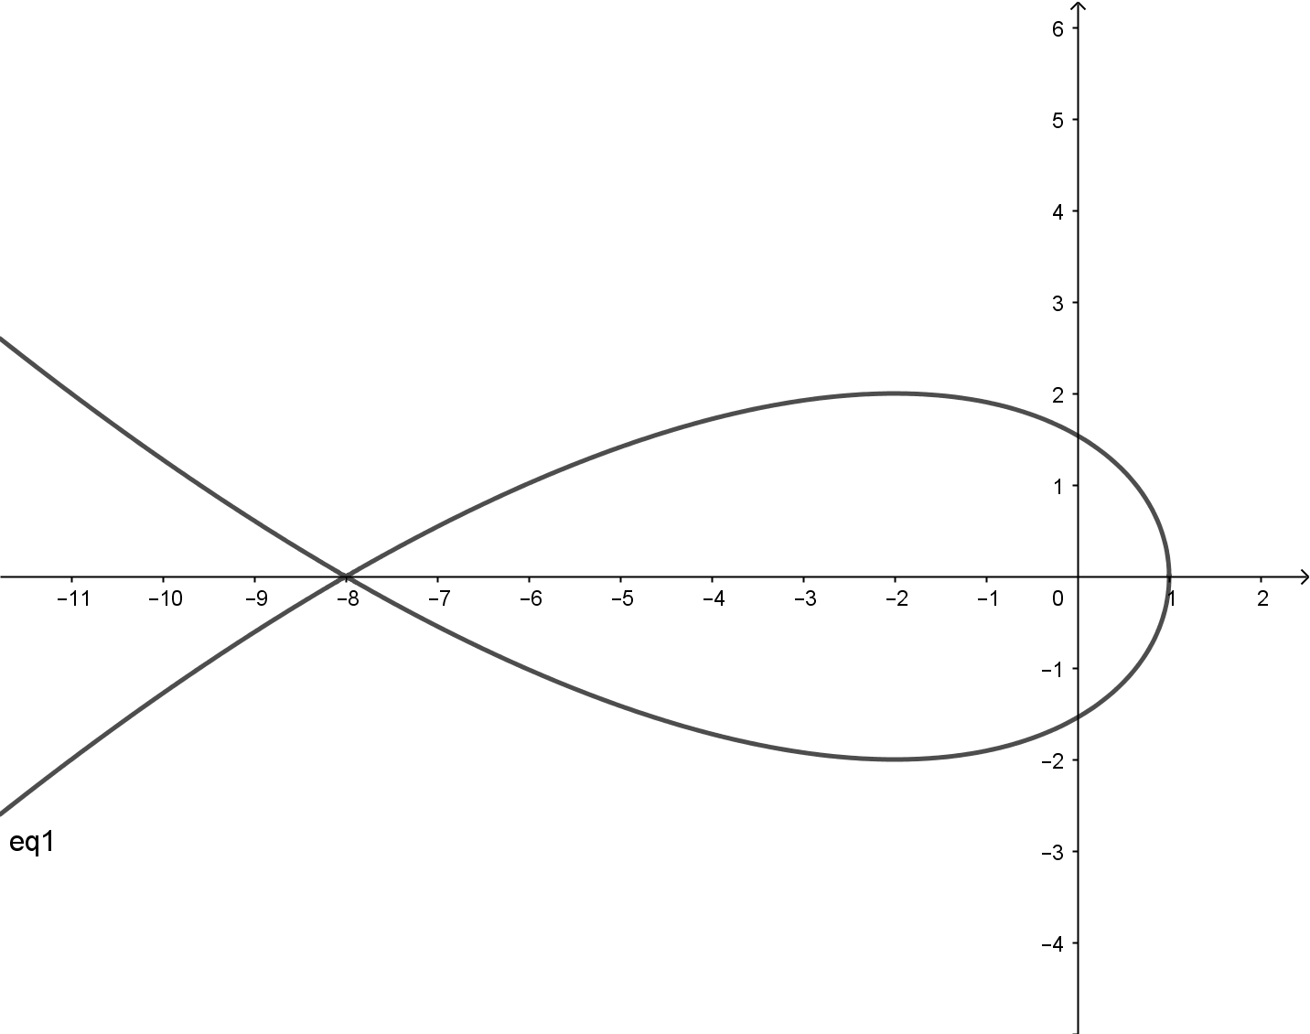

Looking at these parts b and c in this problem made me wonder if it was an overreach having curves which intersect themselves. They were a great discussion point about things that can be “funky” at such a point. Algebraically, these were points where we were dividing by zero in the formula for $dy/dx$. I think it was a good talking point, but skeptical teachers may dismiss it as putting in inappropriate problems at this point. Should we just drop it or put in something to the effect that one must be careful when trying to divide by zero?

I think we could actually generate a teaching moment out of this. Here's what I mean: Rather than not including problems (or examples) with self-intersecting curves we include such curves but don't ask any problems about the self-intersection point. At least at the beginning.

In the text itself, and after a few such problems (or examples) we take deliberate notice of the self-intersections, work through an (easy) example, and point out that this is an issue that we will need to address but that we will hold off on until later. If we're careful I think this might even give us a chance to suggest the need for limits (informally, of course) but I haven't thought it through yet.

Most students will say, "Oh, good. I don't have to worry about that now" but a few will be curious and try to work out the difficulties on their own.

<ecb, 10/10/19>

- Problem 4.2.13 on page 52 of Sept 20 version starts with the volume of a raindrop and then says snowball. Snowball should be changed to raindrop.
Done, ecb; 3/8/20

- There are some Practice problems lingering at the end of section 4.2 on p. 65. Do we still want them there or have they been supplanted by earlier practice problems on p. 48?
I suspect we want to keep them, but they are in the wrong place. I’ve marked them for relocation. ecb; 3/9/20

