Lab 3: Product Evaluation (Sensors)
EG 1003, Section G
Ayman Ahmed

Lab Partners: Inez Warshaw, Henry Cowherd
Experiment Date: 02/15/2019
Due Date: 02/22/2019

Abstract
The objective of this lab was to evaluate how a pre-built robot fared on a mini obstacle course, and to measure how accurate and precise the robot was with and without sensor usage. The robot occasionally failed to navigate the course fully, but when it did succeed the results showed that using sensors had a noticeable impact on consistency. Our robot came in third place, being off by one centimeter and seven degrees.

Introduction
Evaluation of a product is one of the most important and frequent tasks for engineers in the workforce. Professional engineers often spend numerous hours testing designs of a product to ensure that the product works efficiently. Some engineers may even be required to test designs of competitors, so the designs of their own products can be improved.
When products are evaluated by engineers, there are specific standards that have to be met, usually related to accuracy and precision. When evaluating a product, multiple trials must happen, and therefore an average must be calculated, instead of basing results off individual trials. The average is the sum of all the test results divided by the number of tests performed. In product evaluation, the average is value most often compared to the standard.
Accuracy and precision are the two important factors in the results of a product evaluation. Accuracy is how close the average is to the standard, while precision is how close the results are to each other. Accuracy is calculated by subtracting the standard from the average, and then finding the absolute value of that number. Precision is calculated by subtracting the value of the highest result from the value of the lowest result. Both accuracy and precision are always positive, so absolute values are used for both. Results for a product evaluation can be accurate, precise, both, or neither, but the goal for most product evaluations is to get results that are both precise and accurate, indicating a quality product. To make accuracy more readable, accuracy can be divided by the standard, and then subtracted from 1 and multiplied by 100 to get a percent value for accuracy that allows easier conclusions to be drawn. Good precision is determined by a tolerance, which is a range of values that the product evaluation results can fall under. If the precision is below the tolerance, then the product is precise.
After product evaluation is completed, there are multiple different ways a product can be improved. One method is using quality improvement, which is where the design of a product is analyzed through computer modeling or through physical observation. The questions that are usually asked in quality improvement are how to make the device perform to standard, or improve its functionality so that it performs beyond the standard. Another method is reverse engineering, which attempts to obtain the original source code for a product where the original version is not available. This method is extremely difficult and requires an expert.
For this robot, the center of gravity had a massive impact upon how consistent the results were. The center of gravity is the position inside the robot where all the weight is centered, a point that changes based on where the weight of the robot is located. If most of the weight of the robot is towards the front, the center of gravity shifts in that direction. Drivetrain design was the format in which this pre-built robot was organized, and it involves a rectangular chassis, two motors, four wheels, and gears to move power from the motors to the gears. Turning scrub is something that happens to all drivetrain designs, and is the friction that occurs when a drivetrain design attempts to turn. In order for this friction to be dealt with, the base of the robot must be wider than it is long. Furthermore, the type of tire also plays a role in how much turning scrub a drivetrain design has.
The pre-built robot contained three EV3 sensors, known as the Light Sensor, the Gyro sensor, and the Ultrasonic sensor. The light sensor measured the light level of anything in front of it, while the gyroscopic sensor measured the relative angle of the robot before and after movement. The ultrasonic sensor measures distance between the robot and whatever is closest to it, which happens to be the wall in this experiment. The code given for the pre-built robot mainly made use of switches and loops. Switches are code statements that act as “if-else” statements, undergoing two possible actions based on whether the initial condition is true or not. On the other hand, a loop continues to run the code within it while the condition for the loop remains true.

Procedures
The materials used for this lab were the pre-built robot, which included the light sensor, the gyro sensor, and the ultrasonic sensor. Also included was a cable to connect the robot to a PC and the Lego Mindstorms software to run code on the robot. In order to properly modify the robot, a seven-hole connector was required to stabilize the frame.
The procedure for this lab was to first fix the various problems with the robot. First, the gyro sensor was removed, and two angled connectors that hindered the ultrasonic sensor from reading data were also removed. Next, right angle connectors that were restricting access to the motors were removed. Afterwards, a seven-hole connector was used to reorient the ultrasonic sensor horizontally to the frame, and to provide support for the gyro sensor which was reattached to the frame in this step. Finally, the tires were attached to the rear wheel, and the light sensor was mounted in the front as close to the ground as possible.
After the robot was successfully modified, the hardcoded trials were run multiple times, and data was recorded. Afterwards, software trials were modified to read data properly from the correct sensor ports, and those trials were also tested. First, the code was modified to make sure the robot stayed upon the trail, and then code was modified to make sure the robot turned properly. Throughout these changes, speed for the motors were changed at multiple instances to further improve consistency.
The final part was the robot competition, where a single trial was conducted to see which robot traveled the greatest number of tiles possible in a single run.

Data/Observations
It was observed that our robot did not function properly upon the first hardcoded trial, so we modified the numbers, and it remained consistent after that. Our averages for the hardcoded trials were 6cm from the wall, and 7 mm off from the center.
Figure 1 – Lab Notes and Hardcoded Trial Results

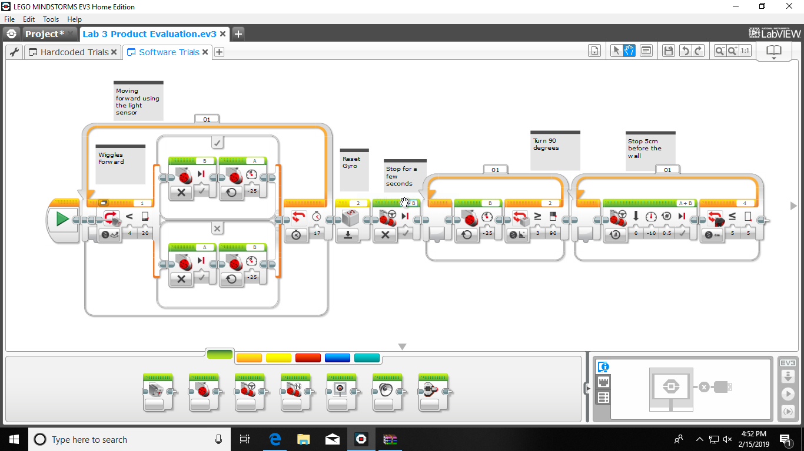
Figure 2 – Screenshot of Code for Software Trials
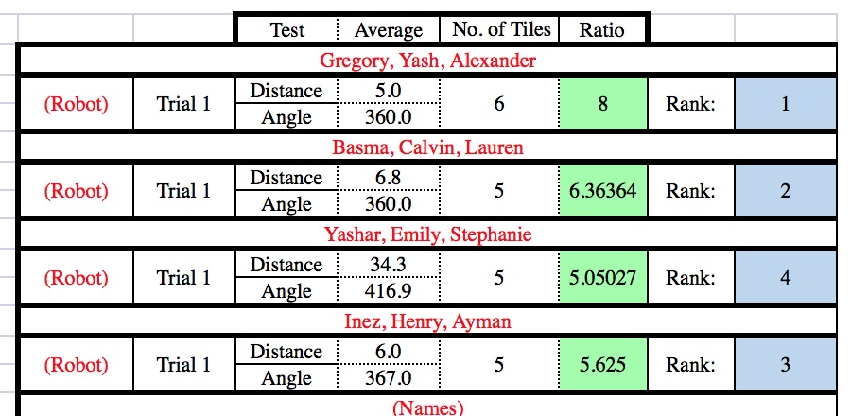
Figure 3 - Results
Discussion/Conclusions
All in all, the lab resulted in a robot that did not fully function, but the hardcoded trials ended up being accurate and mildly precise. This could’ve been improved by fixing our software trials, and making them fully function by the end of the lab.

Works Cited
“Product Evaluation (Sensors).” Product Evaluation (Sensors) - EG1003 Lab Manual, https://manual.eg.poly.edu/index.php/Product_Evaluation_(Sensors).

