Lab 4: Computer Aided Design (CAD) Competition­­­­­­

EG 1003, Section G

Ayman Ahmed

­­­

Lab Partners: Yash Bharti, Henry Cowherd

Experiment Date: 02/22/2019

Due Date: 02/29/2019

**Abstract**

The objective of this lab was to understand multiple different software used in architecture. The main two used were Fusion 360 for CAD and Revit for modeling. The results of the lab were an understanding of common engineering techniques such as stress, product evaluation, design, and the measurement of a safety factor. This is significant because the design can be compared to others and graded based upon aesthetics and safety, while giving the creators insight into common problems architectural designers face.

**Introduction**

Since this lab was a competition, the victors were the ones with the highest competition ratio for Fusion 360. The ratio is:

$CR=\frac{Final safety factor}{Final V Volume}-\frac{Initial Safety Factor}{Initial Volume}$

The rules for the competition were that the winning design cannot contain more than double the volume of the original part, and the updated part must have a safety factor of at least three. Finally, the piece itself must not be altered.

For the Revit competition, the specifications were a 350-400 square foot maximum size for the apartment and an electrical / plumbing plan for the bathroom.

As safety factor was mentioned for the Fusion 360 portion, safety factor is a term describing the strength the system needs for a intended load – minimum safety factor is the minimum amount of strength an object requires to withstand a specific load without failing.

The software used to test safety factor is Fusion 360, which is a CAD drawing software. The software used for the apartment is Autodesk Revit, which is modeling software for architects. Software’s are important because it allows engineer to layout buildings and designs before wasting materials on them, letting money be saved and standards maintained. I believe a universal CAD software would not be beneficial, because although everyone would be able to use it, there would be specific features that the program might be missing found in another CAD software. Minimal design is good for smaller spaces, since it forces thinking about how to efficiently maximize the space allocated. Smaller apartments are becoming more desired because of this reason, as minimal design is becoming more and more popular. The amount of electricity in an apartment can be lowered by using as few wires as possible and minimizing the numbers of lights and procedures.

**Procedures**

Materials used for this lab were a PC, Fusion 360 software, and Autodesk Revit software. The first step involved usage of Fusion 360 to modify a hinge part that was failing stress tests with a low safety factor. First, a trial was conducted by simulating how the part responded to stress using the Fusion 360 software, with the volume and safety factor of the hinge being recorded. Afterwards, a design for improving the structural support of the hinge was designed and implemented using tools available in the Fusion 360 software. Afterwards, the material was changed to have a better response to stress, with titanium being the final material. Finally, the volume of the completed part was recorded, alongside the safety factor.

After the hinge was completed in Fusion 360, a design for an apartment in Revit was planned. First, the units were changed to feet and inches. Once that was completed, the walls were created to ensure the building fit within 350-400 feet. Once the exterior walls were created, interior walls for the bathroom and other auxiliary rooms were created, being 6 inches thick compared to the eight-inch thickness of the exterior walls. Once the walls were completed, doors were added into the apartment, requiring a height of seven feet and a width of three. Afterwards, various pieces of furniture were imported into Revit in order to be placed within the apartment. The bathroom was the first area appliances started being placed, with a toilet, sink, and a standing shower being the three appliances chosen given the space constraints. Finally, all the appliances in the bathroom were connected to the sanitary line, and all the outlets and electrical appliances were attached to the electrical line. The finishing touch was to add a ceiling to the apartment.

**Data/Observations**

Once the data for the hinge supports were recorded, it was seen that the diagonal supports made the hinge greatly above maximum volume and raised the safety factor to eight, which was higher than the minimum three that was required. The material used for our hinge was titanium, because it was the strongest material available.

For the apartment, it did not have functioning plumbing nor functioning electricity. The only thing present in the apartment was a single bathroom with a sink, toilet, and standing shower.

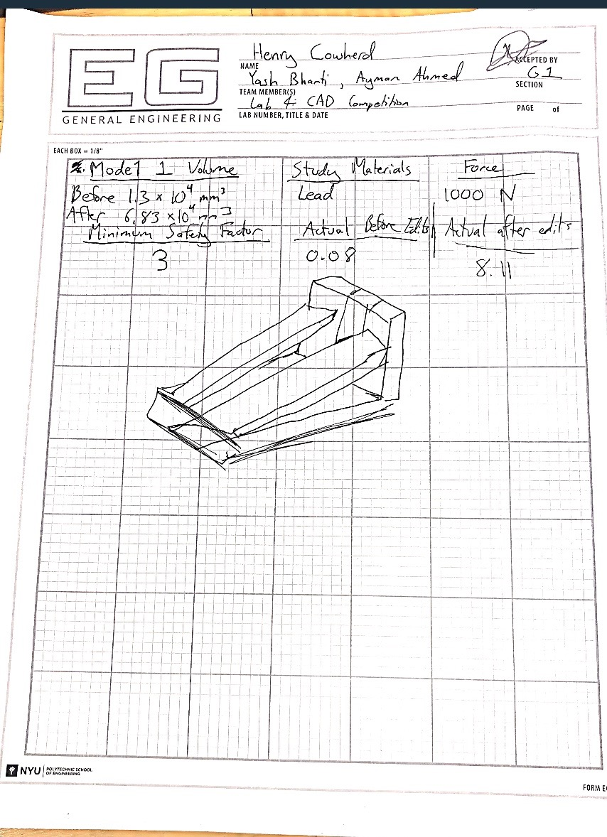

Figure 1 – Lab Notes and Fusion 360 Drawing with Safety Factor Recordings

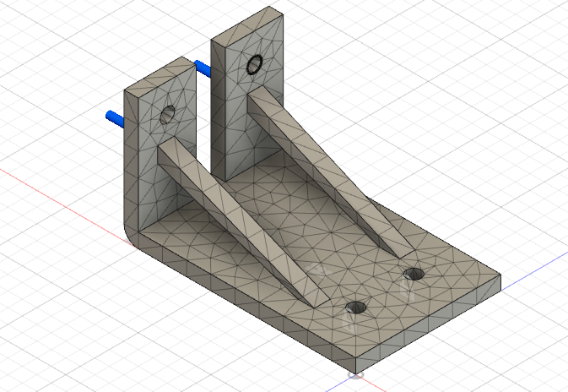

Figure 2 – Fusion 360 CAD Part Mesh

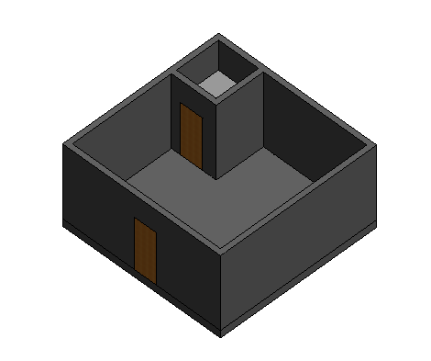

Figure 3 – Revit Apartment

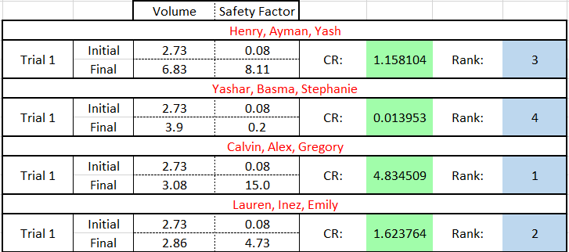

Figure 4 qxaxw- Results

**Discussion/Conclusions**

The hinge’s redesign compared to other groups had a relatively high safety factor, but also had a massively greater volume than some of the other hinge designs. The Fusion 360 design could have been improved by reducing the volume of the part while attempting to maintain the safety factor. For the Revit apartment, the space itself could have been improved with the addition of a few more amenities, such as kitchen appliances and some basic furniture, alongside inclusion of functional plumbing and electricity.

**Works Cited**

“Computer Aided Design (CAD) Competition.” Computer Aided Design (CAD) Competition *- EG1003 Lab Manual*, https://manual.eg.poly.edu/index.php/Computer_Aided_Design_(CAD)_Competition.