Lab 5: Prototyping with Micro-controllers, Sensors, and Materials

EG 1003, Section G

Ayman Ahmed

­­­

Lab Partners: Yash Bharti, Stephanie Hernandez

Experiment Date: 03/01/2019

Due Date: 03/08/2019

**Abstract**

The objective of this lab is to utilize microcontrollers and sensors in order to develop a basic prototype for a product, namely a thermal insulation device. The microcontroller will be used to analyze the temperatures of the thermal insulation device over time, and will be coded to read data from a temperature sensor into data readable by humans. The results were an effective application of a temperature sensor prototype using Arduino, and an efficient thermal design to retain heat.

**Introduction**

Electricity involves three major parts: Amperes, Volts, and Ohms. Amperes is electrical current, volts are electrical power, and ohms are electrical resistance. Ohm’s law V = I * R, stating how the three relate to each other, with I being amperes and R being ohms. The two type of voltage sources are AC and DC, with DC voltage being used for circuits due to a voltage difference across terminals.

Resistors are components that reduce current by a specific amount calculated by Ohm’s law, while capacitors store energy to be let out at a later time, measured in a unit called Farads. Inductors are similar to capacitors, except they store energy in a magnetic field and dissipate it later, measured in Henrys. Push-buttons and switches are two other related tools, which alter the flow of electricity by either switching it on or off. Diodes are electrical blocks that force current to only flow one way, and MOSFETS amplify signals. A form of a diode is called a LED, which is a type of diode that emits light.

Microcontrollers are small, programmable computers that only have the bare necessities to directly access sensors and perform actions upon them without an operating system, mouse, or keyboard. Many appliances today make use of microcontrollers, with Arduino being a prominent one. Arduinos are programmed by using the Arduino IDE, which uploads code to the board which is immediately run; the Arduino can be hooked up to various sensors using a breadboard, and the code itself is modified C++ code that makes use of conditional statements, loops, and variables to program the Arduino and the sensors connected.

Equilibrium, is where heat on the interior and exterior are equal, and heat doesn’t flow in either direction. Heat is the energy contained in vibrating molecules, and is released as the molecules slowly lose their vibrational energy. Heat transfer is the movement of that vibrational energy from one molecule to another, or from a group of molecules to another group of molecules.

Thermal insulation is the act of retaining heat inside a container, by making sure none of the vibrational energy of the molecules within have a chance to leave and transfer to the air around it or to other cooling materials; there are multiple thermodynamic systems that act as insulating containers, with open systems not being an example of those, and closed systems often acting as natural insulators, while isolated systems are the most efficient insulating systems.

**Procedures**

The materials required for this lab were a heated container of beeswax, a temperature sensor, a breadboard, multiple resistors at different Ohms, an Arduino microcontroller, a PC to run the Arduino IDE software, a button, and a small LED. Other materials involved for the thermal insulation device were various insulating materials such as foam cups, fabric, and clay.

After the materials were gathered, the LED circuit had to be assembled on the breadboard, using a 220 Ohm resistor and Arduino code to make the LED blink. Once the LED was confirmed to function properly, the next step was for the button to be attached to the breadboard, and the code modified to allow the LED to activate upon the button being pressed.

Once these two activities were completed, another set of code was implemented that allowed readings from a thermistor, which was then promptly attached to the breadboard alongside a 10K Ohm resistor. Once the thermistor was confirmed to function properly and output data, the insulating container was designed on paper.

After the container was designed, it was assembled using the limited materials provided. Once the insulating container was assembled, a hot beeswax jar was placed within it, attached to the thermistor while the Arduino proceeded to list temperatures. Finally, the data from the Arduino was read into an Excel spreadsheet for analysis and graphing.

**Data/Observations**

The result of the temperature sensor using the Arduino microcontroller was a consistent temperature reading off from the room temperature by three degrees, but extremely stable – the temperature reading was very precise, but mildly inaccurate.

The result of the thermal insulation device was a gradual decrease in temperature over 15 minutes, with a good portion of the heat still being retained after the time period had finished. The Temperature vs Time curve was very smooth, and closely mirrors the trendline of the data indicating a consistent thermal insulation design that let out heat slowly.

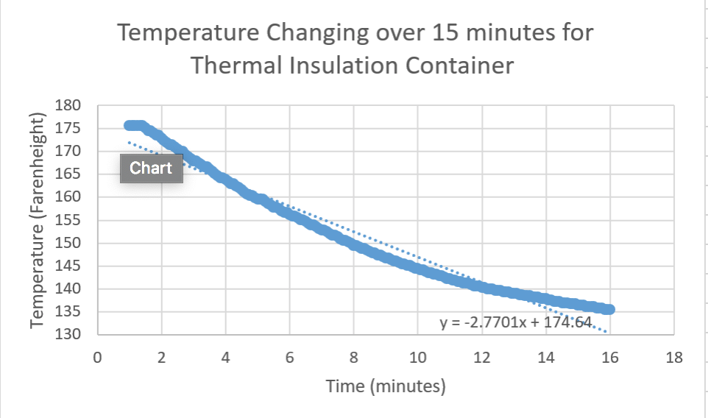

Figure 1 – Temperature Change Graph



Figure 2 – Competition Results



Figure 3 – MDR Ratio

**Discussion/Conclusions**

Although the design was very cost efficient and very low resource, it stands to be improved in the thermal department since it placed third. Despite that, the design managed to achieve the objective of thermally insulating the beeswax, and our measurement of the thermals using the Arduino micro-controller was accurate and well designed. In both cost efficiency and thermal efficiency, the design succeeded, although there are minor improvements that could have been made to further improve thermal performance without sacrificing cost efficiency – one such improvement would have been make the top of the container covered to stop heat from escaping through there.

**Works Cited**

“Prototyping with Micro-controllers, Sensors, and Materials.” Prototyping with Micro-controllers, Sensors, and Materials *- EG1003 Lab Manual*, <https://manual.eg.poly.edu/index.php/Prototyping_with_Micro-controllers,_Sensors,_and_Materials>.

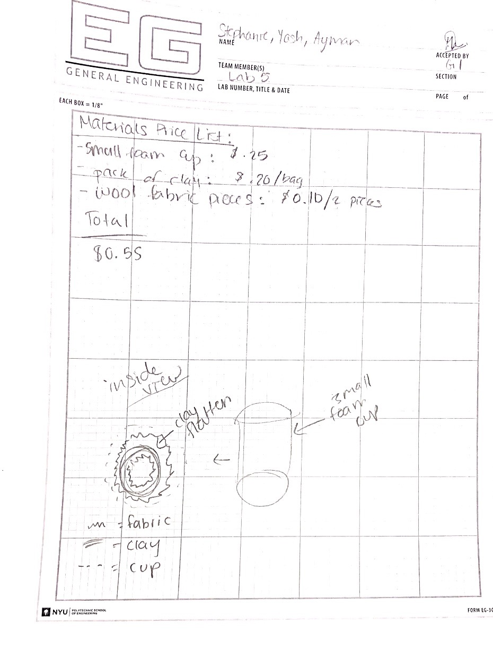

Figure 3 - Lab Notes