msleep24

Autogenerated data summary from dataMaid

2021-01-23 19:48:41

# Data report overview

The dataset examined has the following dimensions:

|  |  |
| --- | --- |
| Feature | Result |
| Number of observations | 20 |
| Number of variables | 3 |

### Checks performed

The following variable checks were performed, depending on the data type of each variable:

|  |  |  |  |  |  |  |  |  |
| --- | --- | --- | --- | --- | --- | --- | --- | --- |
|  | character | factor | labelled | haven labelled | numeric | integer | logical | Date |
| Identify miscoded missing values | × | × | × | × | × | × |  | × |
| Identify prefixed and suffixed whitespace | × | × | × | × |  |  |  |  |
| Identify levels with < 6 obs. | × | × | × | × |  |  |  |  |
| Identify case issues | × | × | × | × |  |  |  |  |
| Identify misclassified numeric or integer variables | × | × | × | × |  |  |  |  |
| Identify outliers |  |  |  |  | × | × |  | × |

Please note that all numerical values in the following have been rounded to 2 decimals.

# Summary table

|  |  |  |  |  |
| --- | --- | --- | --- | --- |
|  | Variable class | # unique values | Missing observations | Any problems? |
| name | character | 20 | 0.00 % | × |
| vore | character | 3 | 10.00 % |  |
| sleep_total_24 | numeric | 18 | 0.00 % |  |

# Variable list

## name

* The variable is a key (distinct values for each observation).

## vore

|  |  |
| --- | --- |
| Feature | Result |
| Variable type | character |
| Number of missing obs. | 2 (10 %) |
| Number of unique values | 2 |
| Mode | “herbi” |

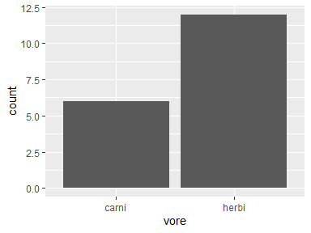

## sleep_total_24

|  |  |
| --- | --- |
| Feature | Result |
| Variable type | numeric |
| Number of missing obs. | 0 (0 %) |
| Number of unique values | 18 |
| Median | 0.17 |
| 1st and 3rd quartiles | 0.14; 0.23 |
| Min. and max. | 0.08; 0.29 |

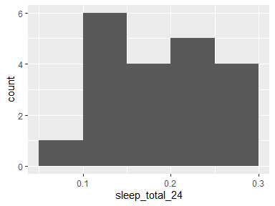

Report generation information:

* Created by: Could not determine from system (username: Unknown)
* Report creation time: Sat Jan 23 2021 19:48:41
* Report was run from directory: C:/Users/ericc/Desktop/BIS15W2021_ecoyle/lab6
* dataMaid v1.4.0 [Pkg: 2019-12-10 from CRAN (R 4.0.3)]
* R version 4.0.3 (2020-10-10).
* Platform: x86_64-w64-mingw32/x64 (64-bit)(Windows 10 x64 (build 19041)).
* Function call: makeDataReport(data = msleep24)