Initial Project Proposal

Year: 2019 Semester: Fall Project Name: Digitopoly

Creation Date: March 30, 2019 Last Modified: April 19, 2019

Team Members (#1 is Team Leader):

Member 1: Karthick Shankar Email: shankak@purdue.edu

Member 2: Niraj Menon Email: menon18@purdue.edu

Member 3: Alexander Gokan Email: agokan@purdue.edu

Member 4: Carson Kelley Email: kelley96@purdue.edu

1.0 Description of Problem:

With the conversion of classic board games like Settlers of Catan, Risk and the Game of Life to simplistic apps, we feel that these digitized versions don’t have the fun and intrigue as their cardboard counterparts do. At the same time, as any board game player can attest, maintaining play pieces and cards for the board game is quite a challenge! And so we asked ourselves: how do we combine the satisfaction of a board game with the simplicity of an app?

2.0 Proposed Solution:

Our project is a cross between that satisfaction and simplicity, with a digital implementation of Monopoly - Digitopoly. It’s a large board combining the traditional Monopoly board with a larger central display for displaying game states and cards for Chance and the Community Chest, and sections on the screen for each player to display their current bank account and held properties, as well as buttons/touch sensors/microphones for making moves, buying properties, and providing random number seeds to pick a Chance/Community Chest card. That means no more lost cards, no missing pieces, and no game money lost all over your house - just one electronic board that will let you experience the same wonder and awe as you did playing the original board game and a pair of electronic dice reporting the roll on its own to the board, The board will include very convenient features like game saves, good control over your digital money and automatic rule enforcement.

In addition, we could potentially make a wristband with a small screen to display the player’s account and potentially, with a touchscreen display, it could send commands to buy properties back to the MCU when the player touches the right soft button. This is our fallback in case the onboard audio processing does not work.

3.0 ECE477 Course Requirements Satisfaction

3.1 Expected Microcontroller Responsibilities

The microcontroller we intend to use is called the Sipeed MAIx, a 64-bit RISC-V based microcontroller with an accelerator for AI applications as well as audio modules for FFTs. It will be used to control game logic, Chance/Community Chest card draw, property allocation, wireless dice communication and other relevant parts of the game requiring computation or randomness. The onboard neural net accelerator will be used to instantiate one or more autonomous players as an option for the game. Since the displays are too huge to be driven by the MCU itself, a Raspberry Pi will be used to drive them. It will be functionally similar to a display controller, and will store the graphics data. The MCU will tell the Pi via UART to draw graphics on the screens as needed.

The central display will be a touch screen in order to accept moves during a player’s turn (such as buying or selling properties). The MCU will also have audio functions, such as playing out loud instructions for the current move while connected to a speaker, and will use a mic array to pick up voice input from a player in order to pick the right move. So when a player lands on an unowned property, the MCU will use a text-to-speech engine to ask whether to buy the property or leave it. When the user says “buy” or “ignore”, the MCU will “hear” that via the microphones and perform the corresponding move.

3.2 Expected Printed Circuit Responsibilities

The PCB will be essential for power delivery to the displays, Raspberry Pi and MCU. This will likely include voltage step down regulators to reach the required voltages for the displays and the microcontrollers. It will allow easier interfacing for the different components, primarily the combination of displays for both the tiles and central displays to the Raspberry Pi. It will provide a pathway for the UART connection from the Pi to the MCU, which will exchange information about the state of the game and player information including location, money and properties owned to be displayed on the central display. The potential buttons will be used to record user input like purchasing properties, and it will be routed through the PCB as well.

As for the dice, we will have a custom miniature PCB to use an accelerometer and either a bluetooth/wifi module to transmit the accelerometer data to the MCU for processing the roll of a die.

4.0 Market Analysis:

Monopoly is widely regarded as one of the most played family games. According to BusinessInsider, some of the most frustrating aspects of the game are having to deal with money while making sure no one steals money from the bank. The concept of a banker, though made easier with the new electronic versions, is still cumbersome. As such, this will be a good alternative to that process with natural language processing to make trades seamless while still holding some of the tradition aspects of a board game like rolling a die. The main market will be the younger portion of the audience that plays Monopoly. They are the ones more in tune with technology and will feel like this is a seamless integration while the older population will welcome the changes to help the annoying aspects of the game.

When it comes down to numbers, board games are doing shockingly well in an age of digitization. According to Quartz, old-fashioned board games are making up to 500 million dollars in pledge funding on Kickstarter from over hundreds of thousands of people. With Digitopoly, we intend to sell to those who like to indulge in nostalgia with a digital twist, which could include those hundreds of thousands of Kickstarter backers, 61,000+ table-top game enthusiasts (who attended Gen-Con, a tabletop board game convention) and over 70 million millennials in the US themselves who grew up playing board games.

5.0 Competitive Analysis:

5.1 Preliminary Patent Analysis:

5.1.1 - US62026082A:

Board Game Apparatus

* Filed for the Monopoly game board
* Expired on 4/9/2019

5.1.2 - US4455025A:

Electronic card and board game

* Design utilized a microcontroller to select random numbers and determine game states for any game
* Expired on 4/9/2019

5.1.3 - US9498711B2:

Multi-player, multi-screens, electronic gaming platform and system

* Utilization of a main board to which four terminals are connected in order to play a multiplayer game.
* Patent is active as of 4/9/2019

5.2 Commercial Product Analysis:

5.2.1 The original Monopoly game:

The original game that we plan to base Digitopoly off of, Monopoly is a classic turn-based board game from the 1980s. The objective of the game is to bankrupt all the other players (in an unlimited-time play) or have the largest assets at the end of the game (in a limited-time play). There is also a randomness factor provided by the roll of dice to determine how many moves are made by each player, as well as shuffled decks of Chance and Community Chest cards to provide disadvantages or advantages to players. Some versions include a device to automatically tally the bank balances for each player, instead of the paper notes that comes with the original version of the game.

The electronic banking system in this game takes a lot of hassle out of the game. There is no designated banker, which helps relieve conflicts between players (as seems to always happen). Instead, players wishing to make a transaction simply slide their cards into a “banker” box, type in an amount, and money is transferred between them (or directly to them, in the case of passing “go” etc). The game still relies on traditional game pieces otherwise.

5.2.2 PlayTable:

PlayTable is a way for physical game pieces to interact with the digital version of popular games, like Settlers of Catan and Battleship. It runs a version of Android with Wi-Fi to play with other PlayTables, and can also utilize RFID game pieces, using a display as a game board.

This table is very expensive, so if someone is interested in playing only one game, this isn’t the product for them. Additionally, it is reliant on an internet connection so that it can connect to its own blockchain in order to validate the game pieces (an obvious problem in a loss of power). However, it has a lot of good features too, such as rule reminders/enforcement. While there is no specific Monopoly game, there’s nothing stopping Hasbro from teaming up with this company to port their game over.

5.2.3 Electronic Battleship:

An electronic version of the popular board game “Battleship”, two players aim to knock out each other’s ships and other battle units on a map by selecting a certain set of coordinates. On the electronic version, players will enter coordinates into a electronic system, which shows the selected coordinates on a display, as well as if they’ve hit something.

5.3 Open Source Project Analysis:

5.3.1 Roll20:

**A gaming tabletop for your computer.**

Roll20 is a suite of easy-to-use digital tools that expand pen-and-paper gameplay. Whether you play online via their virtual tabletop or in person utilizing our character sheet and dice rolling application, Roll20 will save you time and help you focus on enhancing your favorite parts of tabletop gaming. It can be used with a variety of games. The ability to have multiple different screens (one for the GM, one for the players) interacting in one game is a useful idea to model, in the case of a “banker” player. Most of the code is open sourced under the MIT license.

5.3.2 Wesnoth:

The Battle for Wesnoth is an open source, turn-based strategy game with a high fantasy theme. It features both single player and online/hotseat multiplayer combat. The code is licensed under GNU GPL.

5.3.3 Vassal:

Vassal is a free, open source, board game engine used to create online, turn-based, human-vs-human games. It provides libraries for live chat and client-server software in order to implement your game. The code is licensed under GNU GPL.

6.0 Sources Cited:

“This Is How We Roll,” *Roll20*. [Online]. Available: <https://roll20.net>. [Accessed: 15-Apr-2019].

“The Battle for Wesnoth,” The Battle for Wesnoth. [Online]. Available: <http://wesnoth.net/>. [Accessed: 15-Apr-2019].

Hasbro, “Hasbro - Monopoly,” *Monopoly*. [Online]. Available: <https://monopoly.hasbro.com/en-us>. [Accessed: 15-Apr-2019].

“What is Vassal?,” VASSAL. [Online]. Available: <http://www.vassalengine.org>. [Accessed: 15-Apr-2019].

“The Fun Starts Here,” *PlayTable*. [Online]. Available: <https://www.playtable.com/>. [Accessed: 15-Apr-2019].

“US4624462B1 - Electronic card and board game,” Google Patents. [Online]. Available: <https://patents.google.com/patent/US4624462>. [Accessed: 15-Apr-2019].

“US9498711B2 - Multi-player, multi-screens, electronic gaming platform and system,” Google Patents. [Online]. Available: <https://patents.google.com/patent/US9498711B2/en>. [Accessed: 15-Apr-2019].

“US2026082A - Board game apparatus,” Google Patents. [Online]. Available: <https://patents.google.com/patent/US2026082>. [Accessed: 15-Apr-2019].

“Why Monopoly is not a fun game,” *BusinessInsider*. [Online]. Available: <https://www.businessinsider.com/why-monopoly-is-not-a-fun-game-2017-9>. [Accessed: 15-Apr-2019].

Appendix 1: Whole Board Sketch

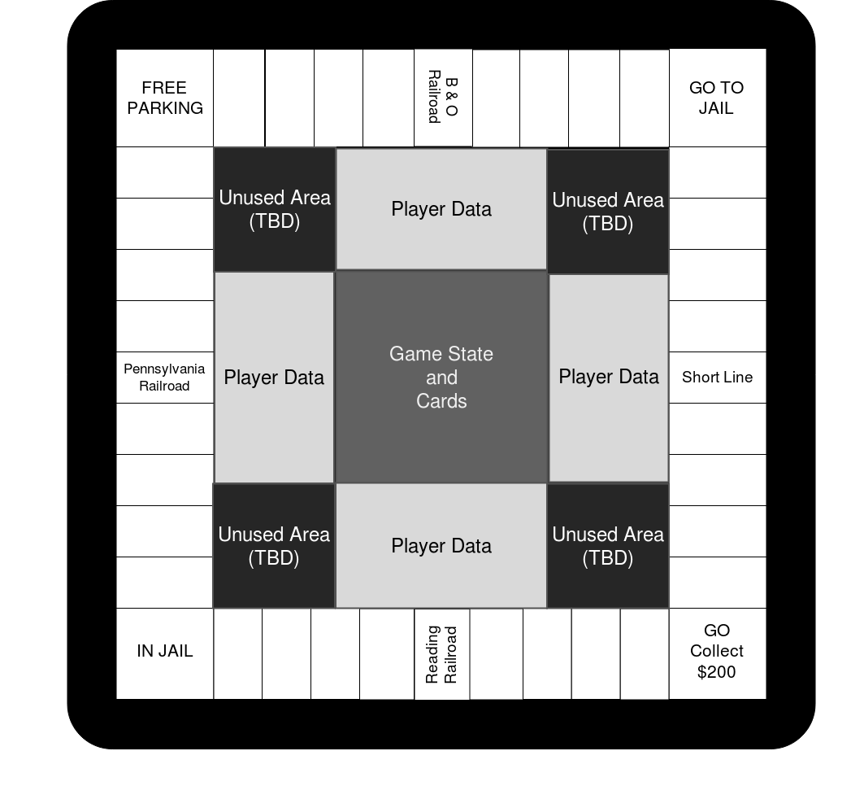

Appendix 2: Sketch of Central Displays