**IOT PHASE-4**

**SMART WATER FOUNTAIN**

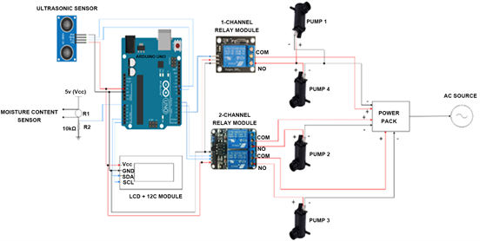

# **Introduction:**

In today's world, where the importance of water conservation and efficient resource utilization cannot be overstated, the integration of technology has proven to be a game-changer. The advent of Internet of Things (IoT) technology has ushered in a new era of smart and sustainable solutions, one of which is the IoT-based smart water fountain. This innovative fusion of traditional aesthetics and cutting-edge technology not only enhances the aesthetics of outdoor spaces but also brings a host of intelligent features that contribute to responsible water management and greater user convenience.

# NEED FOR TECH:

The platform for the IoT-based smart water fountain serves as the central hub for controlling, monitoring, and managing various aspects of the fountain's operation. Here's an overview of what the platform does:

Control Water Dispensing: The platform allows users to start and stop water dispensing from the fountain. Users can activate the fountain remotely or set up automated schedules for watering.

Monitor Water Level: It continuously monitors the water level in the fountain's reservoir. Users can view real-time water level data, which helps prevent overflows and ensures that the fountain doesn't run dry.

Water Quality Alerts: The platform checks the water quality and can provide alerts to users if any issues are detected. For example, it can notify users if the water quality deteriorates due to factors like high mineral content or low pH levels.

Leak Detection: The platform incorporates leak sensors to detect and alert users to any water leaks or overflows. This helps prevent water wastage and property damage.

Data Visualization: It displays data related to the smart water fountain's performance. Users can visualize water usage statistics, dispensing schedules, and historical water level data through charts and graphs.

# **TECHNOLOGIES USED:**

The following technologies used in this project are web based platforms of

⦁ HTML , CSS , JAVASCRIPT.

⦁ MIT APP INVENTOR.

## **WEB PLATFORM:**

The web platform developed for the IoT-based smart water fountain is a sophisticated and user-friendly interface that seamlessly integrates with the fountain's hardware. It provides a comprehensive set of tools for users to control, monitor, and optimize their water fountain, all from the convenience of their computer, smartphone, or tablet.

With features such as remote water dispensing control, real-time water level monitoring, and water quality alerts, the platform empowers users to make informed decisions and conserve water effectively. It offers a customizable and personalized experience, allowing users to tailor watering schedules to the unique needs of their plants.

In addition to its practical functionalities, the platform also serves as an educational hub, offering valuable content on plant care and water conservation. It fosters a sense of community by enabling users to connect, share experiences, and gain insights from fellow smart water fountain enthusiasts.

This web platform represents the synergy between technology and environmental responsibility, demonstrating how IoT can revolutionize the way we interact with and manage our outdoor spaces. It's a powerful tool for promoting sustainable gardening practices and fostering a deeper connection with nature.

Source Code

HTML

<!DOCTYPE html>

<html>

<head>

<title>Smart Water Fountain</title>

<link rel="stylesheet" type="text/css" href="styles.css">

</head>

<body>

<h1>Smart Water Fountain Control</h1>

<button id="startButton">Start Water Dispensing</button>

<button id="stopButton">Stop Water Dispensing</button>

<p>Current Water Level: <span id="waterLevel">Loading...</span></p>

<p>Temperature: <span id="temperature">Loading...</span>°C</p>

<p>Humidity: <span id="humidity">Loading...</span>%</p>

<p>Water Saved Today: <span id="waterSavedToday">0%</span></p>

<a href="#complaintForm" id="complaintLink">Report a Complaint</a>

<p>Water Quality: <span id="waterQuality">Good</span></p>

<p>Leak Status: <span id="leakStatus">No Leaks</span></p>

<h2>Educational Content</h2>

<div id="educationalContent">

<!-- Educational content can be dynamically loaded here -->

</div>

<form id="complaintForm">

<h2>Report a Complaint</h2>

<label for="complaintDescription">Description:</label>

<textarea id="complaintDescription" name="complaintDescription" rows="4" cols="50"></textarea>

<br>

<input type="submit" value="Submit Complaint">

</form>

<script src="script.js"></script>

</body>

</html>

CSS

<!DOCTYPE html>

<html>

<head>

<title>Smart Water Fountain</title>

<link rel="stylesheet" type="text/css" href="styles.css">

</head>

<body>

<h1>Smart Water Fountain Control</h1>

<button id="startButton">Start Water Dispensing</button>

<button id="stopButton">Stop Water Dispensing</button>

<p>Current Water Level: <span id="waterLevel">Loading...</span></p>

<p>Temperature: <span id="temperature">Loading...</span>°C</p>

<p>Humidity: <span id="humidity">Loading...</span>%</p>

<p>Water Saved Today: <span id="waterSavedToday">0%</span></p>

<a href="#complaintForm" id="complaintLink">Report a Complaint</a>

<p>Water Quality: <span id="waterQuality">Good</span></p>

<p>Leak Status: <span id="leakStatus">No Leaks</span></p>

<h2>Educational Content</h2>

<div id="educationalContent">

<!-- Educational content can be dynamically loaded here -->

</div>

<form id="complaintForm">

<h2>Report a Complaint</h2>

<label for="complaintDescription">Description:</label>

<textarea id="complaintDescription" name="complaintDescription" rows="4" cols="50"></textarea>

<br>

<input type="submit" value="Submit Complaint">

</form>

<script src="script.js"></script>

</body>

</html>

JAVASCRIPT :

document.addEventListener('DOMContentLoaded', function () {

// ... (previous code)

// Function to update water quality status (simplified example)

function updateWaterQuality() {

// You can fetch actual water quality data here and set the status accordingly

// For now, let's simulate "Good" water quality

const waterQualityStatus = "Good";

document.getElementById('waterQuality').textContent = waterQualityStatus;

}

// Function to update leak status (simplified example)

function updateLeakStatus() {

// You can fetch actual leak status data here and set the status accordingly

// For now, let's simulate "No Leaks"

const leakStatus = "No Leaks";

document.getElementById('leakStatus').textContent = leakStatus;

}

// Function to load educational content (simplified example)

function loadEducationalContent() {

// You can fetch educational content from your server or database here

// For now, let's add some sample content

const educationalContent = `

<p>Learn how to conserve water by adjusting watering schedules.</p>

<p>Discover tips for better plant care and improving water efficiency.</p>

`;

document.getElementById('educationalContent').innerHTML = educationalContent;

}

// Call the functions to update the water quality, leak status, and load educational content

updateWaterQuality();

updateLeakStatus();

loadEducationalContent();

});

--------------------------------------------------------------------------------------------------------------------------------------------------------------

**OUTPUT**:

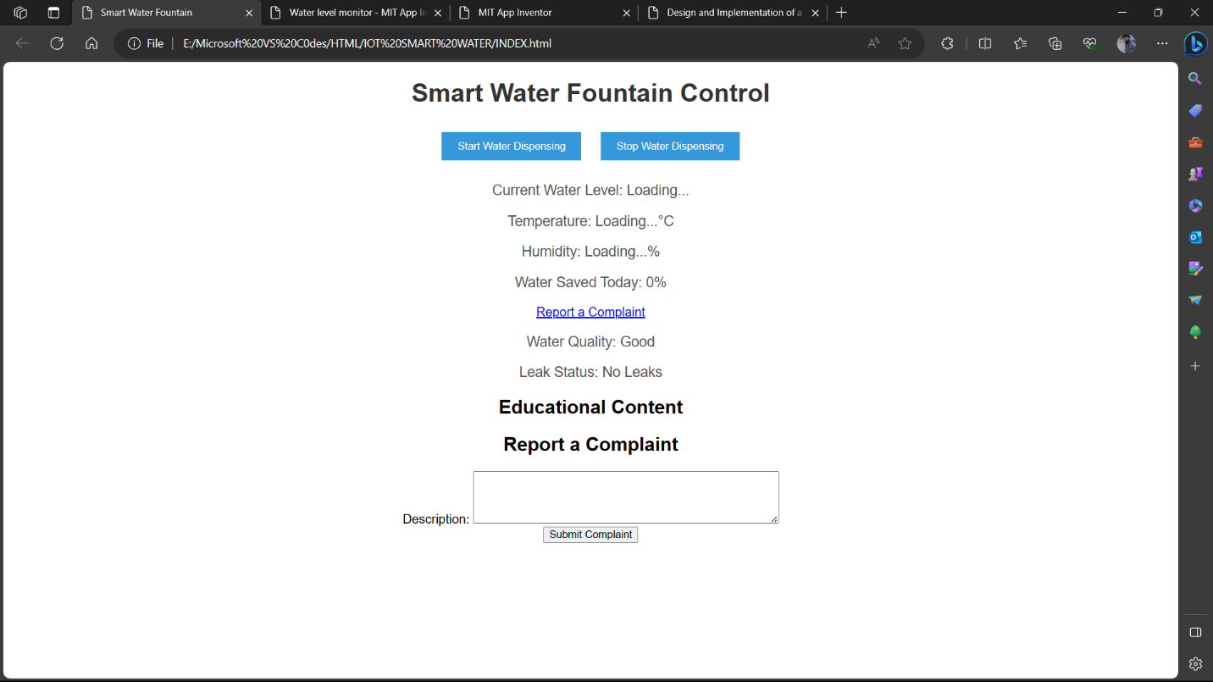

## MIT APP INVENTOR:

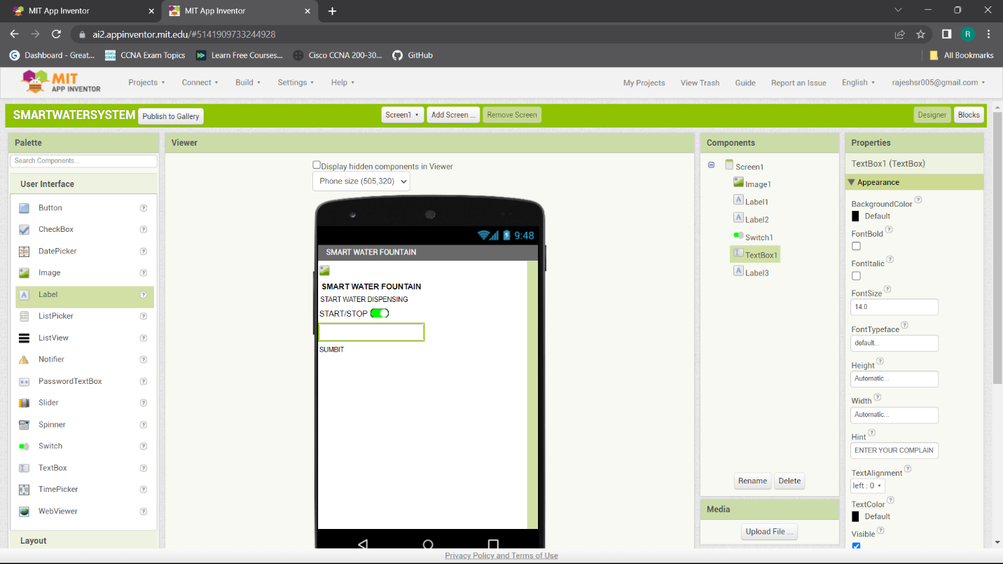

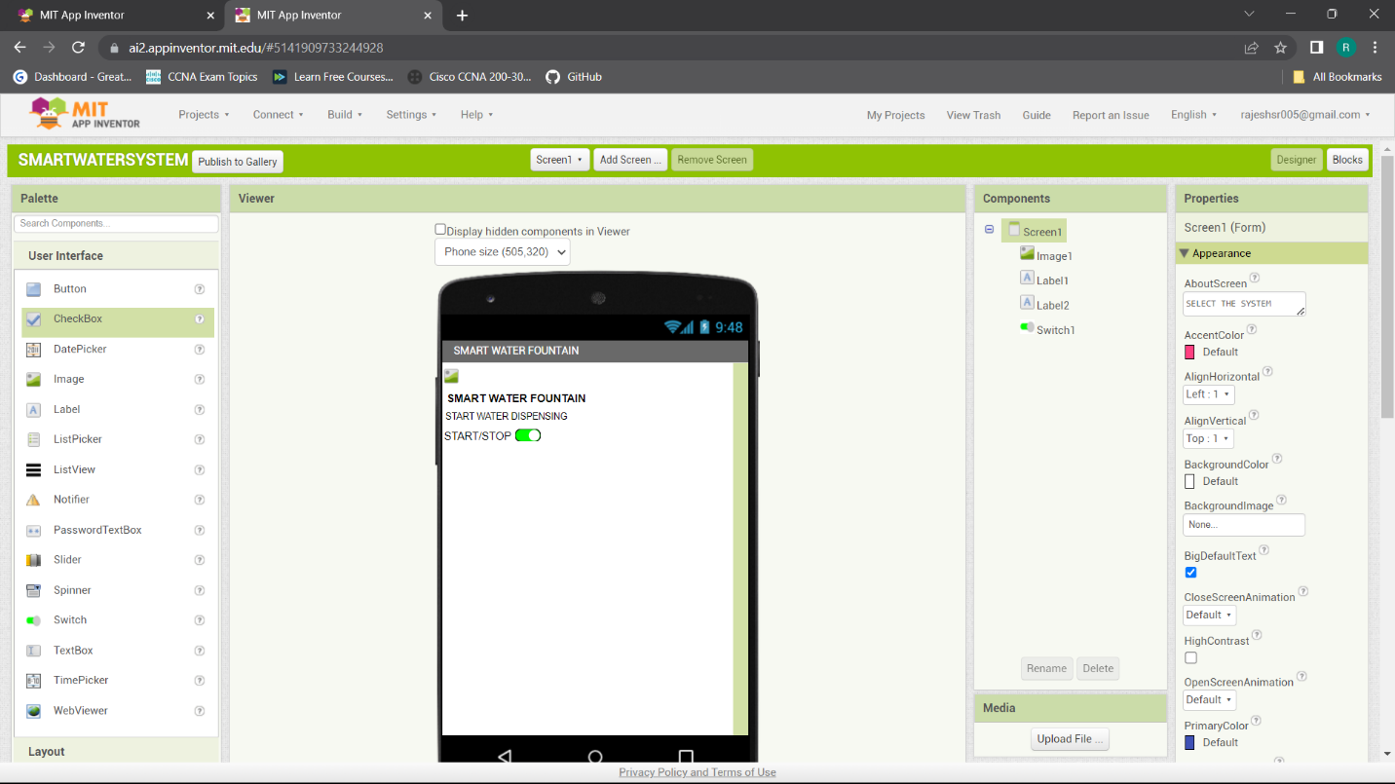

## **CONCLUSION:**

As we conclude our exploration of the IoT-based smart water fountain, it becomes evident that technology plays a pivotal role in addressing critical challenges such as water conservation, efficient irrigation, and user interactivity. This fusion of technology and aesthetics has given rise to a new generation of water fountains, where water-saving features, leak detection, water quality monitoring, and educational content are just a few of the many capabilities provided. Through these advancements, smart water fountains exemplify how technology, when harnessed thoughtfully, can create sustainable solutions that benefit both the environment and society at large. With this fusion of beauty and intelligence, the IoT-based smart water fountain stands as a symbol of progress towards a greener and more connected future.