Adam Ness and Marty Townley
VLSI
Lab8

Counter simulation:

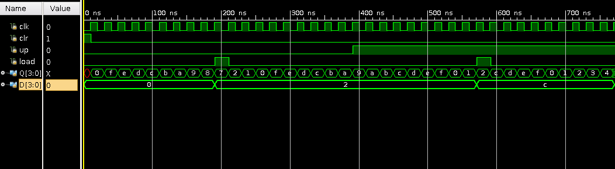
Counter IRSIM waveform:
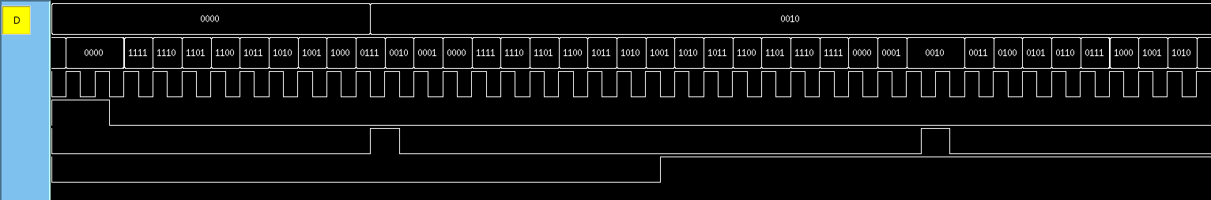
The order of the signals on the above waveform is:
D, Q, clk, clr, load, up

Counter gate schematic:
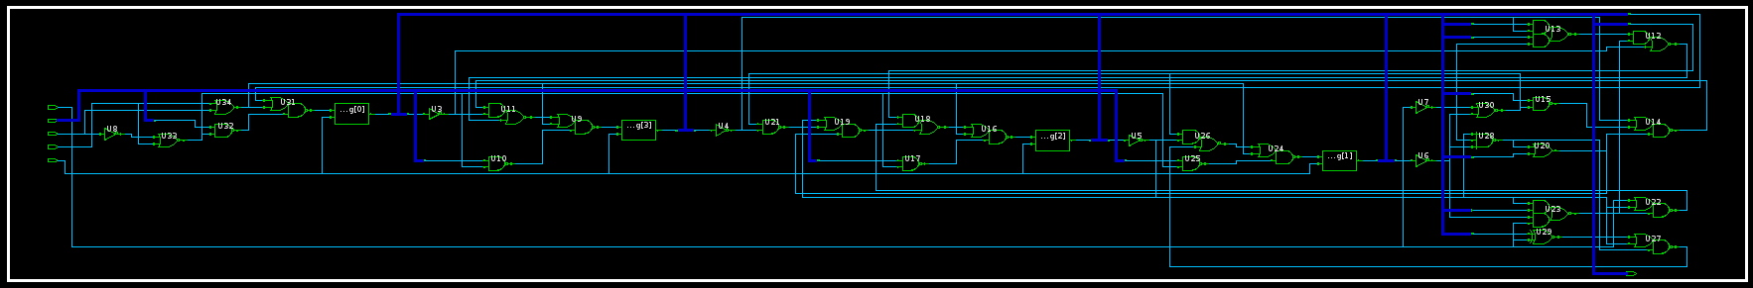

Counter magic layout:
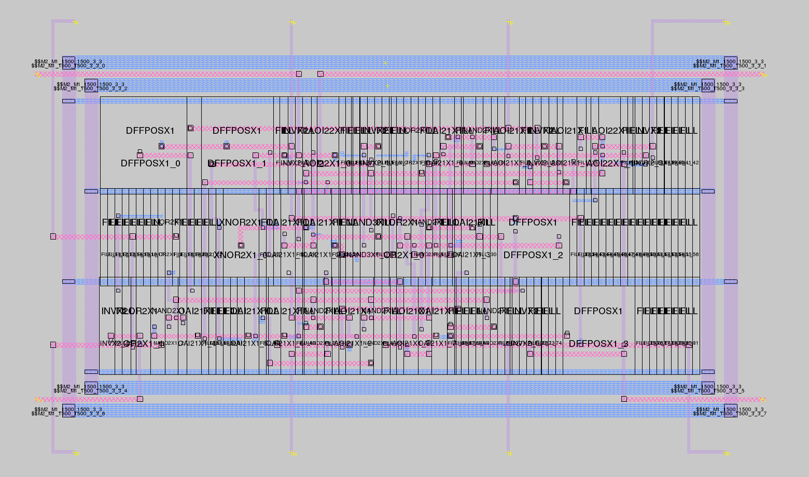

MIPS FSM Simulation waveform:
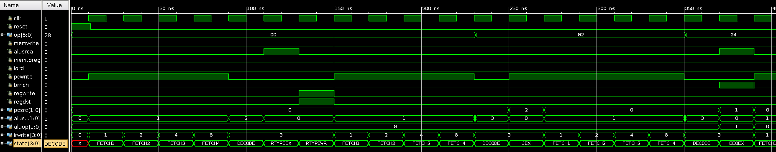
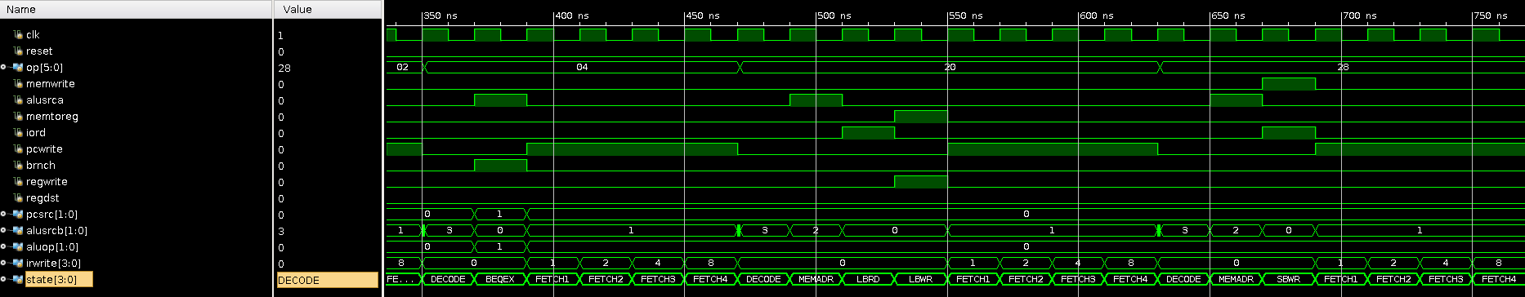

MIPS FSM Magic layout:
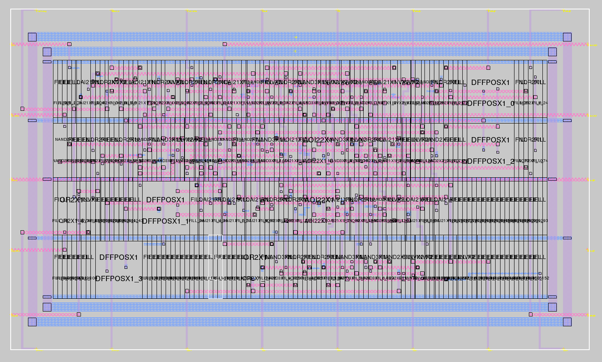
MIPS FSM Magic layout sizing:

microns: 295.20 x 174.00 ( 0.00, 0.00 ), ( 295.20, 174.00) 51364.80
lambda: 984 x 580 ( 0, 0 ), ( 984, 580 ) 570720

Summary:
No major problems were encountered in this lab, the only issue we had was trying to figure out how to deal with a typedef enum as an input.

It took about 4 hours to do this lab

