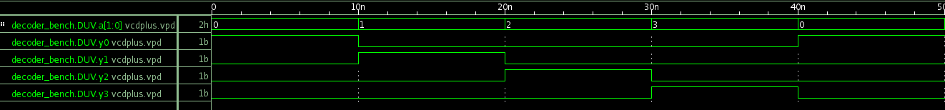
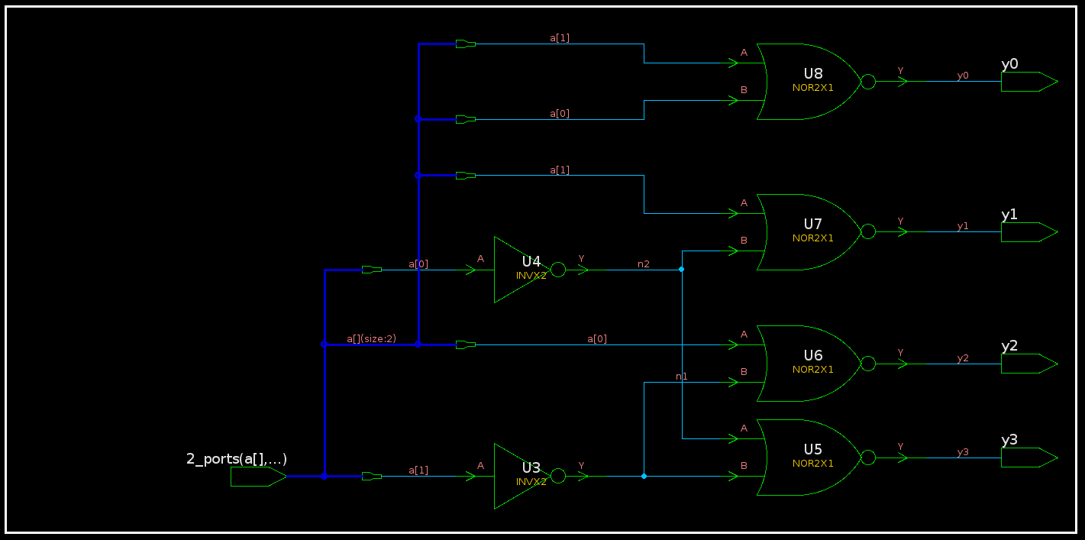
Adam Ness and Marty Townley
2/27/17
ECE424

Lab 5 Report

decoder_bench.v Simulation Waveform:

decoder Schematic:

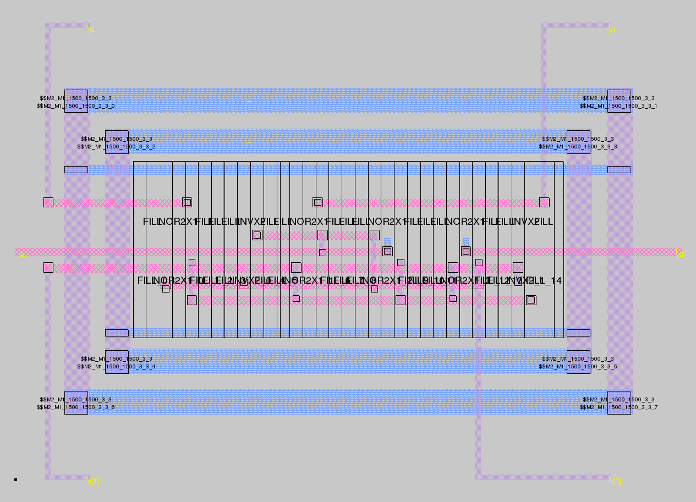
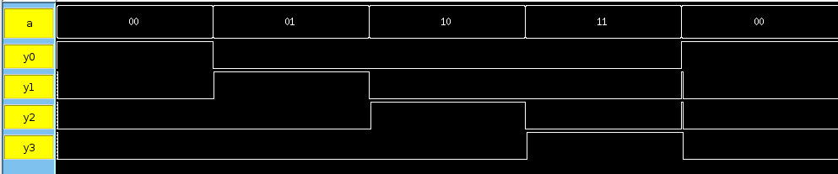

decoder Magic Layout:

decoder IRSIM Waveform:

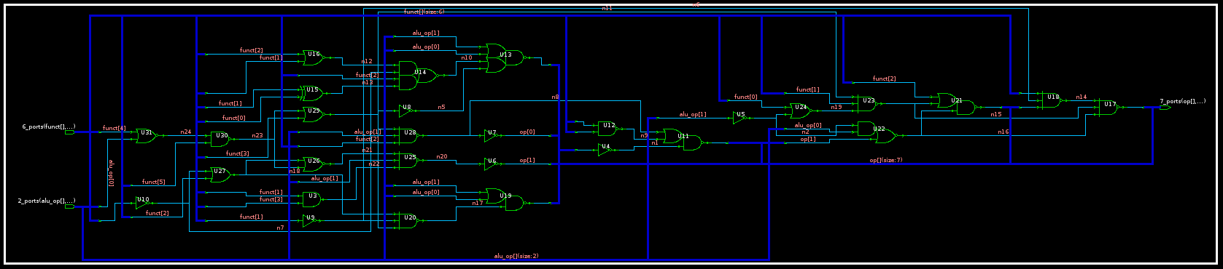

alu_ctl Schematic:

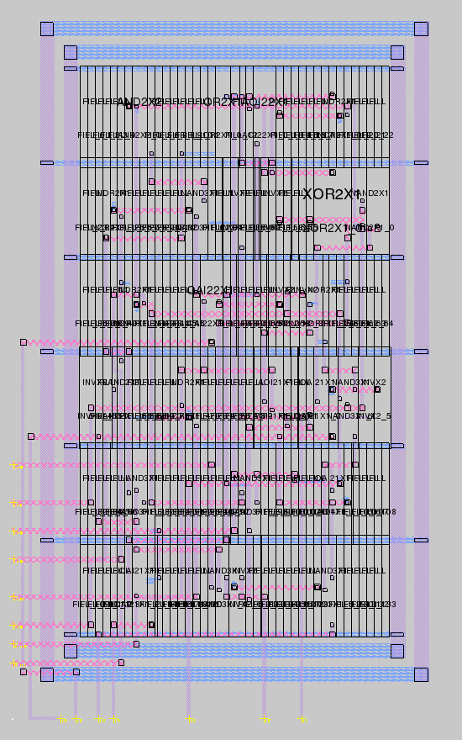

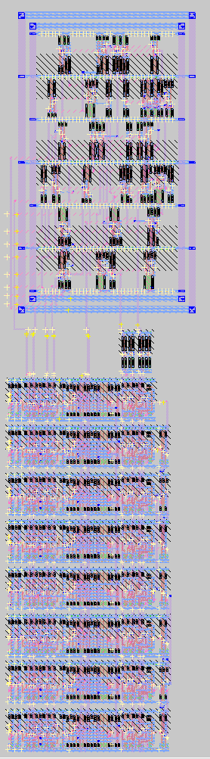

alu_ctl Magic Layout:

alu_decoder Magic Layout (alu_ctl + alt_alu):

alt_decoder IRSIM Waveform:

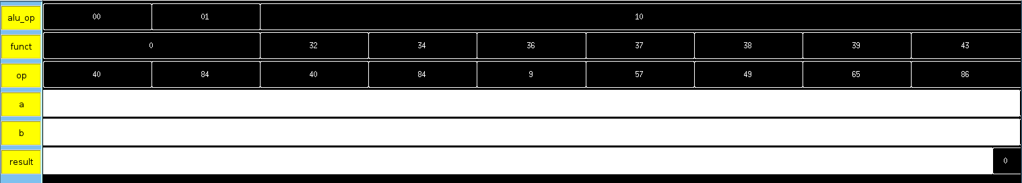
Notes:

In the tarball:

Magic Layout that has only alu_ctl: alu_ctl.mag
Magic Layout with alu_ctl and alt_alu_8: alu_decode.mag

TCL command file for decoder: decoder_test.cmd
TCL command file for alu_decode: alu_decode.cmd

All tests were passed for both simulations.

Appendix:

decoder_test.cmd:

h Vdd!
l Gnd!

##### VECTOR DECLARATIONS #####
vector a {a[1]} {a[0]}

stepsize 100

analyzer a y0 y1 y2 y3

##### EXECUTED CODE #####

setvector a 00
s

setvector a 01
s

setvector a 10
s

setvector a 11
s

setvector a 00
s

alu_decode.cmd:

h Vdd!
l Gnd!

############# VECTOR DECLARATIONS #####################

vector alu_op alu_op1 alu_op0
vector funct funct5 funct4 funct3 funct2 funct1 funct0
vector op op6 op5 op4 op3 op2 op1 op0

vector a a7 a6 a5 a4 a3 a2 a1 a0
vector b b7 b6 b5 b4 b3 b2 b1 b0
vector result result7 result6 result5 result4 result3 result2 result1 result0

stepsize 250

analyzer alu_op funct op a b result zero
w alu_op funct op a b result zero

################## PROCESSES ############################

proc dec2bin {i {width {}}} {
#returns the binary representation of $i
# width determines the length of the returned string (left truncated or added left 0)
# use of width allows concatenation of bits sub-fields

set res {}
if {$i<0} {
set sign -
set i [expr {abs($i)}]
} else {
set sign {}
}
while {$i>0} {
set res [expr {$i%2}]$res
set i [expr {$i/2}]
}
if {$res eq {}} {set res 0}

if {$width ne {}} {
append d [string repeat 0 $width] $res
set res [string range $d [string length $res] end]
}
return $sign$res
}

proc cycleInput {} {
for {set i 0} {$i < 256} {incr i} {

set adec [dec2bin $i 8]
#puts "adec is: $adec"
setvector a $adec

set j 1
while {$j < 256} {
set bdec [dec2bin $j 8]
#puts "bdec is: $bdec"
setvector b $bdec
set j [expr $j << 1]
s
checkAnswer
}
}
}

proc checkAnswer {} {
set expectedNum 0

if { [query op] == 9 } {
#and
set expectedNum [expr [query a] & [query b] ]
} elseif { [query op] == 57} {
#or
set expectedNum [expr [query a] | [query b] ]
} elseif { [query op] == 65} {
#nor
set expectedNum [expr [query a] | [query b] ]
set expectedNum [expr ~$expectedNum]
set expectedNum [expr 256 + $expectedNum]
} elseif { [query op] == 49} {
#xor
set expectedNum [expr [query a] ^ [query b] ]
} elseif { [query op] == 40} {
#add
set expectedNum [expr [query a] + [query b] ]
} elseif { [query op] == 84} {
#sub
set expectedNum [expr [query a] - [query b] ]
if { $expectedNum < 0} {
set expectedNum [expr $expectedNum + 256]
}
} elseif { [query op] == 86} {
#slt
set expectedNum [expr [query a] < [query b] ]
}

set decex $expectedNum
set binex [dec2bin $expectedNum 8]
set decre [query result]
set binre [dec2bin $decre 8]

puts "a is [query a]; b is [query b]"
puts "dec expected: $decex"
#puts "bin expected: $binex"
puts "dec result: $decre"
#puts "bin result: $binre"

#if { $expectedNum < 240} {
assert result [dec2bin $expectedNum 8]
#}

}

####################### EXECUTED CODE: ########################################

#lw, sw, ...
setvector alu_op 0x0
setvector funct 0x00
cycleInput

#beq, bne, ...
setvector alu_op 0x1
setvector funct 0x00
cycleInput

#add
setvector alu_op 0x2
setvector funct 0x20
cycleInput

#sub
setvector alu_op 0x2
setvector funct 0x22
cycleInput

#and
setvector alu_op 0x2
setvector funct 0x24
cycleInput

#or
setvector alu_op 0x2
setvector funct 0x25
cycleInput

#xor
setvector alu_op 0x2
setvector funct 0x26
cycleInput

#nor
setvector alu_op 0x2
setvector funct 0x27
cycleInput

#sltu
setvector alu_op 0x2
setvector funct 0x2B
cycleInput

