Marty Townley and Adam Ness
ECE425
4/18/17

Week 2 Project Deliverable: Complete Funnel Shifter Design (Pass-Transistor Array)

Source Generator Logic:

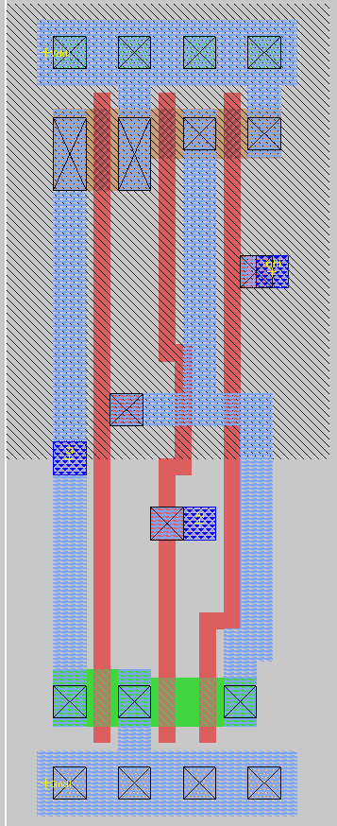
N-2:0:
N-1:

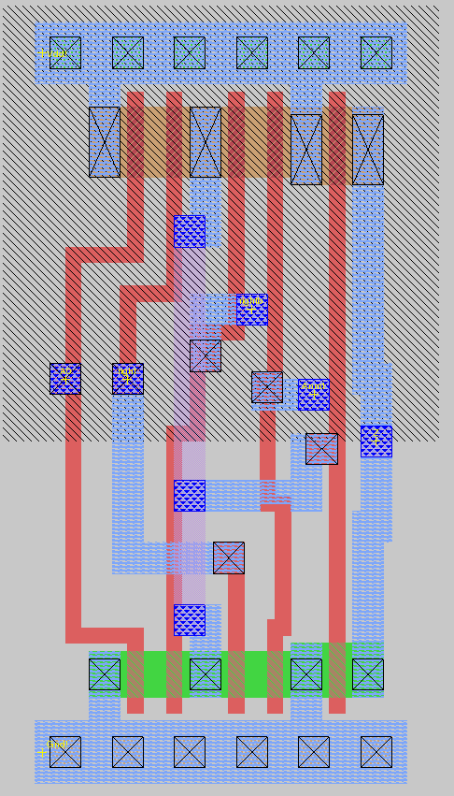
2N-2:N

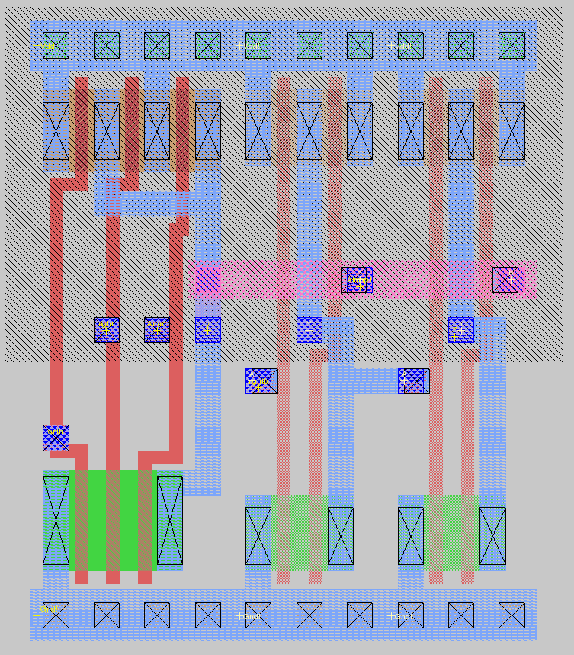

Array Shifter:

Tile:

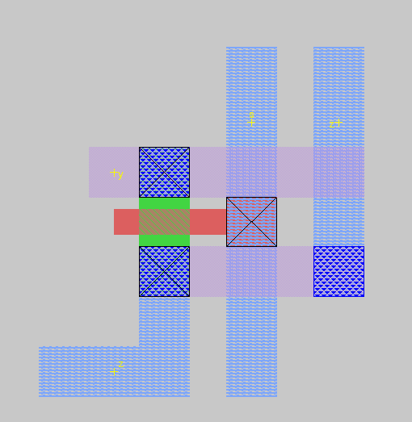

Array:

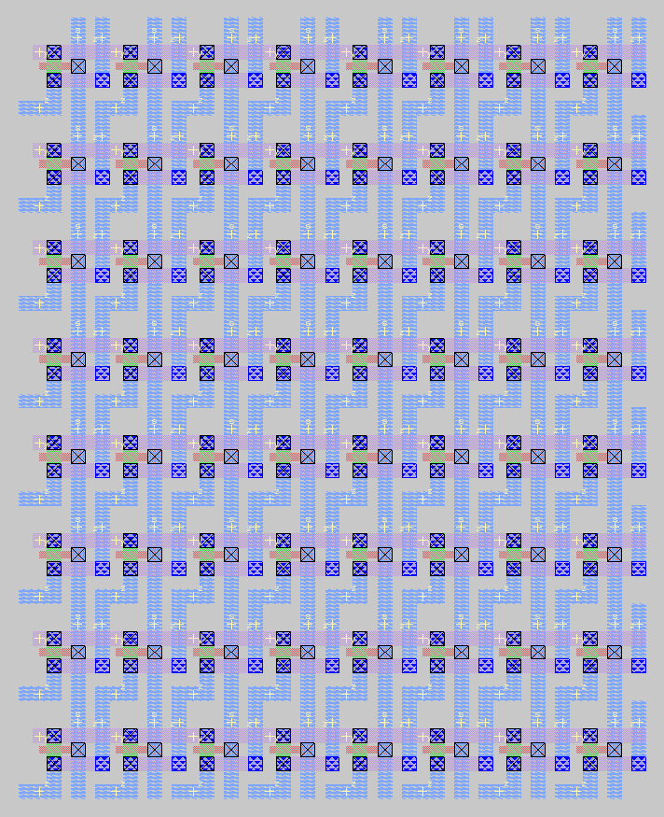

Three-Eight Decoder:

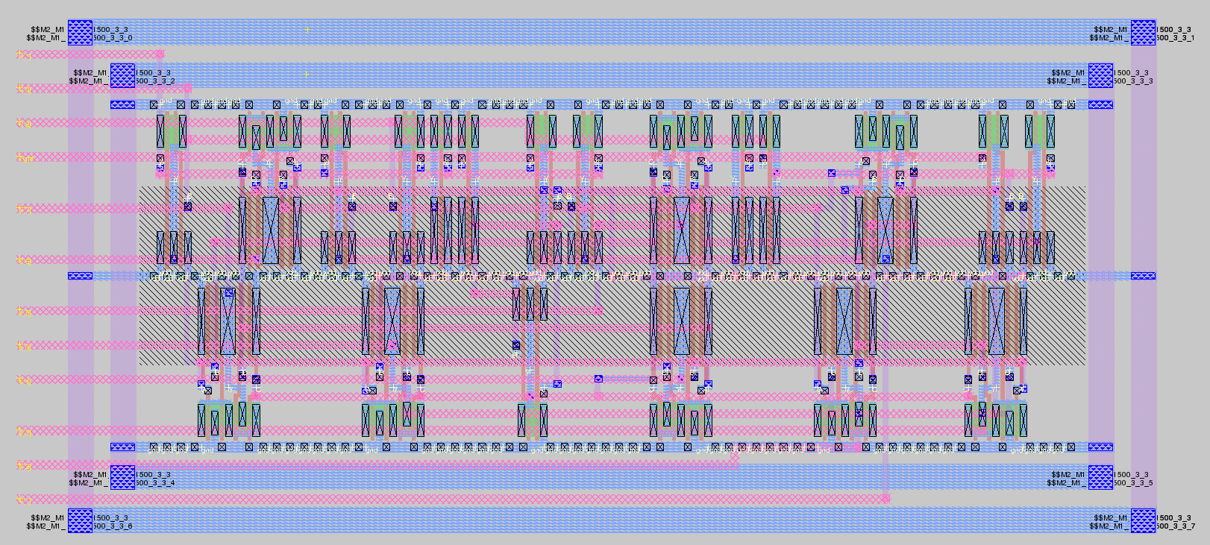

Shifter (Complete):
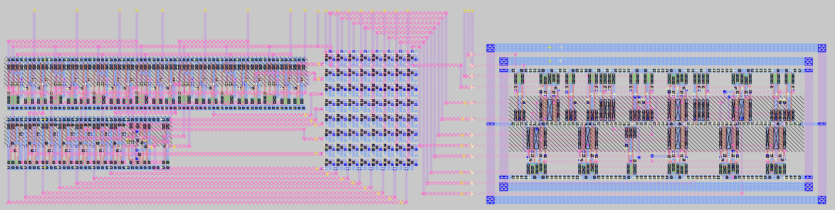
Shifter (Left side detail):

Shifter (Right side detail):

