Adam Ness and Marty Townley
ECE 425
1/31/17
Lab 2

1) NAND3 Gate
Stick Drawing:

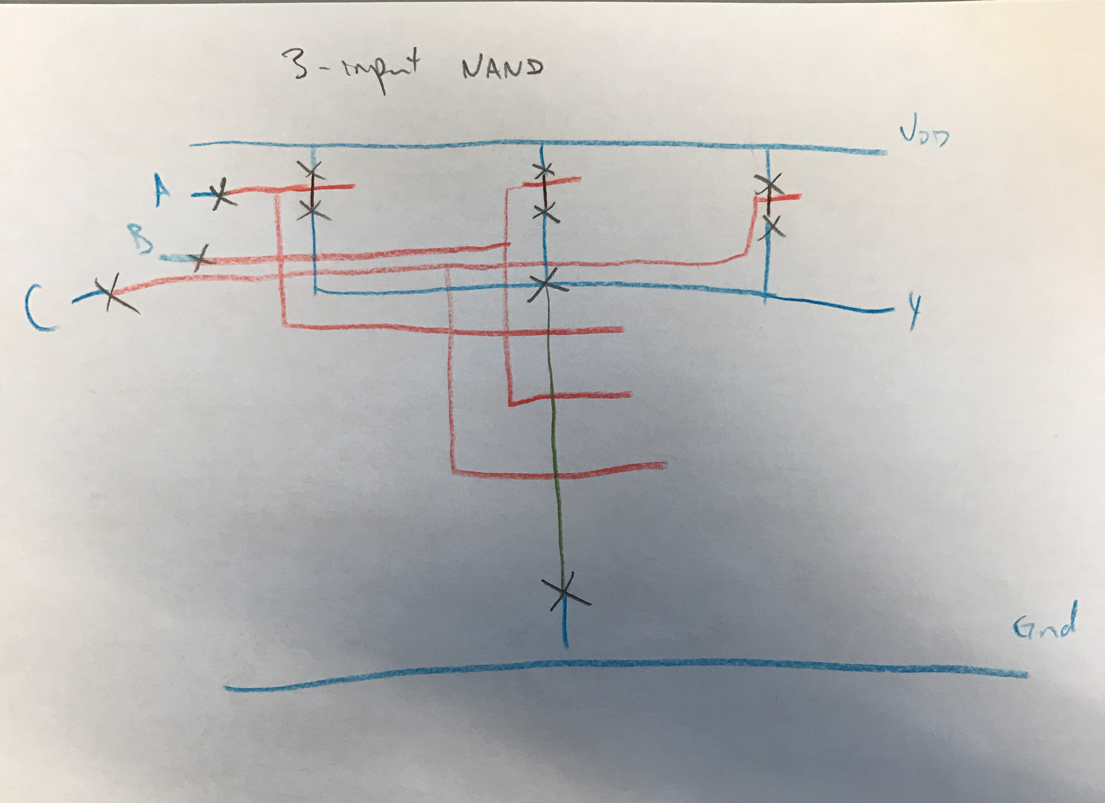

Magic Layout:
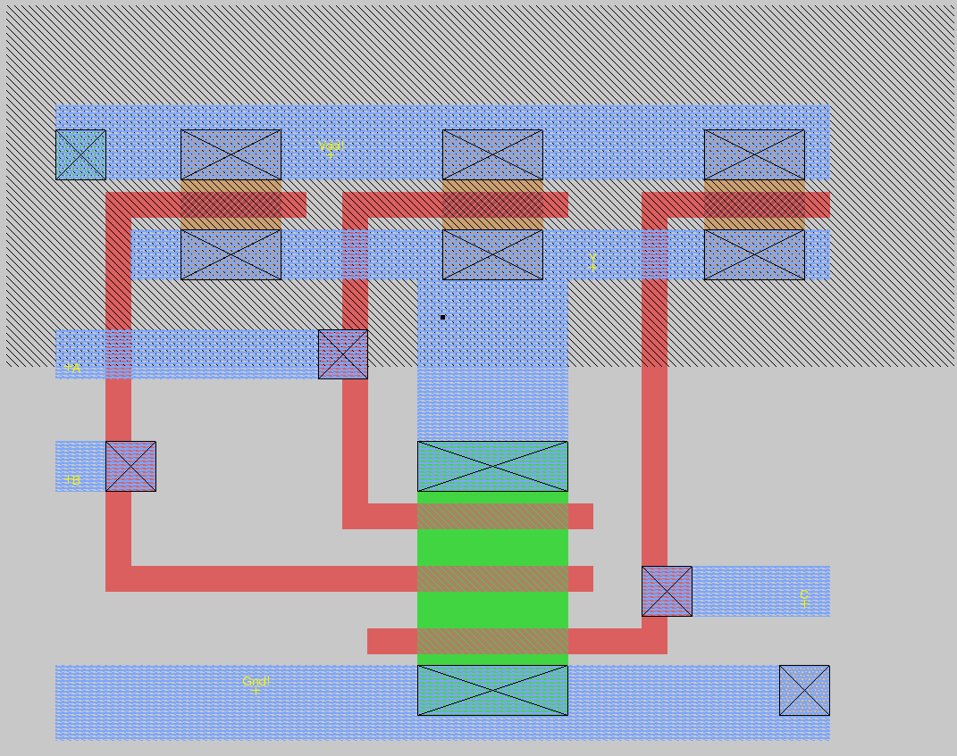

Dimensions and size:
microns: 22.80 x 17.70 (-10.50, -10.20), ( 12.30, 7.50 ) 403.56
lambda: 76 x 59 ( -35, -34 ), ( 41, 25 ) 4484

irsim waveform:
Waves are, from top to bottom, A, B, C and Y
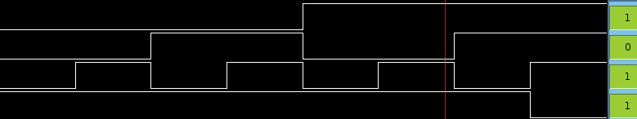

2) AOI21
Stick Diagram:
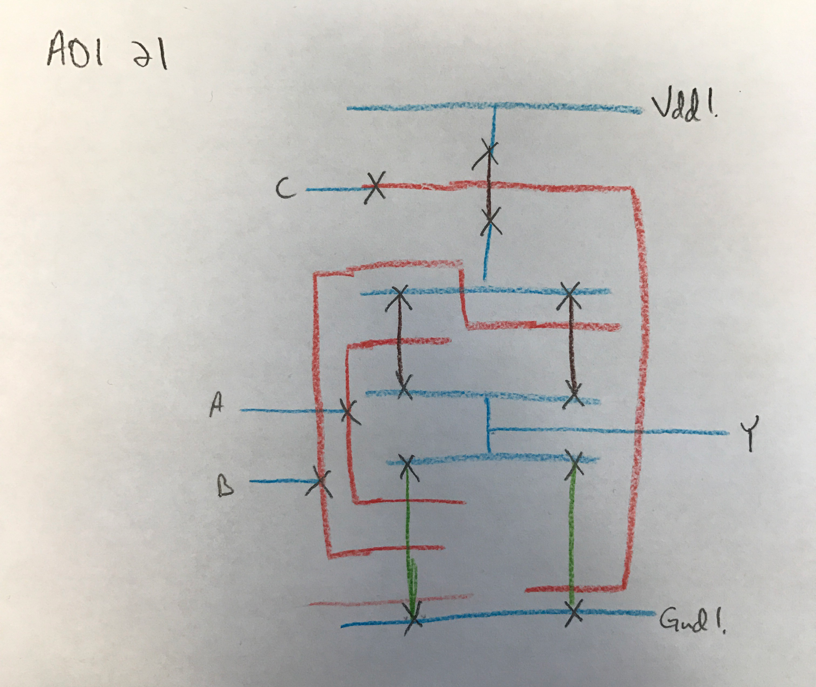
Xcircuit schematic:

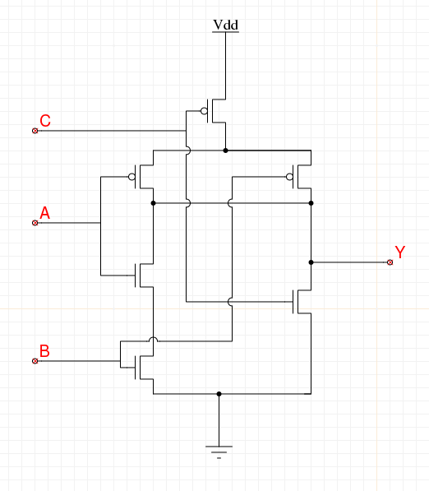

Magic layout:
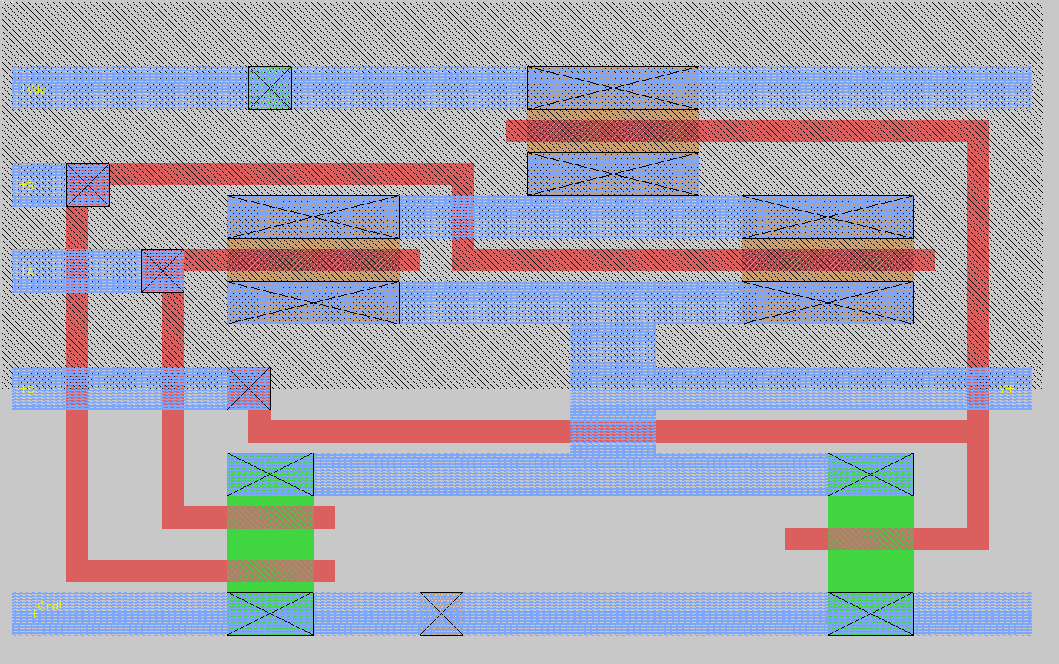
Dimensions:

microns: 29.10 x 17.70 (-21.90, -10.50), ( 7.20, 7.20 ) 515.07
lambda: 97 x 59 ( -73, -35 ), ( 24, 24 ) 5723

xcircuit sim:
Magic sim:
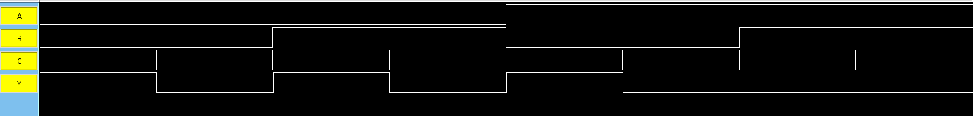
Simulation demonstrates correct operation of the circuit in both cases.

3) Summary:
Learning to use Magic took some time for both of us to familiarize ourselves with the tool. Also, we had to take time to figure out how to layout the poly so that there were no crossovers between different poly sections. Additionally, we had to fix some problems when the design violated some of the design rules. It took us about 3.5 hours to do this lab.

