Adam Ness & Marty Townley
VLSI
4/25/17 – MIPS Project Milestone 3

Layout Plots:

Overall datapath including new alu and shifter:

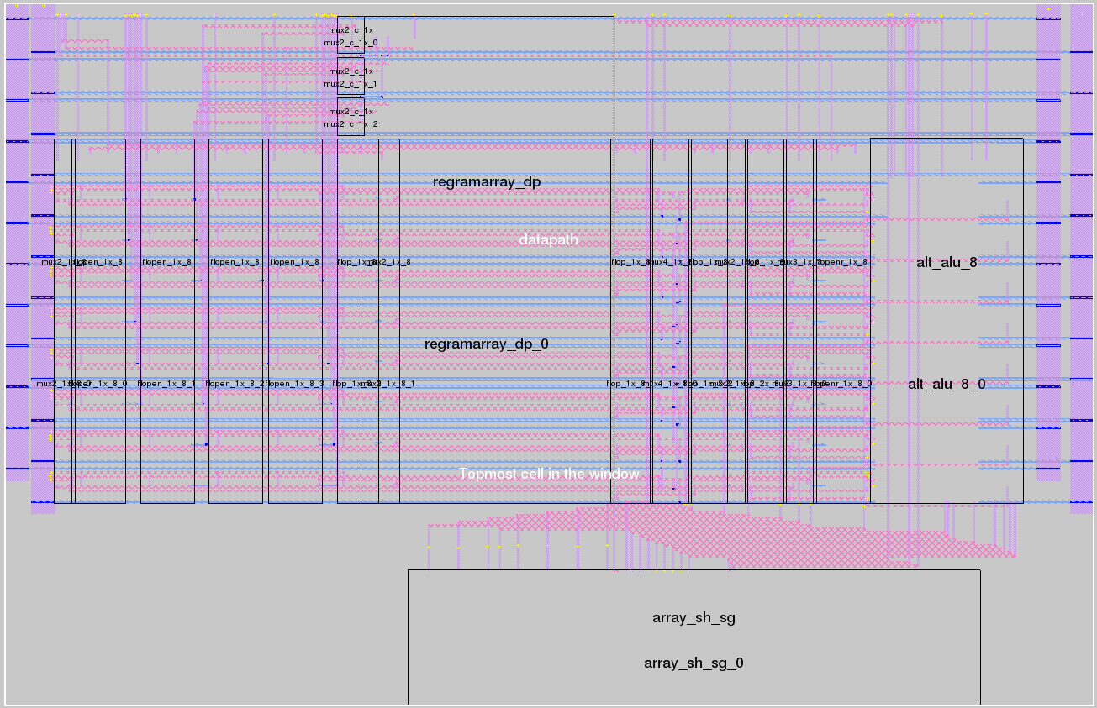

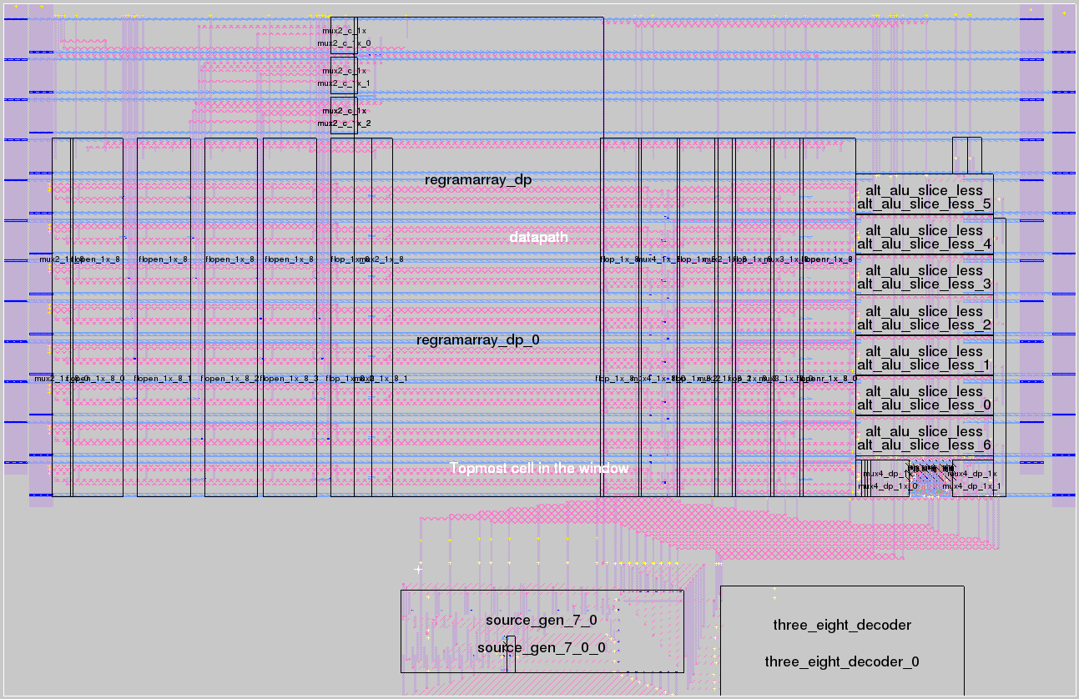
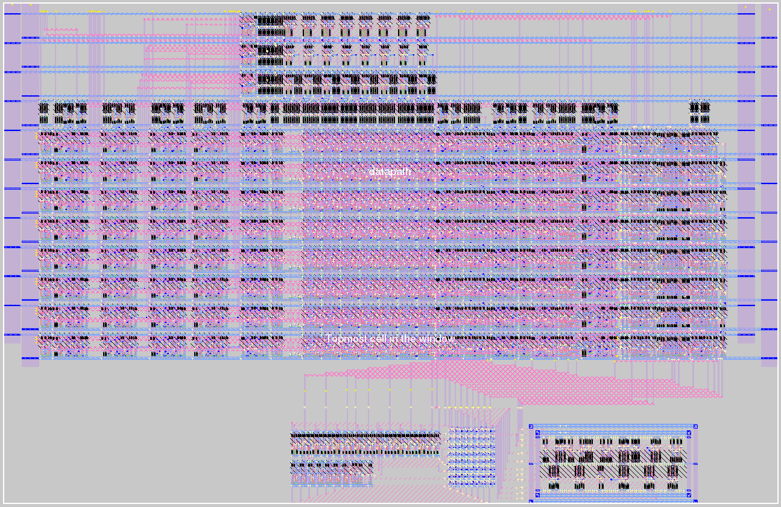
Simulation:

The datapath was tested in irsim, using exhaustive testing on the shifter (demonstrating all possible input values for b and k). The alu operation was also tested the same way as in lab 4. The design passes all tests. Below are a few selected test waveforms:

Complete exhaustive waveform:
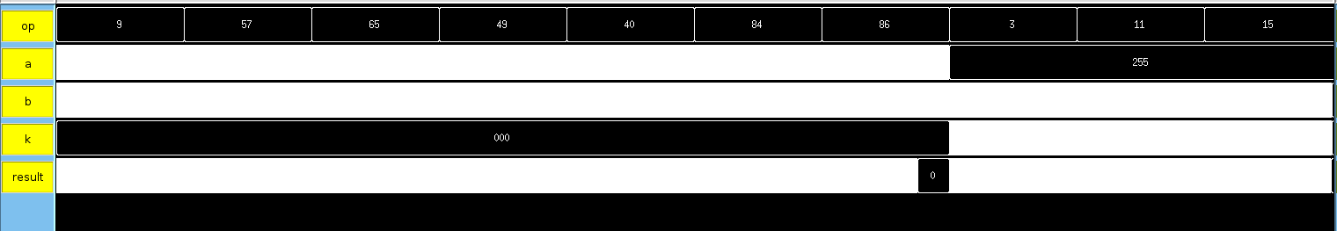
add:
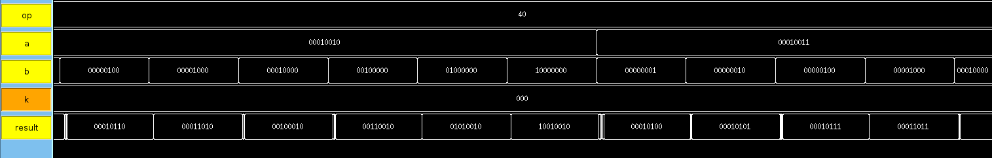
and
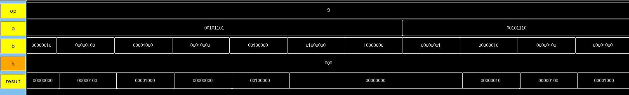
nor:
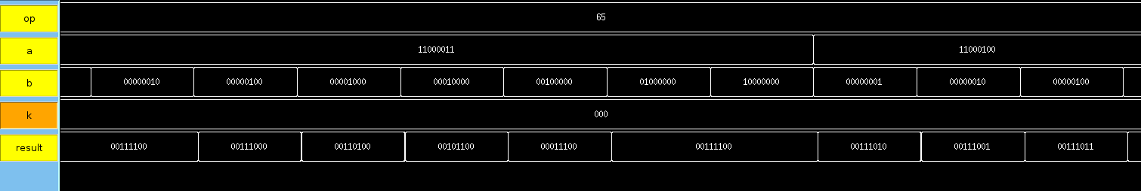
or:
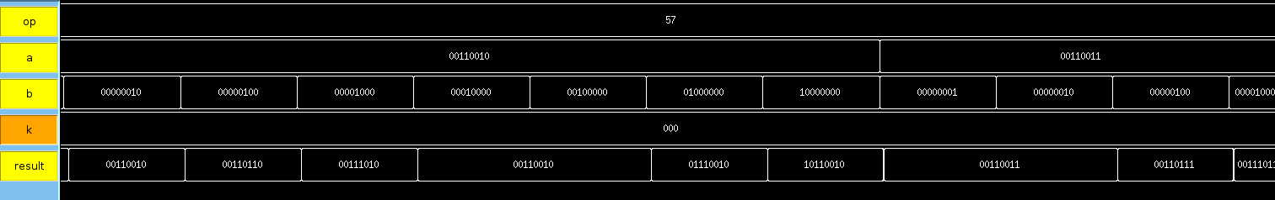

sll:
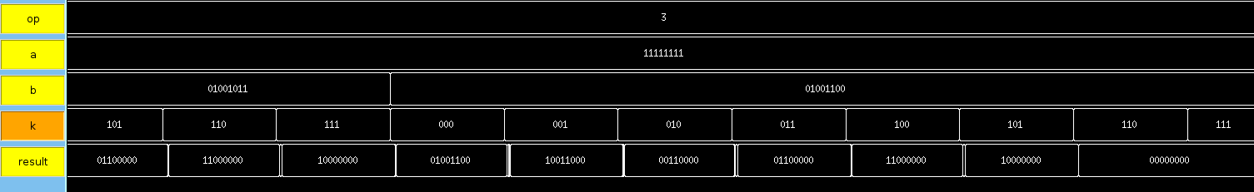
slt:
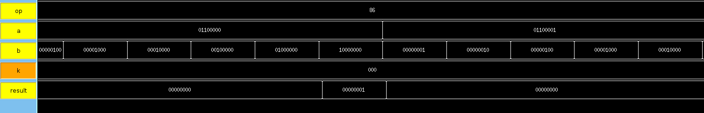
sra:
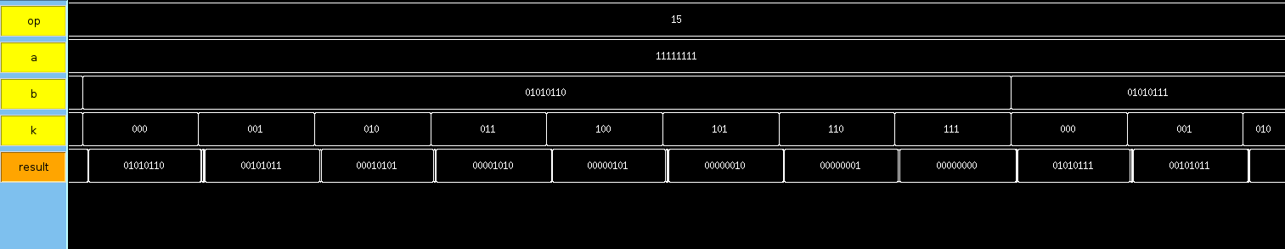
srl:
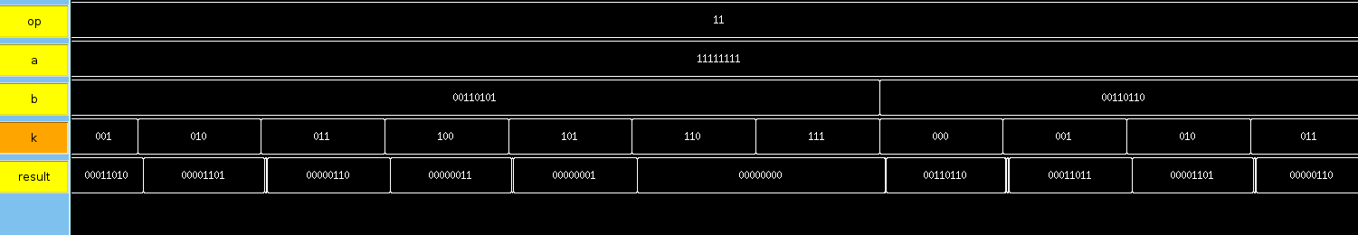
sub:
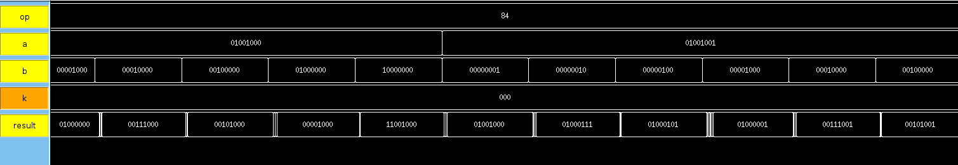
xor:
