Adam Ness and Marty Townley
VLSI
Lab 9
4/8/17

Original assembly program, commented:

.data:00000000 80 02 00 44 lb v0,68(zero) v0=5
.data:00000004 80 07 00 40 lb a3,64(zero) a3=3
.data:00000008 80 e3 00 45 lb v1,69(a3) v1=c
.data:0000000c 00 e2 20 25 or a0,a3,v0 a0=7
.data:00000010 00 64 28 24 and a1,v1,a0 a1=0100, 4
.data:00000014 00 a4 28 20 add a1,a1,a0 a1=1011, 11
.data:00000018 10 a7 00 08 beq a1,a3,0x0000003c branch if a1=a3, doesnt
.data:0000001c 00 64 30 2a slt a2,v1,a0 a2 = v1 < a0 ? 0
.data:00000020 10 c0 00 01 beqz a2,0x00000028 not equal
.data:00000024 80 05 00 00 lb a1,0(zero) a1=68 (44h)
.data:00000028 00 e2 30 2a slt a2,a3,v0 a2= a3 < v0 ? 1
.data:0000002c 00 c5 38 20 add a3,a2,a1 a3=a2+a1 = 1+68, 45h
.data:00000030 00 e2 38 22 sub a3,a3,v0 a3=a3-v0=64, 40h
.data:00000034 08 00 00 0f j 0x0000003c jump to address 0x3c
.data:00000038 80 07 00 00 lb a3,0(zero) a3=44h
.data:0000003c a0 47 00 47 sb a3,71(v0) stores a3 into 4c
.data:00000040 00 00 00 03 sra zero,zero,0x0
.data:00000044 00 00 00 05 0x5
.data:00000048 00 00 00 0c syscall

After some modifications, the original program executed properly on the mips processor.
Simulation screenshot:
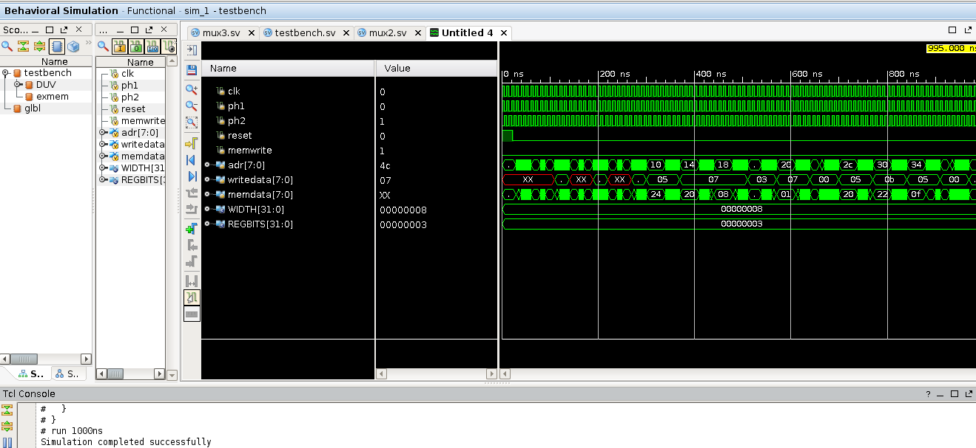

Next, the following assembly program was written to test xor and nor functionality:

.data:00000000 80040014 lb a0,20(zero) a0 = 0xf0
.data:00000004 80050018 lb a1,24(zero) a1 = 0x55
.data:00000008 00a43026 xor a2,a1,a0 a2 = (0xf0)xor(0x55) = 0xa5
.data:0000000c 00a43827 nor a3,a1,a0 a3 = (0xf0)nor(0x55) = 0x0a
.data:00000010 a007001c sb a3,28(zero) write 0x0a to memory
.data:00000014 000000f0
.data:00000018 00000055

Simulating the circuit indicated proper operation:

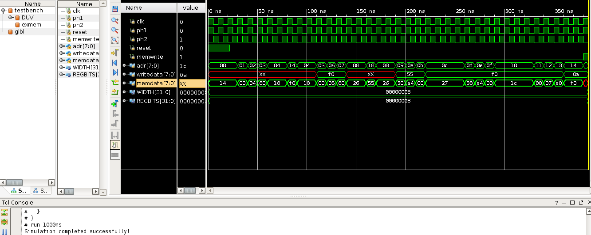
Additionally, re-running the original simulation indicated the circuit still works.

Finally, the shifter was added and simulated.

Standalone shifter simulation:
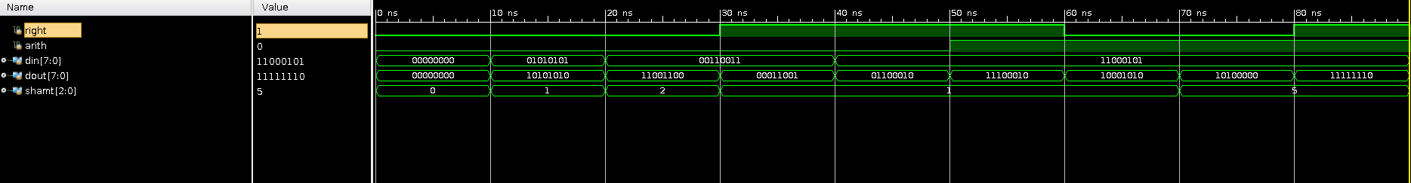

Finally, the shifter was added to and simulated in the mips processor. For ease of integration, the shifter was added to the alu module, and was integrated. A markup of the resulting structure is shown in the following block diagram:
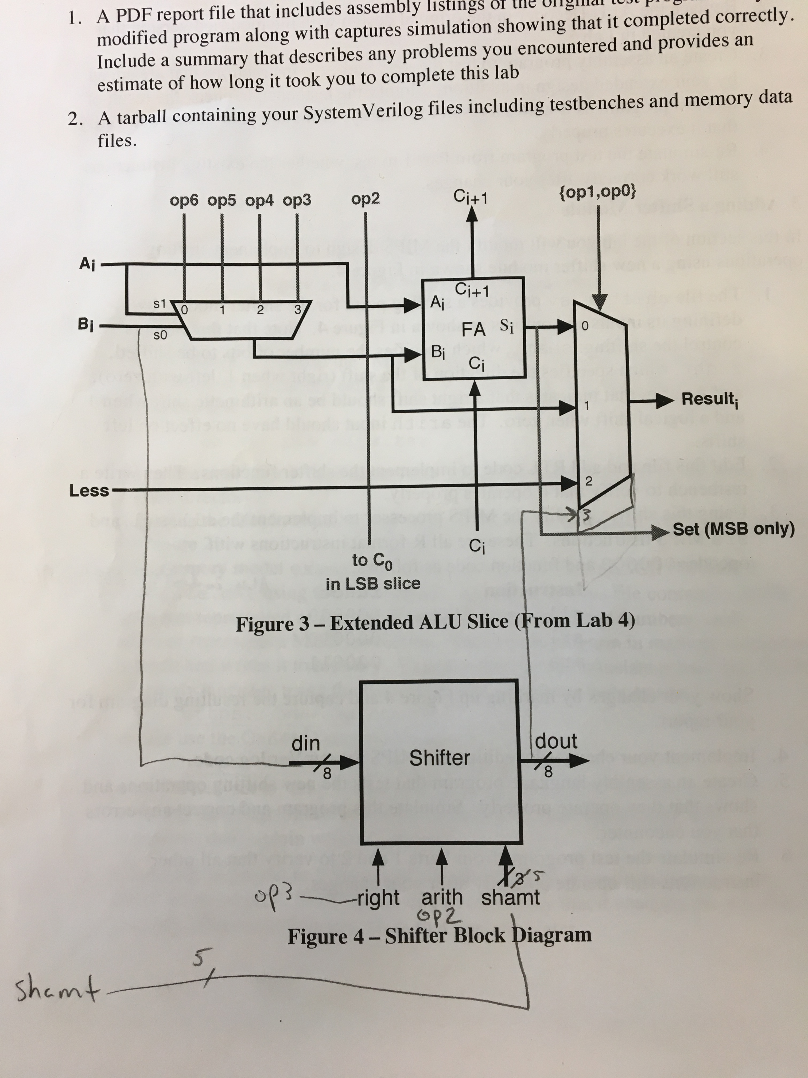

A new mips assembly program was created to test shifting functionality in the processor:

.data:00000000 80040024 lb a0,36(zero) a0 = 0xf0
.data:00000004 80050028 lb a1,40(zero) a1 = 0x55
.data:00000008 00043040 sll a2,a0,0x1 a2 = 0xf0 << 2
.data:0000000c 00043100 sll a2,a0,0x4 a2 = 0xf0 << 4
.data:00000010 00043082 srl a2,a0,0x2 a2 = 0xf0 >> 2
.data:00000014 00053082 srl a2,a1,0x2 a2 = 0x55 << 2
.data:00000018 00043083 sra a2,a0,0x2 a2 = 0xf0 >>> 2
.data:0000001c 00053083 sra a2,a1,0x2 a2 = 0x55 >>> 2
.data:00000020 a006002c sb a2,44(zero) store 0x15 into memory
.data:00000024 000000f0
.data:00000028 00000055

This program was simulated to ensure correct operation, and we found that it works correctly:

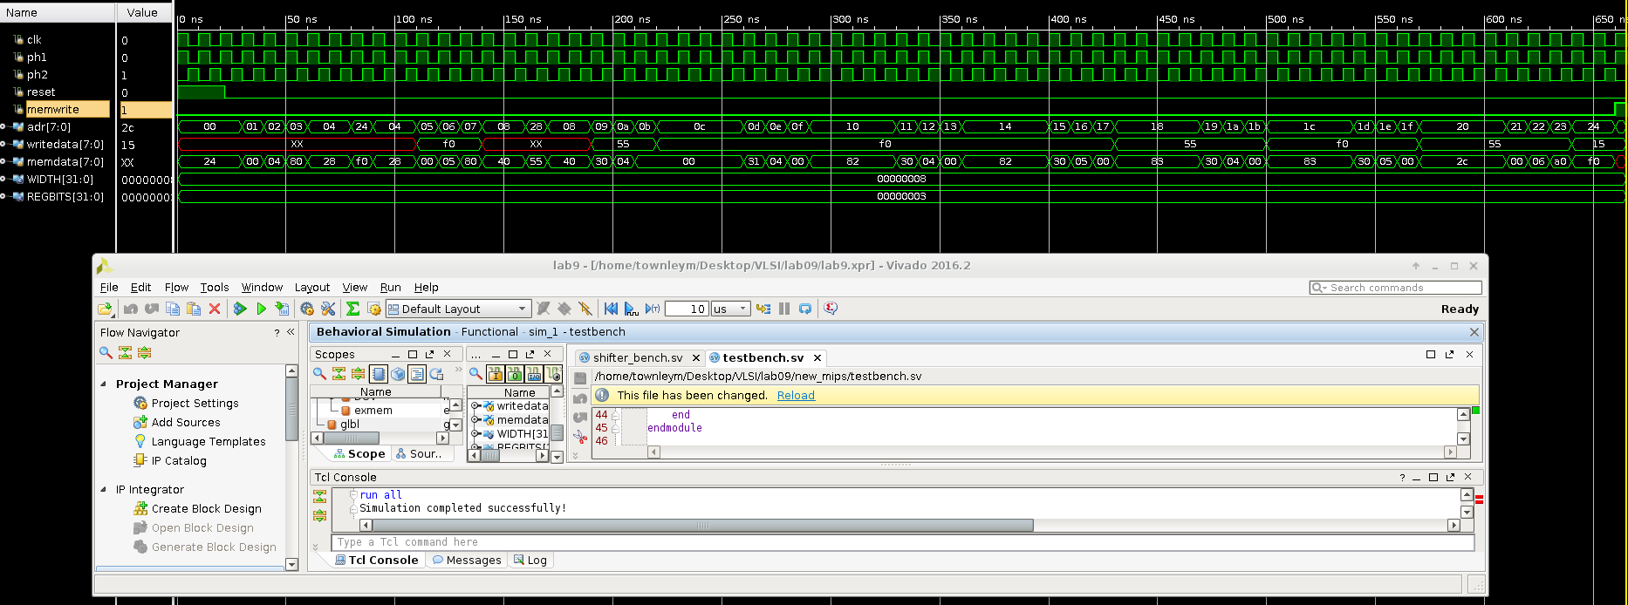

Finally, the previous two programs were run again to ensure correct operation of all instructions, and we found that everything still works fine.

No major problems were encountered. The only issues involved an unsigned operation encoded in the alu_decoder, which needed fixing for the first part of the lab. For the xor and nor simulation, we found that the online assembler encoded an instruction wrong, which also had to be fixed.

It took approximately 7 hours to complete this lab.

