Adam Ness and Marty Townley
ECE425
4/11/17

Design Plan

Chip Floor Plan:
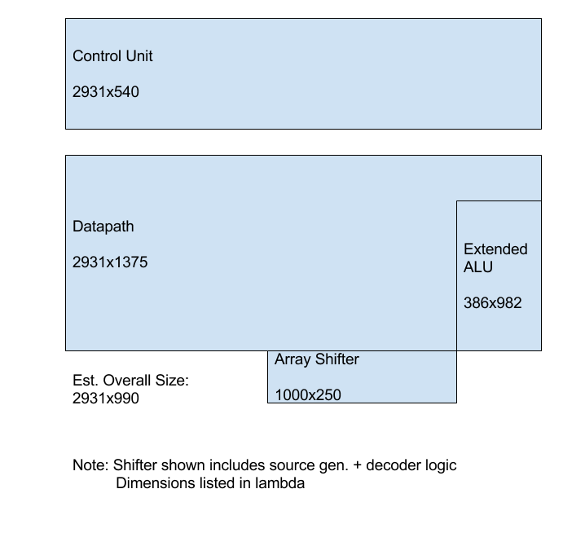

Datapath Slice Plan:
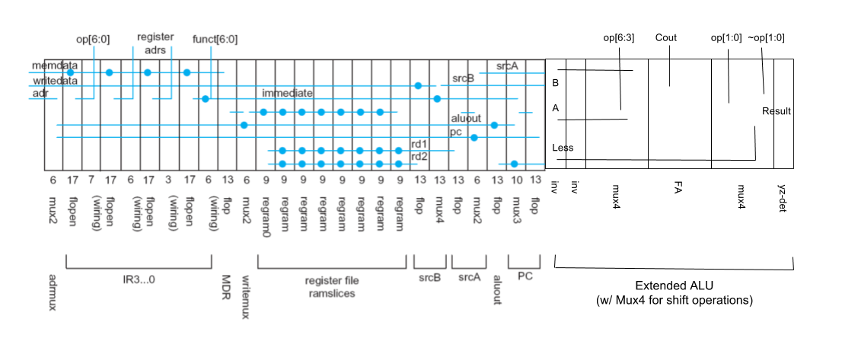

Shifter Slice Plan:

