Adam Ness and Marty Townley
ECE425
2/7/17

Lab 3

nand3_L

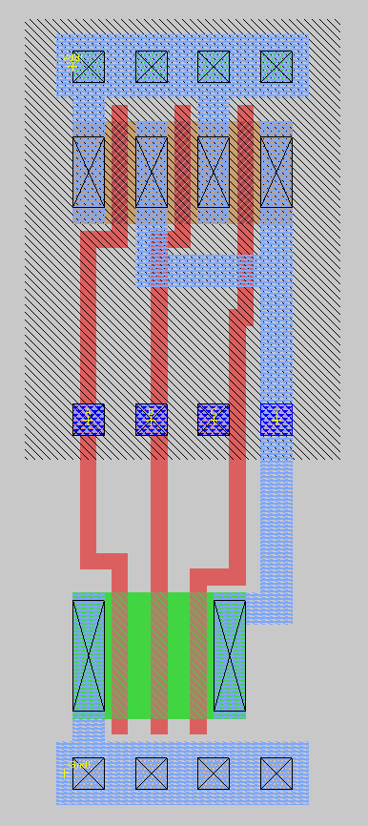

Root cell box:
width x height ( llx, lly ), ( urx, ury ) area (units^2)

microns: 12.00 x 30.00 ( -1.80, -1.20 ), ( 10.20, 28.80) 360.00
lambda: 40 x 100 ( -6, -4 ), ( 34, 96 ) 4000

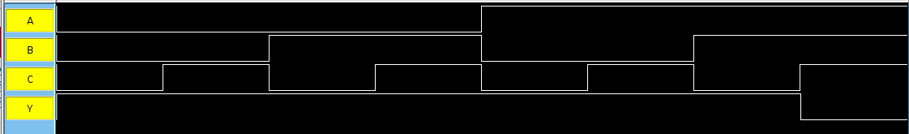

and3_L
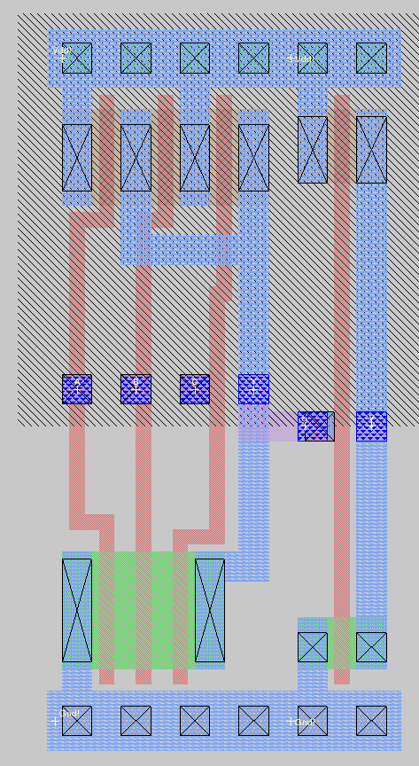

Root cell box:
width x height ( llx, lly ), ( urx, ury ) area (units^2)

microns: 16.80 x 30.00 ( 0.00, 0.00 ), ( 16.80, 30.00) 504.00
lambda: 56 x 100 ( 0, 0 ), ( 56, 100 ) 5600

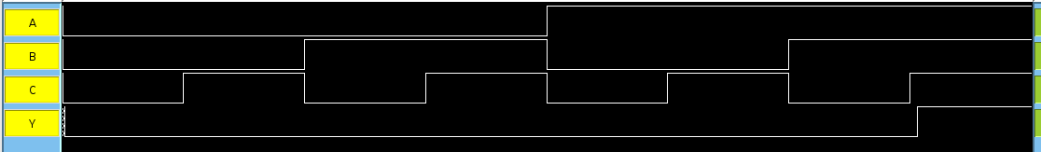

and2_1x_8

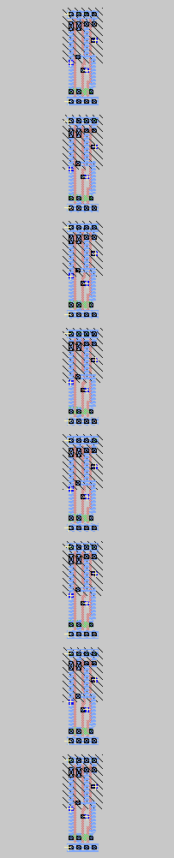

Root cell box:
width x height ( llx, lly ), ( urx, ury ) area (units^2)

microns: 12.00 x 261.00 (-39.60, 8.40 ), (-27.60, 269.40) 3132.00
lambda: 40 x 870 ( -132, 28 ), ( -92, 898 ) 34800

alu

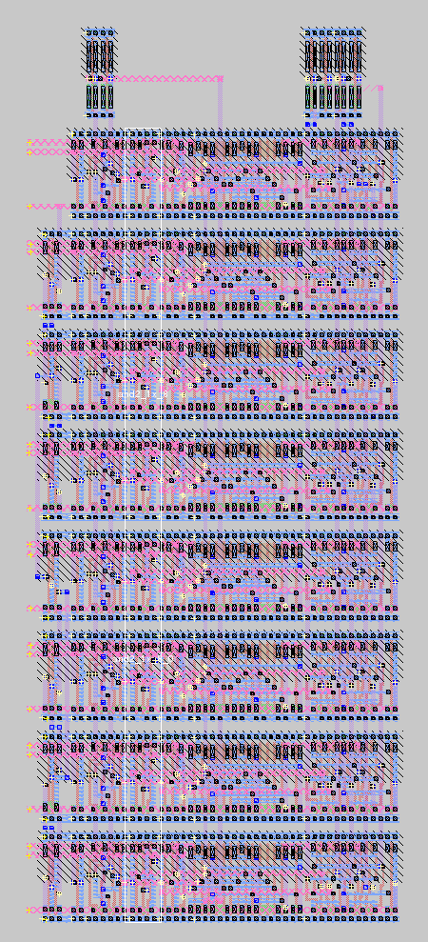

Root cell box:
width x height ( llx, lly ), ( urx, ury ) area (units^2)

microns: 123.30 x 294.00 ( -5.10, -1.20 ), ( 118.20, 292.80) 36250.20
lambda: 411 x 980 ( -17, -4 ), ( 394, 976 ) 402780
ALU Test:
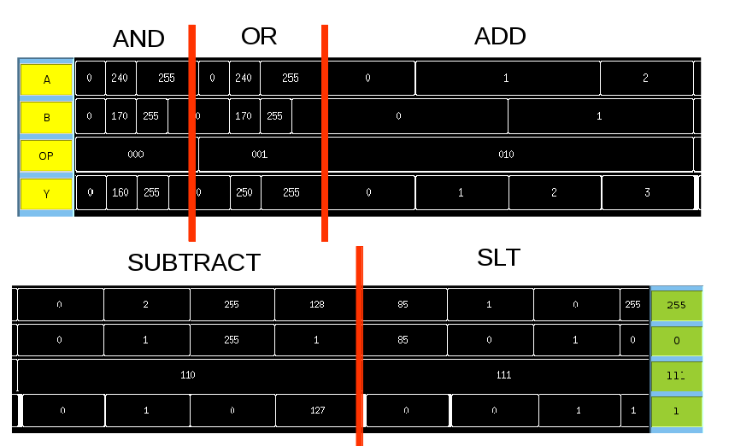

This test indicates that the ALU works properly for the test cases for all operations.

Annotated Slice:

