Adam Ness and Marty Townley
VLSI
03/06/17
Lab 6

Inverter simulation waveform:
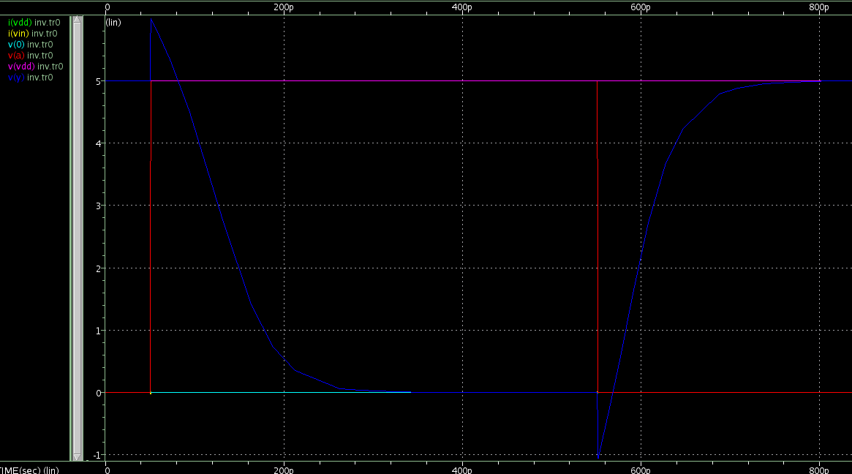
FO4 Simulation Waveform:
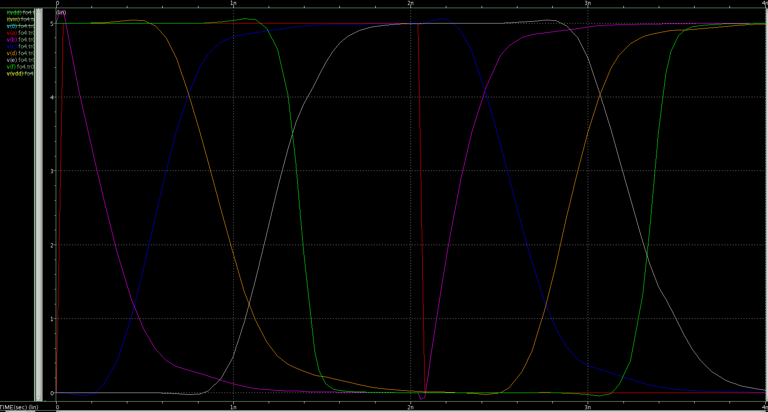

Fo4 timing
****** transient analysis tnom= 25.000 temp= 70.000 ******
tpdr= 291.3731p targ= 2.8921n trig= 2.6007n
tpdf= 355.7412p targ= 927.3073p trig= 571.5661p
tpd= 323.5572p
trise= 323.1150p targ= 3.0624n trig= 2.7393n
tfall= 369.0093p targ= 1.1214n trig= 752.3502p

NOR2 Simulation waveform:
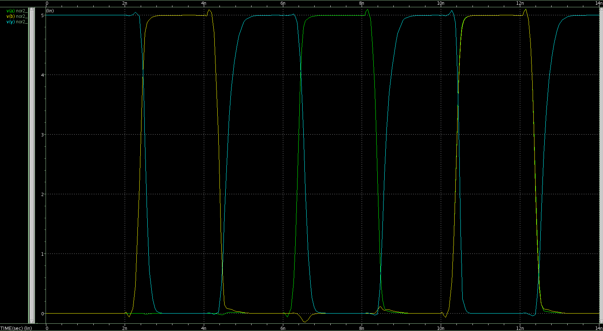

nor2_1x timing:

****** transient analysis tnom= 25.000 temp= 25.000 ******
tpdrb= 138.8399p targ= 2.5240n trig= 2.3851n
tpdfb= 188.3849p targ= 4.5746n trig= 4.3862n
tpdb= 163.6124p
tpdra= 163.8111p targ= 6.5454n trig= 6.3816n
tpdfa= 203.2156p targ= 8.5839n trig= 8.3807n
tpda= 183.5133p
trise= 247.4672p targ= 4.7315n trig= 4.4840n
tfall= 142.8684p targ= 2.5998n trig= 2.4570n

YZDET Simulation waveform:
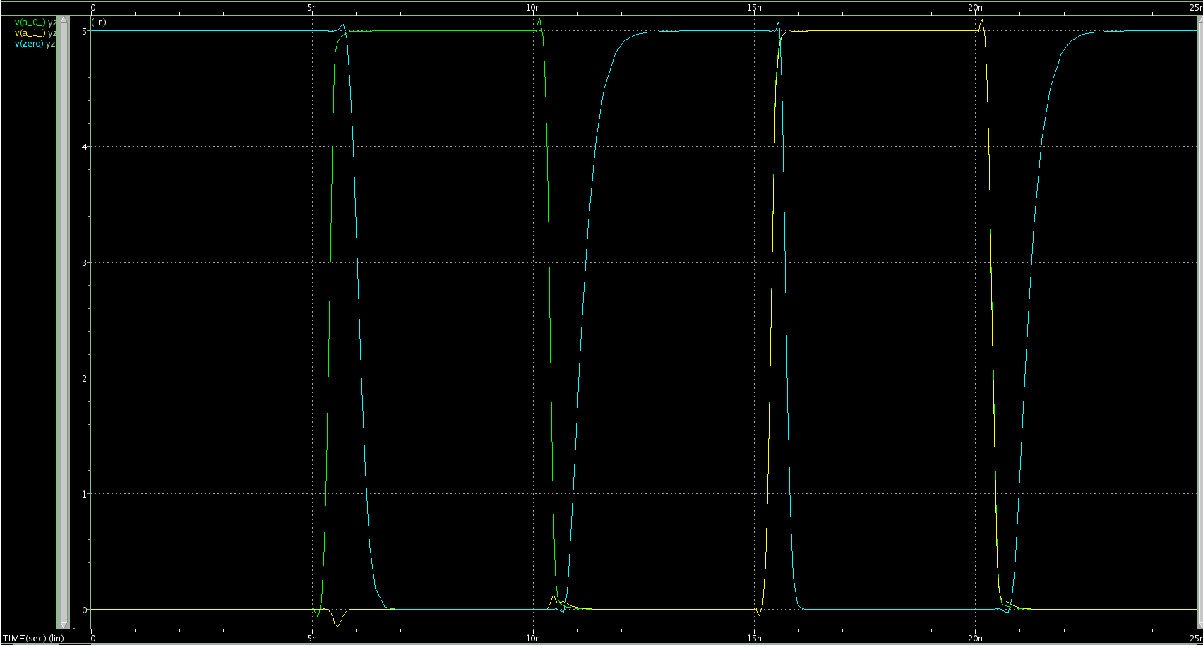

yzdet_8 timing
****** transient analysis tnom= 25.000 temp= 25.000 ******
tpdr1= 686.0806p targ= 6.0719n trig= 5.3858n
tpdf1= 723.7016p targ= 11.1046n trig= 10.3809n
tpd1= 704.8911p
tpdr7= 338.4113p targ= 15.7179n trig= 15.3795n
tpdf7= 813.4812p targ= 21.1891n trig= 20.3757n
tpd7= 575.9463p
trise= 504.5170p targ= 11.4054n trig= 10.9009n
tfall= 307.8549p targ= 6.2350n trig= 5.9272n

For different cases for rising and falling best and worst cases, a different driver was attached to a_0_, while the input for a_1_ thru a_7_ was identical.
Worst and best case for timing: Worst case for rising propagation delay was determined to be when only one input rose. This way, it would need to change all stages of the yzdetect. (tpdr1= 686.0806p)
Best case for input rise propagation delay timing was determined to be when all the inputs rose, so the output would change directly by the fastest path ( tpdr7= 338.4113p).

Worst case for falling inputs was determined to be when all the inputs fell simultaneously. This way, the slowest path determined the change time for the output. (tpdf7= 813.4812p ).
Best case for falling inputs was determined to be when only one input fell. (tpdf1= 723.7016p).

All of these hypotheses were concluded accurate by the simulation.

